Course Title: Medical Biochemistry II
RAD 2nd, Sec A
Lab Assignment
Student Name:Ijaz Ahmad
Student ID: 15998

Note: Avoid copy paste material, as it may deduct your marks.

Q1. Explain the process of Uric Acid Formation.
Q2. Discuss all the protein complexes used in Electron transport chain.

Q1:
Ans1: [[ Uric acid ]]
* Uric acid is the final breakdown of purine degradation in humans.
* uric acid is synthesized from compound containing purines,and it is wasre product derived from purines of the dict such as liver, thymus, meat organs.
* uric acid is only secreted by glomerular filtration a part of it is also reabsorbed by renel tubule.
* serum uric acid determination is used to treat gout.
* In gout blood level of uric acid is increased and also abmormal deposition of uric acid crystal occurs in joints,tendons bones leading to painfull condition of these structures.

[[Synthesis of Uric acid]]
* The end product of purines metobolism in humans is uric acid.
* The nucleotide monophosphate(AMP,IMP,GMP) are converted to their respective nucleoside forms(adenosine, inosine,and guanosine) by the action of nucleotidase.
* The amino group either from AMP or adenosine can be removed to produce IMP or inosine.
* inosine and guanosine are converted to hyoxanthine and guanine by purine nucleoside phosphorylase.Adenosine is not Degregated by this enzyme it has converted to inosine.
* Guanine undergoes deamination by guanase to form xanthine.
* Xanthine oxidase converts hypoxanthine to xanthine and xanthine to uri acid.
Xanthine oxidase liberates H2O2 which is harmful to tissues.
* catalases cleave H2O2 to water and oxygen .
* Uric acid is the final product of purines metobolism.
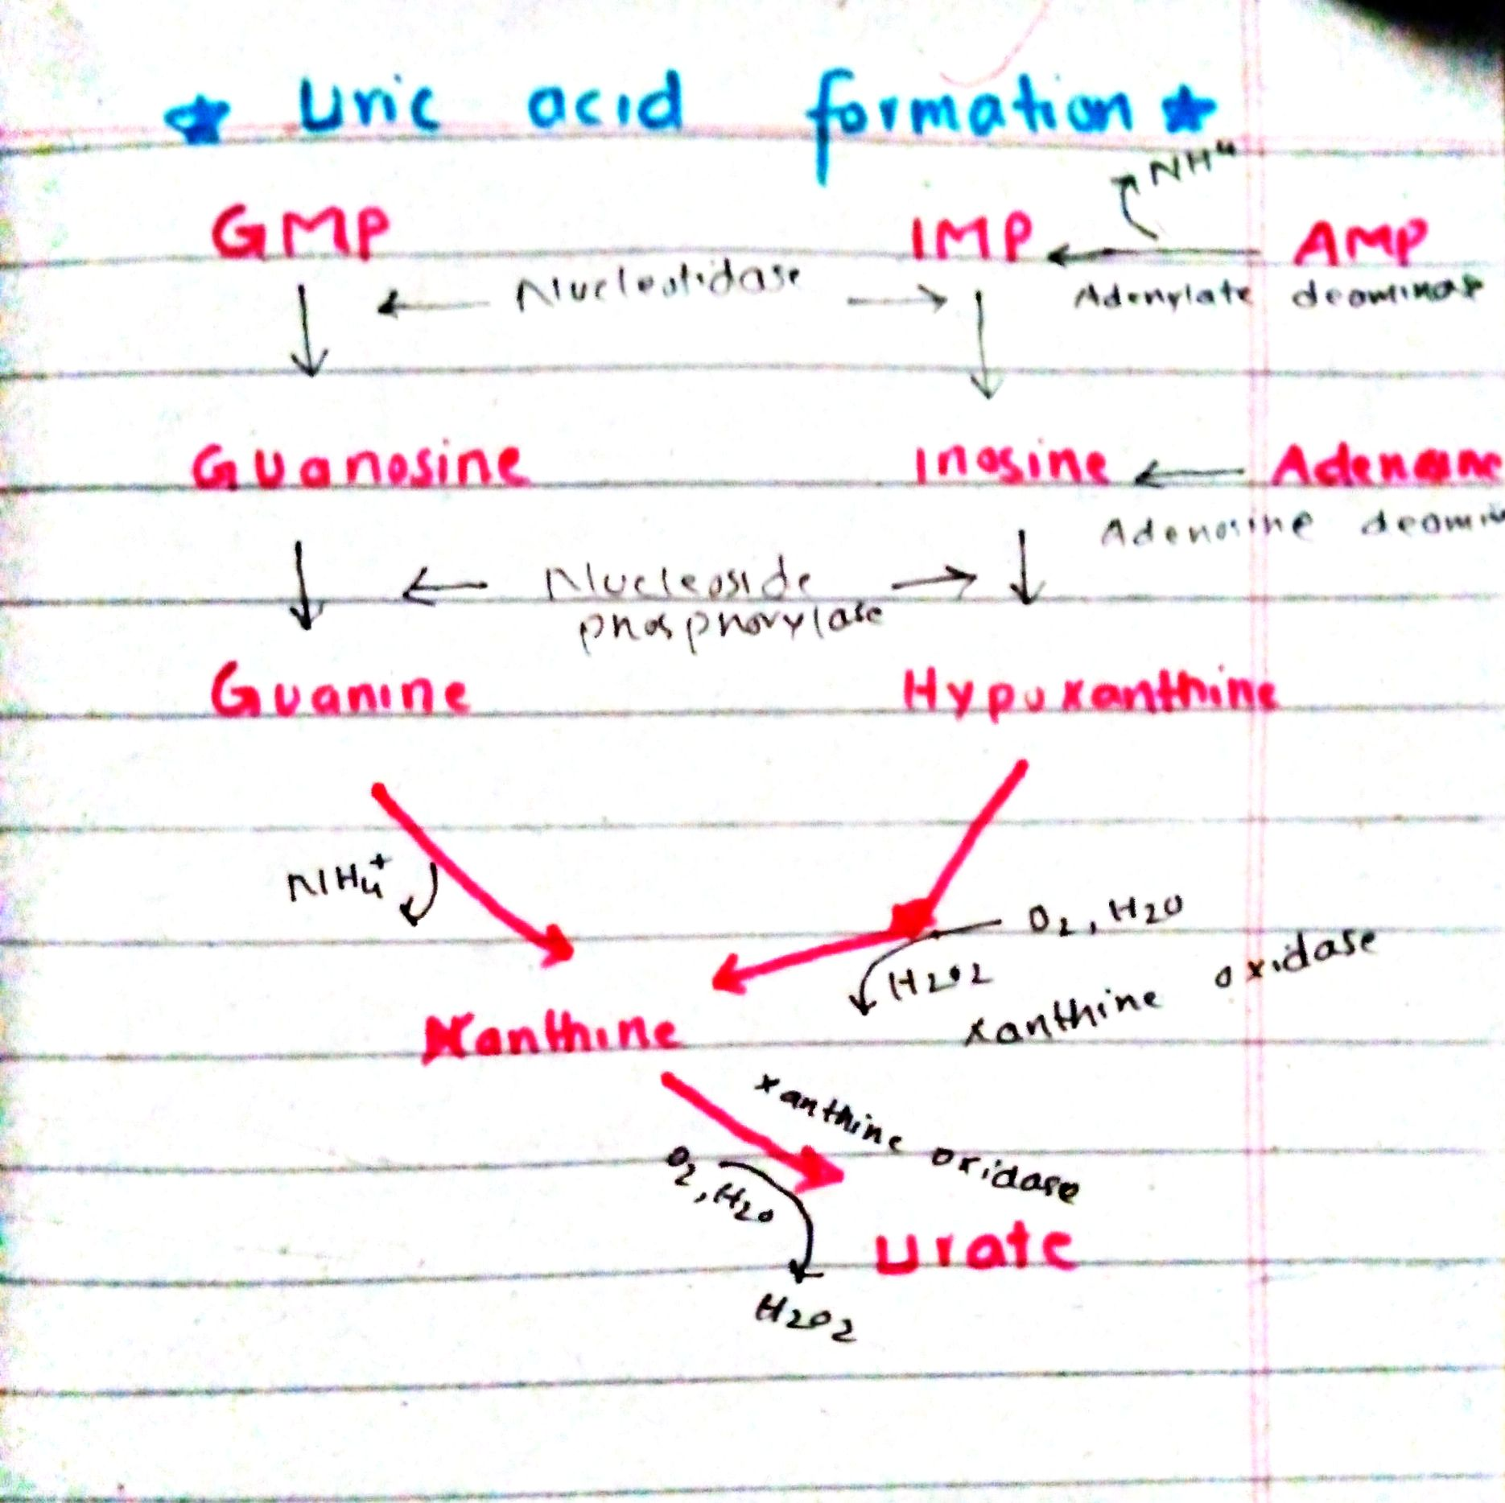
Q2:
Ans2: [[Protein complexes in Electron transport chain]]
the electron transport chain. This causes hydrogen ions to accumulate within the matrix space.This illustration shows the electron transport chain embedded in the inner mitochondrial membrane. The electron transport chain consists of four electron complexes. Complex I oxidizes NADH to NAD^^{+} and simultaneously pumps a proton across the membrane to the inter membrane space. The two electrons released from NADH are shuttled to coenzyme Q, then to complex III, to cytochrome c, to complex IV, then to molecular oxygen. In the process, two more protons are pumped across the membrane to the intermembrane space, and molecular oxygen is reduced to form water. Complex II removes two electrons from FADH_{2}, thereby forming FAD. The electrons are shuttled to coenzyme Q, then to complex III, cytochrome c, complex I, and molecular oxygen as in the case of NADH oxidation.
Complex I
To start, two electrons are carried to the first complex aboard NADH. This complex, labeled I, is composed of flavin mononucleotide (FMN) and an iron-sulfur (Fe-S)-containing protein. FMN, which is derived from vitamin B2, also called riboflavin. A prosthetic group is a non-protein molecule required for the activity of a protein. The enzyme in complex I is NADH dehydrogenase and is a very large protein, containing 45 amino acid chains. Complex I can pump four hydrogen ions across the membrane from the matrix into the intermembrane space, and it is in this way that the hydrogen ion gradient is established and maintained between the two compartments separated by the inner mitochondrial membrane.

Q and Complex II
Complex II directly receives FADH2, which does not pass through complex I. The compound connecting the first and second complexes to the third is ubiquinone (Q). The Q molecule is lipid soluble and freely moves through the hydrophobic core of the membrane. Once it is reduced, (QH2), ubiquinone delivers its electrons to the next complex in the electron transport chain. Q receives the electrons derived from NADH from complex I and the electrons derived from FADH2 from complex II, including succinate dehydrogenase. This enzyme and FADH2 form a small complex that delivers electrons directly to the electron transport chain, bypassing the first complex. Since these electrons bypass and thus do not energize the proton pump in the first complex, fewer ATP molecules are made from the FADH2 electrons. The number of ATP molecules ultimately obtained is directly proportional to the number of protons pumped across the inner mitochondrial membrane.

Complex III
The third complex is composed of cytochrome b, another Fe-S protein, Rieske center and cytochrome c proteins; this complex is also called cytochrome oxidoreductase. Cytochrome proteins have a prosthetic group of heme. The heme molecule is similar to the heme in hemoglobin, but it carries electrons, not oxygen. As a result, the iron ion at its core is reduced and oxidized as it passes the electrons, fluctuating between different oxidation states: Fe++ (reduced) and Fe+++ (oxidized). The heme molecules in the cytochromes have slightly different characteristics due to the effects of the different proteins binding them, giving slightly different characteristics to each complex. Complex III pumps protons through the membrane and passes its electrons to cytochrome c for transport to the fourth complex of proteins and enzymes.

Complex IV
The fourth complex is composed of cytochrome proteins c, a, and a3. This complex contains two heme group and three copper ion .The cytochromes hold an oxygen molecule very tightly between the iron and copper ions until the oxygen is completely reduced. The reduced oxygen then picks up two hydrogen ions from the surrounding medium to make water (H2O). The removal of the hydrogen ions from the system contributes to the ion gradient used in the process of chemiosmosis.

Thank you

