Final-Term Assignment

Course Title: Human Physiology I
DT plus Rad 1st semester
Instructor: Dr. M .Shahzeb khan (PT)
Marks: 50

Note:
- Attempt all questions, all questions carry equal marks.
- Answer Briefly and to the point, avoid un-necessary details

Q1: What is pituitary gland? Explain different lobes and hormones release from form it?
Ans: Pituitary Gland:
The pituitary gland is a small pea-sized gland that plays a major role in regulating vital body functions and general wellbeing. It is referred to as the body's 'master gland' because it controls the activity of most other hormone-secreting glands.
Anterior lobe:
✕ Growth hormone (GH)
✕ Prolactin
✕ Thyroid stimulating hormone (TSH)
✕ Adrenocorticotrophic hormone (ACTH)
✕ Follicle stimulating hormone (FSH)
✕ Luteinizing hormone (LH)

Posterior lobe:
Vasopressin (ADH)
oxytocin.
Anterior Lobe:
1)Growth Harmone:
Stimulating of growth of bones, cartilage and connective tissue:
✕ Increase calcium absorption from GIT
Decrease sodium, potassium, calcium and phosphorous
excretion from kidney.
2)Prolactin:
Actions of prolactin:
✕ Prolactin plays an important role in the development of the mammary gland and in milk synthesis.
3)Thyroid-stimulating hormone(TSH) :
It stimulates the thyroid gland to produce:
Thyroxin (T4), and
Triiodothyronine (T3)
4. ADRENOCORTICOTROPHIC HORMONE(ACTH):
✕ It is often produced in response to biological stress.
✕ Its principal effects are increased production and
release of corticosteroids.
5. FOLLICLE STIMULATING HORMONE(FSH):

FSH regulates the development, growth, pubertal maturation and reproductive processes
of the body.
6. LUTEINIZING HORMONE(LH):
.
In females, an acute rise of LH triggers ovulation

In males, it stimulates the production of testosterone.
Posterior Lobe:
A. Anti-diuretic hormone (ADH) /vasopressin:
To retain water in the body.
A:Oxytocin:
Oxytocin is synthesized in the hypothalamus
Stored in the posterior lobe of pituitary gland.
Action of oxytocin:
Oxytocin stimulates contraction of mammary gland to produce milk.
Stimulate contraction of the smooth muscles of the uterus.
Q2: Write a difference between Appendicular and Axial skeleton?
Ans:
The Appendicular Skeleton
The appendicular skeleton includes all bones of the upper and lower limbs, plus the bones of the pectoral and pelvic girdles that attach each limb to the axial skeleton. There are 126 bones in the appendicular skeleton of an adult. The lower portion of the appendicular skeleton is specialized for stability during walking or running. In contrast, the upper portion of the appendicular skeleton has greater mobility and ranges of motion, features that allow you to lift and carry objects. The bones of the appendicular skeleton are covered in a separate chapter.
The skeletal system includes all of the bones, cartilages, and ligaments of the body. It serves to support the body, protect the brain and other internal organs, and provides a rigid structure upon which muscles can pull to generate body movements. It also stores fat and the tissue responsible for the production of blood cells. The skeleton is subdivided into two parts. The axial skeleton forms a vertical axis that includes the head, neck, back, and chest. It has 80 bones and consists of the skull, vertebral column, and thoracic cage. The adult vertebral column consists of 24 vertebrae plus the sacrum and coccyx. The thoracic cage is formed by 12 pairs of ribs and the sternum. The appendicular skeleton consists of 126 bones in the adult and includes all of the bones of the upper and lower limbs plus the bones that anchor each limb to the axial skeleton.
The Axial Skeleton
The axial skeleton forms the vertical, central axis of the body and includes all bones of the head, neck, chest, and back . It serves to protect the brain, spinal cord, heart, and lungs. It also serves as the attachment site for muscles that move the head, neck, and back, and for muscles that act across the shoulder and hip joints to move their corresponding limbs.

The axial skeleton of the adult consists of 80 bones, comprising the skull, the vertebral column, and the thoracic cage. The skull is formed by 22 bones. Also associated with the head are an additional seven bones, including the hyoid bone (found in the upper neck) and the ear ossicles (three small bones found in each middle ear). The vertebral column consists of 24 bones, each called a vertebra, plus the fused vertebrae of the sacrum and coccyx. The thoracic cage includes 12 pairs of ribs, and the sternum, the flattened bone of the anterior chest.

This diagram shows the human skeleton and identifies the major bones. The left panel shows the anterior view (from the front) and the right panel shows the posterior view (from the back)
Axial and Appendicular Skeleton: The axial skeleton supports the head, neck, back, and chest and thus forms the vertical axis of the body. It consists of the skull, vertebral column (including the sacrum and coccyx), and the thoracic cage, formed by the ribs and sternum. The appendicular skeleton is made up of all bones of the upper and lower limbs and the girdles which attach them to the axial skeleton.

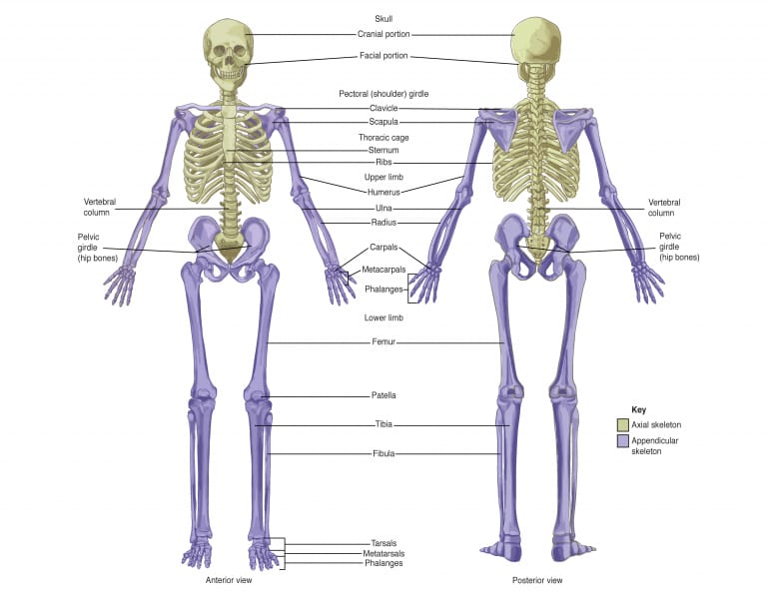

Q3: What is Muscular tissue? Explain different Types of muscles?
Ans: Muscular Tissue:
Muscular cells are called Muscle fibers.
Every fibers contain thousand of Myofibrils.
Inside each myofibril there are many Myofilaments that
are made of two proteins:
the Actin and the Myosin.
The myofibrils are divided in
subunits called Sarcomeres.
Types of Muscles:
There are three types of muscles:
• Skeletal Muscle
Cardiac Muscle
Smooth Muscle
Skeletal Muscles:
• The Skeletal muscles are also known as
Striated or Voluntary.
• They are attached to bones by tendons
providing movement.
• Their contraction is quick and variable
from powerful to precise. It is controlled
by the CNS.
CARDIAC MUSCLE:
• Cardiac Muscle is only found in the Heart.
• It is made of striated fibers and its contraction is
directed by the ANS.
• It contracts involuntarily and rhythmically. It’s also
very resistant to fatigue due to the large number of mitochondria they have.
SMOOTH MUSCLE:
• Smooth muscle are also known as involuntary as
its contraction is lead by the CNS and the glands.
• It covers the hollow walls of many organs such as
the oesophagus, the broncchi, the uterus or
the stomach.
• It contracts slowly.

Q4: Write a note on Cycle of Breathing?
Ans: CYCLE OF BREATHING

The average respiratory rate is 12 to 15 breaths/minute.

Each breath consists of two phases:
(i)Inspiration
(ii)Expiration

(i)Inspiration
When the capacity of the thoracic cavity is increased by simultaneous contraction of the intercostal muscles and the diaphragm.
The parietal pleura moves with the walls of the thorax & the diaphragm.
This reduces the pressure in the pleural cavity to a level considerably lower than atmospheric pressure.
The visceral pleura follows the parietal pleura
,pulling the lungs with it.
This expands the lungs and the pressure within the alveoli and in the air passages,drawing air into the lungs in attempt to equalise the atmospheric and alveolar air pressure.

Q5: Write a detail note on Function of Integumentary system?
Ans: The Integumentary System:
The integument as an organ:
The integument as an organ, and is an alternative name for skin.
The integumentary system includes the skin and the skin derivatives hair, nails, and glands.
The Integument Is the largest system of the body
16% of body weight,
1.5 to 2m2 in area,
The integument is made up of two parts:
1. Cutaneous membrane
a. Epidermis– Superficial epithelium
b. Dermis – underlying CT with blood supply
2. Accessory structures
a. Hair
b. Nails
c. Exocrine Glands
Functions of Integumentary system:
Protection:
First line of defense against
Bacteria
Viruses
Protects underlying structures from
Ultraviolet (UV) radiation
Dehydration
Vitamin D production
Needed for calcium absorption
Sensation
Sensory receptors.
Body temperature regulation:
If too hot
Dermal blood vessels dilate
Vessels carry more blood to surface so heat can escape
If too cold
Dermal blood vessels constrict
Prevents heat from escaping
Excretion:
Small amounts of waste products are lost through perspiration.
Structure of the skin:
Understanding how the skin can function in these many
ways starts with understanding the structure of the 3
layers of skin
The Epidermis
Epithelial tissue
Dermis
Dense connective tissue proper – irregular
Hypodermis
ISubcutaneous tissue- loose connective tissue proper and adipose tissue.
Hair function:
Head:
UV protection
Cushion from trauma
Insulation
Nostrils, Ear canals, Eyelashes:
Prevent entry of foreign material
Body Hair:
sensory detection.
Root hair plexus:
Sensory nerves at base of hair follicle that detect sligh movement of hair
Arrector pili muscle:
Attached to every hair follicle
Contract to stand hair perpendicular to skin surface.
