SUBJECT.HUMAN ANATOMY
SECTION.B
Name: Sardar Hussain
Student ID: 16874
Department:Bs Radiology

Q:1. What are the major features of intracranial fosses of the skull ?
Ans. The anterior cranial fossa consists of three bones: the frontal bone, ethmoid bone and sphenoid bone.
Fossa in the skull?
In anatomy, a fossa is a depression or hollow, usually in a bone, such as the hypophyseal fossa (the depression in the sphenoid bone). Some examples include: In the Skull: Cranial fossa. Anterior cranial fossa.
Middle cranial fossa of the skull?
The middle cranial fossa consists of a central portion, which contains the pituitary gland, and two lateral portions, which accommodate the temporal lobes of the brain. Both parts of thefossa are marked by numerous bony landmarks, which will be discussed below.
Three major areas that make up the skull?
It supports the structures of the face and forms a cavity for the brain. Like the skulls of other vertebrates, it protects the brain from injury. The skull consists of three parts, of different embryological origin—the neurocranium, the sutures, and the facial skeleton (also called the membraneous viscerocranium).
The main functions of the skull?
The main function of the skull is to protect our soft and delicate brain. It also helps to attach the brain and other head organs to the rest of the body by connecting to the spinal cord. Additionally, it contains the bones of the face, which help to form our appearance.
There are three distinct cranial fossae:
- Anterior cranial fossa (fossa cranii anterior), housing the projecting frontal lobes of the brain
- Middle cranial fossa (fossa cranii media), separated from the posterior fossa by the clivus and the petrous crest
- Posterior cranial fossa (fossa cranii posterior), between the foramen magnum and tentorium cerebelli, containing the brainstem and cerebellum
- 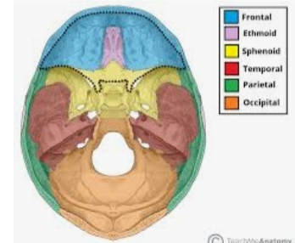
- 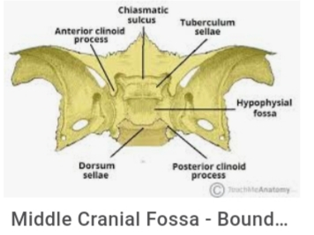

Q.2.write note on the cranial nerves.
Answer:The cranial nerves are 12 pairs of nerves that can be seen on the ventral (bottom) surface of the brain. Some of these nerves bring information from the sense organs to the brain; other cranial nerves control muscles; other cranial nerves are connected to glands or internal organs such as the heart and lungs
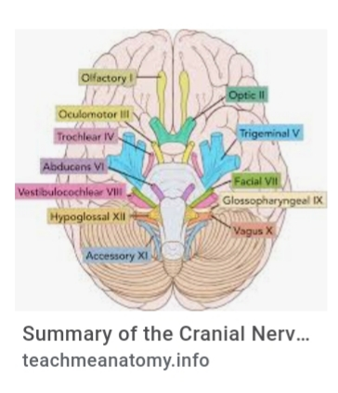
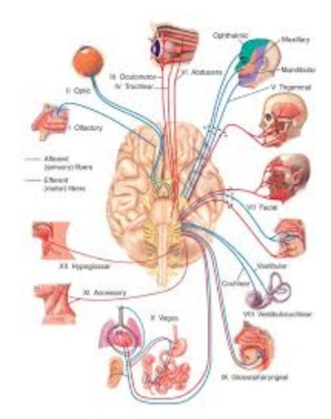

The 12 Cranial Nerves

I. Olfactory nerve
The olfactory nerve transmits sensory information to your brain regarding smells that you encounter.
When you inhale aromatic molecules, they dissolve in a moist lining at the roof of your nasal cavity, called the olfactory epithelium. This stimulates receptors that generate nerve impulses that move to your olfactory bulb. Your olfactory bulb is an oval-shaped structure that contains specialized groups of nerve cells.
From the olfactory bulb, nerves pass into your olfactory tract, which is located below the frontal lobe of your brain. Nerve signals are then sent to areas of your brain concerned with memory and recognition of smells.

II. Optic nerve
The optic nerve is the sensory nerve that involves vision.
When light enters your eye, it comes into contact with special receptors in your retina called rods and cones. Rods are found in large numbers and are highly sensitive to light. They’re more specialized for black and white or night vision.
Cones are present in smaller numbers. They have a lower light sensitivity than rods and are more involved with color vision.
The information received by your rods and cones is transmitted from your retina to your optic nerve. Once inside your skull, both of your optic nerves meet to form something called the optic chiasm. At the optic chiasm, nerve fibers from half of each retina form two separate optic tracts.
Through each optic tract, the nerve impulses eventually reach your visual cortex, which then processes the information. Your visual cortex is located in the back part of your brain.

III. Oculomotor nerve
The oculomotor nerve has two different motor functions: muscle function and pupil response.
- Muscle function. Your oculomotor nerve provides motor function to four of the six muscles around your eyes. These muscles help your eyes move and focus on objects.
- Pupil response. It also helps to control the size of your pupil as it responds to light.
This nerve originates in the front part of your midbrain, which is a part of your brainstem. It moves forward from that area until it reaches the area of your eye sockets.
powered by Rubicon Project

IV. Trochlear nerve
The trochlear nerve controls your superior oblique muscle. This is the muscle that’s responsible for downward, outward, and inward eye movements.
It emerges from the back part of your midbrain. Like your oculomotor nerve, it moves forward until it reaches your eye sockets, where it stimulates the superior oblique muscle.

V. Trigeminal nerve
The trigeminal nerve is the largest of your cranial nerves and has both sensory and motor functions.
The trigeminal nerve has three divisions, which are:
- Ophthalmic. The ophthalmic division sends sensory information from the upper part of your face, including your forehead, scalp, and upper eyelids.
- Maxillary. This division communicates sensory information from the middle part of your face, including your cheeks, upper lip, and nasal cavity.
- Mandibular. The mandibular division has both a sensory and a motor function. It sends sensory information from your ears, lower lip, and chin. It also controls the movement of muscles within your jaw and ear.
The trigeminal nerve originates from a group of nuclei — which is a collection of nerve cells — in the midbrain and medulla regions of your brainstem. Eventually, these nuclei form a separate sensory root and motor root.
The sensory root of your trigeminal nerve branches into the ophthalmic, maxillary, and mandibular divisions. The motor root of your trigeminal nerve passes below the sensory root and is only distributed into the mandibular division.

VI. Abducens nerve
The abducens nerve controls another muscle that’s associated with eye movement, called the lateral rectus muscle. This muscle is involved in outward eye movement. For example, you would use it to look to the side.
This nerve, also called the abducent nerve, starts in the pons region of your brainstem. It eventually enters your eye socket, where it controls the lateral rectus muscle.

VII. Facial nerve
The facial nerve provides both sensory and motor functions, including:
- moving muscles used for facial expressions as well as some muscles in your jaw
- providing a sense of taste for most of your tongue
- supplying glands in your head or neck area, such as salivary glands and tear-producing glands
- communicating sensations from the outer parts of your ear
Your facial nerve has a very complex path. It originates in the pons area of your brainstem, where it has both a motor and sensory root. Eventually, the two nerves fuse together to form the facial nerve.
Both within and outside of your skull, the facial nerve branches further into smaller nerve fibers that stimulate muscles and glands or provide sensory information.

VIII. Vestibulocochlear nerve
Your vestibulocochlear nerve has sensory functions involving hearing and balance. It consists of two parts, the cochlear portion and vestibular portion:
- Cochlear portion. Specialized cells within your ear detect vibrations from sound based off of the sound’s loudness and pitch. This generates nerve impulses that are transmitted to the cochlear nerve.
- Vestibular portion. Another set of special cells in this portion can track both linear and rotational movements of your head. This information is transmitted to the vestibular nerve and used to adjust your balance and equilibrium.
The cochlear and vestibular portions of your vestibulocochlear nerve originate in separate areas of the brain.
The cochlear portion starts in an area of your brain called the inferior cerebellar peduncle. The vestibular portion begins in your pons and medulla. Both portions combine to form the vestibulocochlear nerve.

IX. Glossopharyngeal nerve
The glossopharyngeal nerve has both motor and sensory functions, including:
- sending sensory information from your sinuses, the back of your throat, parts of your inner ear, and the back part of your tongue
- providing a sense of taste for the back part of your tongue
- stimulating voluntary movement of a muscle in the back of your throat called the stylopharyngeus
The glossopharyngeal nerve originates in a part of your brainstem called the medulla oblongata. It eventually extends into your neck and throat region.

X. Vagus nerve
The vagus nerve is a very diverse nerve. It has both sensory and motor functions, including:
- communicating sensation information from your ear canal and parts of your throat
- sending sensory information from organs in your chest and trunk, such as your heart and intestines
- allowing motor control of muscles in your throat
- stimulating the muscles of organs in your chest and trunk, including those that move food through your digestive tract (peristalsis)
- providing a sense of taste near the root of your tongue
Out of all of the cranial nerves, the vagus nerve has the longest pathway. It extends from your head all the way into your abdomen. It originates in the part of your brainstem called the medulla.

XI. Accessory nerve
Your accessory nerve is a motor nerve that controls the muscles in your neck. These muscles allow you to rotate, flex, and extend your neck and shoulders.
It’s divided into two parts: spinal and cranial. The spinal portion originates in the upper part of your spinal cord. The cranial part starts in your medulla oblongata.
These parts meet briefly before the spinal part of the nerve moves to supply the muscles of your neck while the cranial part follows the vagus nerve.

XII. Hypoglossal nerve
Your hypoglossal nerve is the 12th cranial nerve which is responsible for the movement of most of the muscles in your tongue. It starts in the medulla oblongata and moves down into the jaw, where it reaches the tongue.
Function. The cranial nerves provide motor and sensory supply mainly to the structures within the head and neck. The sensory supply includes both "general" sensation such as temperature and touch, and "special" senses such as taste, vision, smell, balance and hearing.
Qno3. :write note on the silent features of norma frontalis and Norma occipitals of skull .
Norma frontalis?
norma frontalis. The outline of the skull viewed from the front. Synonym: anteriornorma; norma facialis.
Norma Occipitalis?
norma basalis. 4. The highest nuchal lines are not always present. They are curved bony ridges situated about 1 cm above the superior nuchal lines. They begin from the upper part of the external occipital protuberance and are more arched than the superior nuchal lines.
Meant by salient features?
The salient facts about something or qualities of something are the most important things about them: She began to summarize thesalient features/points of the proposal. The article presented the salient facts of the dispute clearly and concisely. Very important or urgent.
Licensed from GettyImages. adjective. The definition of salient is something that is very noticeable, jumps or is prominent. An exampleof salient is a large dark mole on someone's forehead. An example of salient is a key point in a proposal.skull

Salient Features
What are the characteristic features of a good essay? | eNotes Jan 13, 2009 ... A good essay consists of three elements of composition: content, structure, and mechanics. If the writer deals effectively with each of these, theÂ ... What is a salient feature of a good essay - Answers.com I will mention a few salient features of good essays. They are interesting, clear, and logical. Top Salient Features That Make Us Popular for write my essay ... Apr 22, 2015 ... post and know more about the salient featuresof our writing service. ... When students hire any professional writer for writing essay paper forÂ ... Key Characteristics Of Analytical Essay For College Students Define your thesis: Every good analytical essay (every good essay, for that matter) begins with a strong thesis. Your thesis statement is the backbone of yourÂ ... The 3 defining features of a great essay | Bookboon Blog Nov 13, 2013 ... Once you know how to go about putting a good essay together, it is less work than you might think. Let's take a look at the 3 most essentialÂ ... How to write a good essay, or what are the qualities of a good ... How do you write a good essay? Very carefully. There is no formula to college essay writing, and that is exactly why colleges require one from you. The importantÂ ... Qualities Of A Good Abstract ABSTRACTS. An abstract presents the essential information contained in a research report, an article, a book, or other document.
Anatomical terminology
The skull is a bony structure that forms thehead in vertebrates. It supports the structures of the face and provides a protective cavity for the brain. The skull is composed of two parts: the cranium and the mandible.

Q no.4:what do you know about muscle of hip and knee ?

Muscles of the hip
In human anatomy, the muscles of the hip joint are those muscles that cause movement in the hip. Most modern anatomists define 17 of these muscles, although some additional muscles may sometimes be considered. These are often divided into four groups according to their orientationaround the hip joint: the gluteal group; the lateral rotator group; the adductor group; and the iliopsoas group.
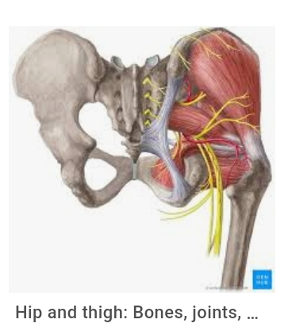
Function.
Movements of the hip occur because multiple muscles activate at once. Most muscles are also responsible for more than one type of movement.
Movements of the hip are described in anatomical terminology using anatomical terms of motion. The movement that brings the thighs close to the abdomen is called "flexion". When the legs open, such as in the lotus posture of yoga, this is called "lateral rotation", with the opposite movement called "medial rotation". Hip abduction occurs when the femur moves outward to the side, as in taking the thighs apart. Hip adduction occurs when the femur moves back to the midline. Many muscles contribute to these movements:
- The psoas is the primary hip flexor, assisted by the iliacus. The pectineus, the adductors longus, brevis, and magnus, as well as the tensor fasciae latae are also involved in flexion.
- The gluteus maximus is the main hip extensor, but the inferior portion of the adductor magnus also plays a role.
- The adductor group is responsible for hip adduction.
- Medial rotation is performed by the gluteus medius and gluteus minimus, as well as the tensor fasciae latae and assisted by the adductors brevis and longus and the superior portion of the adductor magnus.
- Each muscle of the lateral rotator group causes lateral rotation of the thigh. These muscles are aided by the gluteus maximus and the inferior portion of the adductor magnus.

Structure

Gluteal group
Main article: Gluteal muscles
The gluteal muscles include the gluteus maximus, gluteus medius, gluteus minimus, and tensor fasciae latae. They cover the lateral surface of the ilium.

Adductor group
Main article: Adductor muscles of the hip
The adductor brevis, adductor longus, adductor magnus, pectineus, and gracilismake up the adductor group.

Iliopsoas group
Main article: Iliopsoas
The iliacus and psoas major comprise the iliopsoas group. The psoas major is a large muscle that runs from the bodies and disc of the L1 to L5 vertebrae, joins with the iliacus via its tendon, and connects to the lesser trochanter of the femur.

Lateral rotator group
Main article: Lateral rotator group
This group consists of the externus and internus obturators, the piriformis, the superior and inferior gemelli, and the quadratus femoris. These six originate at or below the acetabulum of the ilium and insert on or near the greater trochanter of the femur.

The Knee Joint
The knee joint is a hinge type synovial joint, which mainly allows for flexion and extension (and a small degree of medial and lateral rotation). It is formed by articulations between the patella, femur and tibia.
In this article, we shall examine the anatomy of the knee joint – its articulating surfaces, ligaments and neurovascular supply.
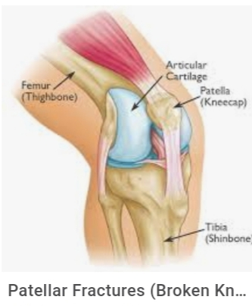

Articulating Surfaces
The knee joint consists of two articulations – tibiofemoral and patellofemoral. The joint surfaces are lined with hyaline cartilage, and are enclosed within a single joint cavity.
- Tibiofemoral – medial and lateral condyles of the femur articulate with the tibial condyles. It is the weight-bearing component of the knee joint.
Patellofemoral – anterior aspect of the distal femur articulates with the patella. It allows the tendon of the quadriceps femoris (knee extensor) to be inserted directly over the knee – increasing the efficiency of the muscle.

Neurovasculature
The blood supply to the knee joint is through the genicular anastomoses around the knee, which are supplied by the genicular branches of the femoral and popliteal arteries.
The nerve supply, according to Hilton’s law, is by the nerves which supply the muscles which cross the joint. These are the femoral, tibial and common fibular nerves.

Menisci
The medial and lateral menisci are fibrocartilage structures in the knee that serve two functions:
- To deepen the articular surface of the tibia, thus increasing stability of the joint.
- To act as shock absorbers by increasing surface area to further dissipate forces.
They are C shaped, and attached at both ends to the intercondylar area of the tibia.
In addition to the intercondylar attachment, the medial meniscus is fixed to the tibial collateral ligament and the joint capsule. Damage to the tibial collateral ligament usually results in a medial meniscal tear.
The lateral meniscus is smaller and does not have any extra attachments, rendering it fairly mobile.
Q:5. Write a comprehensive note on the femoral triangle .
Femoral triangle. The femoral triangleis a wedge-shaped area formed by a depression between the muscles of the thigh. It is located on the medial aspect of the proximal thigh. It is the region of the passage of the main blood vessels between the pelvis and the lower limb, as well as a large nerve supplying the thigh.
Structure of the Femoral Triangle
- Superior border - inguinal ligament.
- Medial border - adductor longus muscle.
- Lateral border - sartorius muscle.
- Medial floor - adductor longus and pectineus muscle.
- Lateral floor - iliopsoas muscle.

Clinical significance
Since the femoral triangle provides easy access to a major artery, coronary angioplastyand peripheral angioplasty is often performed by entering the femoral artery at the femoral triangle. Heavy bleeding in the leg can be stopped by applying pressure to points in the femoral triangle. Another clinical significance of the femoral triangle is that the femoral artery is positioned at the midinguinal point (midpoint between the pubic symphysis and the anterior superior iliac spine); medial to it lies the femoral vein. Thus the femoral vein, once located, allows for femoral
Key facts for the femoral triangle
Borders (SAIL) | Lateral border: Sartorius muscle  Medial border: Adductor longus muscle  Base or superior border: Inguinal Ligament
Contents (NAVEL) | Femoral Nerve, Femoral Artery, Femoral Vein, Femoral canal (Empty space), Lymphatics
Clinical importance | Femoral pulse, vascular access and catheterization, femoral hernias

Borders of the femoral triangle
Lateral border | Sartorius
Medial border | Adductor Longus
Base or superior border | Inguinal Ligament
The borders of the femoral triangle can be remembered using the word SAIL, as demonstrated in the table above. As well as these boundaries, the femoral triangle also has a floor and a roof. The floor is comprised of four muscles that can be easily remembered by using the mnemonic APPI (adductor longus, pectineus, psoas major and illiacus muscles). The roof is formed by the fascia lata, superficial fascia, and the skin. The apex of the triangle is pointed downwards towards the adductor canal.
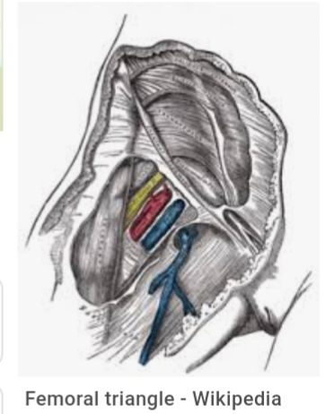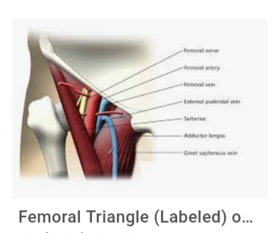

The end

