ID: 14192
Name: Salman khan
Subject: programming Fundamental
Program: BS(cs)
Date: 15/06/2020

Q1: Using a do-while loop, write a program that will do banking transactions as per the figures below:
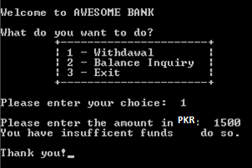
ANS:
#include<iostream>
#include<stdio.h>
using namespace std;
main()
{
int num=1;
int amo;
cout<<"Welcome to AWESOME BANK"<<endl;
cout<<"What do you want to do "<<endl;
cout<<"+------------------------------------------+"<<endl;
cout<<" | 1-Withdawal |"<<endl;
cout<<" | 2-Balance Inquiry |"<<endl;
cout<<" | 3-Exit |"<<endl;
cout<<"+------------------------------------------+"<<endl;
cout<<"Please enter your choice: ";
cin>>num;
do
{
cout<<"Please enter the amount of money in RS: ";
cin>>amo;
cout<<"Thank you for your transaction. Your Balance is " <<amo<<endl;
cout<<"do you want to exit the transaction: (Y/N)"<<endl;
}
while(num==1);
return 0;
}
THE OUTPUT IS
