NAME AFTAB SHEHZAD
ID 16138
SECTION A
SEMESTER 2ND
(CONCRETE TECHNOLOGY) CIVIL ENGINEERING DEPARTMENT

Q.1
(a) What is re-tempering of concrete? In which case is re-tempering of concrete done?
(b) What is the normal RPM of the agitator of a transit mixer? What is the minimum limitation of total revolutions of agitator in a transit mixer set by ASTM before concrete placement?
ANS
(a).The process of remixing of water to concrete, in addition to required quantity of water is known as retempering of concrete. Sometimes, extra cement is also added while retempering..
Retempering is done owing to loss of workabilty or undue stiffness of concrete at actual side in case of long tunnels, road construction etc. where batching plant is few kilometers away.
(b) Mixers generally run at speed of 15-20 revolutions per minute.
Normally 25-30 revolutions are required for a well designed mixer to mix ingredients properly.
Mixing time is usually 1.5 to 2.5 minute and depends upon volumetric capacity of mixer.
Batching plant takes 12 minutes to load a transit mixer of 6m³ capacity.
Q.2
- (a) What will be the expected loss in strength of 3000psi concrete if it curing has not been performed at all?
(b) What is the percentage efficiency of membrane curing as compared to water curing?
(c) What is meant by retrogression of strength in concrete? Which method of curing promotes retrogression in concrete strength?
ANS
(a) When concrete is not cured properly, its durability, strength and abrasive resistance are affected. ... Inadequate curing of concrete results in the loss of properties of the surface layer of concrete up to 30–50 mm, not meeting the requirements of the design in terms of durability, strength and abrasion resistance.
(b) Membrane curing is 80% efficient as compared to water curing.
(c) Curing at high temperature can cause ‘Retrogression in strength’ which refers to high strength in early age due to heating but loss in strength at later age. Steam Curing at Ordinary Pressure method promotes retrgression in concrete strength.
Q.3
- (a) What do you mean by endurance level? What is the endurance level of concrete and steel?
(b) What is the difference between attrition and erosion of concrete?
(c) What steps should be taken to improve bond strength of reinforcement in concrete?
ANS
(a) The fatigue strength (S) decreases as the number of cycles (N) increases. The minimum value of S below which failure does not occur is known as endurance level.
For steel S=0.5xstrength. Concrete does not have a minimum endurance level.
(b) Attrition is the resistance of the building to being broken down under certain load.
Erosion is the mechanical damage of concrete by water wave due to which sand and aggregates are washed away.
(c) The use of methylcellulose (0.4% to 0.8% by weight of cement) as an admixture in cement paste or concrete was found to increase the shear bond strength with steel reinforcing bar, steel fiber, or carbon fiber to values attained by using latex (20% by weight of cement) as an admixture, even though latex was used in a much larger quantity than methylcellulose. The bond strength increased with increasing methylcellulose amount. The contact electrical resistivity between cement and fiber or between concrete and reinforcing bar was increased by latex addition, but not changed by methylcellulose addition. The combined use of silica fume (15% by weight of cement) and methylcellulose (0.4% by weight of cement) as admixtures was found to give concrete that exhibited high bond strength to steel reinforcing bar, in addition to previously reported high tensile modulus, tensile ductility, flexural strength, and flexural toughness; the bond strength attained was higher than that attained by using either silica fume or methylcellulose as admixture. Latex in combination with silica fume did not work because of low workability. Methylcellulose in combination with silica fume was effective because of silica fume increasing the matrix modulus and methylcellulose promoting adhesion.
Q.4
What is creep? What are the factors affecting creep? What difference is between creep and strain relaxation?
ANS
The increase in strain of concrete with in passage of time under sustained stress is known as creep.
All materials exhibit the phenomenon of creep, but in concrete its considerably more.
The deformation of material under design stress is termed elastic and the subsequent increase in deformation under sustained design stress in creep.
If a loaded concrete specimen is retrained in such a way that strain over time remains constant, creep will manifest itself in the form of progressive decrease in stress over time. This is term as relaxation.
Creep is not a completely reversible phenomenon
Factor affecting creep
- Stiffer the aggregate lower the creep. More the content of aggregate per unit volume of concrete, lower the creep.
- Decrease in W/C causes decrease in creep. In other words strength and creep and inversely proportional.
- Creep is smaller when concrete is cured at high temperature because strength is higher than when cured and loaded at high temperature.
- Creep also depends upon the applied stress. The relationship is directly proportional.
- Creep also depends on the type of cement. High alumina cement experiences less creep as compared to Ordinary Portland Cement.

Difference between creep and strain relaxation
two terms are sometimes used interchangeably, although they're really different. Creep is an increase in plastic strain under constant stress. Stress relaxation may be a decrease in stress under constant strain. Creep is rarely of importance in electrical contact design, although it is often a problem within the plastic housing into which most connectors are molded. However, creep is way easier to define and understand than stress relaxation.
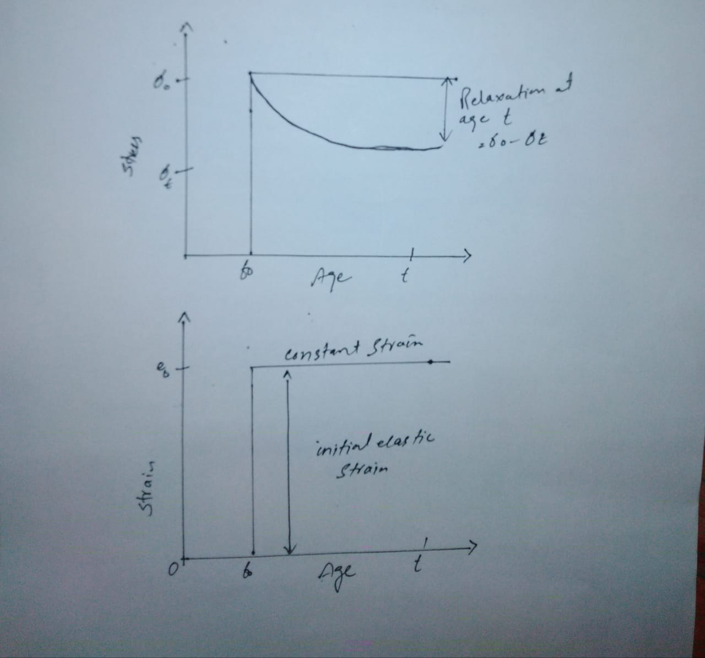
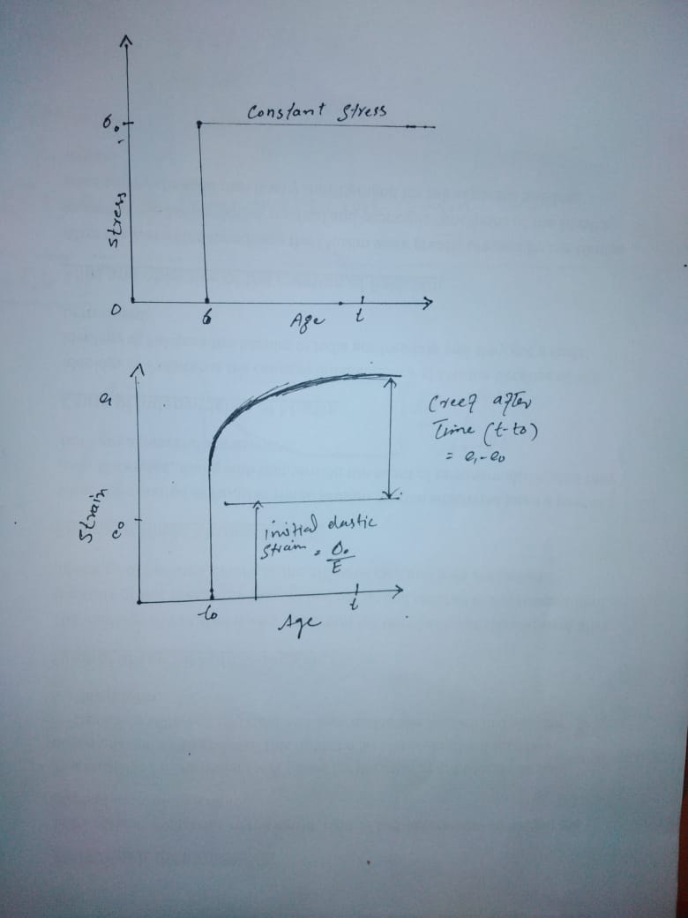
Q.5
What is the difference between drying shrinkage and plastic shrinkage? Is drying and plastic shrinkage reversible?
ANS
If the volume reduction occurs before the concrete hardens, it is called plastic shrinkage. The volume reduction that occurs primarily due to moisture loss after the concrete has hardened is known as drying shrinkage. Or Withdrawal of water from hardened concrete causes drying shrinkage.
Plastic cracking (Plastic Shrinkage Cracking) is cracking that occurs in the surface of the fresh concrete soon after it is placed and while it is still plastic.
The volumetric contraction of cement is called plastic shrinkage.

- Yes drying and plastic shrinkage are reversible.

Q.6
(a) What are risks to concrete structure exposed to sea water? How do you increase resistance of concrete to sea water?
ANS
RISKS
The constituents of seawater reacts chemically with constituents of cement concrete which results damage to the concrete structure in several ways. The magnesium sulfate present in seawater reacts with calcium hydroxide of cement and forms calcium sulfate as well as magnesium hydroxide precipitation.
Magnesium sulfate also reacts with hydrated calcium aluminate and forms calcium sulpho aluminate. These final formations are the primary reasons for chemical attack on concrete structures.
The deterioration of concrete structures by seawater is more due to leaching rather than expansion of concrete. Leaching more effects the small concrete structures than expansion while large concrete structures are effected by leaching as well as expansion.
Sulfates attack the concrete and cause expansion but due to the presence chlorides in seawater the swelling of concrete retards. Hence, erosion and loss of concrete takes place without showing much Expansion.
The lime content present in the concrete also lost due to leaching. Both calcium hydroxide and calcium sulfate are soluble in seawater this will result in increased leaching action. The temperature is also a factor chemical attack, higher the temperature more will be the attack.
Concrete is not 100% impervious. When seawater enters into the pores of concrete and reaches the reinforcement then corrosion will occur. It will affect the durability of structure.
Another case is that concrete damaged by abrasion. Seawater may carry sand and silt especially at the shallow end of the sea. When it forcibly contacts the concrete surface abrasion occurs. Abrasion also occurs due to mechanical force buy wave action..
- Cement with low C₃A content should be preferable to make concrete.
- Prepare rich concrete with low water cement ratio which makes the concrete impervious. Then the pores in concrete are very small and they cannot hold seawater results in the prevention of expansion by freezing of water and crystallization of salt in the pores.
- The concrete is of low water cement ratio. To make it workable for construction, Water reducing admixtures can be added to the concrete which is recommended by ACI 318 and ACI 357.
- The admixtures should not contain chloride in any form otherwise corrosion of reinforcement takes place.
- Adequate cover should be provided for reinforcement in concrete structure to enhance durability. ACI 357 recommended cover for reinforcement bars

6. Good compaction and well-made construction joints in the structure helps the concrete structure to withstand against expansion caused by seawater.
7. Use of pozzolanic material in the preparation of concrete is good against salt water.
8. For better durability, High pressure steam cured concrete elements can be used for construction of structure in marine conditions.
9. Both ACI 318 and ACI 357 recommended that suitable air entraining agents can be used to prevent the effect of seawater on concrete.
10.Aggregates used for making concrete should be thoroughly washed with fresh water to reduce the chloride ion concentration in it.

