Name: Ijaz Ulhaq
ID :14558
Programme: Bs(MLT) 4th semester
Instructor: Zakir Rahim
Subject: Computer Applications (Major Assignment)
Q. Different types of transmission media?
Your answer should include:
- Brief description of each media.
- Characteristics
- Benefits and limitations (if any)
Use appropriated diagram for each media type.
**Transmission Media**
Transmission media is the pathway that carries information from sender to receiver. We use different types of waves or cables to transmit data. Transmission media is also called communication channel.
Types
1: Guided Media
It is also referred to as Wired or Bounded transmission media. Signals being transmitted are directed and confined in a narrow pathway by using physical links. There are 3 major types of Guided Media:
(i) Twisted Pair Cable –
It consists of 2 separately insulated conductor wires wound about each other. Generally, several such pairs are bundled together in a protective sheath. They are the most widely used Transmission Media. Twisted Pair is of two types:
Unshielded Twisted Pair (UTP):
This type of cable has the ability to block interference and does not depend on a physical shield for this purpose. It is used for telephonic applications.
Shielded Twisted Pair (STP):
This type of cable consists of a special jacket to block external interference. It is used in fast-data-rate Ethernet and in voice and data channels of telephone lines.
(ii) Coaxial Cable –
It has an outer plastic covering containing 2 parallel conductors each having a separate insulated protection cover. Coaxial cable transmits information in two modes: Baseband mode(dedicated cable bandwidth) and Broadband mode(cable bandwidth is split into separate ranges). Cable TVs and analog television networks widely use Coaxial cables.
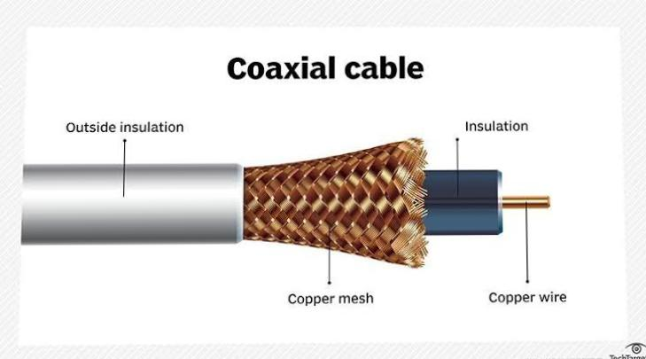
(iii) Optical Fibre Cable: It uses the concept of reflection of light through a core made up of glass or plastic. The core is surrounded by a less dense glass or plastic covering called the cladding. It is used for transmission of large volumes of data.

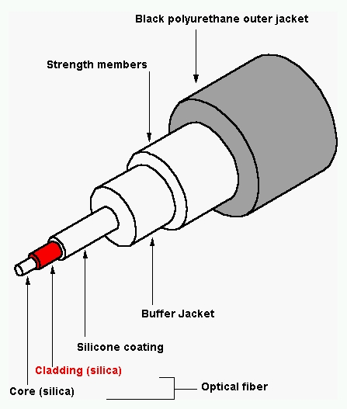
2:Unguided Media
It is also referred to as Wireless or Unbounded transmission media. No physical medium is required for the transmission of electromagnetic signals.
There are 3 major types of Unguided Media:
(i) Radiowaves :These are easy to generate and can penetrate through buildings. The sending and receiving antennas need not be aligned. Frequency Range:3KHz – 1GHz. AM and FM radios and cordless phones use Radiowaves for transmission.
Further Categorized as (i) Terrestrial and (ii) Satellite.
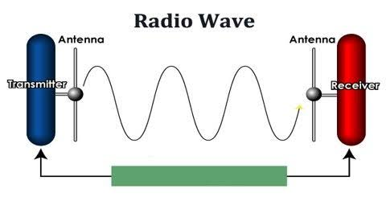

(ii) Microwaves :It is a line of sight transmission i.e. the sending and receiving antennas need to be properly aligned with each other. The distance covered by the signal is directly proportional to the height of the antenna. Frequency Range:1GHz – 300GHz. These are majorly used for mobile phone communication and television distribution.

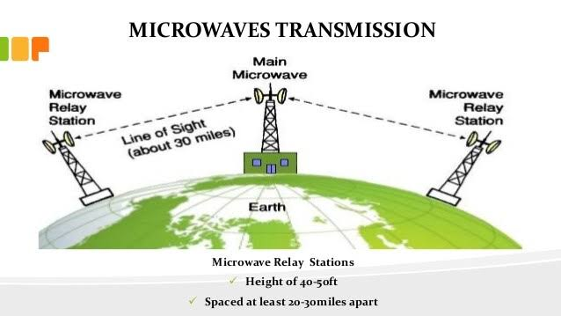

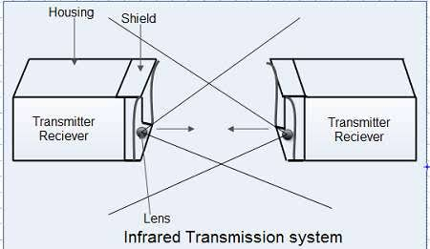
(iii) Infrared Waves: Infrared waves are used for very short distance communication. They cannot penetrate through obstacles. This prevents interference between systems. Frequency Range:300G 400THz. It is used in TV remotes, wireless mouse, keyboard, printer, etc.

Characteristics
- Voice band: It transmits data at a rate of 300 bps eg via telephone lines( twisted pair wire).
- Broad band: It transmits data at a rate of 1000 characters per second eg via coaxial cables and fibre optic cables.
- Narrow band: It transmits data at rate of less than 300bps eg Used in telegraph lines.
- Physical media: It transmits data through physical cables/ wires that can be touched.
- Wireless media: It transmits data through the air.
Other characteristics are....
- Easy to install.
- Bandwidth Capacity
- Node Capacity
- Attenuation
- Electromagnetic Interference.
Benefits and Limitation Of Guided Media
Twisted Pair Cable
Benefits
- Trained personnel easily available due to shallow learning curve.
- Can be used for both analog and digital transmissions.
- Least expensive for short distances
- Entire network does not go down if a part of network is damaged.
Limitations
- Signal cannot travel long distances without repeaters.
- High error rate for distances greater than 100m.
- Very thin and hence breaks easily.
- Not suitable for broadband connections.

Coaxial Cables
Benefits
- Excellent noise immunity.
- Signals can travel longer distances at higher speeds, e.g. 1 to 2 Gbps for 1 Km cable.
- Can be used for both analog and digital signals.
- Inexpensive as compared to fibre optic cables.
- Easy to install and maintain.
Limitations
- Expensive as compared to twisted pair cables.
- Not compatible with twisted pair cables.

Optic fibre Cable
Benefits
- High bandwidth.
- Immune to electromagnetic interference.
- Suitable for industrial and noisy areas.
- Signals carrying data can travel long distances without weakening.
Limitations
- Optical fibre cables are expensive.
- Sophisticated technology required for manufacturing, installing and maintaining optical fibre cables.
- Light waves are unidirectional, so two frequencies are required for full duplex transmission.

Benefits and Limitations of Unguided Media
Radiowaves
Benefits
- Inexpensive mode of information exchange.
- No land needs to be acquired for laying cables.
- Installation and maintenance of devices is cheap.
Limitations
- Insecure communication medium.
- Prone to weather changes like rain, thunderstorms, etc.

Microwaves
Benefits
- Supports larger bandwidth and hence more information is transmitted. For this reason, microwaves are used for point-to-point communications.
- More antenna gain is possible.
- Higher data rates are transmitted as the bandwidth is more.
- Antenna size gets reduced, as the frequencies are higher.
- Low power consumption as the signals are of higher frequencies.
- Provides effective reflection area in the radar systems.
- Low-cost miniature microwave components can be developed.
Limitations
- Cost of equipment or installation cost is high.
- They are hefty and occupy more space.
- Electromagnetic interference may occur.
- Variations in dielectric properties with temperatures may occur.
- Inherent inefficiency of electric power.

Infrared Waves
Benefits
- Infrared transmission requires minimum power to operate and can be set up at a low cost.
- This is a secure way to transfer data between devices as the signal cannot pass beyond a room or chamber.
Limitations
- The speed of data transfer in infrared is slow.
- Infrared can be used for a small range distance.
- Infrared signals are interpreted by objects and people.
- These signals are impacted by weather conditions.

................THE END.......

