NAME : HASEEB ULLAH KHAN

ID NO : 16081

SUBJECT : GEOLOGY

DEPARTMENT : CIVIL ENGINEERING

SECTION : A

QNO1: (A) Rock is broken down by frost rain and sun at A. what name given to this process?

ANS: The process is mechanical weathering.

(b) How is sediment grains in a river changed during transport from A to B? State two differences in the likely appearance of the grains.

ANS : Sediment grains in a river are changed by clay, sand and slit and by accumulation and deposition of small other particles and subsequent cementation of minerals are organic particles on the floor of river.

Differences:

The first difference of likely appearance of the grains is ‘size’ they are different from each other on the basis of size.

The second difference of likely appearance of grains is it ‘texture’ they are difference from each other on the basis of texture.

(C) How do loose sediment at C become changed into solid rock?

ANS:

Sediment are squeezed together by weight of overlaying sediments on the top of them. Fluid fill space between the loose particles of sediment and crystalize to create a rock by cementation calcite and silica are common mineral that these sediment together and form solid rock.

D) Rocks are deeply buried in the earth’s crust may undergoes metamorphism. Describe two changes that happen in rocks during metamorphism and explain point d?

ANS: Deeply buried rocks undergoes two main changes.

Mineralogical

Structural .

Explanation:

Metamorphic underground melt to become magma. When a volcano erupts, magma flows out of it. (When magma is on earth’s surface, it is called lava.) As the lava cools it hardens and become igneous rock.

QNO2: FIGURE3: Shows the structure of volcano and the rock layer beneath.

1: What type of volcano shown in the figure by shape and if eruption is more often, which category it fits?

ANS: Composition volcano.

2: The eruption shown in the figure is producing an ‘Ash column’ that rises thousand of meter above the volcano summit.

(A): Explain how gases trapped in the magma help produce ash column?

ANS:

The composition of gases in magma are.

Mostly H2O (water vapor) and some other gasses like CO2.

Minor amount of sulfur, chlorine and fluorine gases.

(b): Many people in the world live close to volcanoes so, when volcanos erupts, thousand of lives may be at risk.

1: Suggest one sign that might indicates if a volcanos is about to erupt.

ANS: An increase in the frequency and intensity of felt earth quakes.

Small changes in heat flow.

Swelling in ground surface.

2: Suggest two danger that might result from ash fall near volcano.

ANS: Health concern after a volcano eruption that cause infection disease, respiratory illness, burns, injuries from falls and vehicle accident related the slippery and harsh condition caused by ash.

D: 1 In the table below are statement that refer to either weathering or erosion complete the table by writing weathering or erosion in the space provided.

Statement: breakdown of rock without it being moved.

ANS: Weathering.

2: Wearing away of rock during transport of rock particles.

ANS: Erosion.

3: A process caused by wind, running water and moving ice.

ANS: Erosion.

4: An effect of plants root growing in rock joints and fractures.

ANS: Weathering.

II) A statue was made from limestone. Rain makes limestone weather more quickly than sandstone. What substance in the rainwater causes this ?

ANS: Because limestone it broken down by CO2 in the rain in the form of carbolic acid, ph of aprox 5.6and sandstone is made of hard silica grains that depending on there matrix or ‘glue’ that’s why sandstone weather relative slower than limestone.

III) Why igneous rock never contain fossils?

ANS: If the magma cools slowly large crystal form in the rock they are intrusive igneous rock Because they form from magma underground. Unlike sedimentary rock, igneous rock do not contains any fossils. This is because any fossils in the original rock will have melted when magma formed.

IV) Granite takes much longer to cool deep underground than basalt lava at the Earth’s surface. How and why is the size of the crystals in granite different from the size of crystal in basalt?

ANS: The difference is between silica content and their rules. If magma cools quickly.

For example:

When basalt lava erupts from volcano, then many crystal form very quickly and resulting rock. Is fine grained with crystal usually less than 1mm in size. Crystal have more time grow large.

V)Describe one process that might be responsible for producing large,angular poorly sorted fragment scree sediment collecting at bottom of the cliff?

ANS: As a result of freeze thaw weathering water seeps into cracks into cracks in the rock, expanding when it freeze and seeping in deeper when it melts, gradually splitting the rock a part. These fragment are removed by gravity and fall in to scree slops beneath.

B:Figure2

In each box, write down the most likely number from the deposit produced column in the table above.

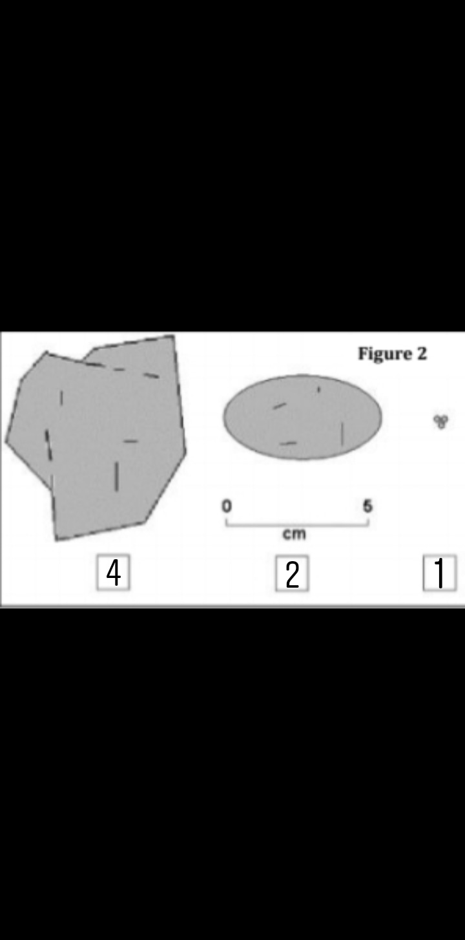

figure B: ii) In your own words, explain how sediment particles changed as they are transported downstream by a river?

ANS: Clay mud in downstream water :

When water and mud are mixed. some of these solid compound may dissolve into the solution of water. Particles of mud become suspended in water, and the water molecule interacting with the mud particles allow the mud to loosen up and change shape.

Rounded pebbles and sand in downstream:

As the sediment is buried it compressed and material dissolved in water of rock.(that are mixed with sand) rounded pebbles not blocky and jagged.

^{Sloping sand layer:}

Water can dissolve the mineral cement that hold grains together. A layer of such sand then become a week layer in the slope.

^{Angular boulder:}

Angular boulder is a big rock that are not dissolved in water.

