4/14/2020

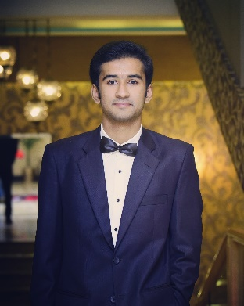
Digital Image Processing
Name : Muahmmad Abdullah Minhas
I.D : 13864
Teacher : Miss Sana Jehan

Question no :1

Q1)(a) What will be the size of the colored picture having resolution 1600*1200 and color dept of 8 bits?
Ans) 1600*1200 = 1920000
Size = 1920000/1000000=1.92MB

(b) If the same image is converted to grey scale image, what will be the size if we keep the same color dept?
Ans) Three colors
Red, blue, green
Grey scale is having black and white so RGB is removed so they 2 are left and the 3 are left and are divided.
1920000/3=640000=6400kb=0.64MB

(c) True color system has 24-bit color dept. why is it not a good idea to increase color dept beyond that?
Ans) If we increase color dept so the quality will remain same but the size of image will be increased . If color dept is 8 bits so size is 1.92MB. If it is 16 bits so the size is 8.84 MB . In true color dept of 24 bits the image will be 5.76 MB

Question no: 2
When removing noise from images , the pixel values that are disorted are fixed by replacing them with values calculated using the surrounding pixels . In the given pixel grid , the pixel p and q are such distorted pixels.
- Find value of P, where P= average of N8P.
Ans) 98+95+93+86+84+88+89+93=726
726/8 = 90.75
Average of N8P = 90.75
So the .75 is ignored
P = 90

(b) Find the value of Q, where Q =Average of N8P.
Ans) 81+79+80+7+69 = 316
316/5 =63.2
Average of N8Q= 63.2
The .2 is ignored
Q=63

(C) Do you think that after the insertion of calculated values, the pixel grid in its original form? Explain your answer.
Ans) No, the values of P rises from 0 to 255 but we will take the which is closest to the actual value

Question no: 3

Spatial Resolution:
Spatial resolution is a term that refers to the number of pixels utilized in construction of a digital image. Images having higher spatial resolution are composed with a greater number of pixels than those of lower spatial resolution.

Image Representation:
Image resolution is the detail an image holds. The term applies to raster digital images, film images, and other types of images. Higher resolution means more image detail. Image resolution is the detail an image holds. The term applies to raster digital images, film images, and other types of images. Higher resolution means more image detail

(a)QR CODE:
Ans) QR codes are special types of lining having resolutions in it . The white space is detected by scanner. The best resolution for is spatial resolution . The QR code can be of size 21 * 21 . similarly our whatsapp has also a QR code.

(b) Finding the dominant color of an image.
Ans) Image representation is used for finding the dominant color in an image. Histogram is playing an important role in image representation it shows us the grey levels of images . Histogram depends upon the contrast higher the contrast rate higher and more clearly it will show the dominant color

(c) Finding the dominant faces in a picture.
Ans) spatial resolution is used for finding dominant faces in a picture because it depends upon the resolution . and spatial resolution gives more higher resolution than other. Spatial resolution is having more clarity so we can spot the faces.

