NAME : MUHAMMD UZAIR KHAN

ID : 16703

SECTION : B { CIVIL ENGINEERING}

DATE: 11 , 06 ,2020

ASSIGNMENT :
ISLAMIC ARCHITECTURE OF INDONESIA AND MALAYSIA

- ISLAMIC ARCHITECTURE OF INDONESIA
Although religious architecture has been widespread in Indonesia, the most significant was developed in Java. The island's long tradition of religious syncretism extended to architecture, which fostered uniquely Javanese styles of Hindu, Buddhist, Islamic, and to a lesser extent, Christian architecture.

Menara Kudus Mosque
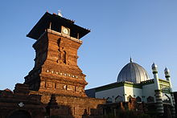

By the fifteenth 15th century, Islam had become the dominant religion in Java and Sumatra, Indonesia's two most populous islands.
At the time, Javanese mosques took many design cues from Hindu, Buddhist, and even Chinese architectural influences. They lacked, for example, the ubiquitous Islamic dome which did not appear in Indonesia until the 19th century, but had tall timber,multi-level roofs similar to the pagodas of Balinese Hindu temples still common today. A number of significant early mosques survive, particularly along the north coast of Java.
In the 19th century, the sultanates of Indonesian archipelago began to adopt and absorb foreign influences of Islamic architecture, as alternative to Javanese style already popular in the archipelago.The below mosque is one of the example of Islamic architecture.
KAUMAN GREAT MOSQUE:
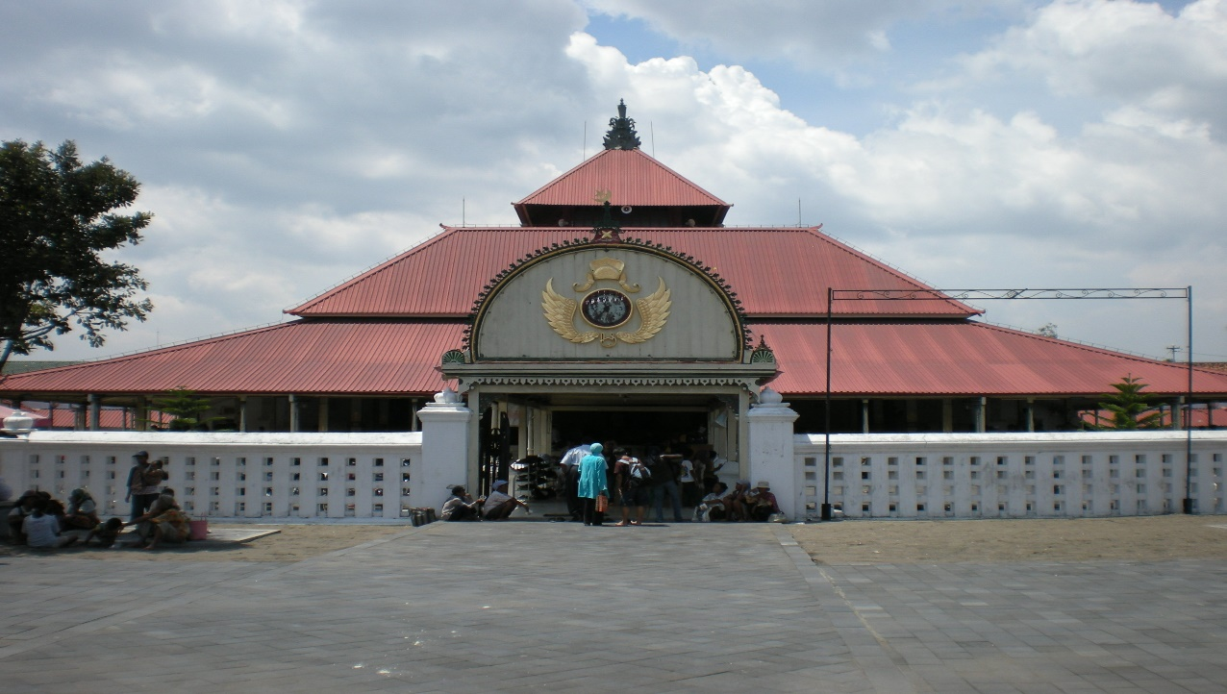

In the 19th century, the sultanates of Indonesian archipelago began to adopt and absorb foreign influences of Islamic architecture, as alternative to Javanese style already popular in the archipelago. The Indo-Islamic and Moorish style are particularly favored by Aceh Sultanate and Deli Sultanate, as displayed in Banda Aceh Baiturrahman Grand Mosque built in 1881, and Medan Grand Mosque built in 1906. Particularly during the decades since Indonesian independence, mosques have tended to be built in styles more consistent with global Islamic styles, which mirrors the trend in Indonesia towards more orthodox practice of Islam.

- ISLAMIC ARCHITECTURE OF MALAYSIA
- The architecture of Javanese Indonesian mosques had a strong influence on the design of other mosques in Indonesia, Malaysia, Brunei, and the Philippines.
- Today, with increasing Muslim pilgrimage to Mecca, Indonesian-Malaysian mosques are developing a more standard, international style, with a dome and minaret.

Kampung Laut Mosque is the oldest surviving mosque in Malaysia dating to early 18th century. It is located in Tumpat, Kelantan. Masjid Kampung Laut was built in the 1400s by a group of fishers consisting Pattani, Jawa and Brunei sea routers.
It was build with a with architectural styles that reflect most of the characteristics of traditional local architecture, and suitable to local climate, just like the local houses around the area. The original mosque had a basic architectural styles, structure with four pillars and had palm fronds for the roof.
Kampung Laut Mosque

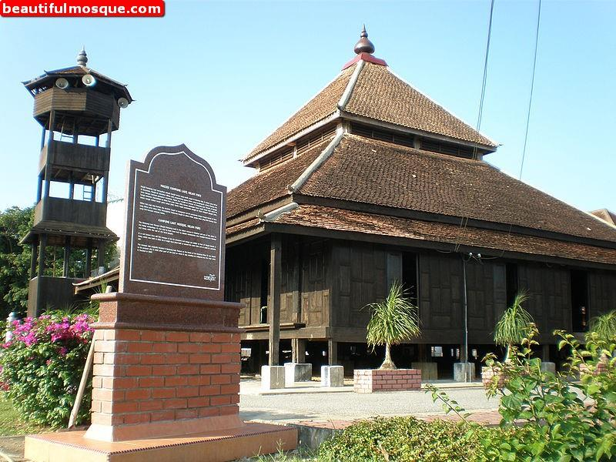

During the reign of the Sultan of Kelantan between 1859 and 1900, The mosque became an important meeting point for the Sultans and religious leaders. The mosque was also used as a trading post. During this period, the mosque was expanded and upgraded with 20 pillars, a three-tiered roof, a tower or minar (for muezzin to call for prayers), an attic, and a water tank while the flooring was made of well quality Timber..
The mosque was handed over to the Kelantan Government under Menteri Besar Datuk Asri Muda's administration in May 1970.

The Federal Territory Mosque is a mosque in Kuala Lumpur, Malaysia. It is located near MATRADE complex and the Federal Government Complex off Jalan Duta, in Segambut district.

The mosque's design is a blend of Ottoman and Malay architectural styles, heavily influenced by the Blue Mosque in Istanbul, Turkey. It has 22 domes made from a composite material of glass fibre fabric mixed with epoxy resin to make it durable and light.

Most of the modern Islamic architecture was implemented in Malaysia in 1997 to 2000 time period.

THE FEDERAL TERRITORY MOSQUE is one the best example of modern Islamic architecture of Malaysia.

Kuala Lumpur, Malaysia: Federal Territory Mosque





