Final Term Assignment (2020)
Course Title: Basic Physiology (DT– 2nd) Instructor: Dr. Irfan Ali Khan

Question Paper Time: 48 hours
Class Code. BS . D.T Name: Malik Saqib Ali

Section: A ID: 15814
- Attempt all questions from this section.
- Use Blue / Black Ink only. Do not use red color.
- Tick or encircle only one option in each given question.
It’s an open book Conceptual Assignment paper. Time to Use your brain now.

- Briefly explain the process of hematopoiesis along with diagrammatic illustration. (Marks 10)

Hematopoiesis:
Hemta means blood
Poesis means formation
Definition of hematopoiesis:
It the process of formation of blood cells (RBC,WBC,PLATLETS) and cellular blood components the process begin with stem cells called hematocytoblast.
Stem cells are capable of dividing and producing new cells that go on to become particular type of cells. a hematocytoblast a type of stem cell that produces blood cells which are present in yolk sac in first embryonic trimester after it stem cells present in liver in second trimester and then move to bone marrow in last trimester till death. Early differentiation separates myeloid stem cells from lymphatic stem cells. Myeloid stem cells produce many different type of blood cells including red blood cell s, WBC and platelets and all the blood cells except lymphocytes. The lymphatic stem cell produce lymphoblast which become lymphocytes. In adult red blood cells and white blood cells are present in red bone marrow which looks like blood but with a thicker consistency. In child the medullary cavity of nearly every bone is filled with red bone marrow. In adults red bone marrow is limited to the vertebrae, ribs, sternum, part of pelvic girdle, and the proximal head of humerus and femur

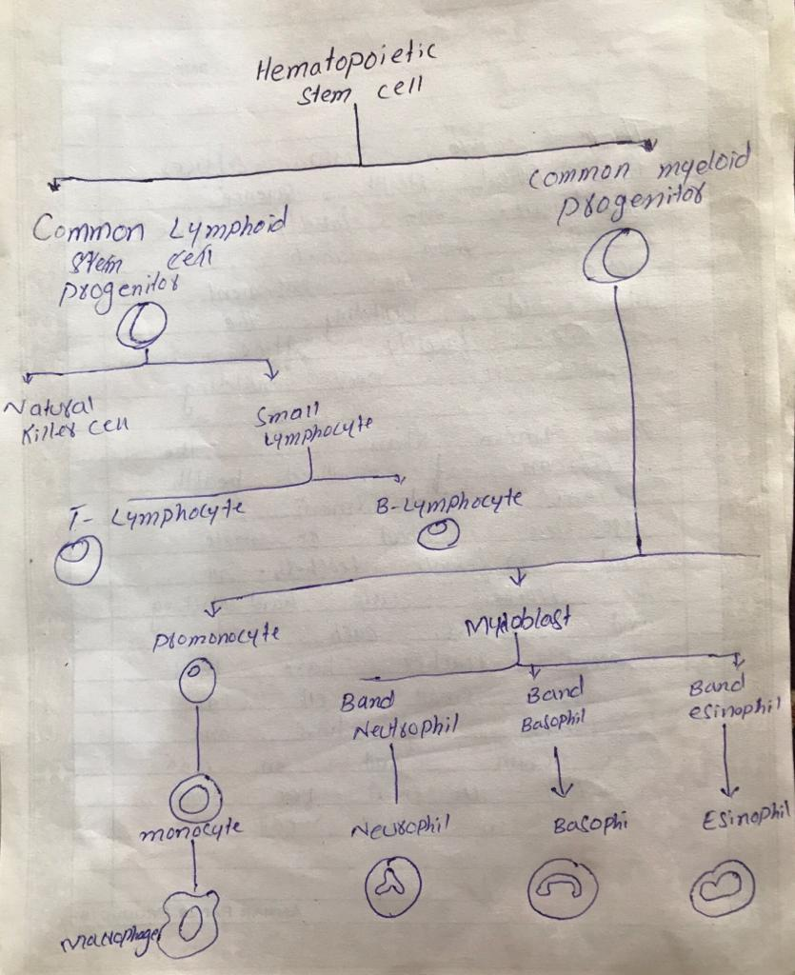

- What are the factors that influence the respiratory rate, explain in detail. (Marks 10)

There are two types factors which affect and influence the rate of respiration
- Physical factors :
- Increased body temperature
- Exercise
- Talking
- Coughing
- Voliation (conscious control)
- Emotional factors
- temprature
2.Chemical facrors :
    - carbon dioxide levels
    - concentration of glucose
    - medication
    - level of carbon in the blood is the main regulatory chemical for respiration
    - increased carbon dioxide increases respiration
    - changes in carbon dioxide act directly on the medulla oblongata

- Enlist different layers of skin, write a detailed note on epidermis. (Marks 10)

Skin:
It is the outermost layer of human body which covers and protect all the internal organs from external pathogens. It is the largest organ of human body.

Layers of skin:
Skin of human body mainly consist of two layer
- Epidermis:
- Dermis

Epidermis:
It is the outermost layer of the skin. It form the waterproof, protective wrap over the body surface and is made up of stratified squamous epithelium with underlying basal lamina. It is a thin layer and does not contain any blood vessels there for it depends on dermis layer.
The epidermis layer of the human skin if further divided into the following parts

- Stratum corneum
- Stratum lucidum
- Stratum granulosum
- Stratum spinosum
- Stratum germinativum

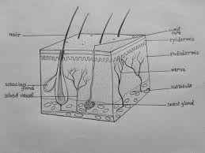

- Define lymphatic system, what are different components of lymphatic system? (Marks 10)

Lymphatic system:
It is a network of vessels which drains lymph from one tissue into the to the blood. It is a part of immune system and circulatory systemit is made up of a large network of lymphatic vessels the vessels carry a clear fluid to the heart called lymph.

The tissues and organ that produce store and carry white blood cells that fight infections and other diseases. The bone marrow, spleen thymus, lymph nodes, and lymphatic vessels [a network of thin tube that carry lymph and white blood cells.

Different component lymphatic system
Lymphatic system structures. The major component of the lymphatic system include lymph, lymphatic vessels, and lymphoid tissues and organs like spleen, thymus, and tonsils
Lymphatic vessel are structures that absorb fluid that diffuses from blood vessel capillaries into surrounding tissues.

- What is blood pressure? How will you check and record blood pressure of a patient? (Marks 10)

Blood pressure:
It is the pressure which is produced by heart on the wall of arteries. Blood pressure decreases as the heart relaxes. There are two types blood pressure .
- Systolic pressure: it is the pressure release by heart during the contraction of ventricles
- Diastolic pressure: it is the pressure releases by heart on the wall of arteries when the ventricle relax.

Measuring blood pressure:
When we are checking the blood pressure of patient we use two devices it may be digital or analog
Stethoscope and aneroid meter. First of all we wrapped the cuff of aneroid meter around the upper portion of the arm of patient and pumped with until the blood flow in the artery is blocked. When we relaxed pressure in the cuff two numbers are recorded.
First number taken is the force felt in the arteries when ventricle contract this is called systolic pressure which is 120mmHg in normal state.
Second number taken is the force of blood on the arteries when ventricle relax this is called diastolic pressure which is 80mmHg in normal state

Stay home, stay Safe

