IQRA NATIONAL UNIVERSITY
DEPORTMENT: CIVIL ENGINEERING
PAPER: INTRODUCTION TO ARCHITECTURE AND TOWN PLANNING
EXAM: MID TERM
SEMESTER: 2ND
STUDENT:16086
NAME: HammadAli

Question1: Done
Question2: Done
Question3:done

Question1: Take any building from internet, put its picture in Microsoft Word and explain its positive and negative points according to the principles of design. What could be done to make the building more attractive? Answer must be at least 200 words. (CLO1-PLO7)

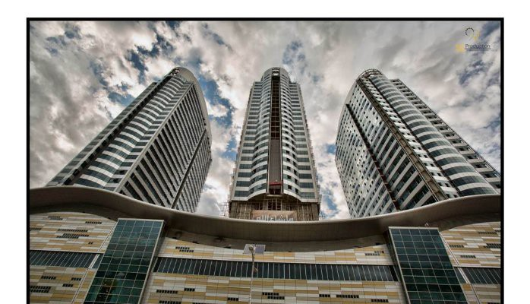

Mall The centaurus
Mall The centaurus is situated right in the heart of Islamabad, on Fazal-e-Haq road. It's the first real mall in Islamabad with almost all the amenities. Various local and international brands are available in the mall under one roof for shoes, clothing and electronics. Also various cafes and restaurants are available as well as a food court on top floor. There is a multiplex cinema on the sa.e floor of food court. They have 3 storey car parking and also various parking spots are available around the mall. There is a metro station in front of the mall, so it can be easily accessed via metro or taxis or careem/uber. On weekends it gets over crowded sometimes, so can be irritating sometimes. Centaurus
Design: The building of Centaurus Mall Islamabad is designed by British architectural company WS Atkins. It has three skyscrapers, corporate offices and residential apartments.
Positive and negative points of centaurus mall
Positive
1: Cantarausmall design is an anattracttive design.
2. Repetition
This towers hosted a variety of repetition in shapes,colors and other elements.Repetition is a great way to reinforce an idea. It’s also a great way to unify a design that brings together a lot of different elements
2. Rhythm
The spaces between repeating elements can cause a sense of rhythm Movement Movement refers to the way the eye travels over a design.
3:The modular three shaped building which are connected to each other and an herently stable configuration for structure and provide good floor flates for residential
3.Movement
Movement refers to the way the eye travels over a design. The most important element should lead to the next most important.
4:The usage of centaurus mall the three idol towers plan is idol for residential and hotel usage,with wings allowing maximum outwards views and inward nature light.
5:The floor ratio of cantaraurus mall is allotted to much for car parking and for walk etc.
6:such a design like this is used for advertisement purposes.
7:Cantaurrus was design with fully fire protestiontecnhol;ogy in emergency.
Negative points:
1: They have use a lot of glass on the outside of exterior.they need to be used heat resistance material instead of glass.which is much efficient.due to the glasses the building temperature will be Always high.
2: As a desighner I would like to add some greenery to the building.which is not available in cantauraus.
3: For fresh air there must to be some green patches on building.
4:Thedesigh down of shopping mall is to boring when you enter it cut off your natural lights.There must be a possible way to give a touch to the natural environment.
5:Oscillation occur due to earthquake which is danger to human life.
For attraction of building.
First we need to build a design on the basis of golden ration.If we work on a focal desgn of the building it will automatically increase the beauty of the building.For the attraction of building a desginer need to be maintain the propoertion,variety.movement,pattern,rathym and repititaion in the design.

QUASTION:-2 DESIGN AND SKETCH AN IDEAL SINGLE STOREY HOUSE ON THE SITE SHOWN BELOW.THE DESIGN SHOULD BE FREE HAND AND CAN BE DRAWN ON GRAPH PAPER. IF A GRAPH PAPER IS NOTAVAILABLE THEN MAKE A GRID OF 5’X5’ ON A SEPARATE WHITE A4 SIZE PAPER. THEHOUSSHOULDNATURALLY VENTILATED AND HAVE NATURAL LIGHTING. ALSO, IT SHOULD BE FREE OF NOISE. THE SITE IS LOCATED IN PESHAWAR. LABEL OR EXPLAIN THE PLAN NEATLY.
Answer:
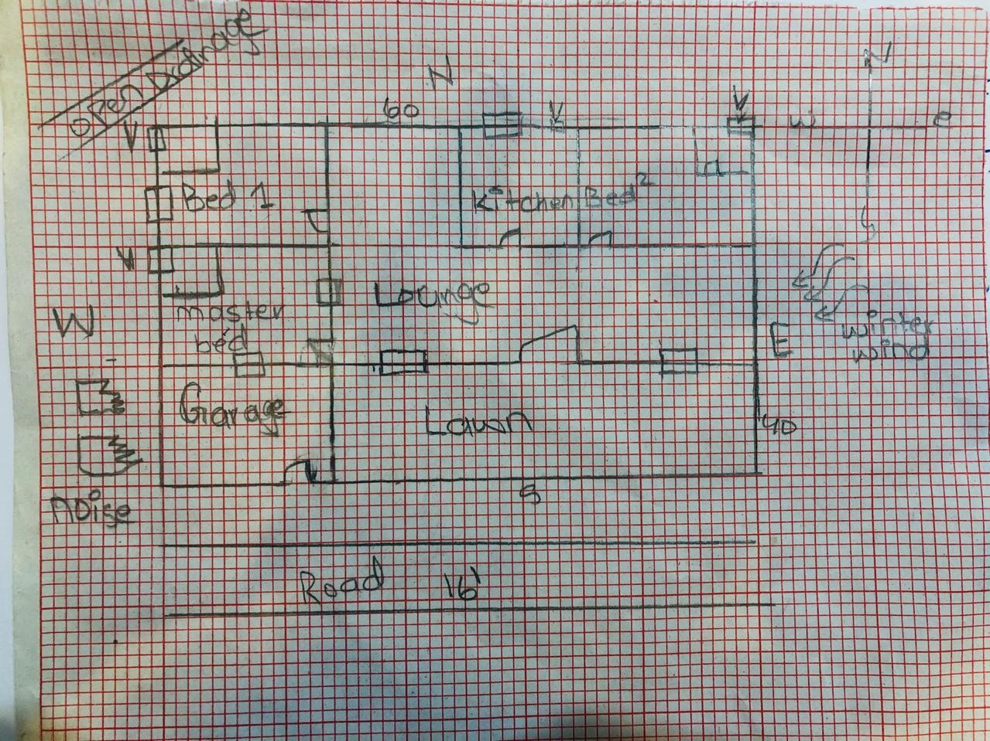
Every room has attached battroom having the facility of vantillation(exhaust).
Single story building.the natural air and natural light has full access to all rooms and all rooms are well vantillated.
Question3:
Select a site at the place where you live. Do Micro site analysis of Site and make its sketch on another A4 paper and write about it in detail. You can take your own lawn as a site foranalysis or any other site in the neighborhood. Additionally, make a solar path diagram for your area on a separate piece of paper to find the exact sun angles for both winter and summer. Watch videos on YouTube to understand and make Solar Path diagram. Use these sun angles sketch of a room. Show window height, type of fixed sun shade used, angle and to make a roughheight of shade as well as its depth and width by keeping sun angles in mind. The purpose for the sketch is to show how winter sun is allowed and summer sun is blocked.
Answer:
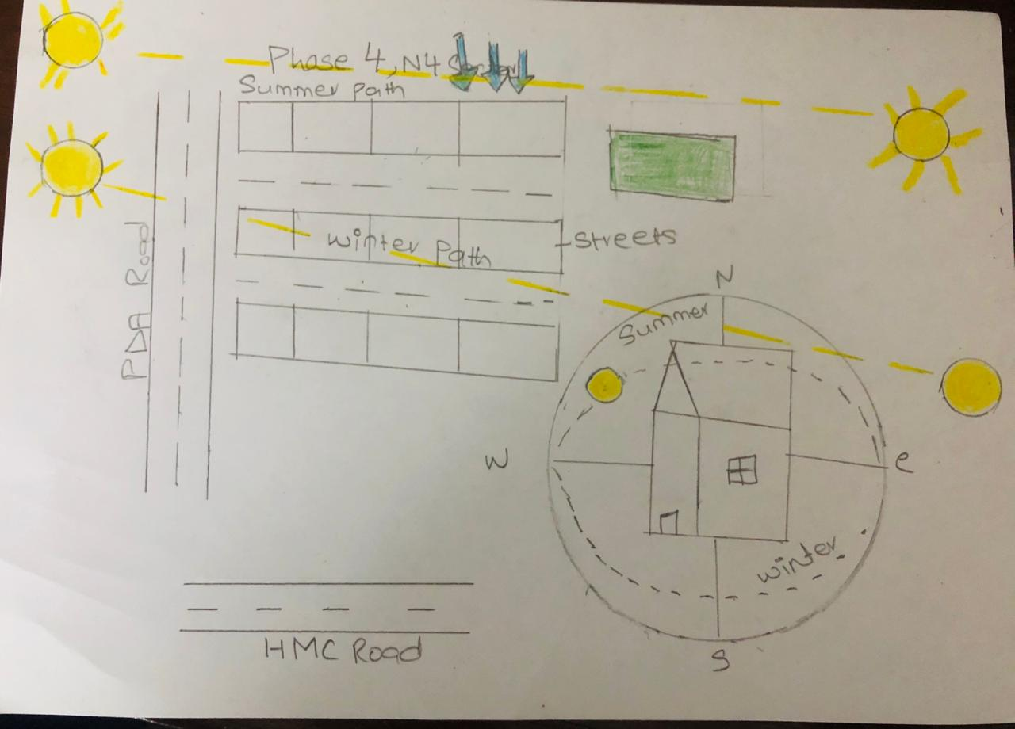
Micro analysis
Hayatabad is a modern suburb on the south-western fringe of Peshawar, the capital of the Khyber Pakhtunkhwa, Pakistan. It was named after Hayat Sherpao, former Governor of Khyber Pakhtunkhwa and a notable leader of Pakistan Peoples Party.
Latitude: 33° 59' 5.99" N
Longitude: 71° 27' 14.99" E
Wind
The meteoblue climate diagrams are based on 30 years of hourly weather model simulations and available for everplace on Earth. They give good indications of typical climate patterns and expected conditions (temperature, precipitation, sunshine and wind). The simulated weather data have a spatial resolution of approximately 30 km and may not reproduce all local weather effects, such as thunderstorms, local winds, or tornadoes.
Calculating sun angles.
Desginers have device that computerized drafting programs that calculate the sun angles and shadows for various location and topographies based on a digital site survey.

Topography
Peshawar sits at the eastern end of the Khyber Pass, which has been used as a trade route since the Kushan era approximately 2,000 years ago.
Peshawar is located in the broad Valley of Peshawar, which is surrounded by mountain ranges on three sides, with the fourth opening to the Punjab plains. The city is located in the generally level base of the valley, known as the Gandhara Plains

Climate
Peshawar features a hot semi-arid climatWinter in Peshawar starts in November and ends in late March, though it sometimes extends into mid-April, while the summer months are from mid-May to mid-September. The mean maximum summer temperature surpasses 40 °C (104 °F). The mean minimum temperature during the coolest month is 4 °C (39 °F), while the maximum is 18.3 °C (64.9 °F).
Fixed shading
Shading Devices inhibit the solar radiation (block, allow,, etc.) incident on a building and are used either internally or externally or in between the internal and the external building space. ... Sun Shading Devices improve internal environment in order to provide greater comfort for occupants.

