Name: SUBHANULLAH
Class ID:16161
Section:B
SEMESTER: 2nd BS MLT

Q1.What are the circulating cells in acute inflammation?Also write the characteristics of Acute inflammation.

ANSWER:
INFLAMATION:
The reaction of living tissues to all type of injury is called inflamation
★★CIRCULATING CELL IN ACUTE INFLAMATION:
CELLS ARE GIVEN BELOW:
★Neutrophils.
★Monocytes
★eosinophils
★lymphocytes
★basophils
★platlets.
★★★CHARACTERICS OF ACUTE INFLAMATION:
★The Short duration.
★Lasting from a few minutes
upto a few days and so on.
★The Formation of
inflammatory exudae.
★The Predominantly
neutrophil leukocyte
accumulation is also occure.
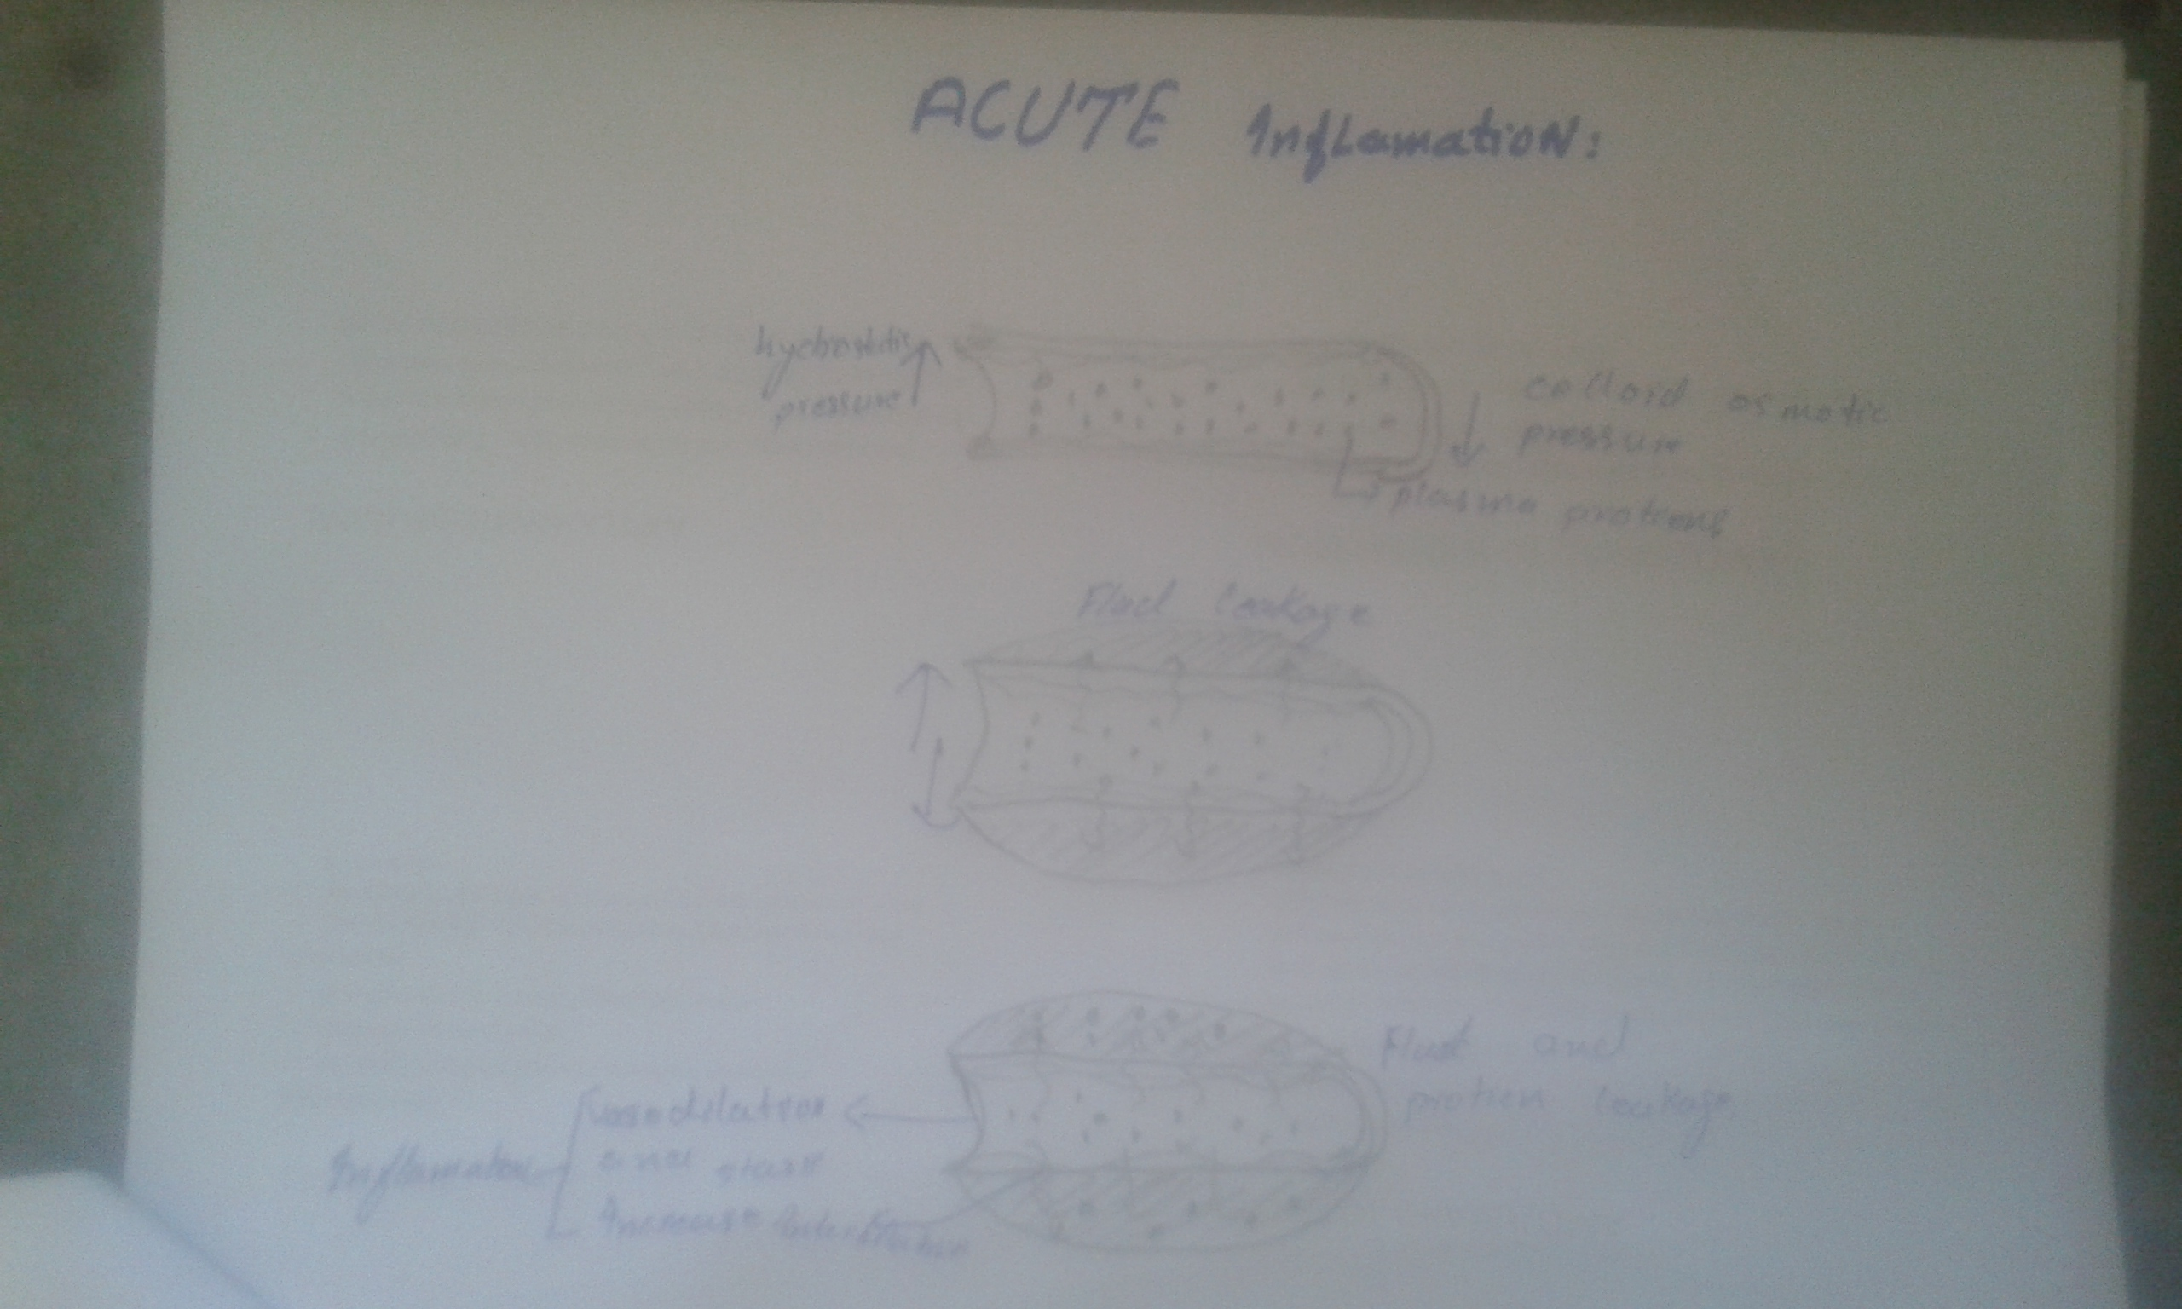
THE END

Q2. Write a note on infarction and its types and write a note on Mast cells.
ANSWER:
★INFARCTION:

DEFINITION:
Formation of a localizad area of ischemic necrosis within a tissue or organ due to impaired arterial supply or the venous drainage. The necrosis area is called “infarct”.
An extremely important cause of clinical illness:
★myocardiac infarction
★cerebral infarction
★★Causes infraction:
★Occlusion of arterial supply or
venous drainage
★ Thrombosis, embolism,
athermanous plaques, external
compression
★Functional spasm of arteriole
★Traumatic rupture of the artery
★TYPES OF INFRACTION:
★1:White infarction/anemic infarcts.
★ DEFINITION:
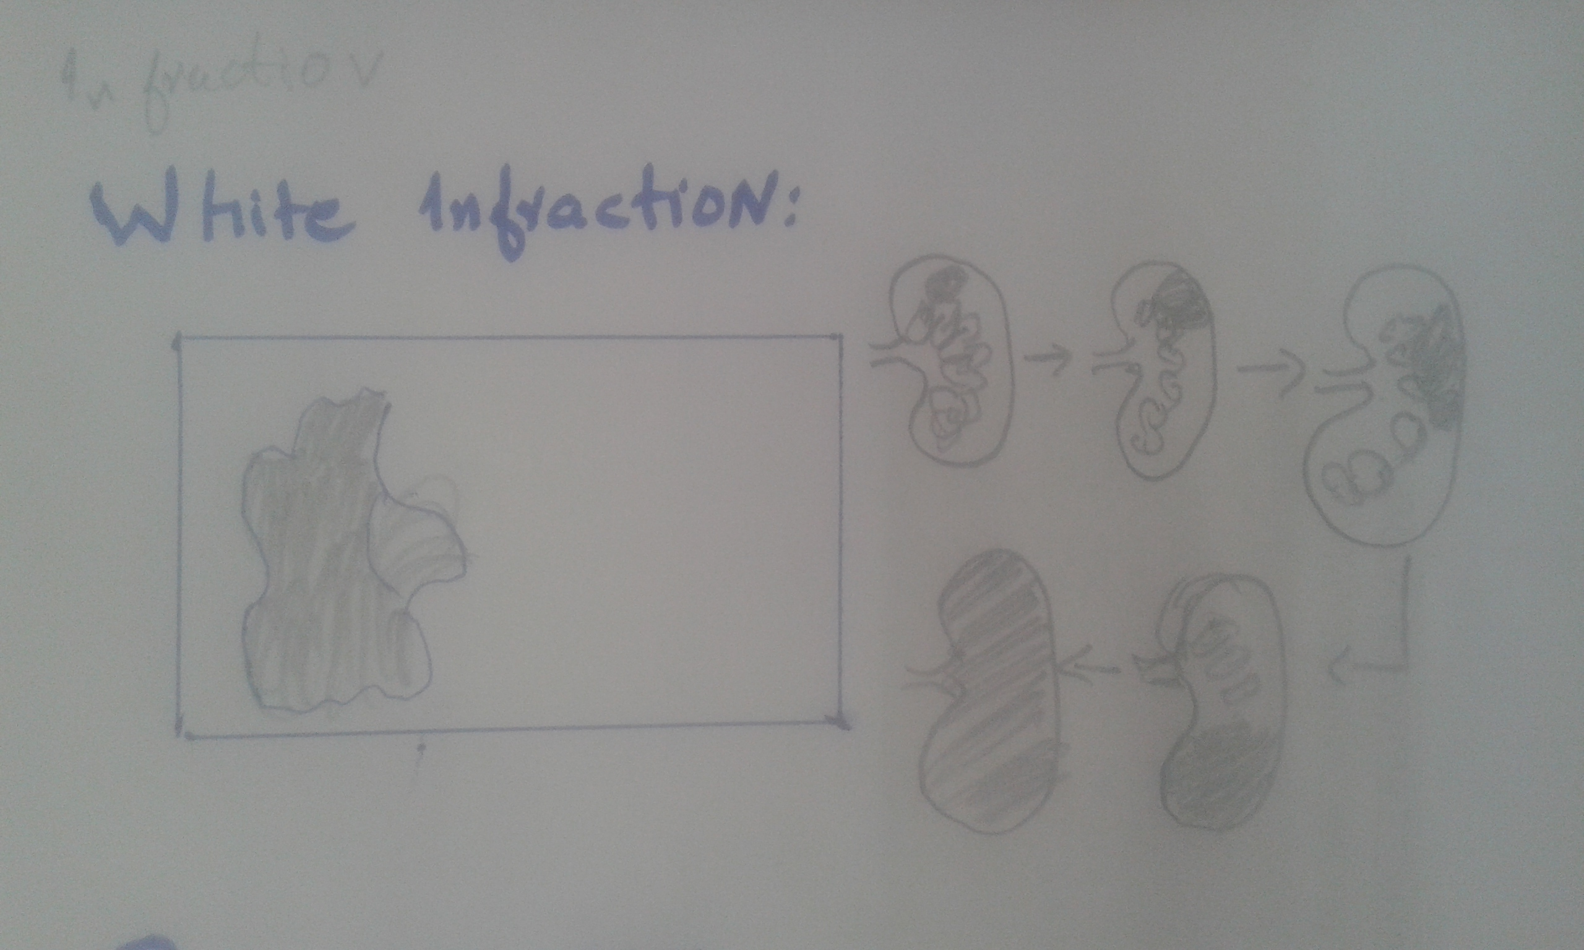
Anemic infarcts (also called white infarcts or pale infarcts) are white or pale infarcts caused by arterial occlusions, and are usually seen in the heart, kidney and spleen. These are referred to as "white" because of the lack of hemorrhaging and limited red blood cells accumulation, (compare to Hemorrhagic infarct).

★Arterial occlusion
★Solid, compact organs
★Few collateral circulation
★(spleen, kidney, heart,brain
etc)
★Morphology
★Gross
★Dull pale, dry, wedge-shaped
necrotic lesion
★A hemorrhagic zone
surrounding
★2: RED INFARCTION:
★DEFINITION:
Red infarctions (hemorrhagic infarcts) generally affect the lungs or other loose organs (testis, ovary, small intestines). The occlusion consists more of red blood cells and fibrin strands. Characteristics of red infarcts include: occlusion of a vein

★Arterial occlusion
★Venous occlusion
★ Loose tissue
★Dual circulations: lung , small intestine
EXAMPLE:
★Brain infarction (liquefied
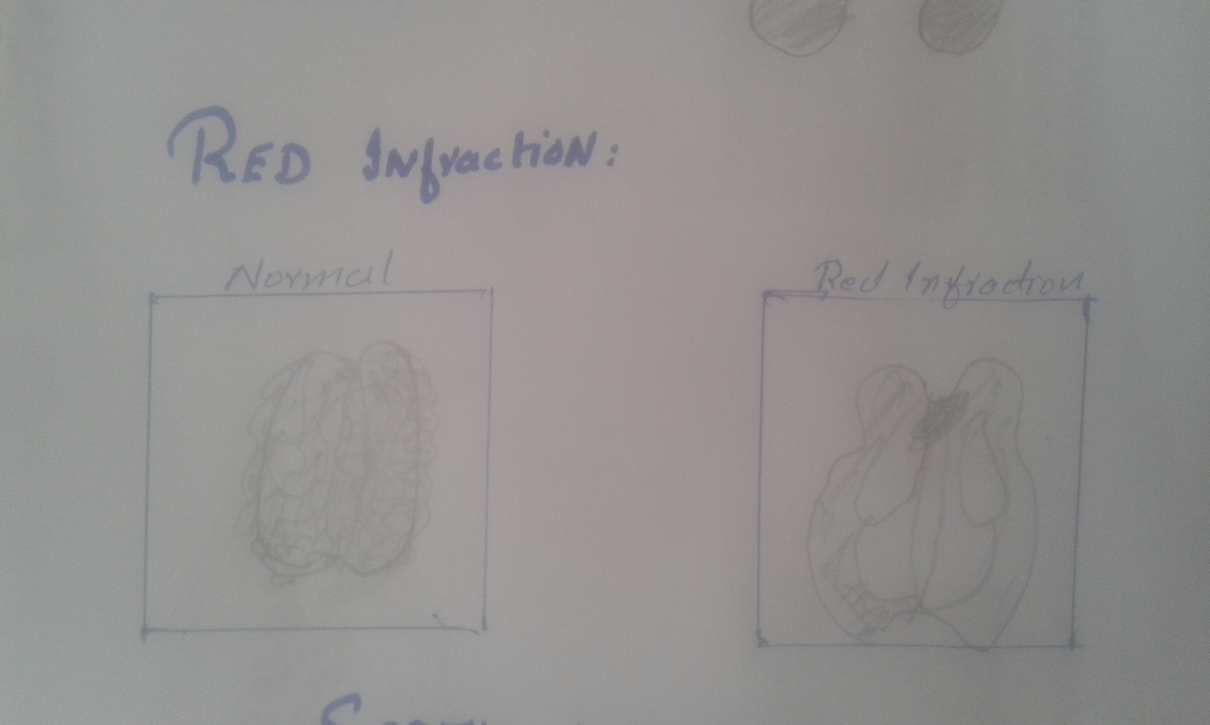
necrosis)
★3: SEPTIC INFARCTION:
DEFINITION:
Area of necrosis resulting from vascular obstruction caused by emboli consisting of clumps of bacteria or infected material.
Bacteria contaning emboli may form abscess and pus.
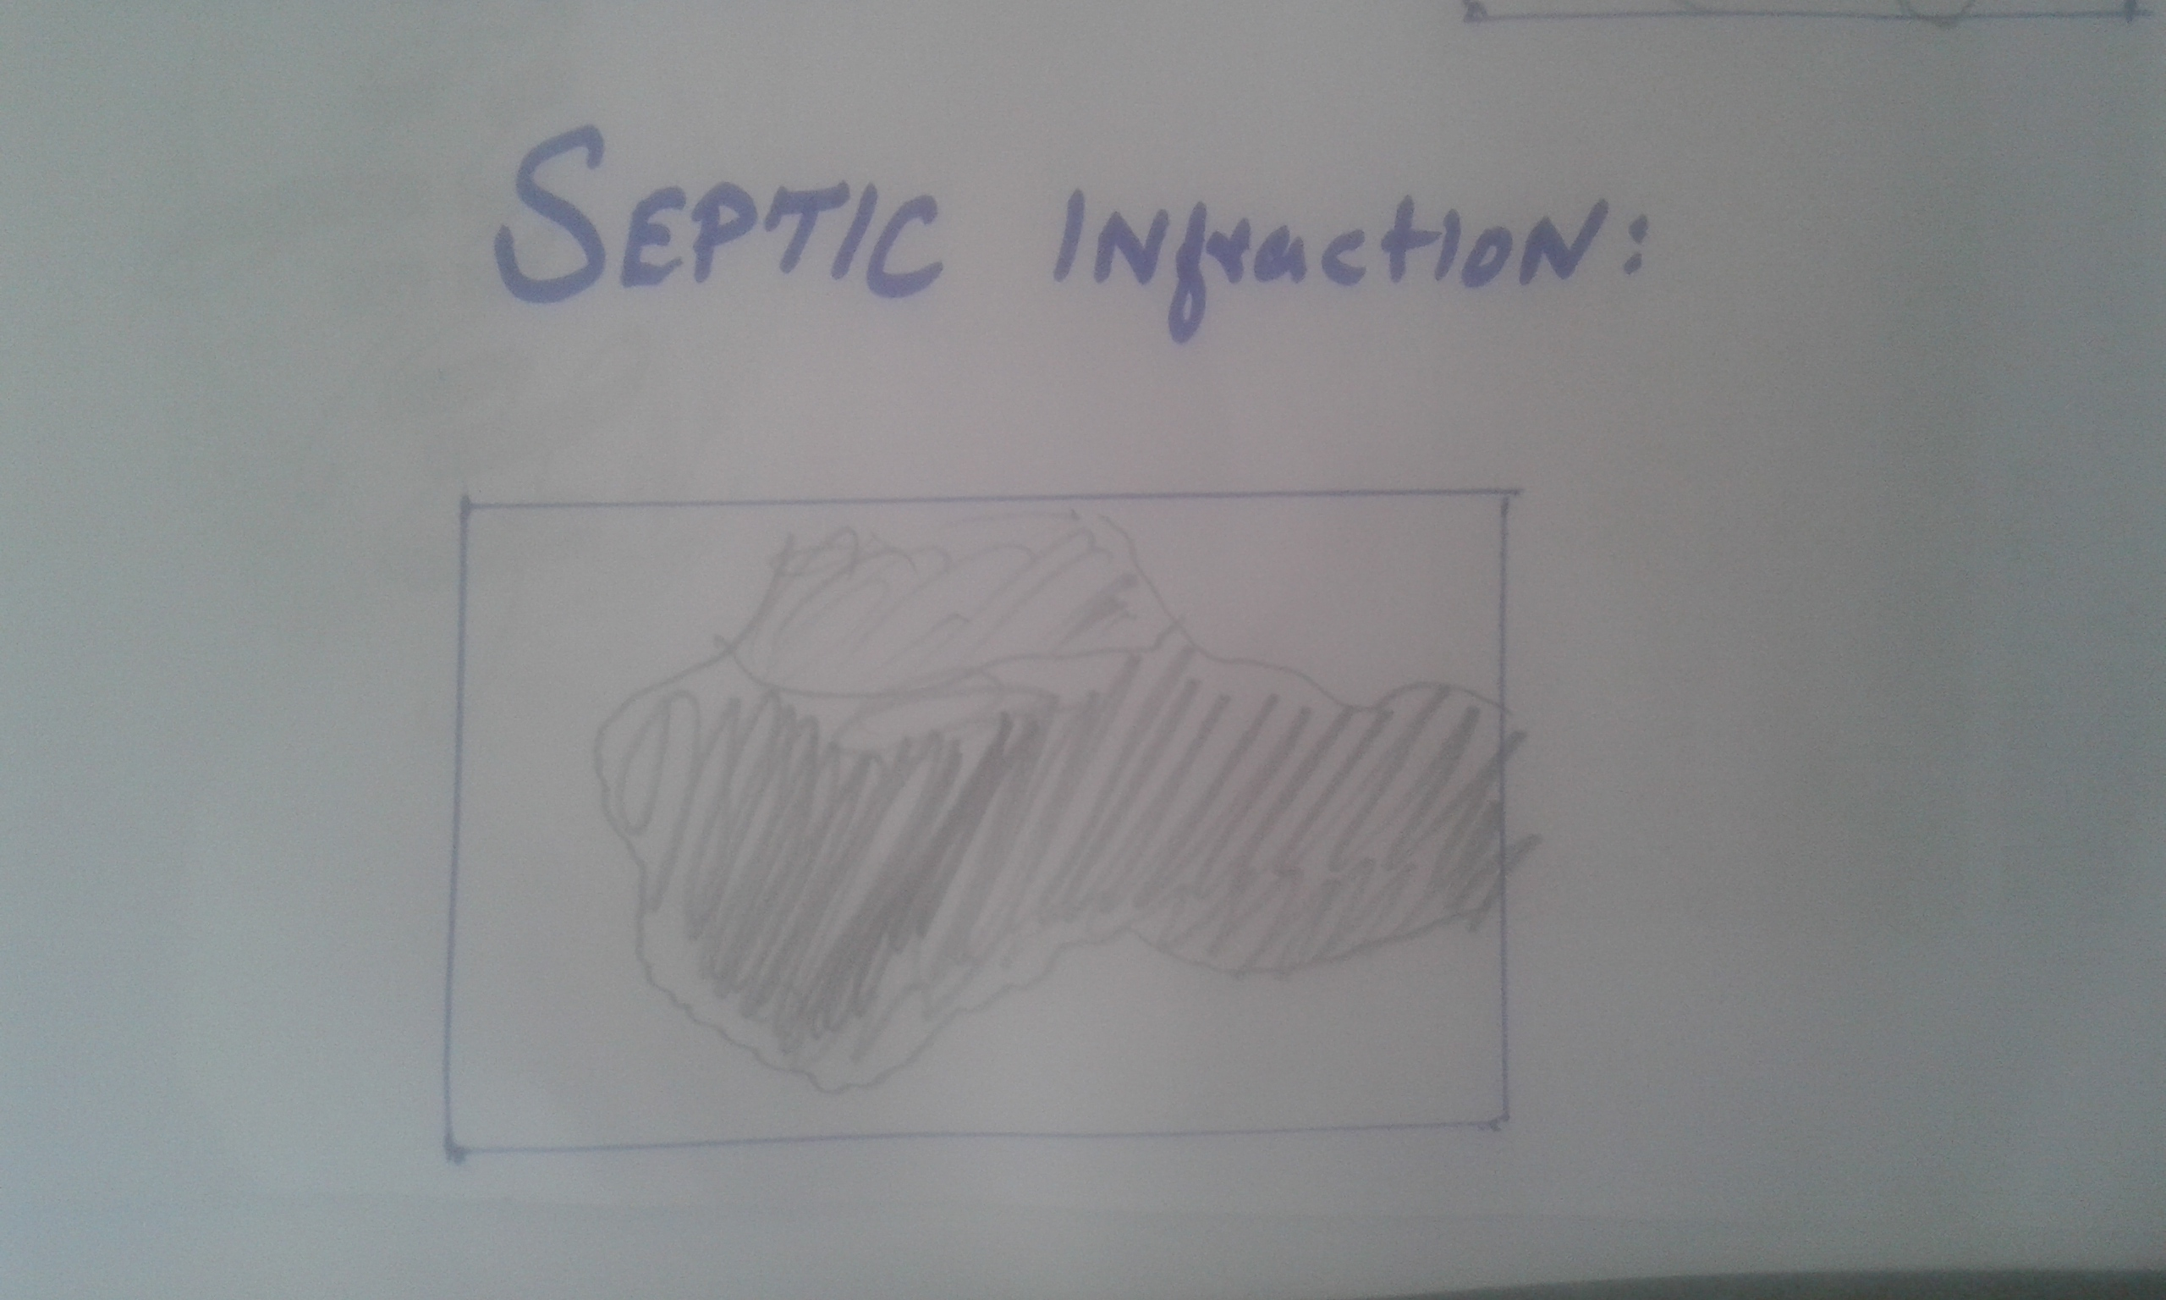
★ MAST CELL:
★Meaning:
mast cell (mast sel) A type of white blood cell that is found in connective tissues all through the body, especially under the skin, near blood vessels and lymph vessels, in nerves, and in the lungs and intestines.

★Definition:
A type of white blood cell that is found in connective tissues all through the body, especially under the skin, near blood vessels and lymph vessels, in nerves, and in the lungs and intestines.
★EXPLANATION:
Mast cells play an important role in how the immune system responds to certain bacteria and parasites and they help control other types of immune responses. They contain chemicals such as histamine, heparin, cytokines, and growth factors. They release these chemicals during allergic reactions and certain immune responses. These chemicals have many effects, including the widening of blood vessels and angiogenesis. During an allergic response, they can cause flushing (a hot, red face) and itching. In large amounts, they can also cause abdominal cramps, muscle pain, nausea, vomiting, diarrhea, low blood pressure, and shock. Mast cells are part of the body’s immune system.
★FUNCTION:
Mast cells contribute to homeostasis in the immune system. They serve as a first line of defense against antigens entering the body due to their location in the skin and mucosa. Mast cells are especially important in the homeostasis of the commensal bacteria of the gut.
★LOCATION OF MAST CELL IN BODY:
Mast cells are located at the junction point of the host and external environment at places of entry of antigen (gastrointestinal tract, skin, respiratory epithelium). Mast cells are located in areas below the epithelium in connective tissue surrounding blood cells, smooth muscle, mucous, and hair follicles.
THE END

Q3. Which are the cells having proliferative capacity?Explain them,also write about the characteristics of Benign tumor?
ANSWER:
The cell which have proliferative capacity are the following:
★1:LABILE CELLS:
Continously dividing cells , these are proliferative throughout life and replacing those cells that are continusly dying.
☆example:
-Squamous stratified epithelium
cells of skin ,
-oral cavity ,
-vagina and cervix.
-Columnar epithelium of GIT,
-uterus and fallopian tubes.
-Hematopoietic (blood forming) cell
of bone marrow.
★2: STABLE CELLS:
These cells have ability to regenerate but in normal condition donot acitvely replicate. However they can undergo rapid divisoin in respone to a variety of stimulus or activation of a stimulus. Low proliferating ability.Regeneration can occur in labile cells and stable cells.
★example:
*Paranchymal cells of liver , kidney and pancreas.
*Mesenchymal cells, e.g smooth muscle , cartilage, connective tissue, fibroblast and vascular endothelial cells.
★3:NON DIVIDING CELLS:
These cells are incapble of division and regeneration. If they are destroyed , the loss is permanent and repair occure only by the proliferation of connective tissue( scar formation).
☆example:
*Nerve cells( neuron)
*Cardaic muscle
*Skeletal muscle
*Regeneration and repair aslo depends on extent of injury and also on inflammation.
★★:CHARACTERISTIC OF BENIGN TUMOR:
It is one of the type of neoplasia and its charactiristic is below:
☆Well differentiated
☆ low mitosis
☆ no necrosis
☆ Slow growing
☆Well demarcated
☆ Encapsulated
☆Do not infiltrate or metastasize
☆May not recurrence
☆Low dysplasia
Q4. What is hypovolumic shock?Explain along with its conditions.
ANSWER:
★HYPOVOLIMIC SHOCK:
★ INTODUCTION:
Severe bleeding or loss of body fluid from trauma, burns, surgery, or dehydration from severe nausea and vomiting. Blood pressure decreases, thus blood flow is reduced to cells, tissue, and organs.
OR
Reduced circulating blood volume with secondary decreased cardiac output.
CONDITIONS:
1:Hemorrhagic
★GI bleed
★Trauma
★Massive hemoptysis
★A rupture
★Ectopic pregnancy, post-partum
bleeding
2:Non-hemorrhagic
★Vomiting
★Diarrhea
★Bowel obstruction, pancreatitis
Burns
★environmental (dehydration)

★CONDITIONS OF HYPOVOLIMIC SHOCK:
★ Heart pumps well, but not enough blood volume to pump :
Normal MAP = CO x SVR
Hypovolemic: 1.MAP = ↓CO x SVR
2.MAP = ↓CO x ↑ SVR
3.↓MAP = ↓↓CO x ↑ SVR
★ When the blood flow decrease the resistance of the blood vessel increase to response the body constrict the blood vessel cause vasoconstriction due to sympathatic tone of vessel.
Due to increase the resistance of vessel the blood flow squeese towards the heart, mostly happened in the venous drainage.
Sympathetic tone also act on the heart to increased the heart rate.
THE END

Q5.What is Edema?Explain its types also write about the classification of Thrombosis.
★ANSWER:
★DEFINITION:
Abnormal and excesses amount of fluid in the interstitial tissue spaces is called edema.
★EXPLINATION:
Fluid collections in different body cavities may have various designations.Hydrothorax (pleural effusion).Hydropericardium
Hydroperitoneum (usually called ascites).Anasarca is severe, extreme generalized edema with profound subcutaneous tissue swelling.
Edema is swelling caused by the increase extra fluid in the interstatial space. It usaually happen in feet , ankle , legs, but also involve the entire body.
There are many causes of edema including certain health condition and some medication. Older adult and pregnant women are more likely to get edema , but it can happen to any one.Edema is a disease of many symptom. It happen to build up fluid in the interstial fluid. It also happen when the blood flow to the heart is restricted.In this condition the fluid and blood back up and leak in to the surrounding tissue. Edema may also be the body respone to inflammation or injury. In injury or inflammation can leak the small bloodvessel(capallaries) and cause edema.When capallaries leak , they release fluid in to the surrounding tissue , these tissue swell up due to the extra cellular fluid.

★TYPES OF EDEMA:
★1: Dependent edema:
Prominent feature of congestive heart failure,particularly of the right ventricle.

★2:RENAL EDEMA:
Edema as a result of renal dysfunction or nephrotic syndrome is generally more severe than cardiac edema and affects all parts of the body equally.

★3:PITTING EDEMA:
Finger pressure over substantially edematous subcutaneous tissue displaces the interstitial fluid and leaves a finger-shaped depression.
★4:PULMONARY EDEMA:
Most typically seen in the setting of left ventricular failure.

★ CLASSIFICATION OF THROMBOSIS:
★VENOUS THROMBOSIS:
Venous thrombosis is the formation of a thrombus (blood clot) within a vein There are several diseases which can be classified .
★DEEP VEIN THROMBSIS:
Deep vein thrombosis (DVT) is the formation of a blood clot within a deep vein. It most commonly affects leg veins, such as the femoral vein. Three factors are important in the formation of a blood clot within a deep vein—these are the rate of blood flow, the thickness of the blood and qualities of the vessel wall. Classical signs of DVT include swelling, pain and redness of the affected area.
★PORTAL VEIN THROMBOSIS:
Portal vein thrombosis affects the hepatic portal vein, which can lead to portal hypertension and reduction of the blood supply to the liver. It usually has a pathological cause such as pancreatitis, cirrhosis, diverticulitis or cholangioarcinoma.

★RENAL VEIN THROMBOSIS:
Renal vein thrombosis is the obstruction of the renal vein by a thrombus. This tends to lead to reduced drainage from the kidney. Anticoagulation therapy is the treatment of choice.
★JUGULAR VEIN THROMBOSIS:
Jugular vein thrombosis is a condition that may occur due to infection, intravenous drug use or malignancy. Jugular vein thrombosis can have a varying list of complications, including: systemic sepsis, pulmonary embolism.Though characterized by a sharp pain at the site of the vein.
★ARTERIAL THROMBOSIS:
Arterial thrombosis is the formation of a thrombus within an artery. In most cases, arterial thrombosis follows rupture of atheroma, and is therefore referred to asatherothrombosis.
★★★★There are further three classification of thtombosis which is given below:
★ON THE BASIS OF COLOR AND COMPOSITION OF THROMBSIS:
1:- pale thrombosis:formed of platelets and fibrin with RBCs.
2:-RED THROMBOSIS:formed of platelets and fibrin with RBCs.
3:-MIXED THROMBOSIS:contaning parts of pale thrombas and part of red thrombas.
★ON THE BASIS OF LOCATION:
1:cardial thrombosis.
2:antrrial thrombosis.
3:venous thrombosis.
4:capiliray thrombosis.
5:lamphatic thrombosis.
★ON THE BASIS OF PRESENCE OR ABSENCE OF BECTERIA:
1:Infected or septic.
2: non infected or aseptic.
THE END

