Mid term assignment
Pathology and microbiology (DPT 4th)
Instructor: Dr. Imran khan

Max Marks: 30
Name ; Javearia zafar ID 14541

Q1: Write down any viral or bacterial disease in detail
Ans) viruses are very small infections agents. They are made up of a piece of genatic material, such as DNA or RNA , that is enclosed in a coat of protein.

Viruses invade cells in your body and use components of those cells to help them multiply, this process often damages or destroys infected cells.
Not all viral diseases are contagious. This mean they aren’t always spread from person to person .but many of them are.

Viral disease names;

- Common cold
- Measles
- Chicken pox
- Bird flu
- Rabies
- Hepatitis
- HIV
- AIDS
- Yellow fever
- Polio
- Small pox
- Mumps
- Dengue fever

- HIV (viral disease )

HIV is a virus that damages the immune system. The immune system helps the body to fight off infections. Untreated HIV infects and kills CD4 cells, which are a type of immune cell called T cells , the body is more likely to get virus types of infections and cancers .

Note; if HIV not treated on time it may convert into AIDS.

- HIV is transmitted through ;

- Blood
- Semen
- Veginal and rectal fluids
- Breast milk

The virus doesn’t spread in air or water, or through casual contact.

- Stages of HIV / AIDS

- Stage 1; acute stage, the first few weeks after transmission
- Stage 2; clinical latency ,or chronic stage
- Stage 3; AIDS

Note ; life expectancy with AIDS is about 3 years . HIV symptoms may appear after one week .

- HIV dose NOT spread through;

- Skin to skin contact
- Hugging , shaking hands or kissing
- Air or water
- Sharing food or drinks
- Saliva, tears, or sweat mixed with blood of effected person
- Sharing a toilet, towels or bedding
- Mosquitoes or other insects

- Test used to detect HIV or AIDS

- Antibody /antigen tests
- Nucleic acid test (NAT)
It takes 5 to 21 days to detect HIV in blood

- Symptoms of HIV

- Fever
- Chills
- Swollen lymph nodes
- General aches and pains
- Skin rash
- Sore throat
- Headache
- Nausea
- Upset stomach

- Precautions ;
- Get tested and know your partners HIV status
- Choose less risky sexual behaviour
- Use condom
- Limit your number of sexual partners
- Don’t inject drugs

Q2: What is cancer? How cancer is diagnosed? What is the role of genetics in cancer? Also explain TNM diagnostic test for cancer

ANS) cancer is the uncontrolled growth of abnormal cells in the body , cancer develops when the body normal control mechanism stops working. Old cell do not die and instead grow out of control, forming new, abnormal cells. These extra cells may form a mass of tissue, called tumor.

- Cancer diagnosis ;

- Imaging tests
- Computerized tomography (CT) scan
- Bone scan
- Magnetic resonance imaging (MRI)
- Positron emission tomography (PET) scan
- Ultrasound
- X-ray
- Biopsy

- Cancer treatment ;

- Surgery
- Chemotherapy
- Radiation therapy
- Bone marrow transplant
- immunotherapy
- hormone therapy
- targeted drug therapy
- clinical trials

- Genetics Role in Cancer;
Cancer is a genetic disease that is , cancer is caused by certain changes to genes that control the way our cell function, especially how they grow and divide. Genetic changes that promote cancer can be inherited from our parents if the changes are present in germ cells , which are the reproductive cells of the body (eggs and sperm) . such changes ,called germline changes, are found in every cell of spring.

- TMN diagnostic ;
Another factor your doctor probably will use to determine your overall cancer stage is the TNM system , short for tumor ,node and metastasis. She will measure each of these and give it a number or an X if a measurement cant be determined . The symbols are bit different for each type of cancer, but this is generally what they mean ;

- Tumor ; (t) followed by a number from 0 to 4
- Node ;(n)followed by a number from 0 to 3
- Metastasis;(M)followed from 0 to 1
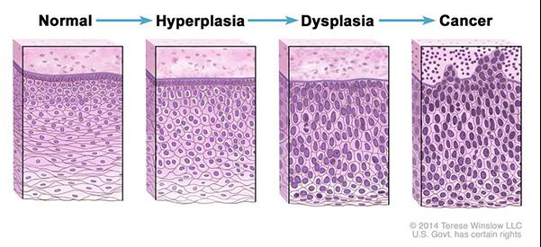
Q3: Explain structure of bacterial cell. How antibiotics kill bacteria? What is the mode of action of antibiotics?

ANS) Bacterial cell structure :

Bacteria are prokaryotes, lacking well -defined nuclei and membrane -bound organelles, and with chromosomes composed of a single closed DNA circle . they come in many shapes and sizes , from minute spheres , cylinders and spiral threads, to flagellated rods , and filamentous chains.

- Bacterial cell composed of ;

- Capsule
- Cell envelope
- Cell wall
- Cytoplasm
- Cytoplasmic membrane
- Flagella
- Nucleoid
- Pili
- Ribosomes
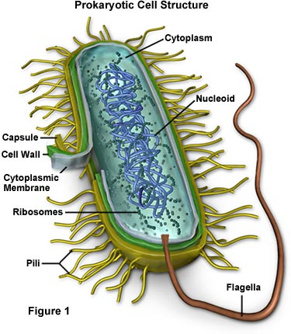
- Antibiotics work against bacteria:
Antibiotics are medications used to fight infections caused by bacteria. They are also called antibacterial . they treat infections by killing or decreasing the growth of bacteria. The antibiotics fight bacterial infections either by killing bacteria or slowing and suspending its growth . they do this by ;
- Attacking the wall or coating surrounding bacteria
- Interfering with bacteria reproduction
- Blocking protein production in bacteria

- Antibiotics are available in the form of ;
- Tablets
- Capsules
- Liquids
- Creams
- Ointments

- Mode of action of antibiotics;

Some of antibiotics work by binding to components involve in the process of DNA or RNA synthesis ,which causes interference of the normal cellular processes which will ultimately compromise bacterial multiplication and survival. Examples; quinolones, metronidazole and rifampin . inhibitors of other metabolic processes,

Different antibotics have different modes of action, owing to the nature of their structure and degree of affinity to certain target sites with in the bacterial cells.

- Inhibitors of cell wall synthesis
- Inhibitors of cell membrane function
- Inhibitors of protein synthesis
- Inhibitors of nuclei acid synthesis
- Inhibitors of other metabolic processes

