Name. Safi ur rahman Subject> Pak studies Subject failed previous > Pakistan study Lecturer> Sir Sad haider
ID# 14659 Dep. Allied Health Science ( MLT ) Mid Tem Examination August 20-2020 previous Cleared > 4th semester

Subject Pakistan Studies instructor: Mr. Saad Haider
Student Name: Safi ur rahman ID: 14659
Midterm Assignment 30 Marks
Department AHS Second Semester

Attempt all the following Questions.
Q1. Explain the importance of ideology in national life.
Q2. Describe the Services render by Sir Syed Ahmad khan for the cause of Indian Muslims.
Q.3.Write any five basic points of ideology of Pakistan.

Q. 1 Answer
Importance of Ideology
- Ideology is very important because it is a motivational force, and it is a program of plan which is based upon .philosophy.
Or,
- The science of ideas, manners thinking,
Ideas on basis of social, economic system or political theory known as ideology.
So, ideology of Pakistan is based on Islamic culture.

- Motivational Force:
It is for society to strive hard to bring stability.
For example,
If in our class, we want to get high marks, so, we will be motivating /dedicates to achieve high marks, so, will create a motivating source for nation.

- Common Platform:
Ideology is important to provides, a common platform for the society, that brings them closer to each other’s .for a common cause.

- Joint Line of Action:
The sequence means, to following for accomplishment goal.
Ideology can birth to existing structure,
Existing ideology, civilization and culture.
Revolution occurred and culture and civilization will be reshaped.
- Revolution occurred > culture shaped

Ideology is important to cooperate previous and thinking about future.

Q. 3 Answer
Ideology of Pakistan
>Some Basic Points

- It is an implantation of Islamic teachings.
- Ideology means to maintain struggle and national unity between Muslims and as Islamic rules.
- Cultural and political background on basis of Islamic philosophy called ideology of Pakistan.
- Pakistan ideology is an Islamic ideology
- The ideology can be reflects the ideas of any nations, like thinking, aspirations, culture shape, religions make binds them together.
- Ideology is basically tended to arise in times of social stress and as well crises.
- To emerges ideology, the society can challenge accepts the challenge, and make the hold steps, and make some principles followed it, and then after meats that challenge.
For example
COVID-19 wohan china
- While in china as nation, and they challenge and fight, so ultimately they will win challenge of COVID-19.
Now Wohan is opened for all sorts of traits and activities.
It they make it compulsory, we will follow instructions and will fight against this pandemic COVID-19.
- Ideology is a system of beliefs, thinks of society or nation.
Values, ideas, goals or convections.
And the people will be considers as true, practicable and binds.
Traditional goals.

Q. 2 Answer

Services Render by Sir Syed Ahmad khan & Cause of Indian Muslims:
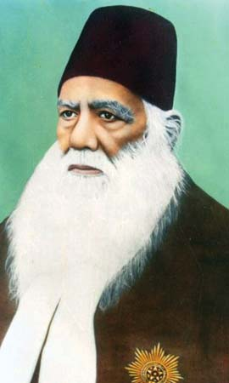

A leader his name Sir syed Ahmad khan ,who struggle for Indian Muslims to separate from Hindus ,and considered as Muslims is a different nation from hindus.and as well as British.

Introduction of Sir Syed Ahmad Khan
Sir Syed Ahmad khan was born in 1817 in Delhi, and died in 1898.
Then he worked as jurist/judge in east India Company.
He wrote Risala (Asbab-e-Baghawat-e-Hind) after war of 1857.
He wrote in Risala that, why Muslims and Hindus are become against British GOVT.
Then he was establish Aligarh Muslim University in year of (1875)
Then he denounced scientific society.
He together Muslims teams and said that Hindus and British is one team and there is no space/rights for Muslims in govt.
(So, now if we look to world, we are down in knowledge, so we should get education and be modern)

Sir Syed Said, if you not learn English language, you, l never modernizes the western culture.
He also motivated that if you not learn English literature and western philosophy, so you unable to plays against ruling peoples.
- Those above all messages were for the Muslims of sir syed Ahmad khan.

Sir Syed Ahmad khan Objectives were,
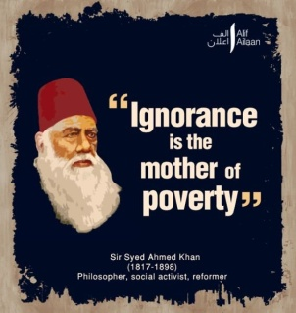
- Removing tension in state between British GOVT and Muslims.
- And he wanted for Muslims to get jobs and more facilities, with new GOVT.

Sir Syed Ideas were,
- He wanted for creating mutual understanding among Muslims and non-Muslims.
- And he motivated the Muslim people to learn the western knowledge.
- Means that, first at all we are Muslims, and then become scientists as well.
- He persuaded the Muslims to abstain the agitational politics.
- Muhammad (SAW) is the last prophet of Allah and he is messenger of Allah.

Hindus & Muslim Differences
- Hindus burnt their died bodies while Muslims (Dafan) the died bodies.
- Muslims are like to eat cow meets, while Hindus not eats cow meets and considers as, mother/cow. 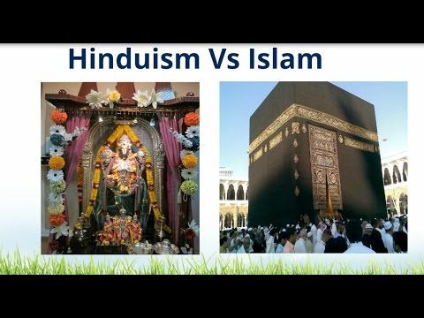
- They are different to each others, in religions and everything’s.
- So, because of those situations some leaders created/made tow nation theory for to separate Muslims from Hindus.
- And made different ideology of Pakistan in subcontinent.

Muslim as a Nation Muslim is Different
Nation from Hindus
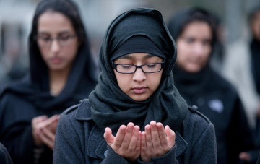
A nation word used by sir syed for muslims.because Muslims is separate religion.
While some society’s people said that, Hindus and Muslims are one nation.
But sir syed and Muslims opinioned that Muslims is as separate nation.
>In that time Hindus and Muslims were one nation in ration. Like today’s pathans, balochis etc.
>He talked about separate electorate for Muslims in 1883 and said,
(Majority override interests of minority)
>Means, Muslims must be plays elections together, not with Hindus.
>He was meeting with name of patriotic association in 1888, and he tried to fail congress propaganda.
>while he founded another association in dec-1893.
>This association aimed to protects Muslims religions, political, and social rights.

Urdu – Hindi Controversy 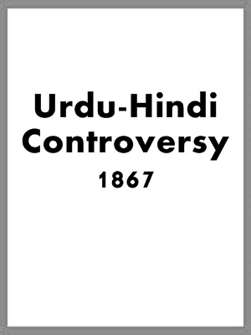

- At first sir syed Ahmad khan struggles about Hindus, he used the word Indians before the 1867.
(In Indian categories involved whole Indians, Muslims, sicks etc.
His struggle was about Muslims and Hindus as well, but Urdu –Hindi controversy became in 1867.
- At banarasi, Hindus began compain for replacing Urdu by Hindi.
, and more Muslims were killed in that compain which Hindus started.
- After that compain sir syed started struggles about Muslims and decided that Hindus and Muslims are not one nation, and they must lives with separate states.
- And he tried to save Urdu language.

The En________________________________________________d

