NAME ABDULLAH
ID 16779
DEPARTMENT BS MLT
PEPAR HEMATOLOGY
SEMESTER 2ND
INSTRUTOR ADNAN AHMAD
Q1: DISCUS DEVELOPMENTAL STAGES OF ERYTHROPOIESIS. 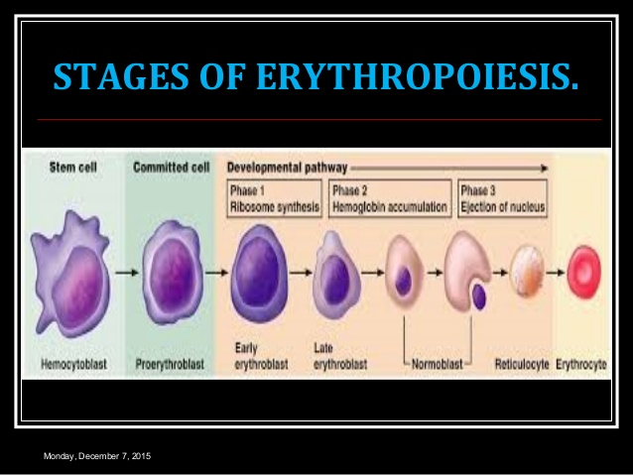
ANS: Synthesize By Per tubular Cell Of Kidney In Response To Hypoxemia.
Present In Minute Amount In Urine
Liver Secretes 10% Of Endogenous Erythropoietin
Responsible For Low Level Erythropoietin.
Half Life Of 6-9hrs In Anemic Patient.
In Normal State The Balance Of Production And Destruction Is Maintnedat Remarkably Constant Rate.
As The Early Precursor Cell Matures Its Nucleus Increases In Size As Maturation Goes On Cell Become Smaller And More Eosinophilia Indication Hemoglobin ,
FURTHER MATURATION: Hemoglobin Synthesize Continue And Cytoplasm Become Entirely Eosinophilia.
LATE STAGES OF MATURATION: Hemoglobin Is Abundant Few Mitochondria And Ribosome Are Present Nucleus Is Small Dense And Circumscribed.
Q2: ENLIST COMMON CAUSES OF POOR BLOOD FILAM ( BLOOD SMEAR)
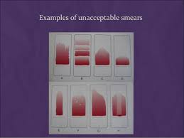
ANS: common causes of poor blood smear:
1: DROP OF BLOOD TO LARGE OR TOO SMALL.
2: SPREDER SLIDE PUSHED ACROSS THR SLIDE IN THE JERKYMANNER .
3: FAILUR IN KEEP THE ENTIRE EDGE OF THE SPREDER SLIDE AGAINST THE SLIDE WHILE MAKING THE SMEAR.
4: FAILURA TO PUSH THE SPREDER AT A 30 ANGEL WITH THE SLIDE.
5: FAILURA TO IN KEEP THE SPREDER SLIDE COMPLETELY ACROSSE THE SLIDE .
6: irregular spread with ridges and long tial edges of spreader dirty or chipped dusty slide.
7: holes in film slide contaminated with for or greases and air bubbles.
8: cellular degenerative changes delay in faixing indequte faxixng or methanol contaminated water.
Q3: BRIEFLY EXPLAIN GRANULUPOIESIS IN DETAIL.
ANS: Granulopoiesis is the process by which committed hemophilic progenitor cells devil into granulocytes under the influence of viruses growth facto and cytokines.
Neutrophil lobulated dark nucleus , mature grey cytoplasm with small granules.
Neutrophilc band or stab cell: hores shoe shaped darking nucleus gray mature cytoplasm .
Neutophilic myelocytes: large ovel non indeten nucleus large amonte of cytoplasm with specific and non specific ganules.
Promylocytes: larg ovel non indented nucless large amount of sky blue cytoplasm with and non spicepic ganueles/
Granulocyte, any of a group of white blood cells (leukocytes) that are characterized by the large number and chemical makeup of the granules occurring within the cytoplasm. Granulocytes are the most numerous of the white cells and are approximately 12–15 micrometers in diameter, making them larger than red blood cells (erythrocytes). They also have a multiplied nucleus and are important mediators of the inflammatory response. There are three types of granulocytes: neutrophils, eosinophil, and basophils. Each of these types is distinguished by the cooler that the granules stain when treated with a compound dye. The differences in staining characteristics reflect differences in the chemical composition of the granules.
Q4: WHAT IS IRON DEFICIENCY ANEMIA? ALSO DISCUSS ITS CAUSES.
ANS: IRON DEFICINCY OF ANEMIA:
Iron deficiency is a common type of anemia a condition in which blood lacks adequate healthy red blood cells. Red blood cell carry oxygen to the body tissues as the name implies iron deficiency anemia is due to insufficient iron.
CAUSES OF IRON DEFICENCY ANEMIA:
CHRINIC BLOOD LOSS
UTERINE
Gastrointestinal e.g peptic ulcer esophageal varies aspirin( or other non-steroidal anti anal amatory drugs ) ingestion partial gastrostomy carcinoma of the stomach colon or rectum hookworm angiodysplasia colitis piles self-inflicted blood loss.
DIAGNOSIS OD IDA: clinical: symptom ( fatigue dizziness palpitations etc)
Laboratory
Stainable iron in bone marrow
Reponses to iron supplements
LAB FINDIGN IN IDA:
PCV DECRAESED
PLATELET COUNT DECRAESED
RETICS COUNT DECRAESED
SERUM COUNT DECRAESED
Despite of these teste following tests can be helpful.
Q5: CLASSIFY ANEMIA ON THE BASIS OF MORPHOLOGY WITH EXAMPLES.
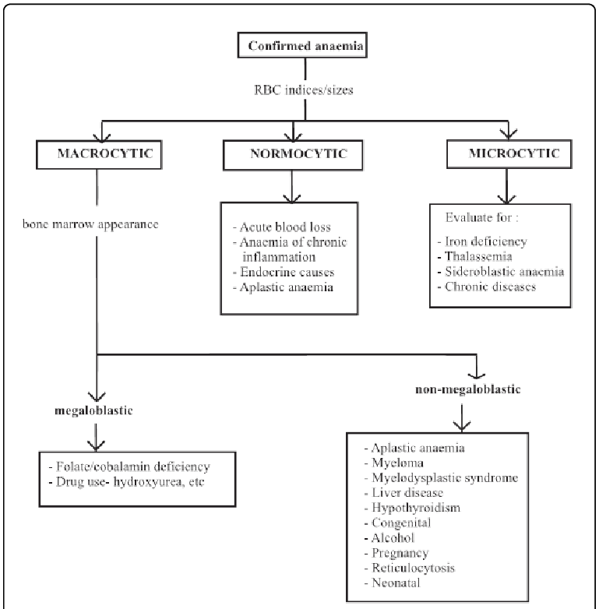
ANS: Anemia Is Classified By Morphology Or Pathophysiology. The Morphological Classification Is Based Partly On The Size Or Volume Of The Red Blood Cell. Normocytic Would Indicate A Red Blood Cell Of A Normal Size Or Volume. Microcytic Indicates An Abnormally Small Cell, And Macrocytic Indicates An Abnormally Large Cell.
Microcytic Anemias:
To Etiologic Possibilities Are
1 Irone Deficincy
2 Thalassemia
3 Sideroblastic Anemia
4 Anemias Of Chronic Disease
Severe Microcytic Anemia (Mcv<76 Fl) Is Cauesd Mianly By Iromn Defincy Or Thalassemia.

. ... An example of a free morpheme is "bad", and an example of a bound morpheme is "ly." It is bound because although it has meaning, it cannot stand alone.

