DISCRETE STRUCTURES
  - ANSWER SCRIPT
TAYYABA SHAH | BS.SE | ID: 15835
June 25, 2020
2ND SEMESTER

Q1.

(a)
ANSWER
Definition: A bi-conditional statement is defined to be true whenever both parts have the same truth value. The bi-conditional operator is denoted by a double-headed arrow. The bi-conditional pq represents "p if and only if q," where p is a hypothesis and q is a conclusion. The following is a truth table for bi-conditional pq.
p | q | pq
T | T | T
T | F | F
F | T | F
F | F | T
In the truth table above, pq is true when p and q have the same truth values, (i.e., when either both are true or both are false.)

Q1.

(b)
ANSWER
- Sam had pizza last night if and only if Chris finished her homework. pq
- Pat watched the news this morning if Sam did not have pizza last night. ¬p → r

- Pat watched the news this morning if and only if Chris finished her homework and Sam did not have pizza last night. r ↔(q^¬p)
- In order for Pat to watch the news this morning, it is necessary and sufficient that Sam had pizza last night and Chris finished her homework. r↔(p^q)

Q2.

(a)
ANSWER
- It is sunny if and only if it is hot today.
- It is hot today if and only if it is sunny and it is raining.
- It is hot today if and only if it is sunny or it is raining.
- It is raining if and only if it is hot today or it is sunny.

Q3.
ANSWER
ARGUMENT:
An argument is a sequence of statements . All statements (forms) in an argument (form) except for the final one, are called premises (or assumptions, or hypothesis). The final statement (form) is called the conclusion. The symbol ◦ ◦ ◦ which is read “therefore” is normally placed just before the conclusion. Now we have a formal definition for an argument, we can state what we mean by a valid argument.
Example 1
Determine the validity of the following argument: “Robbery was the motive for the crime only if the victim had money in his pockets. But robbery or vengeance was the motive for the crime. Therefore, vengeance must have been the motive for the crime.” Let p :=“robbery was the motive for the crime”, q :=“the victim had money in his pockets”, and r :=“vengeance was the motive for the crime”. Then the argument translates as follows:

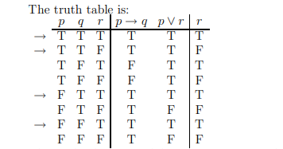
This is clearly not a valid argument - as stated above, if the victim had money in their pockets, and the motivation of the crime was robbery but not vengeance, this satisfies all hypothesis, but not the conclusion as suggested by the truth table.

Example 2

Use a truth table to test the validity of the following argument.
If you are a hound dog, then you howl at the moon.
You don't howl at the moon.
Therefore, you aren't a hound dog.
A. Valid
B. Invalid

Step 1
Symbolize the argument.
Let p be the statement "You are a hound dog."
Let q be the statement "You howl at the moon."
Then the argument has this symbolic form:
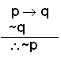

Step 2
Make a truth table having a column for each premise and for the conclusion.
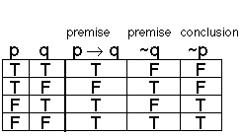

Step 3
Interpret the truth table.
Notice that in this truth table, there is NO ROW in which conclusion is FALSE while both premises are TRUE.
This tells us that the argument is VALID.

Q4.
(a)
ANSWER
UNION:
The set made by combining the elements of two sets.
So the union of sets A and B is the set of elements in A, or B, or both.
The symbol is a special "U" like this: ∪
Example:
Soccer = {alex, hunter, casey, drew}
Tennis = {casey, drew, jade}
Soccer ∪ Tennis = {alex, hunter, casey, drew, jade}
MEMBERSHIP TABLE FOR UNION :
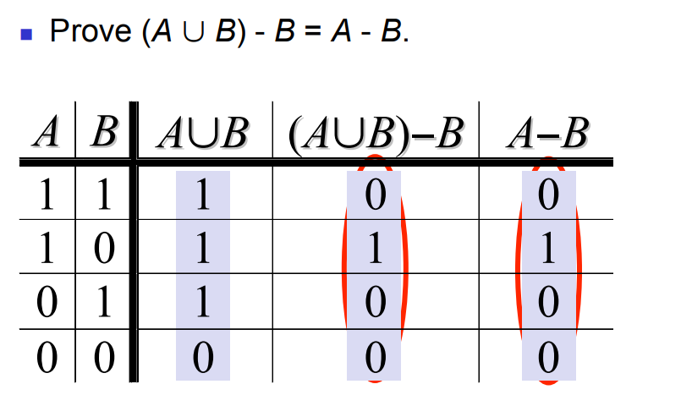

Q4.
(b)
ANSWER

INTERSECTION:
The intersection of two sets A and B, denoted by A ∩ B, is the set of all objects that are members of both the sets A and B. In symbols,

That is, x is an element of the intersection A ∩ B if and only if x is both an element of A and an element of B.
For example:
- The intersection of the sets {1, 2, 3} and {2, 3, 4} is {2, 3}.
- The number 9 is not in the intersection of the set of prime numbers {2, 3, 5, 7, 11, ...} and the set of odd numbers {1, 3, 5, 7, 9, 11, ...}, because 9 is not prime.

Membership Tables
We combine sets in much the same way that we combined propositions. Asking if an element xx is in the resulting set is like asking if a proposition is true. Note that xx could be in any of the original sets.
- Analog to truth tables in propositional logic.
- Columns for different set expressions.
- Rows for all combinations of memberships in constituent sets.
- Use “1” to indicate membership in the derived set, “0” for non-membership.
- Prove equivalence with identical columns.

MEMBERSHIP TABLE 1:
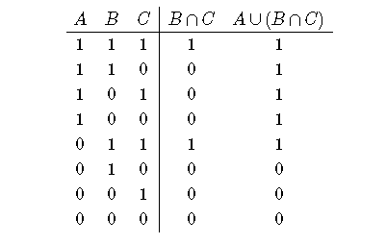
MEMBERSHIP TABLE 2
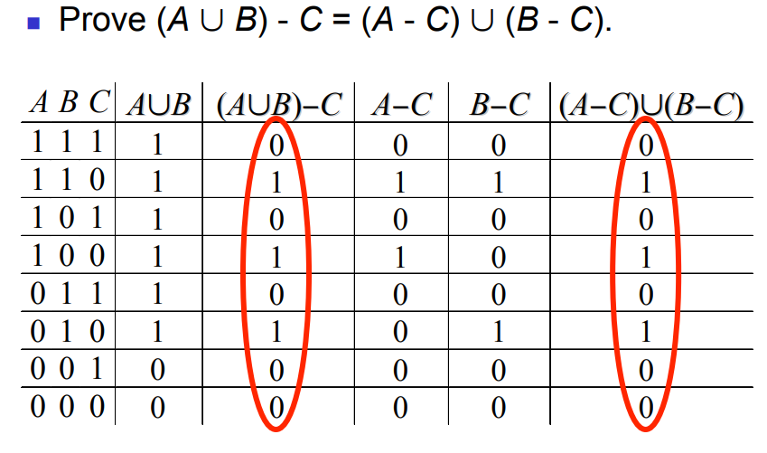

Q5.
(a)
ANSWER

VENN DIAGRAM
A Venn diagram is an illustration of the relationships between and among sets, groups of objects that share something in common. Usually, Venn diagrams are used to depict set intersections (denoted by an upside-down letter U). This type of diagram is used in scientific and engineering presentations, in theoretical mathematics, in computer applications, and in statistics.
EXAMPLE:
In the diagram below, there are two sets, A = {1, 5, 6, 7, 8, 9, 10, 12} and B = {2, 3, 4, 6, 7, 9, 11, 12, 13}. The section where the two sets overlap has the numbers contained in both Set A and B, referred to as the intersection of A and B. The two sets put together, gives their union which comprises of all the objects in A, B which are {1 2 3 4 5 6 7 8 9 10 11 12 13}.
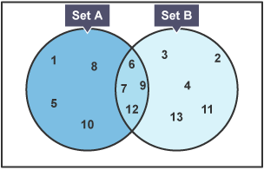
Example
Given U = {1, 2, 3, 4, 5, 6, 7, 8, 10}
X = {1, 6, 9} and Y = {1, 3, 5, 6, 8, 9}
Find X ∪ Y and draw a Venn diagram to illustrate X ∪ Y.
Solution
X ∪ Y = {1, 3, 5, 6, 8, 9}
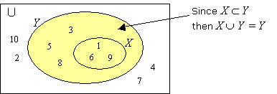

Q5.
(b)
ANSWER
List out the elements of P.
P = {16, 18, 20, 22, 24} ← ‘between’ does not include 15 and 25
Draw a circle or oval. Label it P. Put the elements in P.
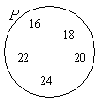

Q5.
(c)
ANSWER
Draw a circle or oval. Label it R. Put the elements in R.
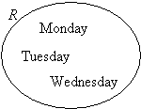

Q5.
(d)
ANSWER
Since an equation is given, we need to first solve for x.
2x – 3 < 11 ⇒ 2x < 14 ⇒ x < 7
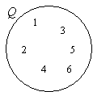
So, Q = {1, 2, 3, 4, 5, 6}
Draw a circle or oval. Label it Q.
Put the elements in Q.

