Anatomy
Name
Zonira Amin
Semester
1st
Department
Radiology
Topic
Joints Of Upper Limb

Joints Of Upper Limb

The upper extremity or arm is a functional unit of the upper body. It consists of three sections, the upper arm, forearm, and hand. It extends from the shoulder joint to the fingers and contains 30 bones. It also consists of many nerves, blood vessels (arteries and veins), and muscles.
The upper limb has a wide range of precise movements associated with it to allow us to effectively interact with our environment, the 6 main joints covered here (from proximal to distal) are the sternoclavicular, acromioclavicular, shoulder, elbow, radioulnar, and wrist joints.

Acromioclavicular Joint

The acromioclavicular joint, or AC joint, is a joint at the top of the shoulder. It is the junction between the acromion (part of the scapula that forms the highest point of the shoulder) and the clavicle. It is a plane synovial joint.

Structure
Ligaments
The joint is stabilized by three ligaments:
- The acromioclavicular ligament, which attaches the clavicle to the acromion of the scapula.
Superior Acromioclavicular Ligament This ligament is a quadrilateral band, covering the superior part of the articulation, and extending between the upper part of the lateral end of the clavicle and the adjoining part of the upper surface of the acromion.
It is composed of parallel fibers, which interlace with the aponeuroses of the Trapezius and Deltoideus; below, it is in contact with the articular disk when this is present.
Inferior Acromioclavicular Ligament This ligament is somewhat thinner than the preceding; it covers the under part of the articulation, and is attached to the adjoining surfaces of the two bones.

It is in relation, above, in rare cases with the articular disk; below, with the tendon of the Supraspinat
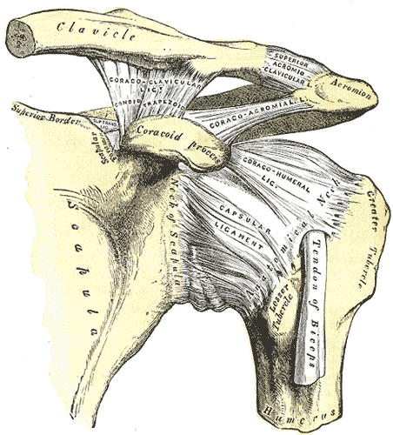
Sternoclavicular joint

The sternoclavicular joint or sternoclavicular articulation is the joint between the manubrium of the sternum and the clavicle bone. It is structurally classed as a synovial saddle joint and functionally classed as a diarthrosis and multiaxial joint. It is composed of two portions separated by an articular disc of fibrocartilage. The bone areas entering into its formation are the sternal end of the clavicle, the upper and lateral part of the sternum, (the clavicular notch), and the cartilage of the first rib, visible from the outside as the suprasternal notch. The articular surface of the clavicle is much larger than that of the sternum, and is invested with a layer of cartilage, which is considerably thicker than that on the sternum.
The costoclavicular ligament is the main limitation to movement, and therefore the main stabilizer of the joint. A fibrocartilaginous disc present at the joint increases the range of movement.
Structure
- Anterior sternoclavicular ligament
- Articular capsule
- Articular disk
- Costoclavicular ligament
- Interclavicular ligament
- Posterior sternoclavicular ligament
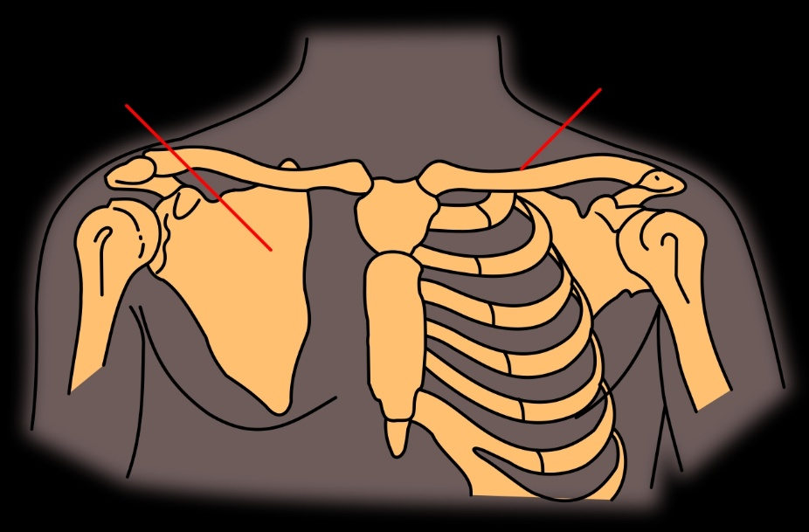
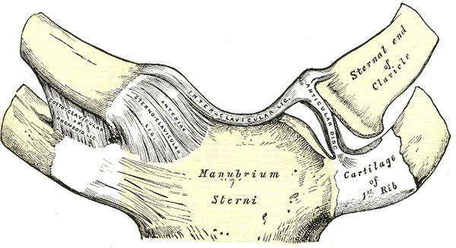

Shoulder joint

The shoulder joint (or glenohumeral joint from Greek glene, eyeball, + -oid, ‘form of’, + Latin humerus, shoulder) is structurally classified as a synovial ball and socket joint and functionally as a diarthrosis and multiaxial joint. It involves articulation between the glenoid cavity of the scapula (shoulder blade) and the head of the humerus (upper arm bone).
Due to the very loose joint capsule that gives a limited interface of the humerus and scapula, it is the most mobile joint of the human body.
The shoulder joint is a ball and socket joint between the scapula and the humerus. However the socket of the glenoid cavity of the scapula is itself quite shallow and is made deeper by the addition of the glenoid labrum.

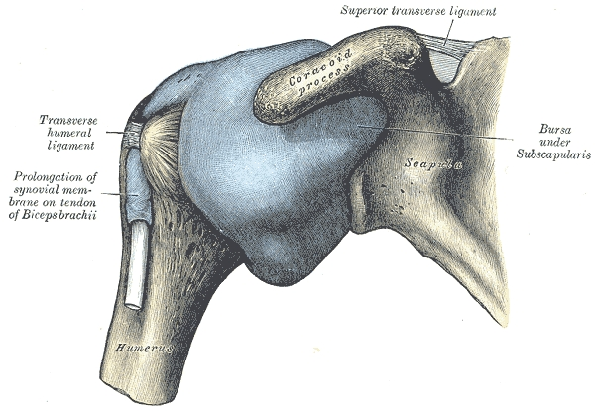

Elbow joint

The elbow is the visible joint between the upper and lower parts of the arm. It includes prominent landmarks such as the olecranon, the elbow pit, the lateral and medial epicondyles, and the elbow joint. The elbow joint[1] is the synovial hinge joint[2] between the humerus in the upper arm and the radius and ulna in the forearm which allows the forearm and hand to be moved towards and away from the body.
Medical Subject Headings defines the elbow specifically for humans and other primates, though the term is frequently used for the anterior joints of other mammals, such as dogs.
The name for the elbow in Latin is cubitus, and so the word cubital is used in some elbow-related terms, as in cubital nodes for example.
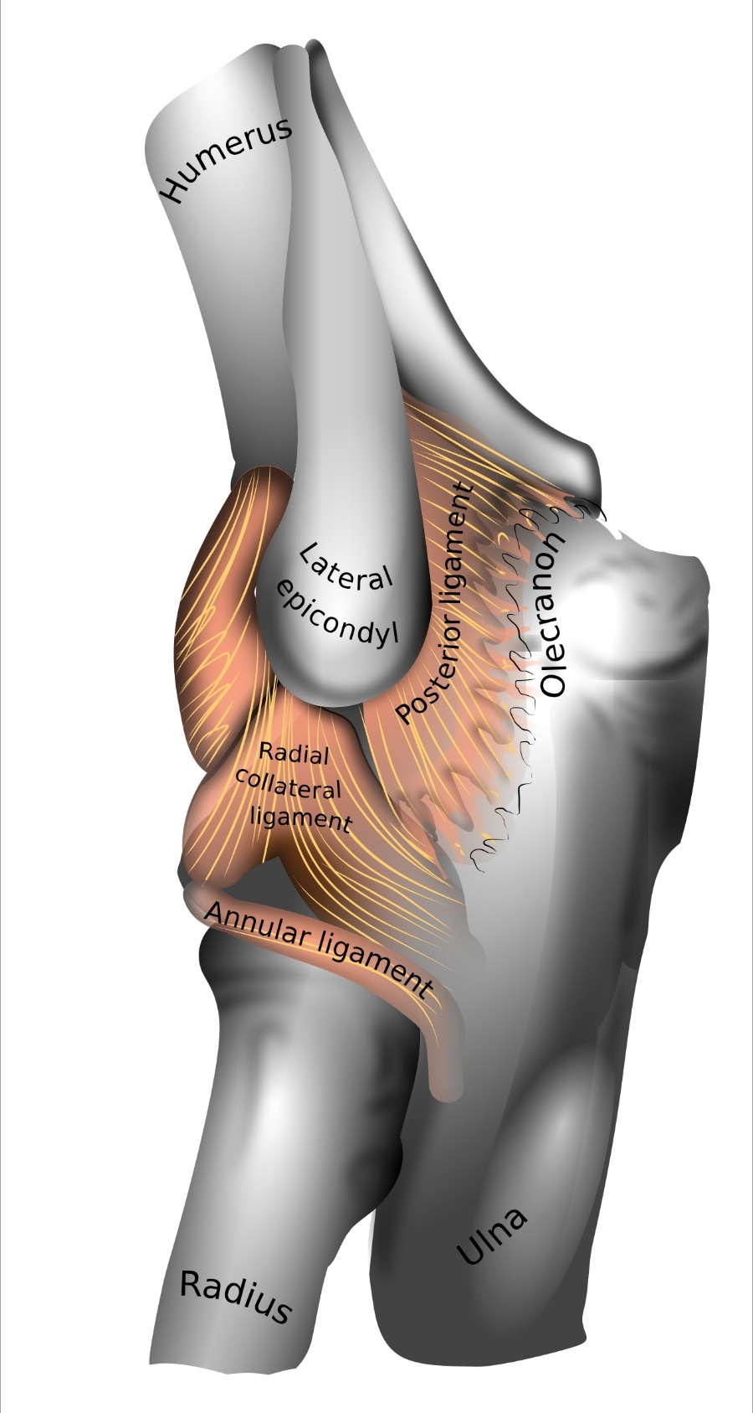

Distal radioulnar joint

The distal radioulnar joint is a synovial joint between the distal ends of the radius and ulna.
This is a uniaxial pivot joint that allows the movements in one degree of freedom; pronation-supination. In simple words, these are the rotatory movements by which the forearm and hand rotate around the long axis of the forearm.
In pronation, the palm of the hand faces downwards, while in supination, it faces upwards. Within the whole human body, these movements are unique to the forearm of the upper limb.
The distal radioulnar joint is the articulation between the crescent-shaped convex distal head of ulna and the concave ulnar notch of radius.

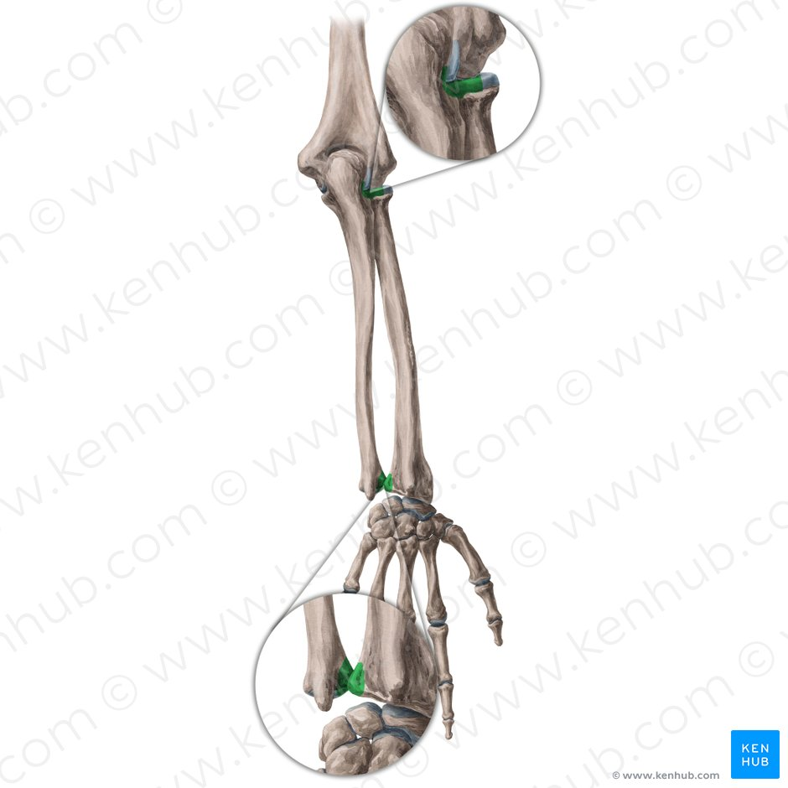

Wrist Joint

The wrist is variously defined as
- the carpus or carpal bones, the complex of eight bones forming the proximal skeletal segment of the hand;
- the wrist joint or radiocarpal joint, the joint between the radius and the carpus and;
- the anatomical region surrounding the carpus including the distal parts of the bones of the forearm and the proximal parts of the metacarpus or five metacarpal bones and the series of joints between these bones, thus referred to as wrist joints.
- This region also includes the carpal tunnel, the anatomical snuff box, bracelet lines, the flexor retinaculum, and the extensor retinaculum.
