Name Asad ullah khan
ID 6830
Sec B
Assignment 2
Semester 8th
Department BSSE
Subject Object oriented analysis & design

Use case
Project Title “Locating Friends and family using GPS with Mobile Phones”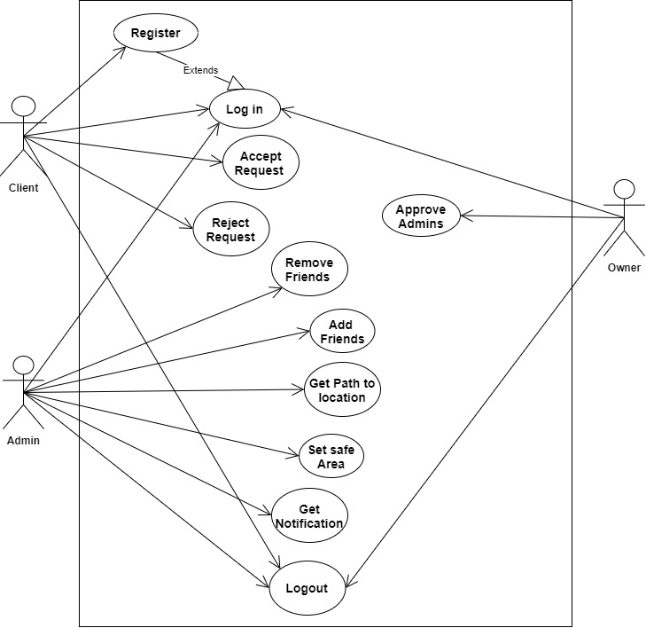

Use Case Description:
This section contains the description of the use cases description and the functionality of an activity.
Register:
Client and Admin will be register by email and name to login to the application client and admin both need to be register first.
Login:
This use case will be used for registered client and admins to login to the application.
Accept Request:
This use case will be use by client to accept Admin request for finding the location of client.
Reject Request:
This use case will be used by client to reject admin request if he not want their location or then admin is not known.
Remove Friend:
This use case will be used by Admin to unfriend friend client if they not want find the location of client.
Add Friend:
This use case will be used by Admin to add client to find their location.
Get path:
In this use case the admin will get location and path towards the location of client.
Set safeArea:
In this use case the admin will set location for client if client cross that location admin will get notification.
Get Notification:
The admin will get notification if client cross safe area.
Logout:
This use case will be use by admin client and owner to logout from the application.

Class Diagram
Project Title “Locating Friends and family using GPS with Mobile Phones”
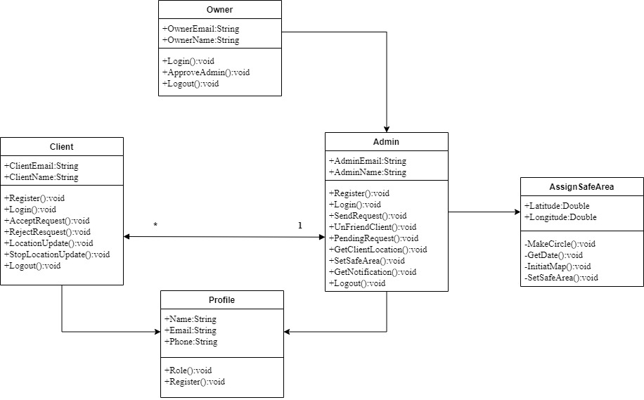

Admin:
Approve by owner to use this app for finding client location and set safe area for them, one admin will have zero or many clients.
Client:
Client will login to the system using internet for this location tracking app the GPS must be on to update the current location of client accurately, one client have zero or many admins.
Owner:
Login to the system using email to approve admin to the app by using approve admin operation
Set safeArea:
Set by admin to make client location safe if client cross that location admin will inform through notification.
Profile:
Admin and client will create profile to use the system in this way the admin will can send friend request to client by using admin name client will identify the admin, for client or admin registration to register to application using name email and phone number.

Activity diagram
Project Title “Locating Friends and family using GPS with Mobile Phones”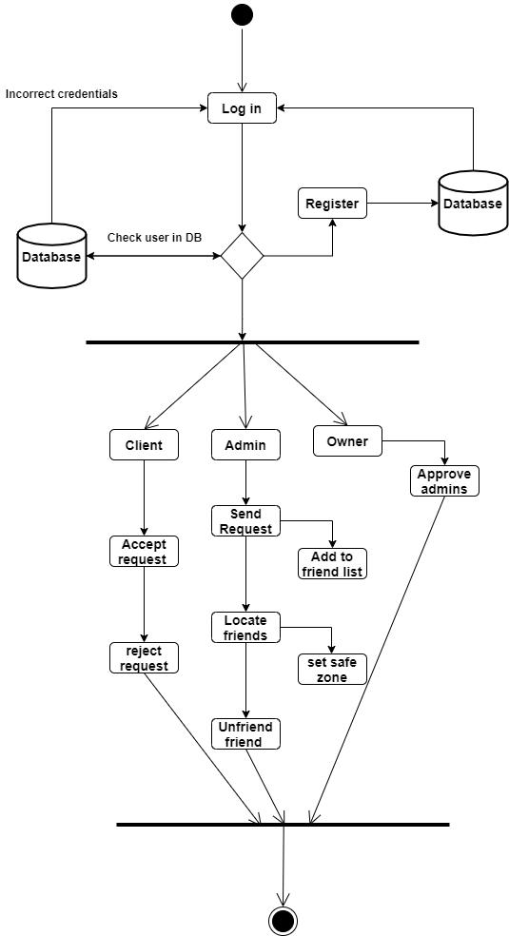

Sequence Diagram
Project Title “Locating Friends and family using GPS with Mobile Phones”