Name : Mudassir Hussain Shah ID : 14652

Semester : 4th Parogramme : BS Dental Technology

Assignment : Dental Morphology II

Q.No. 1 Labeling the Digrame :

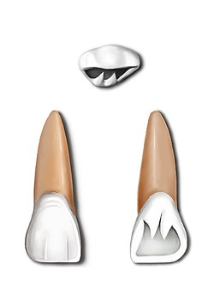
Distal Margin
Cirvical Margin
Mesial Margin
Misial Margin
Distal Margin
Cirvical Margin
LINGUAL ASPECT
Lingual Margin
Labial Margin
Distal Margin
Mesial Margin
INCISAL ASPECT

LABIAL ASPECT

Q.No. 2 Basic Dental Termenologies :

TBC Tip of Buccal Cusp
TLC Tip of Lingual Cusp
BTR Buccal Triangular Ridge
LTR Lingual Triangular Ridge
DBDG Disto Buccal Developmental Groove
DTF Distal Triangular Fossa
MTF Mesial Triangular Fossa
CG Central Groove .

Q.No. 3
The dental anomalies of the permanent teeth are mostly common. The simultaneous occurrence of multiple abnormalities involving groups of teeth or the entire dentition may be genetically determined and can be associated with specific syndromes (1,2). However, most arise sporadically and some, including shape and size , may be affected by environmental factors acting during the morpho differentiation stage of tooth .
The premolar develops for Polo with the exception of the Mindy better the second reminder which develops from follow the official surface of the promoter front face yellow like anterior teeth timing of the T direction can be affected by many factors such as gender environmental factors engineering condition Endeavour from population to population .

