Name. Safi ur rahman Subject. WBCS & Platelets Disorders
ID# 14659 Dep. Allied Health Science Final Examination 26june2020-06-20. 4th semester Instructor .Mem Saima hadi

Final -Term Assignment (spring-20)

Course Title: Wbcs and platelets disorders (MLT 4TH ) Instructor: Saima hadi

Marks: 50

Attempt all questions .Each question carry 10 marks.
Q1. Write a note on Hodgkin lymphoma?
Q2.What is Hemostasis , also explain steps and clotting factors?
Q3.Explain Hemophilia its types, symptoms, and lab diagnosis ?
Q4 .Describe Von Wille Brand disease?
Q5.Explain Hemolytic uremic syndrome and its types?

Answers of the above Questions,
Q1.Answer
Note on,
Hodgkin’s Lymphoma,
<>Lymphoma,
- When lymph node caused cancer ,this condition is known as lymphoma,
Or,
=>Lymphoma is a group of disease, there is malignant lymhocyties, and these are accumulates in the body, so because of this will damage lymph node and spread over all the body.

Lymphoma are two types,
1>Hodgkin’s lymphoma &
2>Non-Hodgkin’s lymphoma

*Hodgkin’s lymphoma,
There is a special type of cells, lymphocytes and there maturation occurred, while those special type of cells are RS cells (read sting birth cells) presents in Hodgkin’s while,
Non-Hodgkin’s lymphoma sign and symptoms are same but ,here is no special cells in non-Hodgkin’s lymphoma.

History,
In 1832 at London hospital, which is guy’s hospital?
There was a doctor his name was Thomas Hodgkin’s so,he discussed at first about Hodgkin’s lymphoma.so,after that
<>In other tow pathologists (kerd sten bark &parotay) ,they said,
>When mutation occurred in lymphocyte and making abnormal cells this is called (H.L).

>Hodgkin lymphoma is a malignant disease,which can affect /damages bone marrow ,spleen,lymphe node and liver.

Stages,
There are four stages, (stage I,Stii,Stiii,stiv & Stv)

Stage I
Here shows one or more than one lymph node will be affected .mostly one lymph node affected.
>This is primary stage and recovering easily.

Stage ii
Two or more than tow lymph nodes are affected, or lymph node is affected only one side of diaphragm.

Stage iii
Shows that the lymph nodes are present above the diaphragm or below the diaphragm are full affected.

Stage IV
Show, here full body will be affected where lymph node is presented, also bone marrow and liver be damage.

Epidemiology/Causes
>Mutation (in b-lymphocytes)
>Epstein bar virus more chances in body due to those infections.

Clinical Features/Sign, Symptoms
*Swelling (painless) may be in neck or feets.
*Fever *Sweetness *Weight losing
*Sever itching (where lymph node presents)
*Increase Sensitivity,
> means the people who’s Hodgkin’s lymphoma ,and they intake alcohol, so , their sign and symptoms increases.

Lab Diagnosis
ESR Test (Erythrocyte sedimentation rate)
>become +ive high, because of swelling .

LDH Enzyme (lactad dehydrogenous enzyme
>will be high

CT Skan
X-Ray > (Spleenomegly)

*Histological Diagnosis
Biopsy
Take sample and examined it, so multiple nucleated cells shown. (RS cells) in biopsy shows like oval eyes.

Q2.Answer
Homeostasis
Hemo-means-blood
Stasis-means-stable
<>It is procedure that prevents blood loss.
>This is the procedure in which the bodies itself arrest/prevents blood loss or bleeding due to any injury or vessel damaged, the procedure known as homeostasis.

Steps in Homeostasis
There are three steps
- Vasocunstructions
>our body vessels perform tow mechanisms. If needs then it dilate/open,
If not required, so blood vessels constructed.
>If a person injured and bleeding, so the vessels prevents blood loss, and blood platelet be releasing.
>And platelet can be releasing special chemicals. Which known as (serotine)
>Those serotine can decrease blood vessels size, because no more bleeding starts.

For example,
At home a child injury and we try to stop his blood with any pieces.

(II) Platelet Plug Formation /Haemostatic plug
>means formation of plug.
>The person body where injured after making a holes in that placed injured due to plug of haemostatic.
>The platelet will release tow type of chemical in blood where injured.
I-Thromboxine
&
Ii-Adenosine diophospate

>Those chemicals help in platelet aggregation, where cells ruptured.
>Also help in vasoconstriction and clots making where injured.

Iii-Coagulation of Blood
We have two types of clots occurred one is primary and the 2nd is secondary clot.

*Primary Clot
>our injured place recovered temporarily,
Upper in injured place a gel type making temporarily.
*Secondary Clot
>in this our inured place recovered completely.
>Fibrin clot making
>here secondary clots performed
>It is a procedure where blood clot making.

Factors
*Fibrinogen
(Making in liver)
*Prothrombin
(Making in liver)
*Thromboplastin/tissue factor
(Making in platelet. Endothelial layer)
*Calcium ion
(Making in bone and GIT tract)
*Labile factor
(Occurred in liver)
*presence not proved
(Still missing)
*Stable factor
(Occurred in liver)
*Anthenophilic
(In blood vessels)
*Christmas
(Discovered by scientists)
*Stuart power factor
(It making in liver)
*plasma thromboplastic or antecedent
(Making in liver)
*Hageman
(In liver formed)
*Fibrin stabilizing
(Formed in liver)

Formula to learn factors easily,
Foolish People Try Climbing Long Sloub After Christmas ,Some people have Foreign.

<>Fibronolysis (Lyses’ of Fibrin)
>It is a mechanism used for the removed of thick mass in skin surface,
_removes holes
>It can defense body from vascular occlusion.
>preventing more fibrin decomposition.
>prevents from clotting.

<>Blood Clot
It is a thick mass as formed and as formed by substances which can stop bleeding.

Q3.Answer
Hemophilia /
Clotting & Coagulation Disorder

>It is disorder in the body difficult, occurred due to environment or congenitally and blood is not clotting .this condition as known as clotting or coagulation disorder.

>This disorder comes from the parents. Or cause with children at the time of birth .this condition called as (congenital clotting disorder)

Hemophilia,
Hem-means-blood
Philia-means-lowing

>It is a common hereditary disorder where clothing factors may reduce or may be does not occurring/producing.
>which clotting factors are number 1 and 9.
>Antihemophilic clotting factors or Christmas clotting factor deficiency.

>Hemophilia is x-linked recessive disorder means one chromosome presented above X-chromosome.
>This condition is common in male because of one x-chromosome and in female there is tow X. chromosome, one is normal and not affected.
Sign and symptoms may include, bleeding as longer time (higher intendancy of bleeding with short injury)

Types of Hemophilia
1. Hemophilia A
2. Hemophilia B

*Hemophilia A
In this type of hemophilia, where deficiency occurring of factor 8.
>It is x-linked recessive disorder

*Hemophilia B
Here occurring deficiency of factor number 9.
>It is also x-linked disorder.

Differences
Hemophilia A | Hemophilia B
>It is classical hemophilia  >Maturation occurred in factor 8 genes.  >Sign & symptoms are the same in both hemophilia A and hemophilia B. | >It is Christmas disease  >Factor 9 gene mutation occurred.  >Sign and symptoms in both types of hemophilia are shows same.

Clinical Features/Sign and Symptoms
*Bruising >on body where hemophilia caused, due to inherited bleeding
*Skin bluish
*Hemoarthrosis
*Muscle bleeding
Even soft tissues
*Swelling
*Bleeding continuous for more time with any injuries.

Lab Diagnosis
Tests
BT/CT
>bleeding time become normal in hemophilia.

CT >Clotting Time
Become high

APTT
(PT-prothombine time)
(Activated partial thrombin time)
PT
>PT mostly diagnosis for extrinsic factors, like ,factor 3,factor 4,factor 7 etc.

APTT>Commonly uses for intrinsic factors like factor 12,factor11,factor 9,factor1o etc.

APTT>value become increase

<>Genetically level
To check genes factors 8 and factor 9.

Q5.Answer
Hemolytic Uremic Syndrome
It continue with 3 words
<> Hemolytic- mean-Destruction in RBCs
<>Uremic –means-due to destruction urea become very high and blood become contaminated.

<>Syndrome,
Curection of sign and symptom disease.

HUS (Hemolytic uremic syndrome)
- It is condition occurred due to with the destruction of abnormal premature red blood cells.
>Once it started, those RBCs can clog in kidneys so, kidneys then stops faltering so because of this condition can cause kidney failure and nitrogenous waste are increases in blood and associating with hemolytic uremic syndrome.

Explanation,
>(HUS) have different causes but it also occurred with a specific E-Coli.
>E-coli can cause diarrhea with bloody commonly in children’s and the symptoms may appearing as 4-14 days.
>In adults causes E-coli infections.
>It also causes bloody diarrhea and caused medications.
>It also occurred some type of infections during pregnancy.

Types of HUS
There are two types in hemolytic uremic syndrome
Which is Typical & Atypical HUSs?

I >Typical Hemolytic Uremic Syndrome
Here with E-coli stain is 0157:H7, so here E-coli can release shiga toxin.
>In typical occurred specific with E-coli and here caused as bloody diarrhea.

Ii- Atypical Hemolytic uremic Syndrome
It is not all caused by E-coli ,it may occurred due to other reasons like, it caused with medications, here caused diarrhea but no bloody .
>with diarrhea.
Q4.Answer

Von-Will brand Disease
- It is an adhesive multiple glycol protein, which presents in our blood.
>Attached with blood vessels and a small granule presented in the blood vessels.
Those granules are weibal palate bodies presenting as in endothelial cells where will brand factors is occurred here.
>A doctor his name was Dr.Erik will brand ,he described this disease ,that it is an hereditary bleeding disorder due to its deficiency .
>It may be acquired or hereditary.
>1st this disease was called as: platelet disorder: but investigation Doctor Erik identified that it is factor with platelet, due to wilbrand difficency,may caused as,
> No addition in platelets,
>no-aggregation of platelets etc.
>Willbrand disease can attached platelets with their self and making clots of platelets.

History & Introduction

*Von-willbrand disease was described by Dr Erik in 1926,
It is composed of 2050 amino acid and glycoprotein .
This disease can be affected as 1 in 100 peoples.
Male and female can be equally affected in this disease.
<>Researchers said that it is the most common genetic disorder.
<>Von-will brand Is an autosomal inheritance disorder.

Physiology
Location
Von-willbrand disease an circulates as in blood plasma.
Synthesis
It can be synthesized as in platelet.
Granules and endothelial cells.

Store,
VWD >can stores as in small granules presented in endothelial cells, which is: weaibal palate bodies:

Cytogenetic Location
VWD> presenting in chromosome 12 p-arm and 13.3 position.
It is also call as coagulation f-iii or coagulation F8vwF.

Clinical Features
*spontaneous bleeding
*Nose bleeding
*Mucosal membrane bleeding (epistoxis)
*Wounds excessive bleeding
*Manuragia in females
*Increase tendency in menses bleeding.
*Symptoms are similar to hemophilia A,
<>GIT bleeding
<>Germs bleeding
<>bleeding in dental extractions
<>Bruising easily etc.

Labe Diagnosis
CBC
- Hemoglobin >normal
- Hematocritic become >normal
- Platelet count>some time normal or sometime low.
- Prothombine Normal
- PT-APTT > high
- BT-CT >increase
- Fibrinogen >normal
- Fviii >decrease.

Lab-Test | Hemophilia A | Hemophilia B | Von wilbrand disease
BiT  APTT  Factor  Viii  Fix  VWF | Normal  Increase  Decrease  Normal  normal | Normal  Increase  Normal  Decrease  normal | Increase  Increase  Normal  decrease  decrease

Functions of Von wilbrand Disease
>It plays major tow roles,
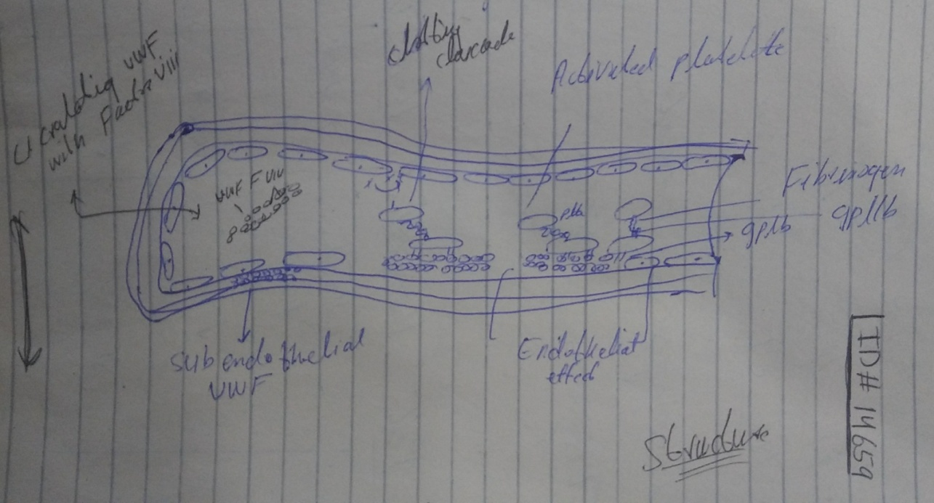
Pathophysiology
/Abnormalities

They are in tow types
Hereditary & Acquired
Types
Type I and type iii is quantitative, while type ii and type iv are qualitative.
They are classified into quantitative and qualitative.
Hereditary is caused when deficiency occurred in von will brand disease.
- In type I deficiency of VWD caused
>mild –moderate disease
>70% of cases.
>Asymptomatic

While,
- Type iii is complete quantitative and deficiency of VWD.
>It is autosomal recessive and less quantitative
>5% of cases
>Homogenous

- Type ii & type iv
>Aoutosomal Dominant
>Deficiency occurred
>Amount normal, but function is difficult.

*Acquired VWD
It is occurred due to autointibodes /infections like,
>Due to any medicine used
>Coagulation abnormalities
The En__________________________________________________d

