Subject: Human Anatomy II
Instructor: Dr. Arooba.
Class: Dental Technology, 2nd semester
Section: B
MidTerm Assignment, Spring 2020. Total marks: 30.

Select the best option.

Name: Abdullah
I.D: 16844

1. A muscle known for tailor master:
A. Iliacus
B. Psoas major
- C. Sartorius
D. Pectineus

2. Which of the quadricep femoris muscles performs extension as well as flexion?
A. Vastus lateralis
B. Vastus medialis
C. Vastus intermedias
- D. Rectus femoris

3. Which of the following muscles crosses two joints?
A. Vastus lateralis
B. Vastus medialis
C. Vastus intermedius
- D. Rectus femoris
4. It is the largest and longest bone of the body:
A. Hip bone
- B. Femur
C. Vertebra
D. Tibia

5. It is the union of three bones:
A. Sternum
B. Femur
- C. Hip bone
D. Tibia
6. The true foot drop occurs because of:
A. Sciatic nerve
- B. Common peroneal nerve
C. Tibial nerve
D. Posterior cutaneous nerve
7. Peripheral hearts are located in:
A. Thorax
B. Abdomen
C. Thigh
- D. Leg
8. Which of the following structure does not take part in the formation of the knee joint?
A. Condyle of tibia
- B. Head of fibula
C. Medial femoral condyle
D. Lateral femoral condyle
9. It is inserted to the quadrate tubercle:
A. Quadriceps femoris
B. Quadratus plantae
- C. Quadratus femoris
D. Rectus femoris
10. How many tarsal bones are there?
A. 12
- B. 14
C. 16
D. 18

Give brief answers to the following questions. Add diagrams/ picture where needed.
Each question carries 5 marks.

- GIVE REASONS:
a) Why hip joint is more stable than shoulder joint?
Answer:
The hip and the shoulder are both ball and socket joints that have cartilage,
Ligament, labrum, and a surrounding capsule. The hip is more inherently stable
than the shoulder. The hip obviously is a weight bearing joint unlike the shoulder which introduce many differences.

b) Why flexor compartment of lower limb is directed posteriorly?
Answer:
The posterior compartment of the leg is one of the facial compartments of the leg and is divided further into deep and superficial compartments. The posterior compartment of the leg contains seven muscle organized into two layer superficial and deeper. The two layers are separated by a band of fascia.

c) Why varicose veins are more common in prolonged standing working persons?
Answer:
Standing for more than four hours per day at work may put professionals such as teacher at risk for varicose veins.
Prolong standing can cause veins to over work and blood may pool in the leg veins increasing pressure in those veins causing the valve to become weak and inefficient leading to varicose veins. Sitting for several house instead of standing is not a solution.
Prolong sitting also Couse blood to pool in the legs which increase vein pressure and may lead to varicose veins.
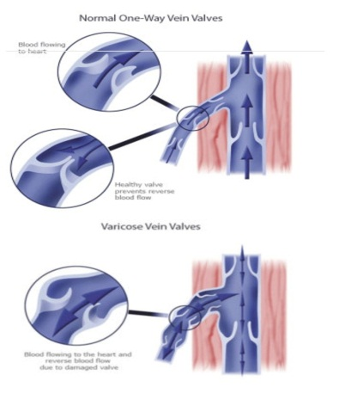

- What do you know about the ligaments of hip joint?
Answer
The hip joint is formed like a ball and socket joint which rotates on more than one axis and is classed as a synovial joint. The ball of the hip joint is comprised of the head of the femur or thigh bone as it is more commonly known whilst the concavity of the socket is created by the acetabulum which is a cap like depression within the pelvic bone.
The main function of the hip joint is to support the body weight in both standing and running or walking. The hips are very important for maintaining balance and damages of the hip may cause impairments in all the function that this joint has that can vary from easy to severe impairment. 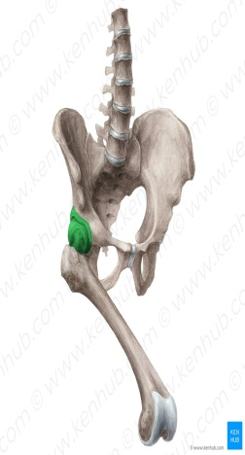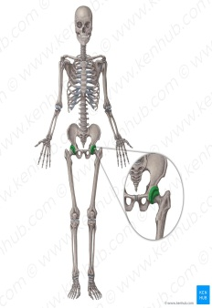

- Write a note on the movements and stability of talocrural joint.
Answer:
The ankle joint (or talocrural joint) is a synovial joint located in the lower limb. It is formed by the bones of the leg (tibia and fibula) and the foot of the (talus).
Functionally it is a hinge type joint permitting dorsiflexion and plantaflexion of the foot.
The main bones of the ankle region are the talus in the foot and the tibia and fibula in the leg. The tolocrural joint is a synovial hinge joint that connects the distal ends of the tibia and of the talus. The articulation between the tibia and the talus bears more weight than that between the smaller fibula and the talus.
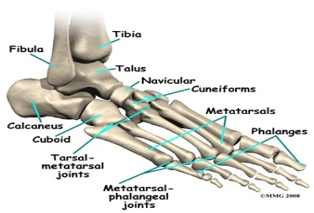Movement of the ankle joint
- Dorsiflexion(toes pointing upward)
It’s performed by the tibial anterior and extensor halluces lunges.
- Planter flexion (toes pointing downward)
It’s performed by the soles planter.

- Write a note on the transverse arch of the foot.
Answer
The transverse arch of the foot is an arch in the coronal plane formed by the three cuneiforms, the cuboid and the bases of the five metatarsals.
There are three arches in the foot, which are referred to as: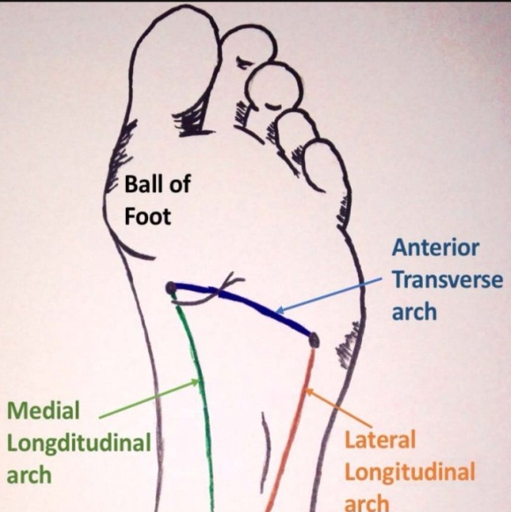

- Medial longitudinal arch
- Lateral longitudinal arch
- Transverse arch

Medial longitudinal arch
The medial longitudinal arch is higher than its lateral counterpart and is visible between the heel of the foot proximally and the medial three metatarsophalangeal joints distally.
The arch consists of two pillars. The anterior pillar consists of the medial three metatarsal heads whilst the tuberosity of the calcaneus forms the posterior pillar.
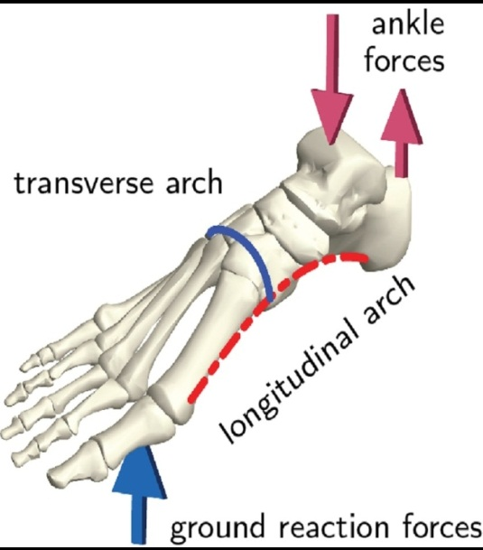

Lateral longitudinal arch
The lateral longitudinal arch is composed by the calcaneum cuboid and lateral 2 metatarsal.
It is characteristically low and just about touches the earth.
It is involved in receving and supporting the body weight during walking and running.

Transverse arch
The transverse arch is located in the coronal plane of the foot. It is formed by the metatarsal bases, the cuboid and the three cuneiform bones.

