IQRA NATIONAL UNIVERSITY
DEPARTMENT OF ALLIED HEALTH SCIENCES
Assignment DPT 2nd Semester Section (A)
Course Title: Anatomy-ll LAB Instructor: Dr attaullah malik
Name Jabran khan. ID 16364

Qno1: Write down a comprehensive note on blood supply and venous return of lower limb?

Ans:. Blood supply of lower limb part A :
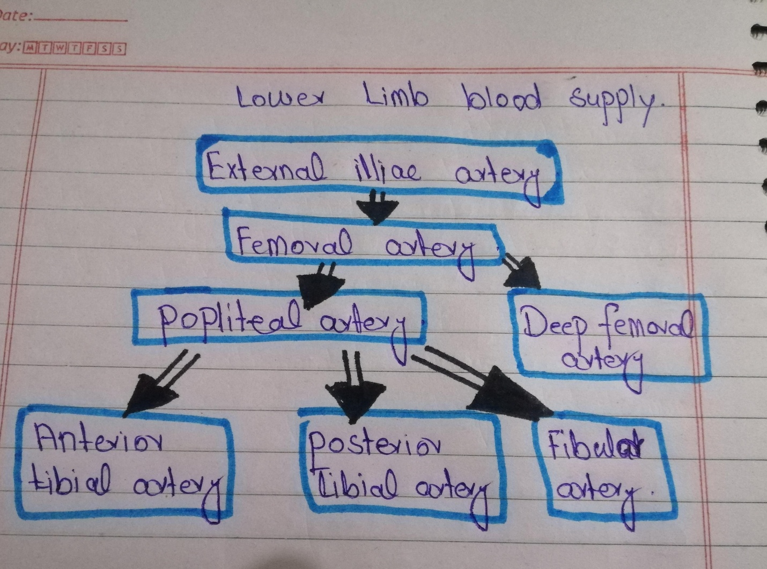
Thigh and Gluteal Region
- In the Thigh and Gluteal Region The main artery is femoral artery. Is a continuation of the external iliac artery (terminal branch of the abdominal aorta).
- The external iliac becomes the femoral artery when it crosses under the inguinal ligament and enters the femoral triangle.
Profunda femoris,
The femoral triangle, the profunda femoris artery arises from the posterolateral aspect of the femoral artery. It travels posteriorly and distally, giving off three main branches:
Perforating branches
Consists of three or four arteries that perforate the adductor magnus, contributing to the supply of the muscles in the medial and posterior thigh.
Lateral femoral circumflex artery
Wraps round the anterior, lateral side of the femur, supplying some of the muscles on the lateral aspect of the thigh.
Medial femoral circumflex artery
Wraps round the posterior side of the femur, supplying its neck and head. In a fracture of the femoral neck this artery can easily be damaged, and avascular necrosis of the femur head can occur.

Diagram of the arterial supply of femoral artery
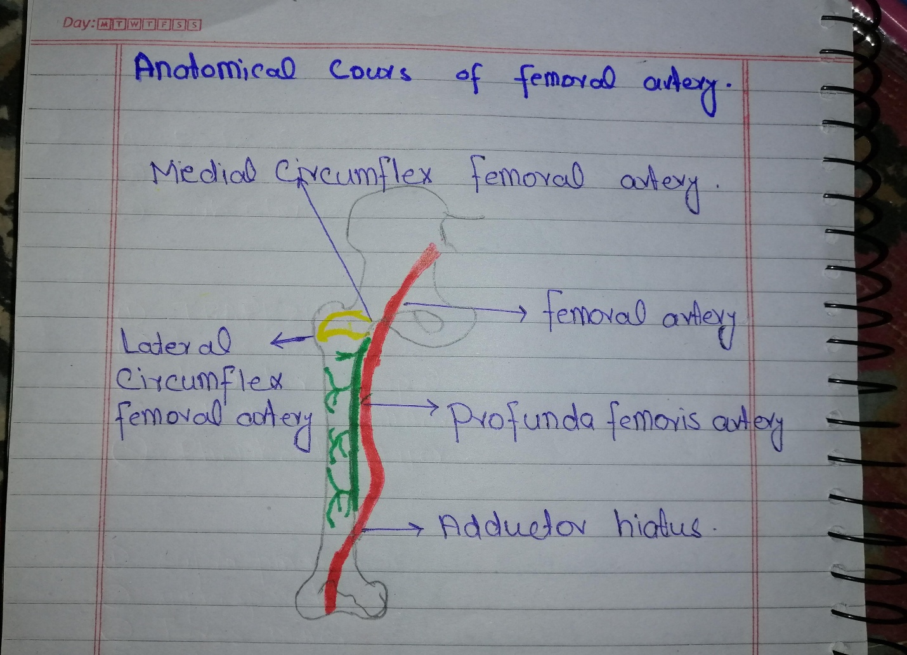
After exiting the femoral triangle, the femoral artery continues down the anterior surface of the thigh, via a tunnel known as the adductor canal. During its descent the artery supplies the anterior thigh muscles.
The adductor canal ends at an opening in the adductor magnus, called the adductor hiatus. The femoral artery moves through this opening, and enters the posterior compartment of the thigh, proximal to the knee. The femoral artery is now known as the popliteal artery.

Other Arteries of the Thigh
In addition to the femoral artery, there are other vessels supplying the lower limb.
Obturator artery
The obturator artery arises from the internal iliac artery in the pelvic region. It descends via the obturator canal to enter the medial thigh, bifurcating into two branches:

Anterior branch – This supplies the pectineus, obturator externus, adductor muscles and gracilis.
Posterior branch – This supplies some of the deep gluteal muscles.
The gluteal region is largely supplied by the superior and inferior gluteal arteries. These arteries also arise from the internal iliac artery, entering the gluteal region via the greater sciatic foramen.

The superior gluteal artery leaves the foramen above the piriformis muscle, the inferior below the muscle. In addition to the gluteal muscles, the inferior gluteal artery also contributes towards the vasculature of the posterior thigh.

Diagram of arterial supply posterior thigh of Gluteal region
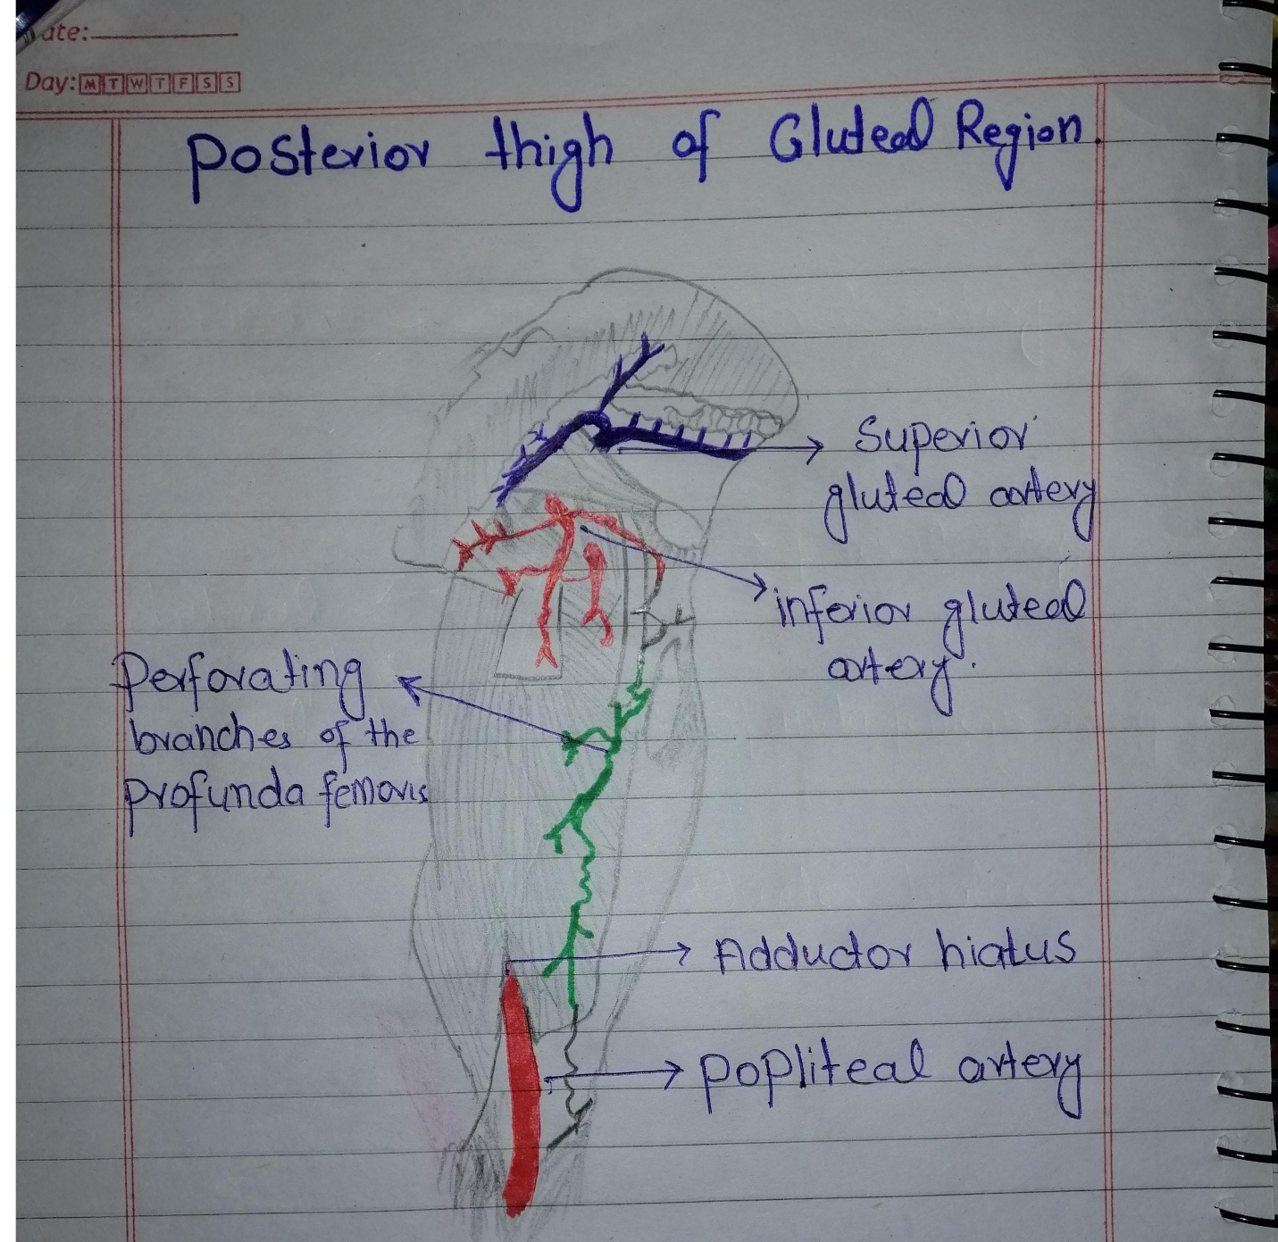

In the Leg
The popliteal artery descends down the posterior thigh, giving rise to genicular branches that supply the knee joint. It moves through the popliteal fossa, exiting between the gastrocnemius and popliteus muscles.

At the lower border of the popliteus, the popliteal artery terminates by dividing into the anterior tibial artery and the tibioperoneal trunk. In turn, the tibioperoneal trunk bifurcates into the posterior tibial and fibular arteries:

Posterior tibial artery
continues inferiorly, along the surface of the deep posterior leg muscles (such as tibialis posterior). It enters the sole of the foot via the tarsal tunnel, accompanying the tibial nerve.

Fibular (peroneal) artery
descends posteriorly to the fibula, within the posterior compartment of the leg. It gives rise to perforating branches, which penetrate the intermuscular septum to supply muscles in the lateral compartment of the leg.
The other division of the popliteal artery, the anterior tibial artery, passes anteriorly between the tibia and fibula, through a gap in the interosseous membrane. It then moves inferiorly down the leg. It runs down the entire length of the leg, and into the foot, where it becomes the dorsalis pedis artery.

Diagram in the leg
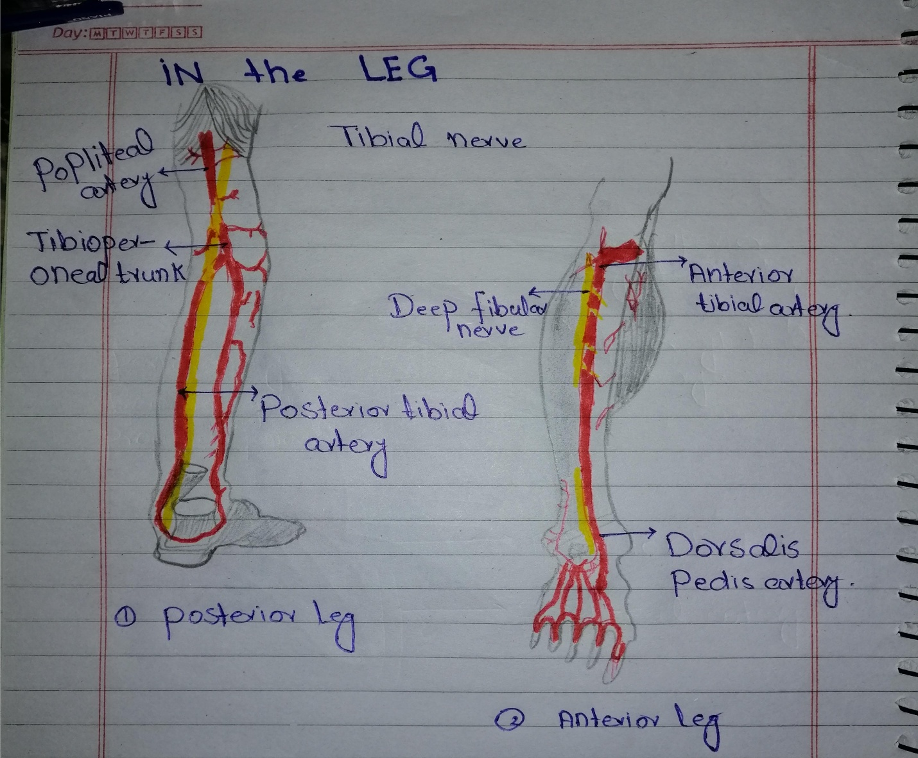
In the Foot
Arterial supply to the foot is delivered via two arteries:

Dorsalis pedis (a continuation of the anterior tibial artery)
Posterior tibial
The dorsalis pedis artery begins as the anterior tibial artery enters the foot. It passes over the dorsal aspect of the tarsal bones, then moves inferiorly, towards the sole of the foot. It then anastomoses with the lateral plantar artery to form the deep plantar arch. The dorsalis pedis artery supplies the tarsal bones and the dorsal aspect of the metatarsals. Via the deep plantar arch, it also contributes to the supply of the toes.

The posterior tibial artery enters the sole of the foot through the tarsal tunnel. It then splits into the lateral and medial plantar arteries. These arteries supply the plantar side of the foot, and contributes to the supply of the toes via the deep plantar arch
Answer 1st part B
Venous return of lower limb
The veins of the lower limb drain deoxygenated blood and return it to the heart.
two groups
- Deep veins are located underneath the deep fascia of the lower limb, accompanying the major arteries. The deep veins accompany and share the name of the major arteries in the lower limb. Often, the artery and vein are located within the same vascular sheath – so that the arterial pulsations aid the venous return.
- Superficial veins are found in the subcutaneous tissue. They eventually drain into the deep veins. . There are two major superficial veins – the great saphenous vein, and the small saphenous vein.
The Great Saphenous Vein
The great saphenous vein is formed by the dorsal venous arch of the foot, and the dorsal vein of the great toe. It ascends up the medial side of the leg, passing anteriorly to the medial malleolus at the ankle, and posteriorly to the medial condyle at the knee.

The Small Saphenous Vein

The small saphenous vein is formed by the dorsal venous arch of the foot, and the dorsal vein of the little toe. It moves up the posterior side of the leg, passing posteriorly to the lateral malleolus, along the lateral border of the calcaneal tendon. It moves between the two heads of the gastrocnemius muscle and empties into the popliteal vein in the popliteal fossa.

Diagram of venous return
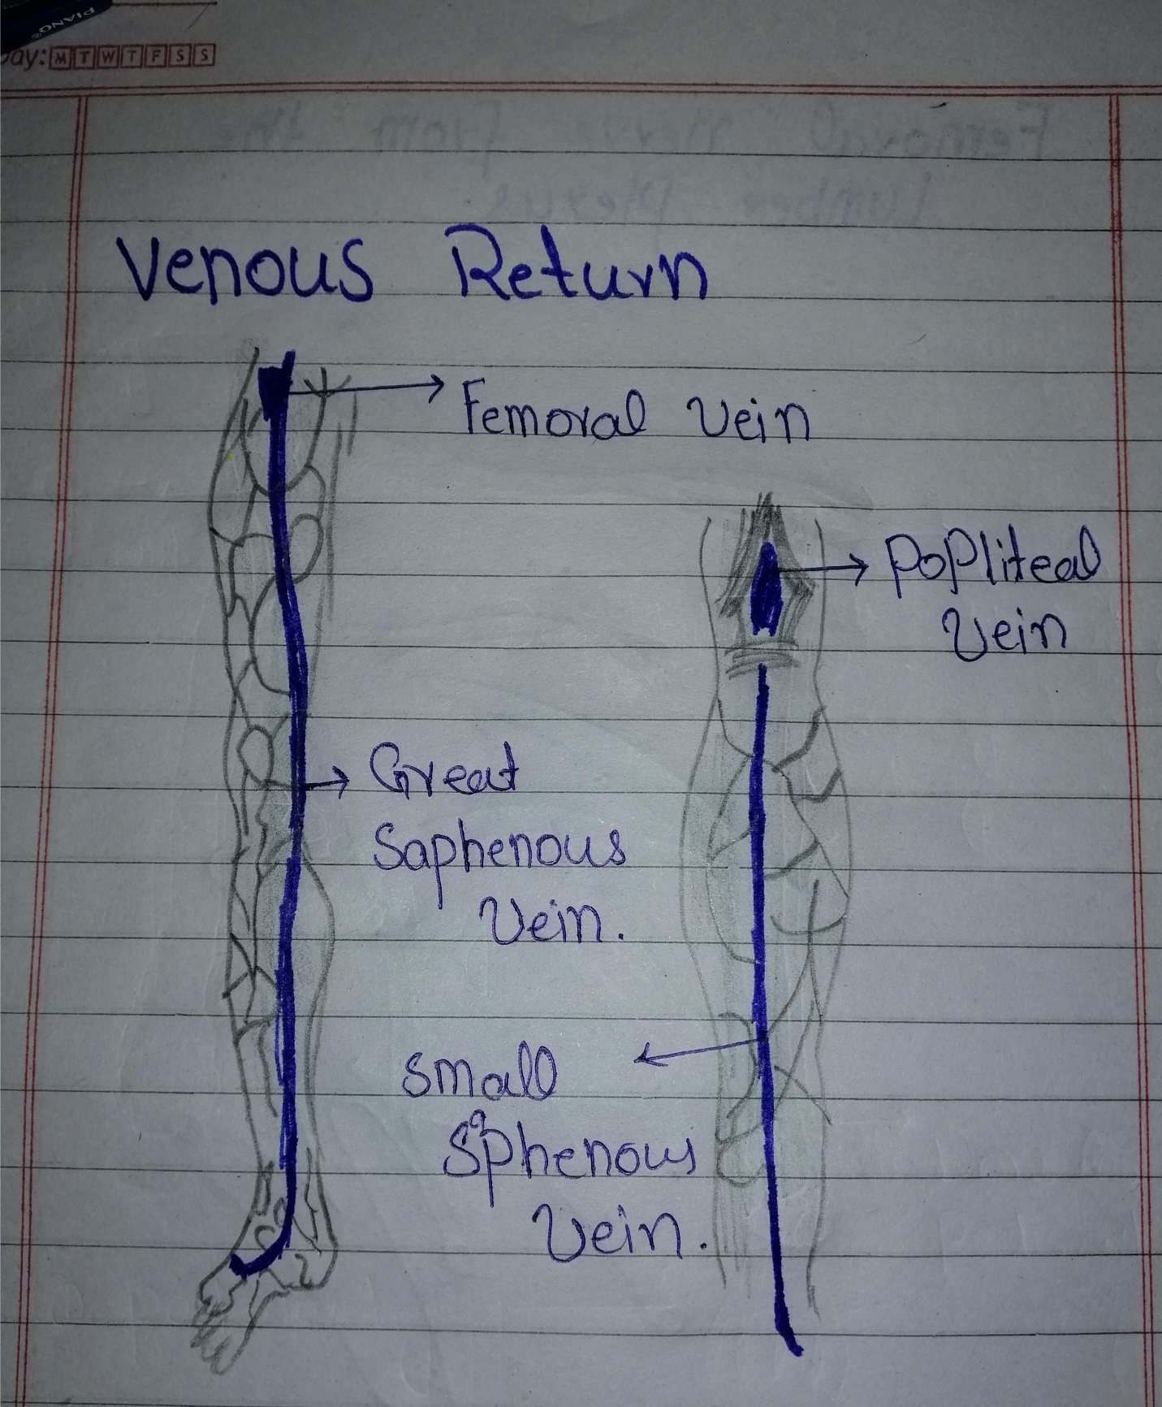
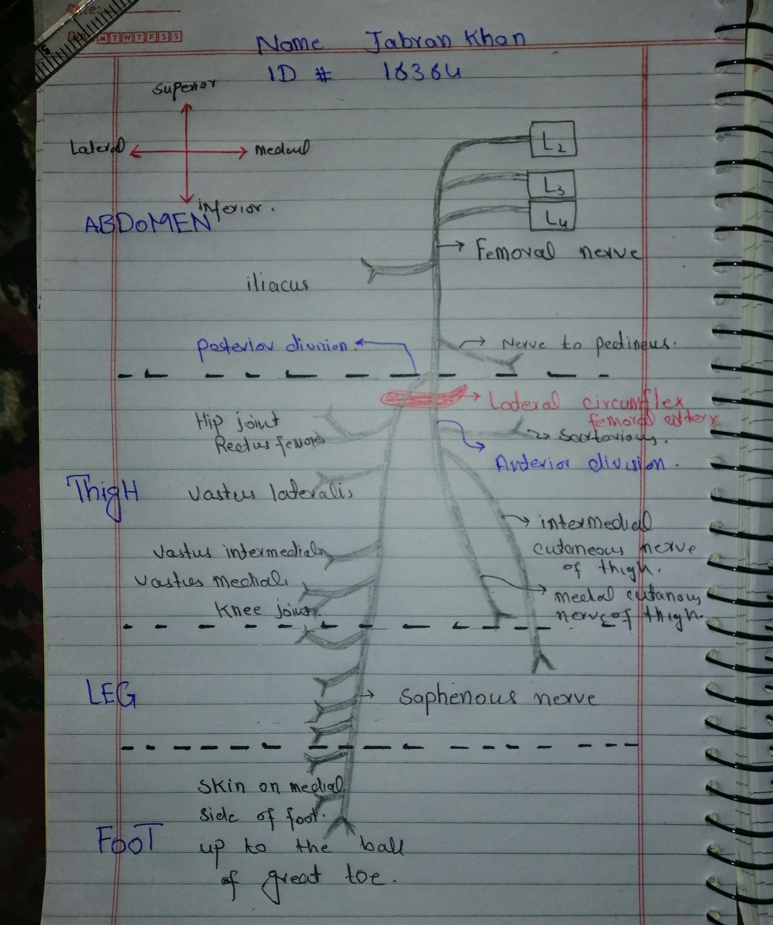
Qno2: Describe anatomical course of femoral and sciatic never with the help of diagrams?

Answer.2
Diagram of all nerve supply

Femoral nerve:
The femoral nerve is one of the major peripheral nerves of the lower limb.

Anatomical Course
The femoral nerve is the largest branch of the lumbar plexus. It is derived from the anterior rami of nerve roots L2, L3 and L4.

After arising from the lumbar plexus, the femoral nerve travels inferiorly through the psoas major muscle of the posterior abdominal wall. It supplies branches to the iliacus and pectineus muscles prior to entering the thigh.

The femoral nerve then passes underneath the inguinal ligament to enter the femoral triangle. Within this triangle, the nerve is located lateral to the femoral vessels (unlike the nerve, the femoral artery and vein are enclosed within the femoral sheath).
Approximately 4cm below the inguinal ligament,

The femoral nerve divides into anterior and posterior divisions:

Anterior division of femoral nerve | Posterior divisions of femoral nerve
- Anterior cutaneous branches | - Saphenous nerve
- Branches to sartorius | - Branches to quadriceps femoris
- Branches to pectineus

The terminal cutaneous branch of the femoral nerve is the saphenous nerve. It travels through the adductor canal (accompanied by the femoral artery and vein) and exits prior to the adductor hiatus. The saphenous nerve innervates the medial aspect of the leg and the foot.

Diagram of femoral nerve from the lumbar plexus

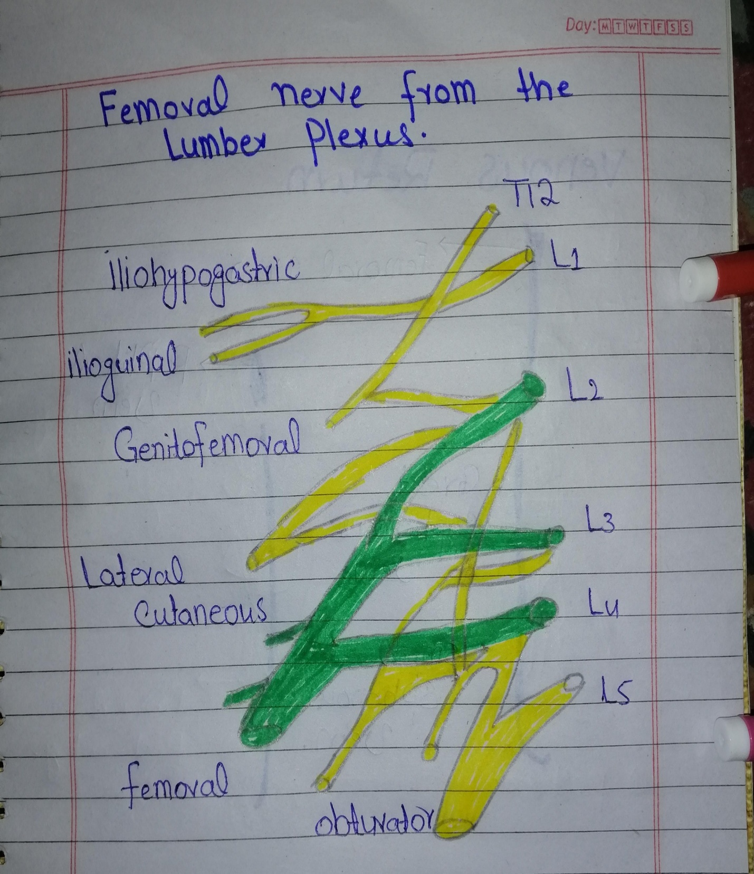

Motor Functions
The femoral nerve supplies the muscles of the anterior thigh:

Diagram femoral nerve and two cutaneous branches
- Anterior cutaneous branches
- Saphenous nerve
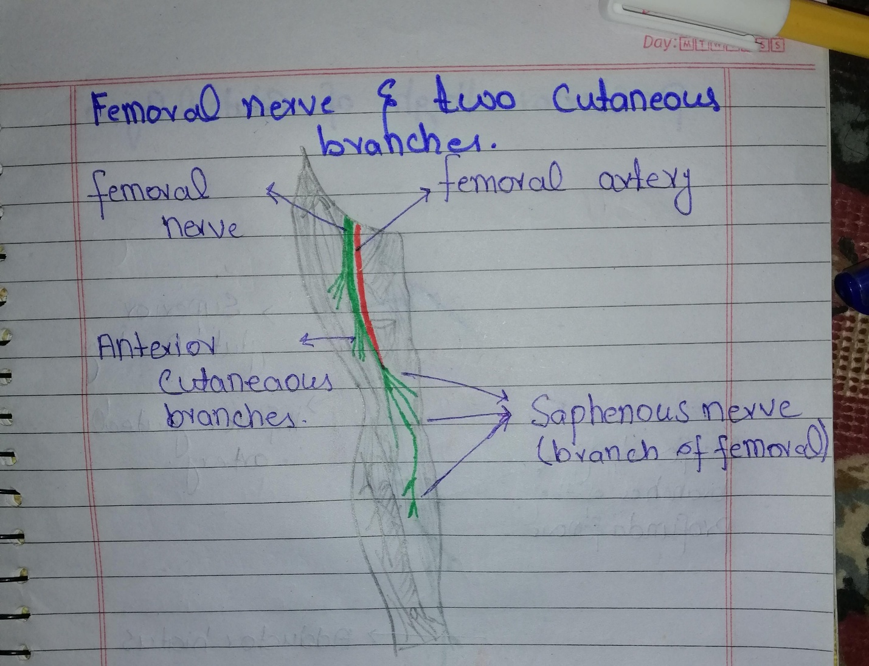
Hip flexors:
Pectineus – adducts and flexes the thigh, assists with medial rotation of the thigh.
Iliacus – acts with psoas major and psoas minor (forming iliopsoas) to flex the thigh at the hip joint and stabilise the hip joint.
Sartorius – flexes, abducts and laterally rotates the thigh at the hip joint. Flexes the leg at the knee joint.
Knee extensors:
Quadriceps femoris (rectus femoris, vastus lateralis, vastus medialis and vastus intermedius) – extends the leg at the knee joint. Rectus femoris also steadies the hip joint and assists iliopsoas in flexing the thigh.
Sensory Functions
There are two main sensory branches that arise from the femoral nerve:

Anterior cutaneous branches
derived from the anterior division of the femoral nerve. They supply the skin of the anteromedial thigh.
Saphenous nerve
a continuation of the posterior division of the femoral nerve. It supplies the skin of the medial leg and foot.

Answer no 2 part B
Sciatic nerve
Diagram derivations of the sciatic nerve from the sacral plexus
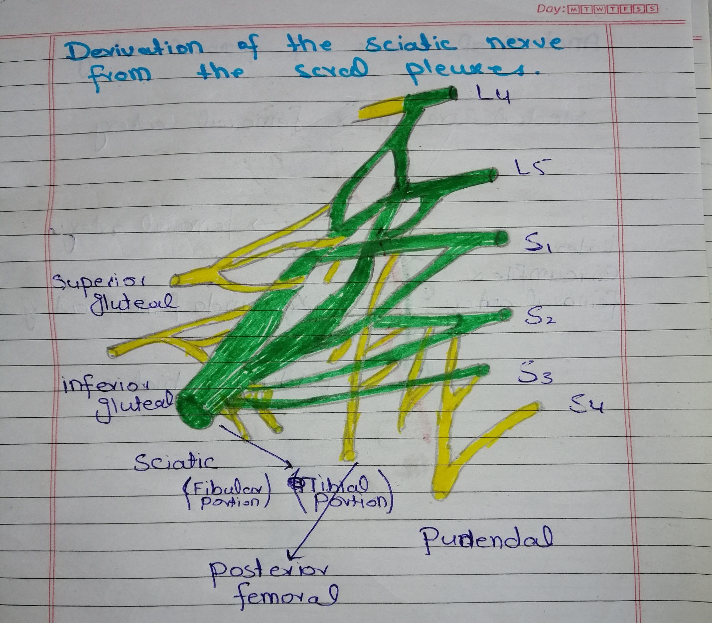
The sciatic nerve is a major nerve of the lower limb. It is a thick flat band, approximately 2cm wide – the largest nerve in the body.
Anatomical Course
The sciatic nerve is derived from the lumbosacral plexus. After its formation, it leaves the pelvis and enters the gluteal region via greater sciatic foramen. It emerges inferiorly to the piriformis muscle and descends in an inferolateral direction.

As the nerve moves through the gluteal region, it crosses the posterior surface of the superior gemellus, obturator internus, inferior gemellus and quadratus femoris muscles. It then enters the posterior thigh by passing deep to the long head of the biceps femoris.

Within the posterior thigh, the nerve gives rise to branches to the hamstring muscles and adductor magnus. When the sciatic nerve reaches the apex of the popliteal fossa, it terminates by bifurcating into the tibial and common fibular nerves.

Note: the sciatic nerve can be described as two individual nerves bundled together in the same connective tissue sheath – the tibial and common fibular nerves. These usually separate at the apex of the popliteal fossa, however in approximately 12% of people they separate as they leave the pelvis.

Motor Functions
Although the sciatic nerve passes through the gluteal region, it does not innervate any muscles there. However, the sciatic nerve does directly innervate the muscles in the posterior compartment of the thigh, and the hamstring portion of the adductor magnus.
The sciatic nerve also indirectly innervates several other muscles, via its two terminal branches:
Tibial nerve – the muscles of the posterior leg (calf muscles), and some of the intrinsic muscles of the foot.
Common fibular nerve – the muscles of the anterior leg, lateral leg, and the remaining intrinsic foot muscles.
In total, the sciatic nerve innervates the muscles of the posterior thigh, entire leg and entire foot.
Sensory Functions
The sciatic nerve does not have any direct cutaneous functions. It does provide indirect sensory innervation via its terminal branches:

Tibial nerve – supplies the skin of the posterolateral leg, lateral foot and the sole of the foot.
Common fibular nerve – supplies the skin of the lateral leg and the dorsum of the foot.
Diagram
