DEPARTMENT OF ALLIED HEALTH SCIENCES

NAME: USAMA SIRAJ:

ID NO: 14991:

INSTRUCTER NAME: DR SALMA ISHAQ

PROGRAM: BS DT:

SEMESTER: 4^{th:}

Course Title: Histology ll

Q1: Distinguish the fibrous capsule and articular disc?

Answer no 1:

The fibrous capsule and articular disc are present in temporal mandibular joint.

Temporo mandibular joint:
- It is a ginglymoarthrodial joint.
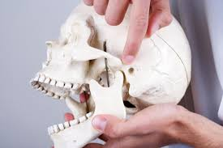
- A term that is derived from ginglymus , means a hinge joint
- and an arthrodial means sliding joint which
- Allows motion backward and forward.
- Type of mobile joint.
- Formed between head of mandible and articular fossa of temporal bone.
- Articulation is between mandible and temporal bone

Structure of TMJ:
- Ligament
- Fibrous capsule.
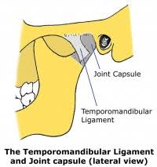
- Articular dise.

The fibrous capsule and articular disc

Fibrous capsule:
- Attached above the articular tubercle.
- Circumference of the mandibular fossa in front
- And behind the squmotypanic fissure
- And below the neck of the mandibular.
- Capsule is of loose Varity above the intra-articular disc,
- Tight below the intra-articular disc.
- Synovial membrane lines the fibrous capsule and the neck of mandible.

Articular disc:
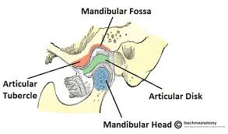
- Oval predominately a fibrous palate.
- Divid the joint into upper and lower component.
- Upper component permits gliding movement.
- Lower compartment permits rotatory as well as gliding movement.
- Disc is a superior concave, convex superior surface.
- As well as a concave inferior surface.
- Periphery of the disc is attached to the fibrous capsule.

Function of articular disc:
- Reduce wear of TMJ
- Stabilize the TMJ
- Aid lubrication of the joint.
- Make articular surface congrument.

Synovial fluid:
- Synovial fluid serves 2 purposes.
- Medium for providing metabolic requirements.
- To the man vasculerarticuler surface of the joint.
- Lubricant between articular surfaces during function.
- Two mechanisms by which synovial fluid lubricants.
- (1) boundary lubrication
- (2) Weeping lubrication.
(1) Boundary lubrication: the boundary lubrication occurs when joint is moved and synovial fluid is forced from one area of cavity into another.
(2) Weeping lubrication: refers to the ability of articular surface to absorb a small amount of synovial fluid.

Q2: Write a short note on the clinical consideration of salivary glands.

Answer no 2

Clinical consideration of salivary gland:
- Careful examination of a patient’s medical history and profile
- Can lend clues to dysfunction of the salivary glands
- they are often associated with other systemic disorders
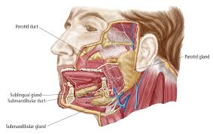
- Such as hormonal imbalances, diabetes mellitus, arteriosclerosis, and neurological disorders.
- Tumors
- Carries
- Periodontal disease.
- Viral and bacterial infection.
- Cystic fibrosis.
Radiation caries:
- Tooth decay that results from radiation-induced dry mouth (xerostomia).
- increased incidence of tooth decay in post radiation patients
- Caused by radiation to the major salivary glands.
- Occur in individuals who receive a course of radiotherapy.
- Include exposure of salivary glands.
Sjogren’s syndrome:
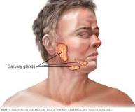
- Consists of keratoconjunctivitis (inflammation of cornea and conjunctiva)
- Xerostomia (dry mouth)
- Rheumatoid arthritis (inflammation of joint).
- And also cause of the disease can be genetic, auto immunological,
Features
- Include dry mouth and dry eyes due to hypo function of lacrimal and salivary glands.
- Most patients are treated symptomatically.
- Ocular lubricants and salivary substitutes are given.
Xerostomia (dry mouth):
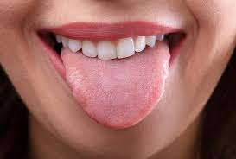
- Subjective complaint of dry mouth.
- Result from a decrease in the production of saliva.
- Not a disease but a symptom caused by many factors.

Other consideration
- Viral inflammation of the gland causes it to swell
- Resulting pain on movement of the jaw.
- Abscesses or cysts of the gland.
- Result in pressure to the facial nerve.
- Calculi in the duct can block.
- Causes painful swelling of the gland.
- Aplasia, Atresia, stafnnes cyst, Fordyce's granules
- Local/systemic disease, endocrine
- Autoimmune, infectious etc.
Parotid gland:
- Fibrous fascia is covering the parotid; its inflammatory swelling is tense and hard.
- Parotid duct is slightly larger along their course than at their caruncle.
- Permits storage of secretions so that a ready flow may be available on stimulation without waiting for secretary process.
- This relatively static reservoir may form obstructions
- Ready nisus for bacterial activity.
- Close association of the facial nerve with the gland
- Very important consideration, during surgical procedures.
Submandibular gland
- submandibular gland and duct system lies in a dependent position
- This predisposes it to retrograde invasion by oral flora.
- Similar to the parotid duct, the Wharton's duct is also wider before reaching the papilla.
- This can lead to sangulation of saliva and organic matter.
Sublingual gland
- Minor salivary glands have short ducts.
- Chances of stasis are less.
- Obstructive lesions do not occur in the glands.
- Minor salivary glands are placed superficially.
- Traumatic lesions such as mucoceles commonly affect these glands.

Q3: Describe the factors that play a role in shading?

Answer no 3

Factors that play a role in shading:
There are two types of factor that involves in tooth shading.

Local factors:

Genetic factors:

1) Local factors:
- In local factor that occur due to two Mechanicham.
1) Pressure:
  - From erupting successional tooth plays as in important role in shedding.
2) Growth;
  - Due to the growth of the jaws and ligament of masticatory muscle probably increase the force applied over the deciduous teeth.

Genetic factors:
In this factor apoptosis occurs:
  - In apoptosis the periodontal ligament fibers the initiation of root resorption is inherent developmental process.
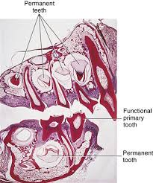
- Permanent incisors, canines, and premolars develop,
- Increase in size, and begin to erupt,
- They influence the pattern of resorption of the deciduous teeth and their exfoliation (shedding).

Histology of shedding:
- Resorption of the hard tissue odontocalst.
- Resorption of the soft tissue pulp.

Pattern of Shedding
- Pattern of exfoliation is symmetrical for the right and left sides of the mouth.
- Except for second molars,
- The mandibular primary teeth are shed before their maxillary counterparts.
- Exfoliation of all four secondary primary molars is practically simultaneous.
- Exfoliation occurs in girls before it does in boys.
- Greatest discrepancy between the sexes is observed for the mandibular canines.
- sequence of shedding in the mandible follows the anterior-to-posterior order.
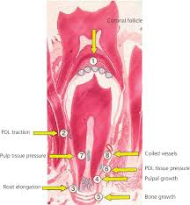
- Maxilla the first molar exfoliating before the canine disrupts this sequence. permanent incisors, canines, and premolars develop,
- increase in size, and begin to erupt,
- They influence the pattern of resorption of the deciduous teeth and their exfoliation (shedding).

Q4: Explain the classification of tooth movement?

Answer no 4:

Classification of tooth movement

Tooth movement:
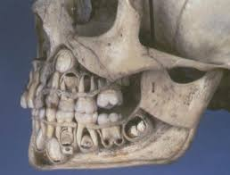
- Term tooth movement refers to.
- Slight tipping of the tooth in its socket.
- And change in tooth position.
- That’s occur during and eruption.

Classification of tooth movement:
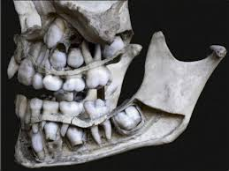
1) Physiologic tooth movement.
- Eruption.
- Drifting.
2) Pathologic tooth movement.
A) Periodontal pathology.
B) Oral pathologies (cysts, tumors etc.)
3) Orthodontic tooth movement:
A) Tooth movement under external clinical force.

Physiologic tooth movement:
- Naturally occurring tooth movement.
- Take place during and after tooth eruption.
In this tooth movement also include:
- Tooth eruption
- Migration or drift of teeth.

2) Pathologic tooth movement.
A) Periodontal pathology.
- gum diseases or periodontal diseases,
- are diseases involving the periodontium (the tooth supporting structures)
B) Oral pathologies (cysts, tumors)
- Cysts form because of infection coming from a tooth which is broken or bad.

3) Orthodontic tooth movement:
- Orthodontic tooth movement causes local hypoxia and fluid flow.
- Pathological process from which the tissue recovers.

Q5: Enlist the function and component of TMJ.

Answer no 5:

Function and component of TMJ.

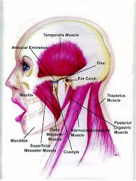
Temporal mandibular joint:
- a term that is derived from ginglymus , means a hinge joint
- and an arthrodial means sliding joint which
- Allows motion backward and forward.
- Type of mobile joint.
- Formed between head of mandible and articular fossa of temporal bone.
- Articulation is between mandible and temporal bone

Function of TMJ:
- Excessive retraction.
- Moving backward of mandible.
- Help in breathing
- eating
- speech
- close of mouth
- mastication

Component of temporomandibuler joint:

Fibrous capsule:
- Attached above the articular tubercle.
- Circumference of the mandibular fossa in front
- And behind the squmotypanic fissure
- And below the neck of the mandibular.
- Capsule is of loose Varity above the intra-articular disc,
- Tight below the intra-articular disc.
- Synovial membrane lines the fibrous capsule and the neck of mandible.

Articular disc:
- Oval predominately a fibrous palate.
- David the joint into upper and lower component.
- Upper component permits gliding movement.
- Lower compartment permits rotatory as well as gliding movement.
- Disc is a superior concave, convex superior surface.
- As well as a concave inferior surface.
- Periphery of the disc is attached to the fibrous capsule.

Ligaments:
- Lateral temporomandibuler ligament:
- Thickened lateral portion of capsule.
- Two parts (1) outer oblique portion.
- (2) Inner horizontal portion.
- Base is attached to zymogenic process of temporal bone.
- And above the articular tubercle.
- Apex is attached to the lateral side of the neck of mandible.
- Sphenomendibuler ligament:
- Accessory ligament.
- Lies on a deep plane away from the fibrous capsule.
- Attached superiorly to the spine of sphenoid bone.
- Inferiorly to the lingual of mandibular foramen.

Relation (lateral):
- Lateral pterygoid muscle.
- Auriculotemporal nerve
- Maxillary artery.

Medial:
- Chordia tympani nerve
- Wall of the pharynx.
- Stylomandibuler ligament:
- Represents a thickened part of the deep cervical fascia.
- Which separate the parotid and submandibular glands?
- Attached to the lateral surface above of styloid process.
- And below to the angle and post border of ramus of mandible.

Synovial fluid:
- Synovial fluid serves 2 purposes.
- Medium for providing metabolic requirements.
- To the man vasculerarticuler surface of the joint.
- Lubricant between articular surfaces during function.
- Two mechanisms by which synovial fluid lubricants.
(1) Boundary lubrication
(2) Weeping lubrication.
(1) Boundary lubrication: the boundary lubrication occurs when joint is moved and synovial fluid is forced from one area of cavity into another.
(2) Weeping lubrication: refers to the ability of articular surface to absorb a small amount of synovial fluid.

Blood supply and innervation:

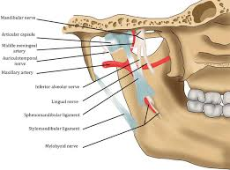
Atrial supply:
- Lateral superficial temporal artery.
- Medially maxillary artery.

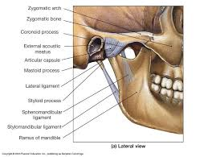
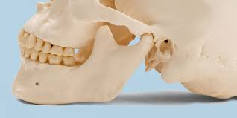
Nerve supply: Massetric and Auriculotemporal nerve.

