Department of Electrical Engineering
Assignment
Date: 20/04/2020
Course Details

Course Title: | Basic Mechanical Technology | Module: | 2nd
Instructor: | Muhammad Khalil Khan | Total Marks: | 30

Student Details
Name: | Muhammad Uzair | Student ID: | 16739

Question no1: (a) A body of mass 1 kg undergoes a change of velocity of 4m/s, what is the force acting on it?
Answer: Explanation:
m= 1kg
Change in velocity = 4ms-1
Time =4s
Then the formula of acceleration is
a = change in velocity / time
a = 4/4
= 1 ms-2
As we know that the force is
From F= ma
F= 1*1
F=1N

(b) A force of 1200 N acts on the surface of area 10 cm2 normally. What would be the thrust and pressure on the surface?

Answer:
Given,
Force(F) = 1200 N
Area (A) = 10 cm² = 0.001 m²
We know,
Thrust is the force acting normally to a surface.
So, Thrust = 1200 N
And, Pressure = Thrust
= 1200 / 0.001
= 1200000
= 1.2 × 10⁶ Pa

Question no2: (a) Define Equilibrium and its conditions.

Answer: Equilibrium
Equilibrium is the state in which market supply and demand balance each other, and as a result, prices become stable. Generally, an over-supply of goods or services causes prices to go down, which results in higher demand. The balancing effect of supply and demand results in a state of equilibrium.

Conditions for Equilibrium
An object is in equilibrium if ;
- The resultant force acting on the object is zero.
- The sum of the moments acting on an object must be zero.

Triangle of forces
When an object is in equilibrium the forces acting on it will form a closed triangle.
Example 1) A point (P) upon which all the forces are in equilibrium.
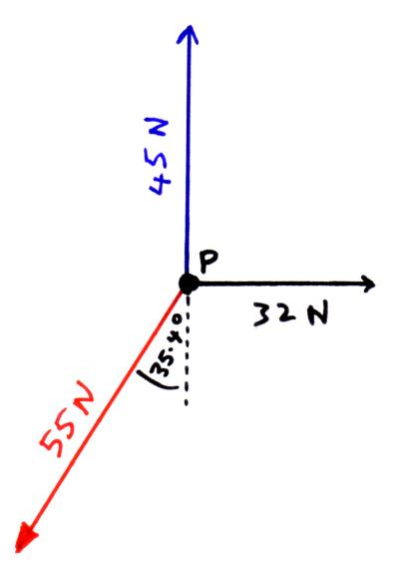
We take the three forces above and keeping the size and direction the same redraw them placing them head to tail with each other. If the forces are in equilibrium the head of the last forces will meet the tail of the first forming a closed triangle, see the example below.
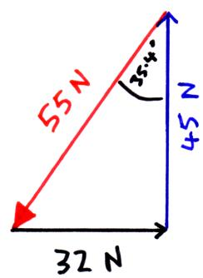
Example 2) A point (P) upon which the forces are not in equilibrium.
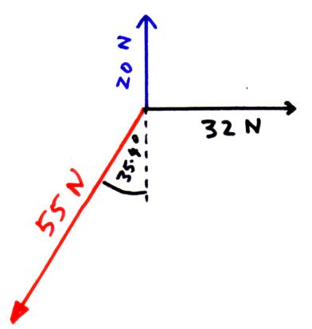
When the forces above are laid head to tail the head of the last force does not meet back at the tail of the first and so these forces are not in equilibrium. See below.
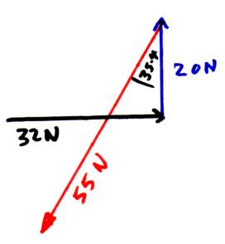

These problems can also be solved by resolving any forces acting at an angle into their horizontal and vertical components. Once you have done this if the forces are in equilibrium then the sum of all the horizontal forces must equal zero and the sum of all the vertical forces must also equal

(b) Differentiate between stable and unstable Equilibrium and give proper examples you will Observe in daily life.

ANSWER: Let's first understand what is equilibrium. Equilibrium is a state where resultant of all forces acting on a body is zero. Thus, first derivative of potential energy with respect to displacement is zero.

Next comes the three states of equilibrium, stable, unstable and neutral.
Stable equilibrium mathematically can be said as the second derivative of potential energy is greater than zero. This won't make much sense of course. Imagine a small ball at the bottom of a hemispherical bowl. If you displace it, it would come back to its original position. This is what is an example of stable equilibrium.

Unstable equilibrium is defined as the second derivative of potential energy is lesser than zero. Imagine the same ball at the top of a hill. If you displace it, it rolls down and doesn't come back to its original position. This is an example of unstable equilibrium.

Neutral equilibrium is the state where second derivative of potential energy is zero. Example: if the same ball is moving with uniform velocity on a straight road.

Example: A system is in unstable equilibrium if, when displaced, it experiences a net force or torque in the same direction as the displacement from equilibrium. A system in unstable equilibrium accelerates away from its equilibrium position if displaced even slightly. An obvious example is a ball resting on top of a hill.

QUESTION NO3: (a) Define the following terms and give daily life example.
• Force
• Gravity force
• Friction force
• Spring force
• Tension force

ANSWER: • Force
A force is a push or pull upon an object resulting from the object's interaction with another object. Whenever there is an interaction between two objects, there is a force upon each of the objects. When the interaction ceases, the two objects no longer experience the force.
• Gravity force
Gravity is a force of attraction that exists between any two masses, any two bodies, any two particles. Gravity is not just the attraction between objects and the Earth. It is an attraction that exists between all objects, everywhere in the universe.
• Friction force
Friction is a force that opposes relative motion between systems in contact. One of the simpler characteristics of friction is that it is parallel to the contact surface between systems and always in a direction that opposes motion or attempted motion of the systems relative to each other.
• Spring force
The spring force is the force exerted by a compressed or stretched spring upon any object that is attached to it. An object that compresses or stretches a spring is always acted upon by a force that restores the object to its rest or equilibrium position.
• Tension force
The tension force is defined as the force that is transmitted through a rope, string or wire when pulled by forces acting from opposite sides. The tension force is directed over the length of the wire and pulls energy equally on the bodies at the ends.

