NAME. YASIR ORAKZAI
ID. 15994
Department. DT

QUESTION ANSWER.
QUESTION no.1

Write the functions and composition of blood?
ANSWERED.

Blood.
- Blood is a combination Of plasma that circulator through the entire body. It is a specialised body fluid that Supply essential substance through the body Such is sugar hormone oxygen it also remove the waste substance in the body.
- Composition of blood.
- 1. Platelet.
- Liquid part of blood.
- Pale yellow made of.
- 92./. waters.
- Mineral ions.
- co2.
- Protein.
- Glucose and nutrients.
- Plasma proteins.
- Albumin .... regulation of blood.
- Globulin .. defence.
- Blood clotting.
- 2 formed of elements.

- 1. RBC Red blood cells.

- Biconcave shape.

- Diameter=7.8.
- Thickness=2.5
- 52.00.000/ cubic
- 470000 in females

2.WBC white blood cells.
7000 per microliter of blood.
6 type of WBC are present.
- Lymphocyte
- Monocytes
- Polymorphonuclear neutrophils
- Polymorphonuclear basophills.
- Polymorphonuclear. Eosinophils.
•
- 3.Platelets.
- 300000 per microliter of blood.

Erythrocyte’s.

- Red blood cell are called Erythrocytes are the most abundant Type of blood cells
- Approximately 3.4 million Erythrocytes produce and per second.
- Approximately quarter of cell In the human body of red blood cell.

RBC function.
.The major function of these cells are the transport of
haemoglobin. Which turned the transport of oxygen from the lungs to the tissue.
- Red blood cell content carbonic anhydrase Which catalyse the reaction between Carbon dioxide in water.

. QUESTIONS no 2..
Write anote on ABO system?.
ANSWERED.

1.Blood groups and their role in blood transfusion

2. Complications of blood transfusion with reference to ABO and RH incompatibility.
Blood groups.
- A blood type (also called a blood group) is a classification of blood based on the presence or absence of inherited antigenic substances(proteins) on the surface of red blood cells (RBCs)
- Blood types are inherited and represent contributions from both parents
- The two most important ones are ABO and the Rh antigen system, they determine someone's blood type (A, B, AB and O, with +, − or Null denoting RhD status. Rhesus (Rh) factor is an inherited protein found on the surface of red blood cells. If your blood has the protein, you're Rh positive. If your blood lacks the protein, you're Rh negative
•
- ABO System.
O 47%
- 41%
- 9%
AB 3%.

- By Dr. Karl Landsteiner 1900
- Inherited from parents
- Based on A and B antigens-Agglutinogens
- May have,
  - Neither of them
  - One of them
  - Both of them
.
Agglutinogens and agglutinins.
- Agglutinogens on surface of RBC
- Agglutinins in blood plasma
- Can cause blood transfusion reactions
. Role of blood groups in blood transfusion.
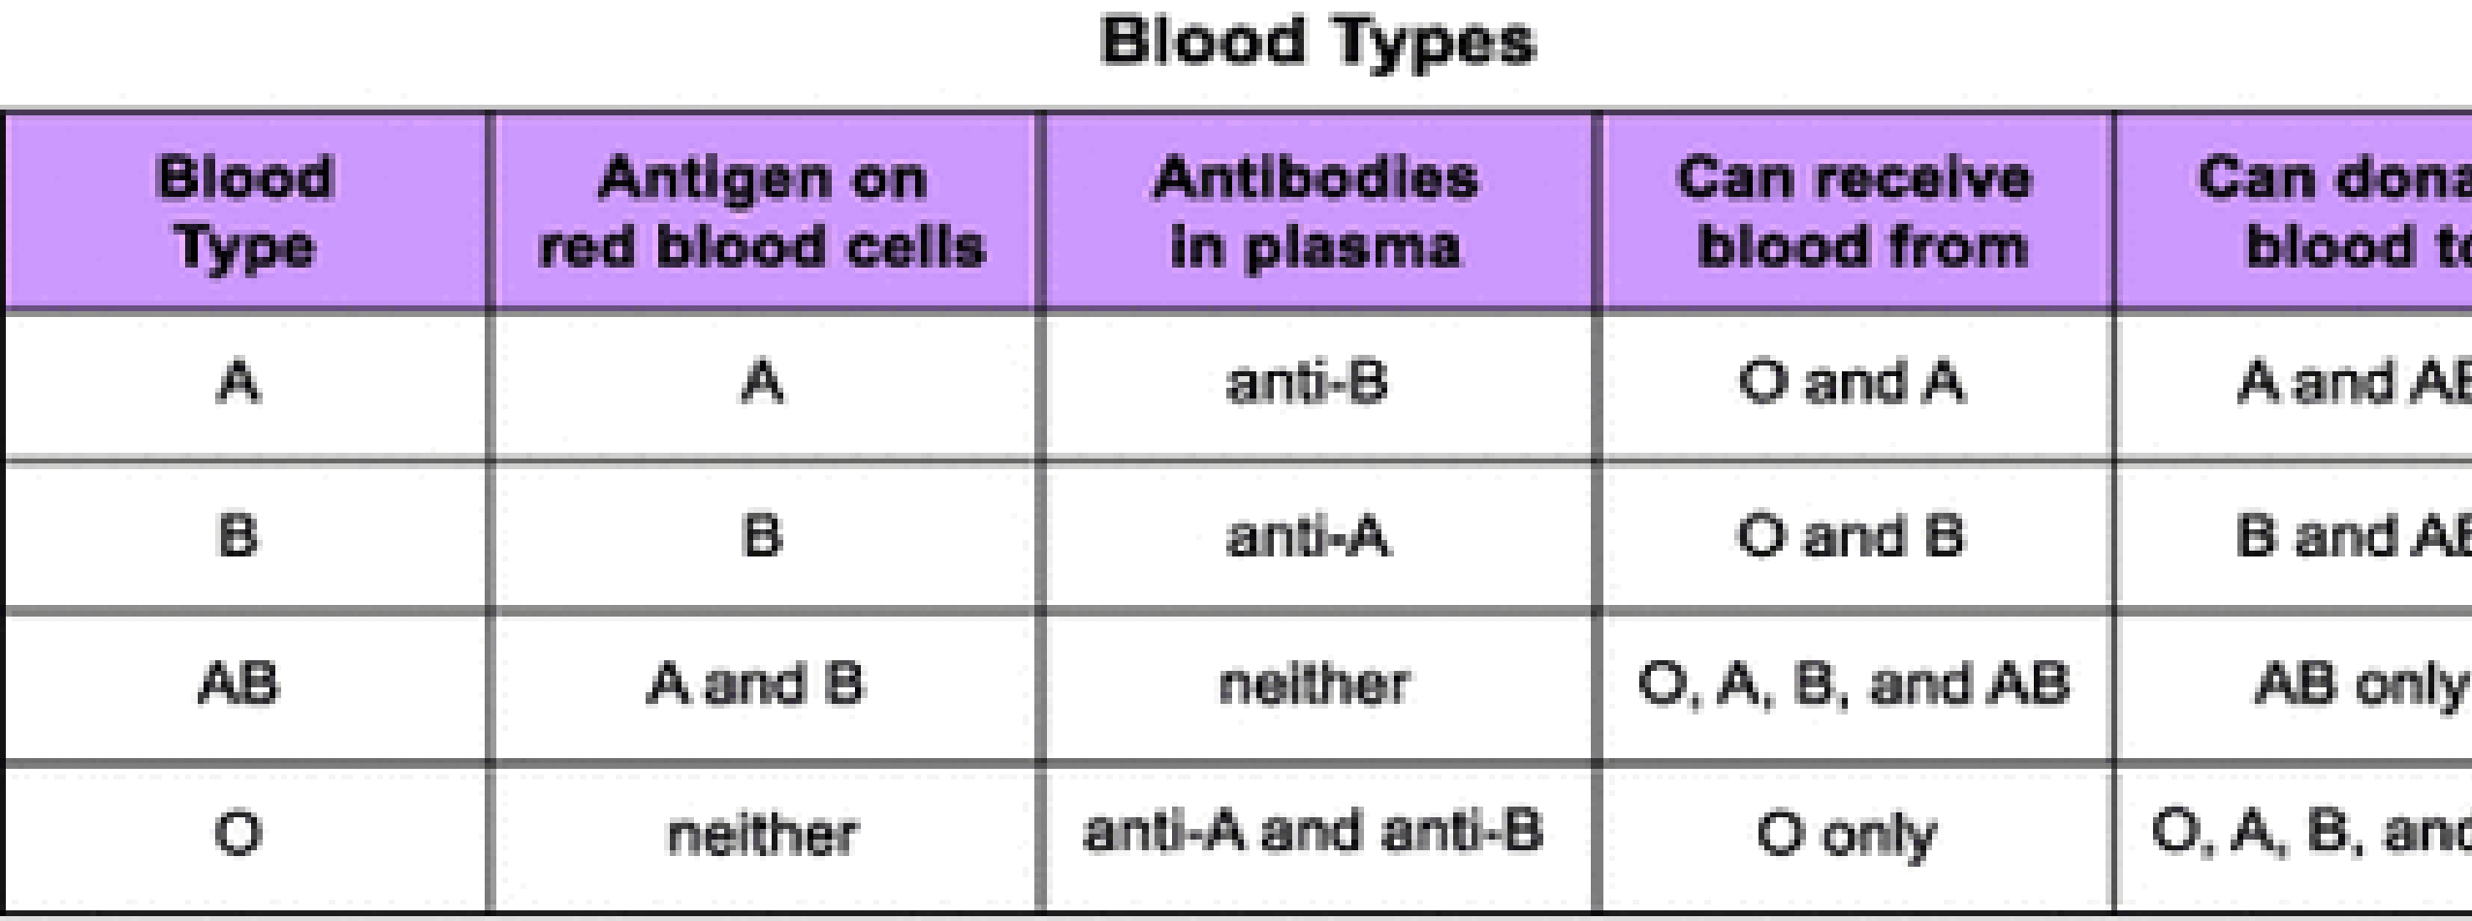
- If mismatched then hemolysis
•
- Blood typing is mandatory
2. Complications of blood transfusion with reference to ABO and RH incompatibility.

Question.no 3 .
What is erythrocytes erythropoiesis erythrocytes and erythropenia?
Answered.
.
Erythropoiesis.

- Erythropoiesis is the process by which red blood cells is produced.
- It is stimulated by decrease o2 in circulation which is detected by the kidney which then secret the hormone.
- The whole process last about 7 days through this processed erythrocytes are continuing produced the red blood bone marrow of large bone..
- Eyrythrocytosis.
- .is the eyrythrocytosis count is more then normal such state is called eyrythrocytosis.

Eyrythrocytosis.
•
- /
- Physiological pathological.
- Eyrythrocytosis.
- Absolute. High temperature.
- Relative. Exercise.
- Primary. Bone marrow disorders.
- Secondary. Due to cv..

Erythropenia.
Absolute. Deficiency of production.
- Relative pregnancy.
- Primary. Bone marrow.
- Secondary. Due to any kidney disorder..

QUESTION No. 4.
What is platelet. Write about blood clotting mechanism in all step.
Answered.
Platelet.
Platelet’s also called thrombocytes are a compound of blood cells whose function is to react to bleeding from blood vessels injury by clumping there by intiating a blood clot.
- Structure.
Platelet have no cell nucleus there are fragments of
cytoplasm that are derived from.
•
- Circulating inactivated plates are biconcave lens shape structure two three diameter.
- Activated platelet cell membrane Projection covering their surface Platelets are found Only in mammals Where is another vertebrae.
- Life Spain.
- 10 days.
• | Functions
.
- • Stop bleeding
- • Maintain homeostasis
- • Clotting mechanism
- . What is clotting mechanism.
- • Coagulationclotting mean blood changes from liquid to gel
instantly after an injury to the blood vessel which has damaged the endothelium lining the vessel.
- Mechanism involves,.
- • Adhesion
- • Activation
- • and aggregation of platelets • • deposition and maturation of fibrin
- . Steps of mechanism (adhesion).
- Injury to the blood vessel
- 2. Endothelium lining the vessel damaged
- 3. Blood comes into space under endothelium
- 4. Underlying collagen exposed to circulating platelets
- 5. Platelets binds with surface receptors of collagen and adhere tightly
- 6. This is adhesion
• | Activation
.
platelets change shape
2.turn on receptors and secrete chemical messengers to activate and invite additional platelets
- 3.Activated platelets adhere tightly at injury site..
• | Aggregation
.
•
- • Platelets connect to each other through receptor bridges
- • Platelet plug formed at injury site unless the interruption is physically too large
.
QUESTION no 5.
A person who fell down from the tree and unconscious
with bleeding from head what will you do from first
aid.?
ANSWERED.
- look closely how they have fallen and carefully put them into recovery position to keep there air way clear they are not breathing start CPR immediately and act according to your organisation emergency policy.
- Apply and maintenances pressure to wound with your gloves hands using a clean pad or dressing if possible.
Continue to apply pressure until the bleeding stop use a clean to dressing to bandage the wound firmly.
- Raised the injuries part of the body to slow bleeding stops covered the wound with anew clean bandage.

QUESTION 5 part 2.
You meet with your friend and you come to know he is COVID positive what precaution measure will you take?
ANSWERED.
- Clean your hand often either with soap and water for 20 second or a hand with sanitizer that contains at least 60% alcohol.
- Avoid closed contact with people who are sick.
- Put distance between your self with other at lest 6 feet.
- Take a bath and clean the body.
- Cover your cough with sneezing with a tissue and through the tissue in the trash.
- Cover your mouth and nose with clothes Face covered with around others.
- Clean and disinfect frequently touched object and surface daily.

The end .

