Subject
Principles of Marketing
Instructor
Sunil Chander
Submitted by
Kainat Ashraf
ID# 6959
Fashion Designing
Assignment
Final paper
Date
24-june-2020

Question: Develop a marketing plan for any existing or hypothetical company?
Introduction:
"MAC Cosmetics, change as M.A.C, is a decorating agent maker settled in Toronto, Canada in 1984 by Frank Toskan and Frank Angelo. "The headquartered is in New York City and turned" out to be a piece of the Estée Lauder Companies in 1996. "MAC stands for Make-up Art Cosmetics."
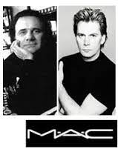
History:
The organization's items were initially planned for cosmetics experts, however are sold straight forwardly to purchasers around the world. Blunt Toskan expressed that he "first produced cosmetics for models, yet then the models needed this cosmetics for their sisters, companions, etc.
During the 1990s, the brand had over a hundred stores around the world, procuring 200 million francs. The advancement of the brand globally, the opening of new retail locations, and the adjustment of product offerings custom fitted to every landmass, allowed for the authors to make new items. In 1994, the organization Estée Lauder assumed responsibility for 51% of portions of MAC Cosmetics and started dealing with the business end while the two originators held imaginative control. In 1997, fellow benefactor Frank Angelo kicked the bucket of heart failure during medical procedure at the period of 49 around then; MAC had an income of US $250 million, which multiplied ten years later. Estée Lauder Inc. finished the obtaining in 1998, and Frank Toskan chose to sell his residual offers presently before leaving the organization toward the finish of that year.
"MAC Cosmetics is named one of the guideline three by and large decorating operators brands, with a yearly turnover of over $1 billion, and 500 free stores, with more than thirty" "stores in France." All stores are constrained by capable beautifier’s craftsmen. MAC is an official cosmetics brand, used to make cosmetics for film entertainers. The most mainstream items by the brand are Studio Fix Fluid and Ruby Woo Lipstick.
In September 2012, MAC Cosmetics propelled in India right off the bat the "MAC Selena" collection as a team with the bequest of Selena Quintanilla Perez. An appeal on Change.org proposed the possibility of this coordinated effort to MAC Cosmetics. Selena's sister, Suzette Quintanilla, worked with MAC to make the ideal collection that truly spoke to Selena. The collection sold out inside hours at MAC stores as well as at different retailers that conveyed the assortment, for example, Nordstrom, Bloomingdales, and Macy's. Fans remained in line for quite a long time to get their hands on the collection yet some walked away empty handed. Due to the appeal for this collection, MAC restocked the collection in December 2016. Her after death coordinated effort with MAC Cosmetics turned into the top of the line superstar collection in the beautifier’s history.
In May 2017, MAC Cosmetics opened up for buy online at Ulta Beauty. Products opened up in stores in June 2017.
On August 24, 2017, MAC Cosmetics declared that a collection engaged with the domain recently vocalist Aaliyah will be made accessible in the late spring of 2018. The Official discharge date for the "MAC Aaliyah" collection will be made accessible on June 20 on the web and June 21 in stores. Alongside the MAC assortment, MAC and I-D Magazine has joined forces up to discharge a short film named "A-Z of Aaliyah" which will match with the launch.
In May 2018, Sephora Canada reported it would convey MAC Cosmetics on the web and in its stores.
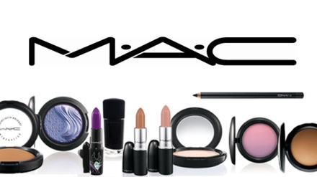
Mission:
To be the universes driving make-up power among both expert make-up specialists and consumers. To address client issues for better quality administrations and then give secure and testing workplace for all representatives.
To address regular issues for nourishment; cleanliness and individual consideration with brands that assist individuals with feeling better, look great, and get increasingly out of life.
Vision:
A MAC beauty care product was established with an inventive vision to fill the hole between cosmetics masterfulness and style photography. Well before their organization history, MAC beautifier’s authors coordinated their product offering towards experts in the excellence and design industry who needed to depend on substantial beautifying agents, cake cosmetics and stage cosmetics to make the special visualizations expected to withstand brilliant lighting during photograph shoots.
Goals:
The goal of the MAC Company is to make the organization a specialist in the business managing beautifying agents and furthermore advance the picture of MAC and lipstick deals. "The LOVE YOUR LIPS" 2011 fight was planned to extend MAC arrangements of lipstick, trigger customer commitment and MAC brand widening."
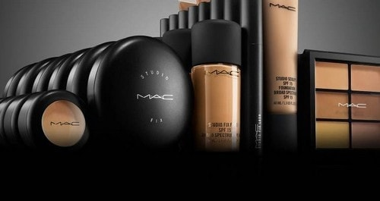
M.A.C stands for:
‘Make-Up Art Cosmetics’
Logo:
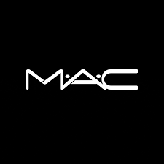
How we make a marketing plan?
A Marketing Plan is somewhat similar to a set of working responsibilities for your organization. Everybody ought to have one, however they're regularly not fit for reason, outdated and assessed inconsistently... Examination has indicated that organizations with plans succeed, outflank contenders, and hold staff, more than those with no arrangement. Without an arrangement there's no course for the organization or its workers, choices can be ignorant, open doors can be missed and dangers can harm or devastate the business.
Regardless of whether you are taking a gander at making a conventional promoting plan or a computerized advertising plan, in this post and in the most recent Smart Insights Business Marketing Planning Guide, I will find a way to making a showcasing plan – incorporating on the web and disconnected.
The seven common steps to make a marketing plan:
- Circumstance Analysis - Understand your clients
- Circumstance Analysis - Marketing review: where are we now?
- Goals - Create maintainable targets: Where would we like to go?
- Methodology: Segment your client base
- Methodology: Target new clients and position your business
- Strategies and Action - Create your showcasing activity plan
- Control - Monitor, oversee and improve

Why we make a marketing plan?
Marketing plan plots the particular moves you need to make so as to construct an enthusiasm to possible clients and customers about your items and additionally benefits. At that point to convince them to purchase the item or potentially benefits that you are advertising.
The Purpose behind the Marketing Plan
- Arrange your business objectives,
- characterize the market make appropriate market division,
- characterize marketing mix and
- Organize exercises about picked promoting systems.
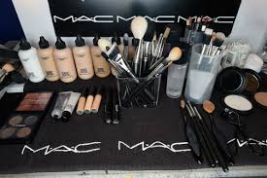

SWOT analysis of MAC:
Strength  - Its items are made for all races, genders and ages  - “Named number two as Forbs" America's most Admired Company"”  - Its brand name is as of now known in the Market  - Remorselessness free | Weakness  - The costs are high than certain people can manage  - It’s only the experts that can get to their PRO colors
Opportunity  - Boosting encounters in web based shopping  - Capacity to extend globally Brazil and India. For example, the organization is taking a shot at establishments and becomes flushed so as to fit explicitly the Indian Skin tone  - Display detached stores in contrast with spots situated in departmental stores | Threads  - Expanded rate of competition as various organizations have lip palette and Eye Shadow mixes constantly each season  - There exist inquiries on whether their web based shopping lift would assume control over well-known individual help.

4p’s of MAC:
- Product:
- Create various mixes of colors to coordinate client's needs in the global market.
- Create diverse solidness/power of colors and thickness to meet PRO versus clients/client needs.
- Permanence quality of durable shades and entirely huge item estimates.
- Particular bundling and limited version.

- Price:
- Customer advantage > cost
- Brand expansions justify premium "skimming" cost
- Multi-section Pricing
- Concentrate on client dedication
- Cost of exchanging
- Corresponding Products

- Place:
- In 1991 M.A.C first outlet was open in Greenwich Village.
- These days the brand claims more than 1000 autonomous stores in more than 70 nations, with more than 30 stores in France itself, bringing a yearly turnover of more than 1 million dollars.
- As clients strictly have confidence in M.A.C's high item standard they are not scared of on line shopping in the event that it goes to their preferred cosmetics brand.
- Stores on line offer an immense measure of items coming in all shapes and sizes. The menu is perfectly clear and basic
- This assists with a shopping procedure.

- Promotion:
- Word of mouth :
- Free items for experts, celebrities and media
- Manufactures validity, awareness

- Persuading Action Communication:
- "Back to M.A.C" – Rewarding top entertainers, persuading high possibilities
- CRM
- Social media:
- Client commitment on site
- Facebook
- Instagram
- Twitter
- YouTube
- Content marketing
- Mobile marketing
- Campaigns
7p’s of MAC:
- Product:
'All ages, all races, all genders'' as an organization life maxim
M.A.C Cosmetics sell a variety of items from professional make up to scents. Throughout the years working under the careful eye of Estee Lauder, M.A.C. increased an overall acknowledgment and regard as a brand, particularly in design industry. Various big names worked and keep working close by the brand, for the most part supporting Viva Glam crusade, from which all the profit are being passed to AIDS/HIV good cause.
In her article in 'The Guardian', Anna Chester (Chester’s, A, 2011) says: ''It's most likely their mentality as much as anything. M.A.C's Moto is 'All ages, All races, and All genders' thus their make-up is intended to be available for all.'' According to the site M.A.C comprises of 5 fundamental qualities, for example, Artistry - for consistent setting the norms higher on the off chance that it comes to rivalry as a main expert cosmetics authority; Individuality - as being offered to individuals of all races all genders and all ages; Community - breathing life into aesthetic dreams by working nearby most noteworthy specialists; Trendsetting - M.A.C craftsmen make inclines behind the stage of design shows around the world, and Social Responsibility which is chiefly connected to Viva Glam battle and M.A.C AIDS Fund. M.A.C Cosmetics gives an assortment of cosmetics items: lipsticks/lip sparkle, eye shadows, mascaras, establishment, mineral powder and nail clean. the greater part of the items are sans oil which benefits the skin as it forestalls the water misfortune which is accept for cosmetics to be increasingly effective and remain on for more. Tests have indicated that the items show a noticeable improvement in perfection and solidness of skin, just as wrinkle decrease and more skin hydration. The investigation was led on female volunteers matured 40 - 65.
- Brand development:
''Exceptional structure, sign, image, words or a combination of these, utilized in making a picture that distinguishes an item and separates it from its rivals. ‘As expressed in Business Dictionary above brand is a remarkable turn of events, something that is stand-out and can't be duplicated. A brand is an item itself and to proceed with brand improvement the organization needs to cause its clients to remain alert. M.A.C. Makeup continues developing keeping its purchasers fulfilled up until today. In late 1980's M.A.C was strongly situated between specialists as it conveyed compensate for all skin tones and colors, that is likewise generally appropriate for stage lighting. M.A.C situated itself as a brand of items for ''all ages, all races and all genders'' and that has made the brand solid and fruitful. Their clients are happy to include a great deal of exertion into the way toward getting wanted item, as they care for a brand and trust it will ALWAYS convey.
''The MAC Cosmetics brand has encountered extraordinary accomplishment by developing to remain important, using powerful situating as far as basic beliefs, brand character and client relationship, alongside continually conveying the brand guarantee additional time.”
- Packaging:
M.A.C. Beauty care products as an iconic brand clearly has iconic, great, all around perceived and ageless bundling. The external bundles are plain secret elements made of paper, which is simple recyclable, with white composing fitting every single individual item is a fundamental and truly unmistakable kind of bundling. Within bundling of a genuine item is made of plastic so it doesn't harm the item. M.A.C. gives 'back to M.A.C' services .which organization is incredibly glad for. It offers a free lipstick in return for 6 unique void compartments. This methodology is nothing not as much as condition agreeable and furthermore by growing such thought; it sets aside organization cash spend on reusing outside the brand.
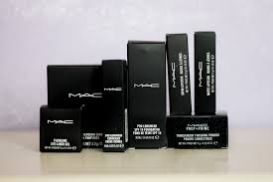
- Pricing:
M.A.C Cosmetics has become a two billion dollar brand and by many is considered as a 'way to progress' Products are valued marginally higher than other contending items, in spite of the fact that clients wouldn't fret to pay more for the confirmation of a fantastic item. The high assortment of items and hues makes M.A.C entirely attractive and simple selling.
The costs fluctuate over the items:
- foundation £22 - £29.50
- blush £13 - £22.50
- eye shadow £10 - £49.50 (for the unit)
- mascara £14 - £19
- lipstick £15 - £18.50
- lip gloss £15 - £20
As per BestProducts.com excellence blog, the top of the line M.A.C lipstick is 'Ruby Woo' propelled in 1999 as a piece of the assortment with another Retro Matte formula. It has taken a spot in Vogue Magazine as one of top 10 red lipsticks ever. Rihanna in 2013 had worked close by M.A.C to make her own wind to a shade called 'Riri Woo'. The lipstick sold out inside the initial barely any hours. M.A.C offers intermittent deals and advancements and offers integral items which are characterized as Product Line Pricing. Their costs are practically identical to contenders which centers for the most part on consumer loyalty. The organization utilizes multi-section evaluating as their procedure to target more clients, all accomplished by providing a wide assortment of wanted items.
- Place:
- Stores:
In 1991 M.A.C first outlet was opened in Greenwich Village. These days the brand claims more than 1000 autonomous stores in more than 70 nations, with more than 30 stores in France itself, bringing a yearly turnover of more than 1 million dollars.
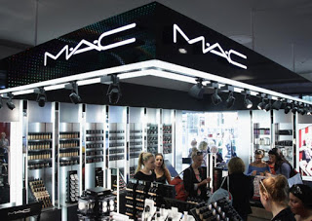
- Online:
As clients strictly have confidence in M.A.C's high item standard they are not scared of on line shopping in the event that it goes to their preferred cosmetics brand. Stores on line offer an immense measure of items coming in all shapes and sizes. The menu is perfectly clear and basic .This assists with a shopping procedure.
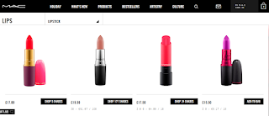

- Face to face services:
M.A.C centers on building a cozy relationship with their clients. As a piece of superb client care MAC gives up close and personal interviews and make up exercises and application in stores. Those services can be reserved legitimately through the official site or by the telephone when it isn't accessible on the web.
- Promotion:
As recently referenced above M.A.C advanced itself back in 1980's by word to mouth, the brand has gotten effective among artists and picture takers in view of its high caliber and shading variety. Since the time the high use on these beauty care products is seen regularly in films, on a runway and is a most loved brand utilized by experts and typical individuals. In 1990 Madonna has mentioned a particular shade of lipstick 'Russian Red' which was made for her and she was wearing it on her 'Blondie Ambition' visit. The shade was a moment hit and outstanding amongst other selling lipsticks, time. Since the time the enormous achievement M.A.C continues working together with stars and superstars bringing moment achievement.
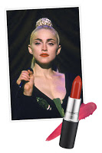
- Personal selling:
As one of the most established and least expensive type of advancement, M.A.C Cosmetics captivates everyone of rivalry. M.A.C utilizes individual selling on everyday premise in the stores, just as on the web. M.A.C gives brilliant client assistance in shops, guarantying for each purchaser feels like a star in a behind the stage of a catwalk. Online make up instructional exercises are accessible day in and day out giving tips and deceives on each part of each sort of makeup.

- Viva Glam:
Recently referenced 'Viva Glam' battle upheld by numerous superstars including Mary J Blidge, Sir Elton John, Pamela Anderson, Fergie and Ricky Martin, has been supporting M.A.C's own cause supporting the victims of HIV/AIDS. The mission is to have any kind of effect ''each lipstick in turn''.
- Modern and exclusive approach:
In 2014 M.A.C Cosmetics has launched another campaign, adopting an alternate strategy from rival organizations. Rather than focusing on all new crowd, as a standard organization would do, M.A.C chose to pick the contrary way and settled on remunerating existing clients. The individuals who shop in a New York leader store and pursue an uncommon mailing rundown will be remunerated a postcard with a one of a kind QR scanner code. The code takes you to let loose make exercises and instructional exercises by M.A.C specialists in a hurry, just as directly to M.A.C. online shop where their client can peruse most loved excellence items and get a counsel on the most proficient method to make the best of it from experts.
- Eye-catching campaigns:
As an organization with a great name for itself M.A.C after all, doesn't spend quite a bit of their cash on promoting, the brand gets a major measure of mouth supports from proficient make up specialists in return of free items. M.A.C promotes itself with a great assistance of supporting famous people around the world, and working close by - style specialists. Make-up is a daily practice, it will consistently be required so M.A.C ought not to stress over losing on clients, as long as it keeps on conveying an elite, in vogue and durable item.
- Liptensity:
Pristine 24 lipsticks conceals with all new improved equation.
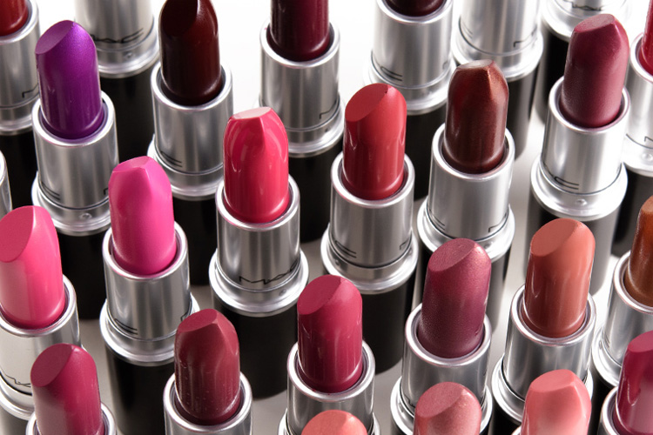
- People:
As referenced before M.A.C is pretty much all ''ages, genders, and all races' thus why M.A.C offers equivalent work open doors for individuals around the globe. On the site here the mother organization, Estee Lauder gives us 5 essential model for what reason is it qualified to work for M.A.C and what are the employments benefits. Clearly M.A.C has just earned a name for itself and each lady/man might want to be associated with making further history. Be that as it may, why other than that you should work for MAC?
- Social responsibility:
M.A.C is associated with numerous ways, in 'offering back' to their clients. For instance above notice of Viva Glam battle or AIDS/HIV subsidizes. M.A.C is continually bringing issues to light of the greatest world issue.
- Network:
Since the earliest reference point of its presence available M.A.C was developing its locale, similar to it was a family. Everything occurred away from public scrutiny, and just selective visitors approached... to make history. Who wouldn't have any desire to be a piece of this selective family?
- Make up power:
As the universes driving proficient make-up power M.A.C lives the benefits of passing the experience, of exploiting offering the mastery to clients.
- Singularity:
‘‘All ages, all races, all genders M·A·C commends decent variety with our specialists and purchasers, appeared through our capacity to address the issues of every single individual client through our broad item and shade extend and customized administration approach''.
- Pattern setting:
Last however not least. In the event that M.A.C isn't the trendiest make-up organization of all, at that point I do realize what is. For quite a long time taking an interest in style shows all inclusive, setting the higher bar to its rivals, M.A.C is a pattern itself. Ground-breaking, bright, exceptionally alluring items are difficult to miss.
- Process:
As recently referenced M.A.C makeup saves money on costs with low ad, doing it principally by word to mouth.
''MAC Cosmetics serious dispersion happens at principally all MAC Pro stores. MAC Pro stores are where you can discover ALL MAC items, for example, colors, void palettes, a few preliminaries, and old and new restricted release things that you probably won't find at a counter, for example, Blooming dales, Macys, or and so forth.. MAC Pro stores consistently have items accessible in each outlet where target clients should get it, for example, the course reading states. Obviously, all items could be discovered online at the MAC cosmetics.com site, yet then it wouldn't be viewed as an outlet, only an online outlet. Because of MAC's exceptional client assistance, items can be conveyed practically when requested when you can't locate a specific thing, aside from restricted release things obviously, in light of the fact that solitary a constrained sum come without a moment's delay.''
M.A.C Cosmetics gathers its crude materials like, sesame seed oil, castor oil and silica in India from where they are being dispatched to Canada by compartment transport. The taxes on items leaving India are very high, so it demonstrates client can anticipate quality item. M.A.C beauty care products items are then planned in their base camp in New York, yet the get together and wrapping up the item occurs in simply outside Toronto, Canada. The items are then dispatched via prepares, trucks and ships the world over where they are being circulated to the stores and prepared for purchasers.
- Physical evidence:
The physical proof of M.A.C Cosmetics, as recently referenced (Viva Glam, Makeup exercises, Online instructional exercises) are being seen an accomplished every day available and on the web. Subsequent to perusing different articles about brand improvement, new up and coming items and advancement, M.A.C has a solid spot in a market and by proceeding on conveying new items the organization will remain up high in make-up business pecking order.
''MAC Cosmetics leads in front of Chanel and Dior in our social scorecard file, which positions different social commitment elements to survey a brand's adequacy on the web. In any case, while there is little to isolate the methodologies of the main brands, there is a prominent distinction between the third and fourth best brands, featuring a noteworthy difference in the procedures of shading beauty care products brands.'
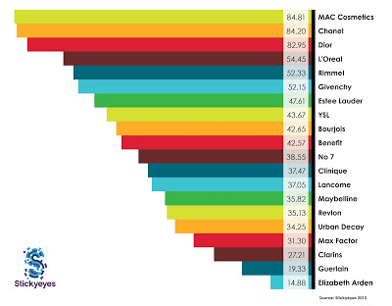

CONCULSION:
The "LOVE YOUR LIPS" MAC battle will extraordinarily help in advancing the organization lipstick deals. Not with standing that, it will help the organization in including clients in their exercises and furthermore in enhancement of the MAC picture. In contrast with its rivals, the organization has various strengths and opportunities, for example, brand acknowledgment that is sure, client loyalty, engaging bundling, pattern setting, big name support and sensible valuing among others. The MAC cosmetics brand has encountered incredible accomplishment by advancing to remain critical, creating successful situating regarding fundamental beliefs, brand character, ad and client connections just as continually conveying the brand guarantee after some time.

