DPT 4th Semester

Course Title: Exercise Physiology Instructor: Ahmed Hayat
Student Name: Aftab ahmad ID: 15096

Final Term Assignment Marks: 50

NOTE: Mention your name and roll number on the assignments.

Q 2. Explain basic principles of training ?
Ans : Principles of taining :
The athaletes to improving their performance use principles of training . Some of these principles are as follows :
- Specificity
- Overload
- Rest
- Adaptation
- Reversibility
But basically most widely are only three basic principles which are also used for fitness as well as performance .These are overload ,Specificity ,and Reversibility.
OVERLOAD:
Overload refers to that observation that a system or tissue must be exercised at a level beyond which it is accustomed in order for training effects to occur .
The system or tissue gradually adapt to this overload .
The pattern of progressively and systematically a system or tissue result in adaptation improving function overtime .
Variables that constitute overload includes the :
- Intensity
- Duration
- Frequency
It is the foundation principle behind all training programs , leading to training gains . If level of condition is high it require greater overload . Overload can be applied by varying frequency , intensity and duration
Frequency :
Frequency is basically repeatation of exercise in a week or day .For normal health and fitness 3-4 times a week exercise should be performed .
Aerobic exercises are more benefited and make the training more frequent
Non endurance athletes frequency is 3x per week.
Endurance athletes frequency is 4-6x per week .
Too much repeation and over training results in injury boredom ,poor technique burnout .
While under training can result in loss of motivation ,poor or no improvement .
Intensity:
It means how hard and to which extent a training should be . correct intensity is necessary to provide sustained improvement in performance due to physiological adaptation .
High intensity exercises result in injury and burnouts .
While low intensity exercises are less beneficial .
By manipulating the frequency and intensity we can overload the system there by making improvements .
Intensity = heart rate (HR) .preceived exertion rate (PER) .repetition max (RM).
Duration :
The length or time up to which a exercise is performed . the time of stimulation .
Fitness increases by increasing the duration and best improment results are shown . because without its adaptation improvements will slow down this means that athletes should devote more time to training .
Specificity :
It refers to a type of adaptation occurring in muscles as a result of training .
In simple words for each specific purpose there is specific training and must suit a particular sports or aspect of fitness .
For example : If a muscle is engage in endurance type of exercise , the primary adaptation are in capillary and mitochondria number ,increasing muscle capacity to produce energy aerobically .
Or if a muscle is involved in heavy resistance training the primary adaptation is an increase in the quantity of contractile proteins , and the mitochondria and capillaries densities may decrease .
The training effect is specific to :
- Muscles involved
- Type of fiber (type 1 or type II)
- Energy system involved .( aerobic or anaerobic )
- Velocity of contraction
- Type of muscle contracted (eccentric , concentric or isometric )
Reversibility :
Loss of improvement when training is decrease or stopped .Gains or loss when overload is removed .The longer the built up the slower the loss .
This may seem like an obvious statement in that one should not expect the arms to become trained during ten weeks jogging programs .
- Ans 2 : Preload, also known as the left ventricular end-diastolic pressure (LVEDP), is the amount of ventricular stretch at the end of diastole.
- Think of it as the heart loading up for the next big squeeze of the ventricles during systole.
- Some people remember this by using an analogy of a balloon – blow air into the balloon and it stretches; the more air you blow in, the greater the stretch
Q3. Describe preload and afterload in simple words.

Preload: The endurance-training effect is believed to be due to the "volume loading" experienced by the heart during exercise. ​
- However, Rowell raises the question that the increase in stroke volume that occurs with endurance training may simply be due to the chronic stretch of the myocardium at rest because of the increased filling time associated with the slower resting heart rate (bradycardia).​
- Plasma volume increases with endurance training.
- Experimental expansion of the plasma volume (200300 ml) causes a 4 per increase in V02 max
- Overall. EDV increases as a result of an endurance training program, and according to the Frank-Starling mechanism an increased stretch of the ventricle leads to an increase in stroke volume
- Cardiac contractility refers specifically to the strength of the cardiac muscle contraction when;​
- the fiber length,​
- after-load (peripheral resistance), and​
- heart rate​ are constant (because all affect contractility).​
- Afterload:
- Afterload, also known as the systemic vascular resistance (SVR), is the amount of resistance the heart must overcome to open the aortic valve and push the blood volume out into the systemic circulation.
- If you think about the balloon analogy, afterload is represented by the knot at the end of the balloon. To get the air out, the balloon must work against that knot.
- After-load refers to the peripheral resistance against which the ventricle is contracting as it tries to push a portion of the EDV into the aorta.​
- Trained muscles offer less resistance to blood flow during maximal workAfter-load refers to the peripheral resistance against which the ventricle is contracting as it tries to push a portion of the EDV into the aorta.​

- If you lifted a 10-kilogram (Kg) weight upward over the distance of 2 meters (m), the work performed would be ? Calculate Work.

Given data :
Mass of an object lifted upward = 10 Kg
Height = 2 meters
Accleration due to gravity =9.8m/sec²
Required:
Work done (W) =?
Solution :
In this case Work done = Potential energy (P.E )
W = P.E
As P.E = mgh
So putting this formula in place of P.E we get :
W = mgh
Putting values we get :
W = 10 kg. 9.8 m/sec² .2 m
W = 10.9.8 .2 (kg m / sec² )
W = 196.0 kg m / sec ²
W = 196.0 joule .

Q4. What are the factors increasing stroke volume.

Stroke volume:
stroke volume (SV) is the volume of blood pumped from the left ventricle per beat.
Stroke volume represents the difference in the amount of blood between:
- The volume in the ventricles at the end of diastole (end-diastolic volume EDV)
- The volume after systole (end-systolic volume ESV).
Normal resting stroke volume:
Normal resting stroke volume is 70ml.
Formula: SV (70ml) = EDV (130 ml) – ESV (60ml)
Factors influencing stroke volume:
Three factors Affect stroke volume:
- Preload.
- Contractility.
- Afterload.
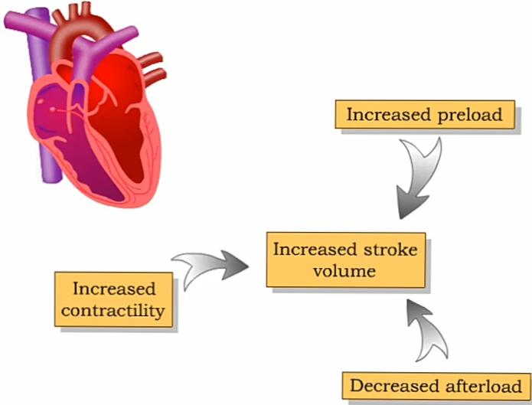
Preload:
Preload is the degree of stretch of cardiac muscles cells prior to contraction.
The amount of stretch is related to the end-diastolic volume (EDV).
Increased return blood flow from the veins increases end-diastolic volume (EDV).cardiac muscle sarcomere stretch and lengthens.

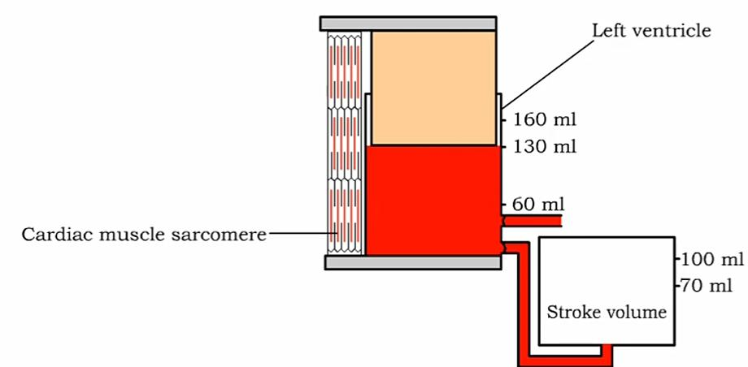
Contraction of the cardiac muscles sarcomeres during ventricular systole provides the force needed to eject blood from the heart.
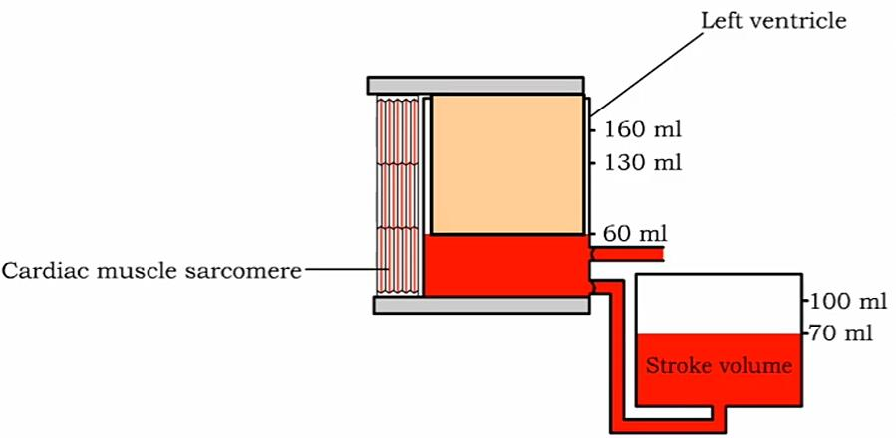

Contractility: Contractility is the forcefulness of ventricular muscle contraction.
Extrinsic Control
Sympathetic stimulation (epinephrine) to the contractile cells increases the strength of contractility
More Ca ion binding to troponin and more cross bridges available for muscle contraction.
Afterload: Afterload is the pressure that must be overcome before ventricles can eject blood.
Mean Arterial Pressure (afterload)
A decrease in mean arterial pressure ( MAP )will increase stroke volume
Vasodilation of arterioles decreases the mean arterial pressure.
Increase in compliance in arteries decreases the mean arterial pressure.

 | Preload | Contractility | Afterload
Stoke volume is raised due to the following. | - Fast filling time.  - Increased venous return.  Increases end diastolic volume.  Increase stroke volume | - Sympathetic stimulation.  - Epinephrine and norepinephrine.  - High intercellular calcium ions.  - High blood calcium level.  - Thyroid hormone.  - Glucagon.  Decreases end systolic volume.  Increases stroke volume. | - Increased vascular resistance.  - Semilunar valve damage.  Increases end systolic volume.  Decreases stroke volume.

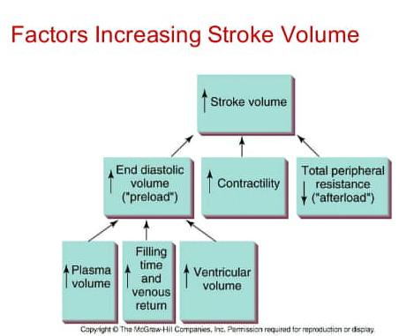

Q5. Differentiate between isometric, isotonic and isokinetic exercises.

Isometric exercises: Contraction in which the muscle length will shorten and movement of a limb takes place (movement).
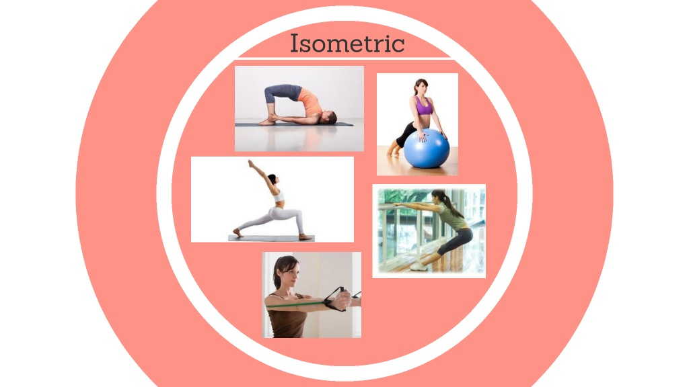

Isotonic exercises: contraction in which the muscle shorten, but no movement in the limb will take place. Agonist and antagonist muscle work against each other (no movement).
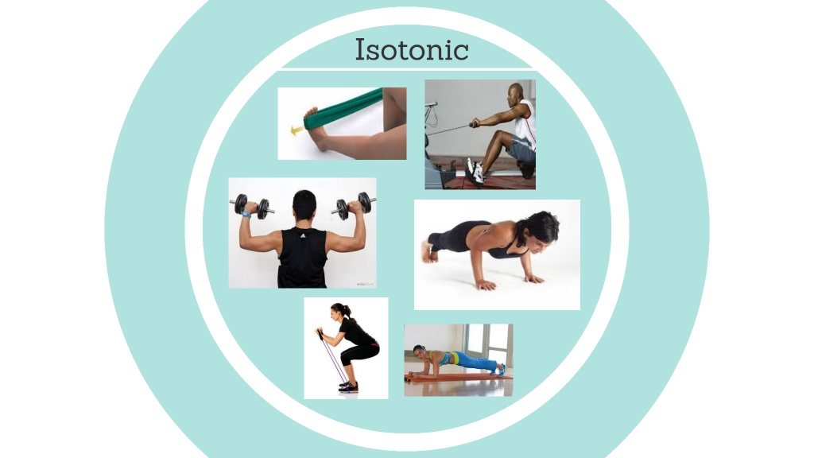

Isokinetic exercises: Contraction performed where the muscle shortens and movements take place, but the speed of the contraction remain the same the entire range of motion (with a machine)
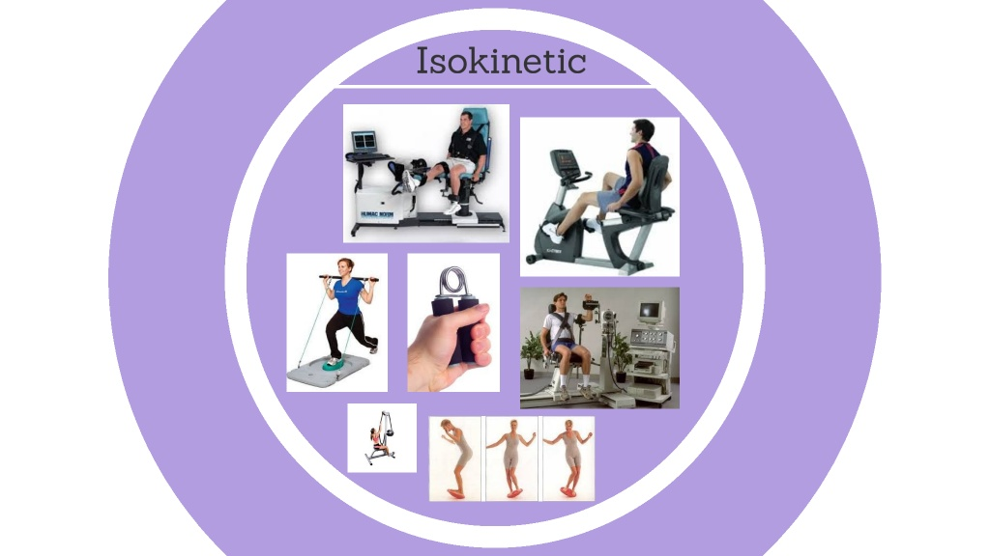

Differences:
 | Isotonic | Isometric | Isokinetic
Introduction | An isotonic exercise is a form of exercise in which isotonic muscular contraction is used to improve joint mobility and strengthen muscles by continuous and sustained movement of the arm and legs | An isometric exercise is a type of strength training in which muscle length and the joint angle do not change.  They are done in static positions rather than being dynamic with a large range of motion. | An isokinetic exercise is an exercise that provides a constant limb movement by a variable resistance.  These exercises require equipment that quickly accommodate resistance changes.
Equipment | - A variety of weight lifting machines.  - Resistance bands.  - Medicine balls.  - Free weights.  - Bench press.  - Kettle balls.  - Dumb bells.  - Your body | - In isometric exercises you don’t use any equipment apart from your body. | - Exertubes  - Elastic bands.  - A stationary bike.  - Specialized machines.  - A dynamometer.
Benefits | These exercises can be very beneficial to your body by raising your heart rate, this increases blood circulation to the rest of the body, also lowering your risk of stroke, heart attack and other heart diseases. | The main benefit is that they can be performed without equipment  These enhances stabilization and boost strength for people with arthritis. | Isokinetic exercises are best for rehabilitation.  They are even better for preventing injury.
Examples | - Weight lifting  - Bench press  - Theraband  - Push-ups  - Squats  - Lunges | - Quad/hamstring set.  - Yoga  - Contracting and relaxing muscles  - Hand presses  - Planks and side planks | - Ankle/wrist circles  - Athletic rehabilitation  - Riding a stationary bike  - Running in place

