DPT 4th
Course Title: Pharmacology I
Student Name: MUNIBA IJAZ
Student ID: 15079

Note:
Attempt all questions
Each question carry equal marks
Pay attention to every point of question
Give to the point answers
Extra detail may leads to marks deduction

- Explain the detailed neurotransmission process

- What does direct and indirect cholinergic agent means? Explain therapeutic application and adverse effects of cholinergic agents in detail.

- Explain the effects and adverse effects of organic nitrates in angina pectoris.
- Write down the treatment algorithm for improving symptoms of stable angina.

- Differentiate between primary and secondary hypertension
- Explain the effect of renin on hypertension
- What is the importance of pharmacological treatment of hypertension

- Differentiate between right heart failure and left heart failure
- Summarize the pharmacotherapy of heart failure
Q1.Explain the detailed neurotransmitter process ?
Ans.NEUROTRANSMITTER PROCESS :
DEFINITION: The transmission of nerve impulses between neurons or between a neuron and a muscle fiber or other structure .
EXPLANATION:
It is the process by which signaling molecules called neurotransmitters are released by the axon terminal of a neuron ( the presynaptic neuron ) and bind to , react with the receptors on the dendrites are released of another neuron ( the postsynaptic neuron ) a short distance away.
STEPS OF NEUROTRANSMISSION :
There are 4 major steps of neurotransmission .
1.Synthesis and storage of the neurotransmitter in the presynaptic neuron .
2.Release of the neurotransmitter into the synaptic cleft .
3.Interaction of the neurotransmitter with receptor on the post synaptic cell .
4.Ternination of the synaptic actions of the neurotransmitter .
STEP 1: SYNTHESIS AND STORAGE :
.This take place in the cell body in the axon or in the axon terminal . Storage of the neurotransmitter in storage granules or vesicles in the axon terminal . Neurotransmitter are synthesized by the enzymatic transformation of precursors .
ACETYLCHOLINE EXAMPLE:
.The precursor choline is transported into cholinergic nerve terminals .
. Once synthesized , acetylcholine is transported into vesicles for storage .
. Because of the ubiquitous nature of acetylcholine these drugs are not used in clinical pharmacology .
STEP2: RELEASE OF NEUROTRANSMITTER INTO SYNAPTIC CLEFT:
They are released from presynaptic terminal by exocytosis when calcium enters axon terminal during an action potential . Diffuse across synaptic cleft to the post synaptic membrane . Calcium enters the axon terminal during an action potential causing release of the neurotransmission into the synaptic cleft .
STEP3: INTERACTION OF THE NEUROTRANSMITTER :
After its release the transmitter binds to and activates a receptor in the post synaptic membrane . After binding with receptors neurotransmitter have two effects on the post synaptic membrane . Excitation of the postsynaptic membrane or its inhibition .
.During excitation , an action potential is generated .
.During inhibition , an action potential is inhibited.
STEP4: TERMINATION : Neurotransmitter effect is terminated in 3 ways by :
1.ENZYMATIC DEGRADATION :
The activity of some neurotransmitter is terminated by degradation by an enzymes that is in the synaptic cleft . A enzymes bind to the neurotransmitter and break it apart so that the neurotransmitter can no longer fit into a receptor on the receiving cell .
.ACETYLCHOLINESTERASE :
Acetylcholinesterase is one of only a few enzymes that have obtained near catalytic perfection .
.The rate of hydrolysis is close to the rate of diffusion to the active site .
. A single enzyme can hydrolyze 14, 000 ACH molecules / second .
. Blockage of acetylcholinesterase will rapidly increase synaptic levels of acetylcholine .
. Neostigmine- reversible inhibitor
.Sarin , malathion-irreversible inhibitors
2.REUPTAKE OF NEUROTRANSMITTER :
The transmitter substance is returned to the presynaptic neuron .Uptake or reabsorbed by the astrocytes or the presynaptic terminals . Dopamine and norepinephrine are inactivated primarily via reuptake .
.Specific transporters that transport the acetylcholamines back into the presynaptic terminal .
. The effects of cocaine and amphetamine are mediated in part through the dopamine transporter .
EXCITATORY AND INHIBITORY EFFECTS :
Neurotransmitters are released in small amounts and produce minimal excitatory or inhibitory effects . This process takes place regardless of the action potential generated or not . This process is amplified when an action potential arrives and the required message is sent from neuron to its target through neurotransmission .

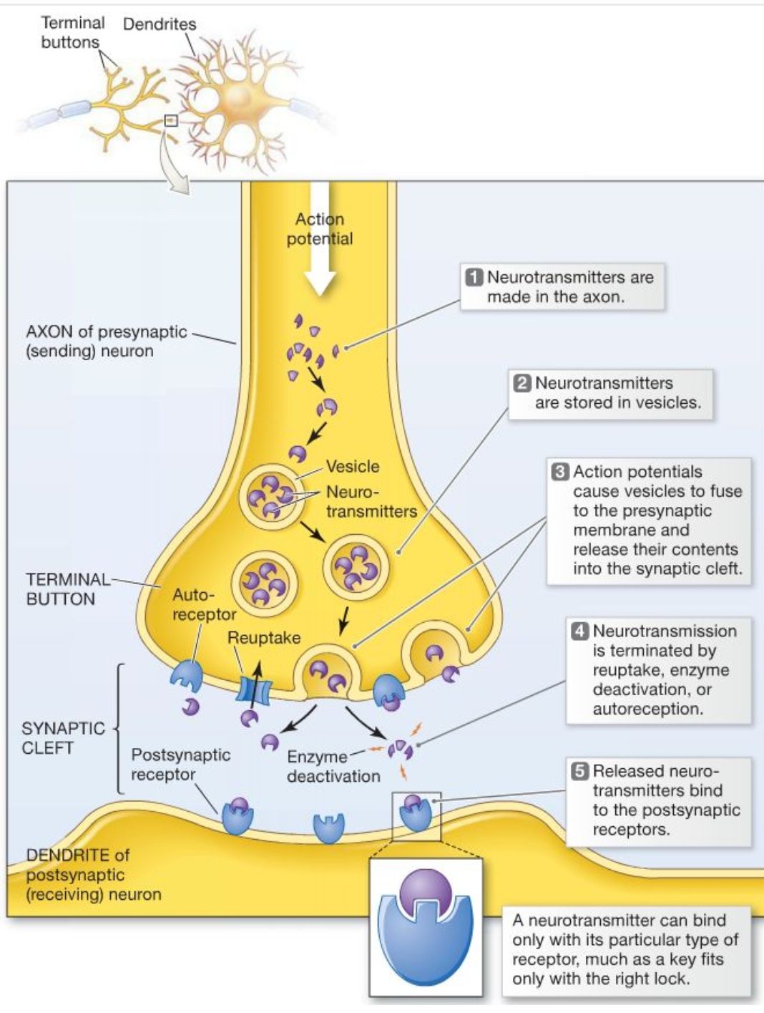
STEPS OF TRANSMITTER PROCESS :

Q4.(a)Difference between primary and secondary hypertension .
PRIMARY HYPERTENSION:
* High blood pressure above 130 over 80 where no causes as known as primary hypertension
* also known as essential HTN.
CAUSES:
*causes of primary hypertension in unknown but is suspected to be a combination of factors
* family history of hypertension : very common
* high BMI very common
* common in 90 to 95 %of people
* SYMPTOMS: primary hypertension is usually asymptomatic and most of the patient are found to have hypertension during periodic medical checkup
* TREATMENT: if the blood pressure is primary hypertension with out any specific cause it can be effectively controlled by healthy eating and habits as well as doing exercise.
SECONDARY HYPERTENSION:
* high blood pressure above 130 over 80 where the cause is known as secondary hyper tension
* common in 5 to 10% of people
* not common
●CAUSES: kidney disease , tumor or adrenal gland causing , thyroid hormones, renal arteries problem, sleep apnea, overproduction of alderosterone.
* SYMPTOMS: headache , easy fatigue , dizziness etc
* TREATMENT: if the blood pressure is persistently high apart from adopting the aforementioned non pharmacological treatment the patient may need to take antihypertensive.
(b): Explain the effect of renin on hypertension .
Ans. EFFECT OF RENIN ON HYPERTENSION :
The renin Angiotensin system or RAS regulates blood pressure and fluid balance in the body. When blood volume of sodium levels in the body are low or blood potassium is high cell in the kidney release the enzyme, renin convert Angiotensinogen, which is produced in the liver to the hormone Angiotensin l. An enzyme known as ACE. Angiotensin_converting enzyme found in the lungs metabolizes angiotensin l into angiotensin ll. Angiotensin II Cause blood vessels to constrict and blood pressure to increase. Angiotensin II stimulates the release of the hormone aldosterone in the adrenal glands which causes the renal tubules to retain sodium and water and excrete potassium. Together, Angiotensin II and aldosterone work to raise blood volume, blood pressure and sodium levels in the blood to restore the balance of sodium, potassium, and fluids. If the renin_angiotension. System becomes overactive, consistently high blood pressure results.
When angiotensin II acting on collecting tubules which cause sodium retention and when 1 molecule of sodium goes out 2molecule of water will also goes out because of this it will cause water retention which will increase blood volume or blood plasma level and blood pressure went from high blood pressure towards normal blood pressure .

(C): What is the importance of pharmacological treatment of hypertension ?
Ans.PHARMACOLOGICAL TREATMENT OF HYPERTENSION:
The goal of hypertension treatment is to lower high blood pressure and protect important organs, like the brain, heart, and kidneys from damage. Treatment for hypertension has been associated with reductions in stroke (reduced an average of 35%-40%), heart attack (20%-25%), and heart failure (more than 50%),
The aim of antihypertensive therapy is to prevent morbidity and mortality associated with persistently raised BP by lowering it to an acceptable level , with minimum inconvenience to the patient . both systolic and diastolic BP predict the likelihood infraction of target organ damage and complications .
Such as :
(a) cerebrovascular disease , transient ischemic attacks, stoke, encephalopathy.
(b) hypertensive heart disease left ventricular hypertrophy, CHF
(c) coronary artery disease (CAD), angina, myocardial, sudden cardiac death
(d) Arteriosclerotic peripheral vascular disease, retinopathy
(e) Dissecting aneurysm
(f) Glomerulopathy, renal failure.
Seven types of drugs are used to treat hypertension.
Angiotensin converting enzyme (ACE) Inhibitors
Angiotensin ll receptor blockers (ARBs)
Diuretics
Beta_ blockers
Calcium channel blockers
Alpha blocker
Alpha_agonists
Renin Inhibitor
Q2.What does direct and indirect cholinergic agents means ? Explain therapeutic application and adverse effects of cholinergic agents in detail .
Ans. DIRECT CHOLINERGIC AGENTS :
Direct cholinergic drugs are act by binding directly to cholinoreceptors . Direct acting cholinergics are lipid insoluble .
Do not readily enter the central nervous system so effects are peripheral .
Resistant to metabolism by acetylcholinesterase .
Effects are longer acting than with acetylcholine . Direct cholinergic drugs are similar to acetylcholine and stimulate receptor like acetylcholine .
E.G. Bethanechol stimulate the urinary bladder contraction and is taken orally to treat non obstructive urinary retention. Methacholine , Muscarine and Carbachol etc.
INDIRECT CHOLINERGIC AGENTS :
These drugs are referred as anticholinesterase drugs .
They act through inhibition of Acetyl cholinesterase enzyme , so increase Acetylcholine level in the synapse .
Accumulation of acetylcholine then occurs which enhance the activation of the nicotinic and muscarinic receptors .
Anticholinesterase drugs are either reversible or irreversible inhibitors of acetylcholinesterase.
E.g. Neostigmine, parathion , sarin and Donepezil etc.
●THERAPEUTIC APPLICATION OF CHOLINERGIC AGENTS :
1.REVERSAL OF NEUROMUSCULAR BLOCKAGE :
By increasing levels of acetylcholine in the neuromuscular joint (NMJ) , the compounds are able to facilitates recovery from competitive neuromuscular blockage .
Restore neuromuscular transmission .
2.GLAUCOMA:
Constriction of the ciliary body promotes aqueous humor outflow , decreased intraoccular pressure .
Direct and indirect cholinomimetics can be used to treat glaucoma .
Pilocarpine is the most commonly used agent.
Typically formulated as eye drops .
3.MYASTHENIA GRAVIS :
Myasthenia gravis is an autoimmune disorder that attacks the nicotinic acetylcholine receptor at the neuromuscular junction . It can lead to profound muscle weakness .
Acetylcholinesterase inhibitors increase the amount of acetylcholine in the neuro muscular junction .
Neostigmine is frequently used for this disorder .
If muscular side – effects are prominent , anticholinergics can be administered . E.g. atropine.
Tolerance usually occurs to the muscarinic side effects .
4.ATONIC GI/GU :
The smooth muscle of the GI and GU systems can show depressed activity in certain sites .
.post- operative ileus
.congenital megacolon
Bethanechol and neostigmine are the most widely used agents which increase secretion and motility in the G.I.tract and can be given orally or by injection .
These agents cannot bee used if there is a mechanical obstruction of the GI or urinary tract .
●ADVERSE EFFECTS OF CHOLINERGIC AGENTS :
1.Cardiovascular effects:
Decreased heart beat ( Bradycardia )
Hypotension and conduction abnormalities ( AV block and cardiac arrest) .
2. Central nervous system effect:
Headache , dizziness and convulsions.
3.Respiratory effect:
Bronchial constriction , narrowed airways
4.Gastrointestinal :
Abdominal cramps , increased secretions , nausea , vomiting .
5.Stimulate pupil :
Constriction ( meiosis) , spasm of accomodation and reduced intraoccular pressure ( increased outflow.
6. Others :
Lacrimation, sweating , salivation , loss of binocular accomodation , difficulty in visual accomodation .
Q5.Differentiate between right heart failure and left heart failure ?
ANS. HEART FAILURE :
DEFINITION:
It is the process in which the heart as a pump is unable to meet the metabolic requirements of the tissue for oxygen and subtractes despite the venous return to heart is either normal or increased .
LEFT HEART FAILURE:
* inefficient pumping action of left ventricle is responsible for the accumulation on blood in the ventricles
* left ventricle fails to collect the blood from lungs due to back pressure
* left ventricle cannot maintain adequate cardiac output of the body pressure backs up in to the lungs
* The left side of the heart is usually affected first
* CAUSES : congestion of peripheral tissues
* SYMPTOMS: fatigue , extreme weakness, dyspnea, cyanosis
RIGHT HEART FAILURE:
Inefficient pumping action of right ventricle is responsible for the accumulation of blood in right ventricle
* Right ventricle fails to collect the blood from peripheral organ
* Right ventricle cannot handle the venous return the _ pressure backs up into the venous system
* the most common cause of right heart failure is left heart failure
* CAUSES: decreased cardiac output
Pulmonary congestion
* SYMPTOMS: Anorexia , cool legs, veins, nausea, edema.
●Summarize the pharmacotherapy of heart failure ?
PHARMACOTHERAPY OF HEART FAILURE:
Ans. Basic goals in congestive heart failure is to improve the heart’s pumping ability .
STRATEGIES :
1.Increased cardiac contractile performance and produce what is referred to as a positive inotropic effect . “Inotropic” refers to the force of muscular contraction . The primary drugs used to exert a positive inotropic effect are the cardiac glycosides.
2.Decreased cardiac workload through an effect on the heart or peripheral vasculature or by controlling fluid volume are recognized as beneficial in congestive heart failure . Angiotensin converting enzymes inhibitors , beta blockers , diuretics and vasodilators .
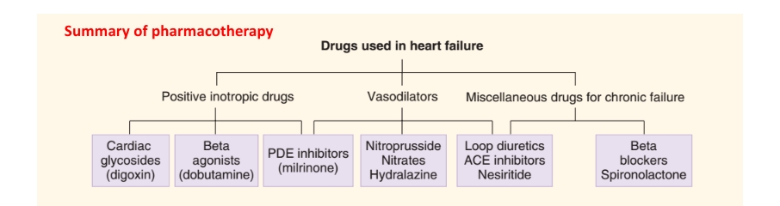
A.Drugs that increase Myocardial contraction force ( positive Inotropic Agents) :
1.Cardiac glycosides: Digoxin ( Lanoxin) and Digitioxin ( Digitaline).
ADVERSE EFFECT :
Anorexia , vomiting , headache , sinus bradycardia .
2.Phosphodiesterase Inhibitors : These agents cause a cAMP- mediated increase in intracellular calcium . Which subsequently increases the force of contraction within the myocardial cell .
Agents : Inamrinone and milrinone .
3.Dopamine and Dobutamine : Exert a fairly specific positive inotropic effect , presumably through their ability to stimulate beta - 1 receptor on the myocardium .
Prenalterol
B. Drugs that decrease cardiac work out:
1.Drugs that affecting the renin – angiotensin system :
A. ACE inhibitors : Captopril (Capoten) and enalapril ( Vasotec) .
Enzymes that convert angiotensin 1 to angiotensin II in the blood stream .
B. Angiotensin II Receptors Blockers :
Candesartan , valsartan and Isoartan . These drugs prevent angiotensin II from binding on vascular tissue .
Skin rashes , dizziness and gastrointestinal discomfort .
2.Beta blockers : It block the effects of norepinephrine and epinephrine . It can also normalize sympathetic stimulation of heart .
Reduced contraction force , Slow heart beat .
Acebutolol , Atenolol , Carvedilol .
3.Diuretics : Diuretics work by inhibiting the reabsorption of sodium from the nephron . Which in turn decrease the amount of water that is normally reabsorbed with sodium , thus increasing water excretion.
Volume depletion , hypokalemia .
Furosemide , spironolactone .
4. Vasodilators : It produce vasodilation by blocking alpha- 1 receptor on vascular smooth muscle .
Headache , dizziness , hypotension .
Prazosin , organic nitrates .
Q3.(a) Explain the effects and adverse effects of organic nitrates in angina pectoris .
Ans. NITRATES :
Nitrates are class of medication not to be confused with the ( byproducts from nitrogen fertilizers)that cause vasodilation by donating nitric oxide (NO . Nitrates exert their effect by dilation venous coronary arteries and small arteries its maximal vaso dilation is in venous vessels
EFFECTS OF NITRATES ON ANGINA PECTORIS:
Nitroglycerine was the first medication used in 1879 by William marwell for treatment of angina pectoris
They act as vasodilators coronary vasodiators and modest arteriolar dilators
The primary anti ischemic effect of nitrate is to decrease myocardial oxygen demand by producing systemic vaso dilation . this systemic vasodilation reduce left ventricular systolic wall stress
For patients with stable angina or predictable angina . long nitrates can be used as prophylaxis .
Increasing exercise to clearance in patients
For patients with acute angina pain, short acting nitrates are useful for symptoms refect
Rapid development of tolerance , loss or diminution of antianginal and antishenic effect
Nitrate work by dilatory blood vessels .
● Nitrate has been used to treat chest pain since 1870 .
●Nitroglycerine patches applied to 10- 12 hours during day increase exercise duration fir 8- 12 hours .
● Nitrate dilates arteries and veins net only in the heart but also else where in the body by dilatory blood vessels of the heart by importory blood flow to heart muscles .
ADVERSE EFFECTS :
Main adverse effect from nitrate use come from dilation of the venous blood vessels .
Other side effect can be reflexes from the activation of sympathetic nervous system or re – exposure after with drawl . These side effect include
Headache ( greater than 10%)
Hypothensiance( 0.1 to10%)
Syncope (0.1 to 10% )
Reflex tachycardia methemoglobinenia .
Monday disease tachycardia headache and dizziness during re – exposure .
● Headache dizziness
● Light head ache flushing
● Warm feeling in the face not everyone experience these .
(b): Write down the treatment algorithm for improving symptoms of stable angina ?
Ans. TREATMENT ALORITHM FOR IMPROVING SYMPTOMS OF STBLE ANGINA:
● If your angina is stable you may be able to control it with is life style changes and medication treatment for stable angina includes life style changes medication .
● You can usually predict when the pain will occur , so reducing physical exertion can help manage your chest pain .
● Dietary changes ( eating head ache ) .
Daily exercise
Quit smoking
Blood thinning medication
Angioplasty
Treat blockages to avoid heart accact .
MEDICATION:
Several medication can improve anginas symptoms inducing
BETA BLOCKERS :
These block the effect of hormones epinephrine due to which heart beat slowly with less force decrease heart effect and angina pain
ASPIRIN (anti platelet medication)make easy for blood flow through narrowed arteries
NITRATES :widen blood vessels and allow more blood to flow to your heart muscles.
STATINA:
It lower blood cholestrol .
CALCIUM CHANNEL BLOCKERS :
Then drugs relax and widens blood vessels this increase blood flow in your heart reducing or preventing angina.
RANOLAZINE (ra na za ) :
Antianginal medication use as a substitute if your symptoms don't improve with other medication .

