NAME : MUJAHID AYAZ ID: 14304
DEP : BS (SOFTWAE ENGNEERING) 5 SEMESTER
SUBJECT: DATA SCEINCE

Q1. What type of errors do occur in Python, write the a program with different
types of errors as well as write separate correction code?
Ans:1: syntax eroor
2: name error
3:type error

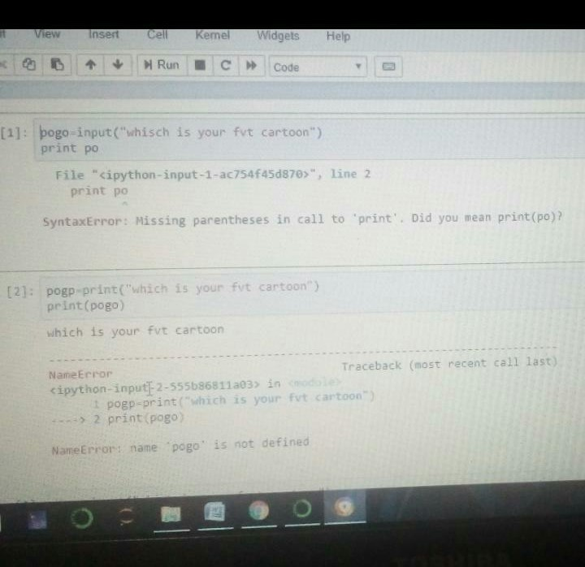
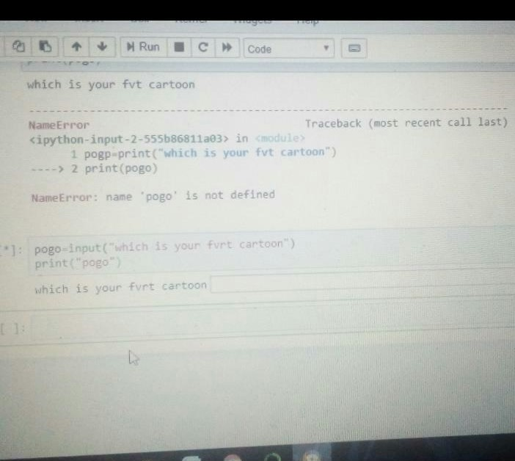
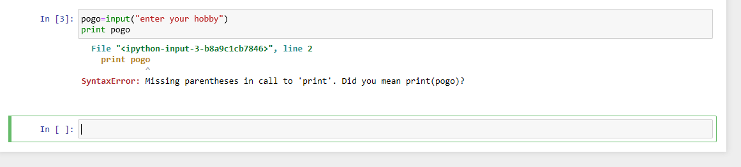
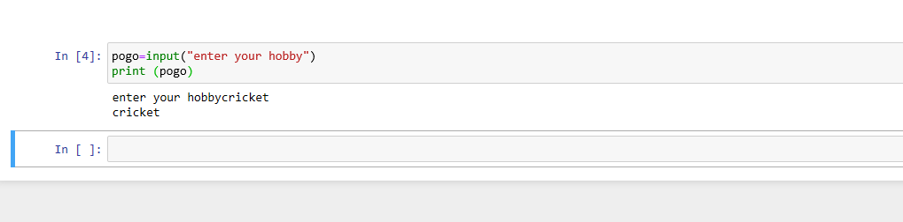
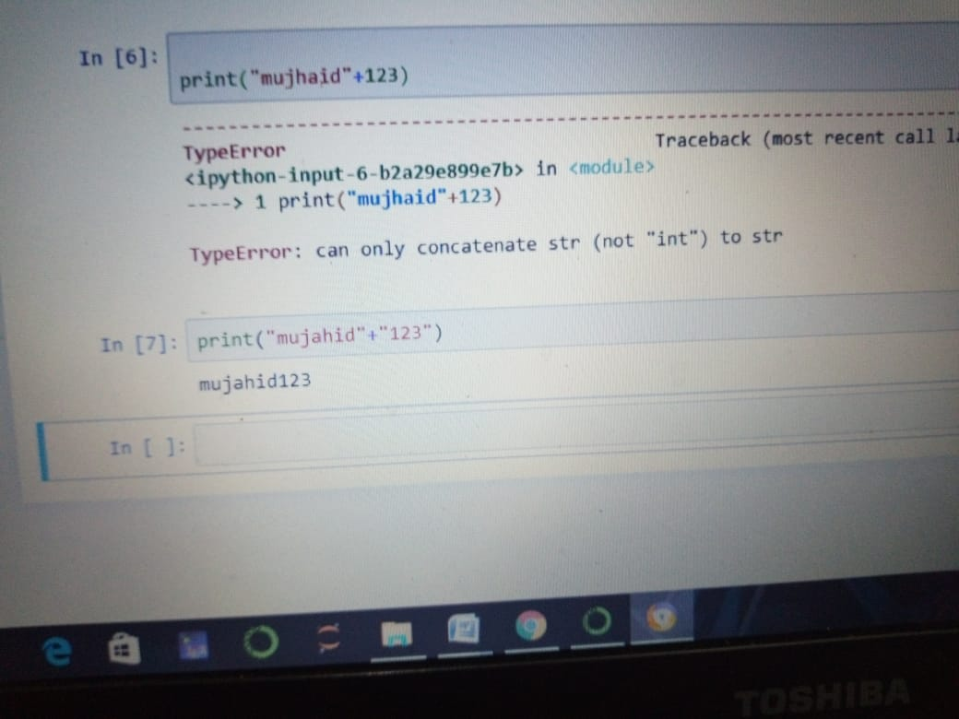

Q2: What are Boolean String test, write the code for each Boolean string test code?
Ans: Boolean strings test are Ture and False and methods are following .
1 : . isalpha() 2: .isnum() 3: .istitle() 4: .isdigit() 5: .islower() 6: .isupper() 7: .startswith()

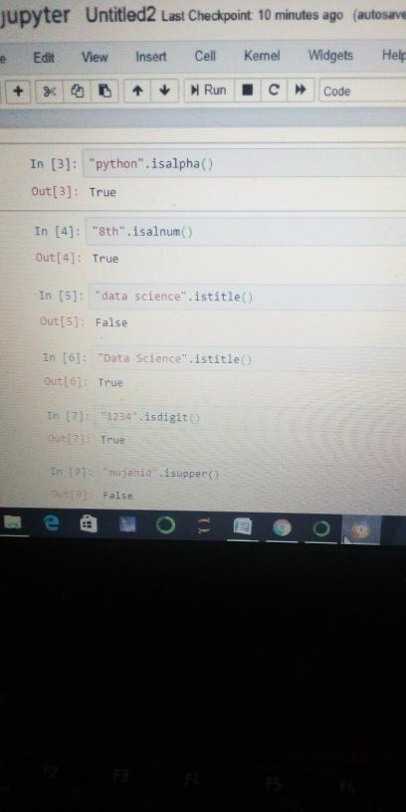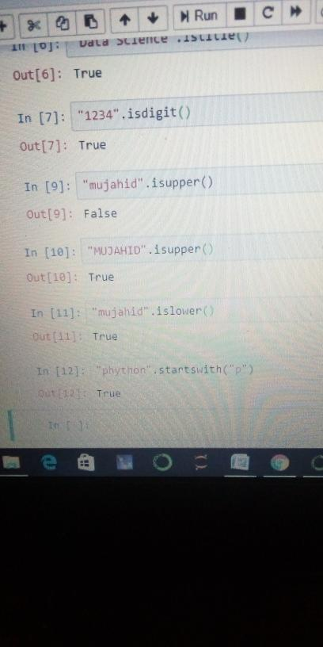

hgcgg

Q3: what is formatting strings input means in python,write a program in which formatting strings input is used?
Ans: String Formatting. Python uses C-style string formatting to create new, formatted strings. The "%" operator is used to format a set of variables enclosed in a "tuple" (a fixed size list), together with a format string, which contains normal text together with "argument specifiers", special symbols like "%s" and "%d".
CODING:
