Mid Semester Assignment

Student Name:
Muhammad Naeem Riasat
Student ID#:
13124
Program: -
BS-SE
Subject :
OBJECT ORIENTED SYSTEM
ANALYSIS AND DESIGN
Class and Section:
SE (A) 8th
Dated:
26 April 2020

Q1: Draw Use Case diagram
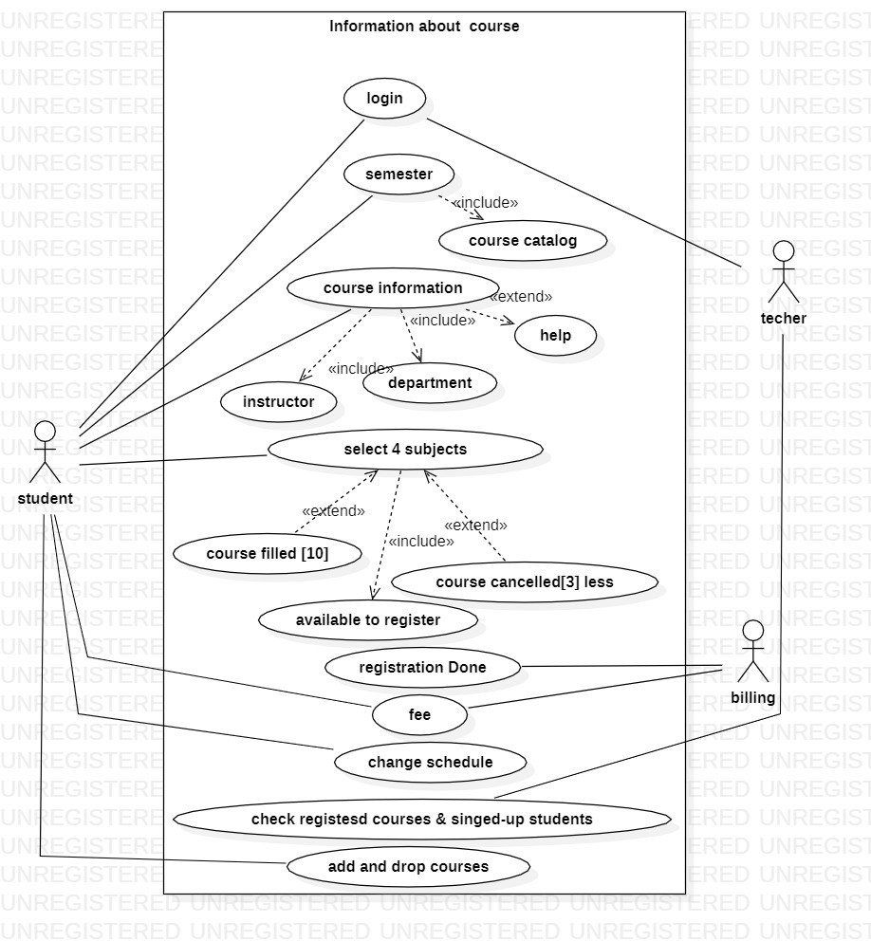

Q2: Draw Class Diagram

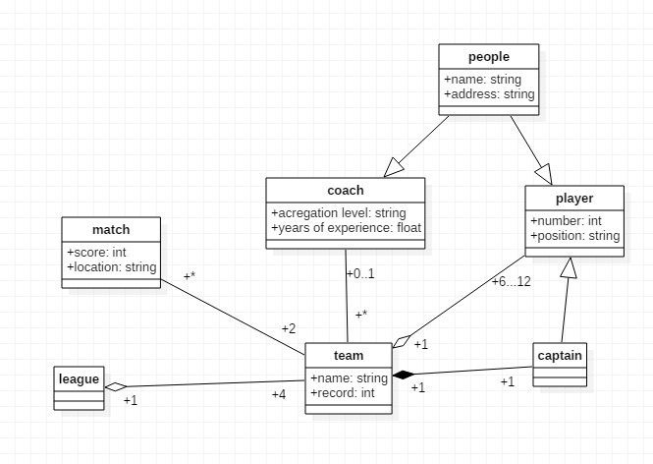

Q3: Draw Activity Diagram
