Name = Amjad ullah
ID # 16226
Dept = BBA
PAPER = Principle of marketing
Teacher = Shahzeb Anwar

Q no4 answer below
Ans /
Branding :·
A branding is a name, sign, term, symbol, or design, or the combination of these, that identifies the maker or seller of a product or service. Consumer view a brand as an important part of a product, and branding can add value to a product. Branding has become so strong that today hardly anything goes unbranded.
Even fruits, vegetables, dairy product, and poultry are branded.
Branding helps buyers in many ways. Brand name helps consumer to identify product that might benefit them.

Example :·
Branding often takes the form of a recognizable symbol to which consumers easily identify, such as a logo.
Some common examples of brands are Nike “swoosh”, the golden arches of McDonald’s, the Apple used by apple computers, Coca-Cola, Ferrari, and so on.

Q no3 answer below
Ans /
Product life cycle :·

As organizations introduce new products to consumers, demand for the product increases, peaks, and declines. Each product passes through a series of stages from product introduction to product decline. The series of stages is known as product life cycle. Most products have a short life span and organization must be aware which product life cycle stage the is in at a particular point in time. There are four stages in the product life cycle.
1. The introduction stage
2. The growth stage
3. The maturity stage
4. The decline stage

Model :·
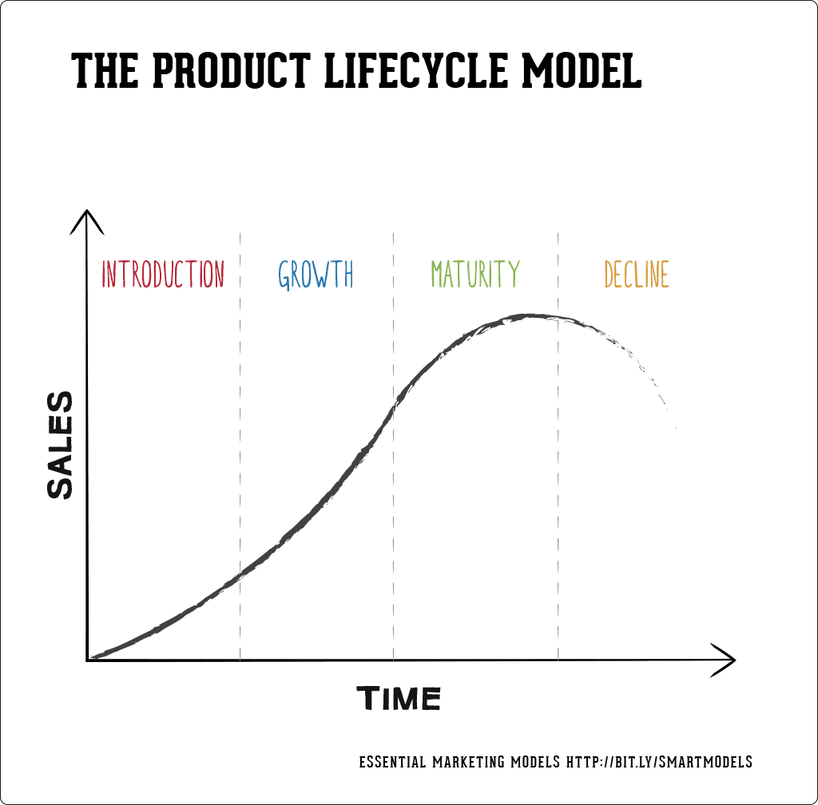

Q no2 answer below
Ans /
New product development process :·

1 ) Idea generation:
• New product development start with idea generation- the systematic search for new product.
• Using internal sources, the company can find the new ideas through formal R&D.
• Company can also obtain good new product ideas from any of a number of external sources.

2 ) Idea screening
• The first reducing stage is idea screening, which helps spot good ideas and drop poor ones as soon as possible.
• Product development costs rise greatly in later stages, so the company wants to go ahead only with those product ideas that will turn into profitable products.
3 ) Concept development and testing
• Product concept
A detailed version of the new product idea stated in meaningful consumer terms.
• Concept testing
Testing new product concept with a group target consumers to find out if the concept have strong consumer appeal.

4 ) Marketing Strategy Development
• The marketing strategy statement consist of three parts.
a) The first part describe the target market; the planed value position; and the sales, market share, and profit goals the first few years.
b) The second part of market strategy statement outlines the product panned price, distribution, and marketing budget for the first year.
c) The third part of the marketing strategy statement describes the planned long run sales, profit goals, and marketing mix strategy.

5 ) Business analysis
• Business analysis involve a review of the sales, costs, and profit projection for the new product to find out whether they satisfy the company’s objectives.
• If they do, the product can move the product development stage.

6 ) Product development
• If the concept passes the business test, it moves into product development.
• Here R&D or engineering develops the product concept into a physical product.
7 ) Test marketing
• If the product passes both concept test and product test, the next step is test marketing, the stage in which the product and it’s proposed marketing program are into realistic marketing settings.

8 ) Commercialization
• Test marketing gives management the information needed to make a final decision whether to launch the new product.
• If a company goes ahead with commercialization, introducing the new product into the market, it will face high costs.
Modle:

Idea screening
Concept development and
testing
commercialization
Test marketing
Product development
business analysis
Marketing
Strategy development
Idea
generation

Q no1 answer below
Ans /
SWOT analysis :·
SWOT (Strengths, Weakness, Opportunities, And Threats) is a framework use to evaluate a company’s competitive position and to develop strategic planning. SWOT analysis assesses internal and external factors, as well as current and future potential.

Why companies use SWOT analysis ?
The SWOT analysis is useful for analyzing a company’s strength, weakness, opportunities and weakness. Even the biggest companies use this simple way to for their business. SWOT analysis tells to the company that where and with whom they should to compete. Companies also use this analysis to improve their productivity and to make more effective
SWOT analysis of INU :·
Strength :·
• Provide quality education with affordable price.
• Transportation and Discipline.
• All programs under one roof.
• Student leadership program.
• Safety measures.
• Upload Islamic values.
• Chartered with HEC.

Weakness :·
• Resistance to change.
• Leading competitors.
• Location.
• Smallest area.

Opportunities :·
• Strong collaboration with MNC’s and local companies.
• Introduction of new specialization to attract wider customer segment.
• Growth potential.
• New constructions.
• International scholarship.

Threats :·
• Political and socio economical conditions.
• Emergence of new business schools and universities.
• Negative public perception.
• Development of another university in the area.

