Name: Hammad ullah
Id: 15839
Section: A
Paper: Human physiology
Instructor: Shahzaib sir

Q:1 How stimulus of smeel moves from nostril to brain make a daigram?
- Smell begins at the back of nose, where millions of sensory neurons lie in a strip of tissue called the olfactory epithelium. The tips of these cells contain proteins called receptors that bind odor molecules. The receptors are like locks and the keys to open these locks are the odor molecules that float past, explains Leslie Vosshall, a scientist who studies olfaction at Rockefeller University.

- People have about 450 different types of olfactory receptors. (For comparison, dogs have about two times as many.) Each receptor can be activated by many different odor molecules, and each odor molecule can activate several different types of receptors. However, the forces that bind receptors and odor molecules can vary greatly in strength, so that some interactions are better “fits” than others.

- "Think of a lock that can be opened by 10 different keys. Two of the keys are a perfect fit and open the door easily. The other eight don’t fit as well, and it takes more jiggling to get the door open," explains Vosshall.

- Odors in the Brain

- This neural code begins with the nose’s sensory neurons. Once an odor molecule binds to a receptor, it initiates an electrical signal that travels from the sensory neurons to the olfactory bulb, a structure at the base of the forebrain that relays the signal to other brain areas for additional processing.

- One of these areas is the piriform cortex, a collection of neurons located just behind the olfactory bulb that works to identify the smell. Smell information also goes to the thalamus, a structure that serves as a relay station for all of the sensory information coming into the brain. The thalamus transmits some of this smell information to the orbitofrontal cortex, where it can then be integrated with taste information. What we often attribute to the sense of taste is actually the result of this sensory integration.

- "The olfactory system is critical when we're appreciating the foods and beverages we consume," says Monell Chemical Senses Center scientist Charles Wysocki. This coupling of smell and taste explains why foods seem lackluster with a head cold.

- You’ve probably experienced that a scent can also conjure up emotions and even specific memories, like when a whiff of cologne at a department store reminds you of your favorite uncle who wears the same scent. This happens because the thalamus sends smell information to the hippocampus and amygdala, key brain regions involved in learning and memory.

- A Better Smeller

- Although scientists used to think that the human nose could identify about 10,000 different smells, Vosshall and her colleagues have recently shown that people can identify far more scents. Starting with 128 different odor molecules, they made random mixtures of 10, 20, and 30 odor molecules, so many that the smell produced was unrecognizable to participants. The researchers then presented people with three vials, two of which contained identical mixtures while the third contained a different concoction, and asked them to pick out the smell that didn’t belong.

- No longer should humans be considered poor smellers. In fact, new research suggests that your nose can outperform your eyes and ears, which can discriminate between several million colors and about half a million tones. “It’s time to give our sense of smell the recognition it deserves

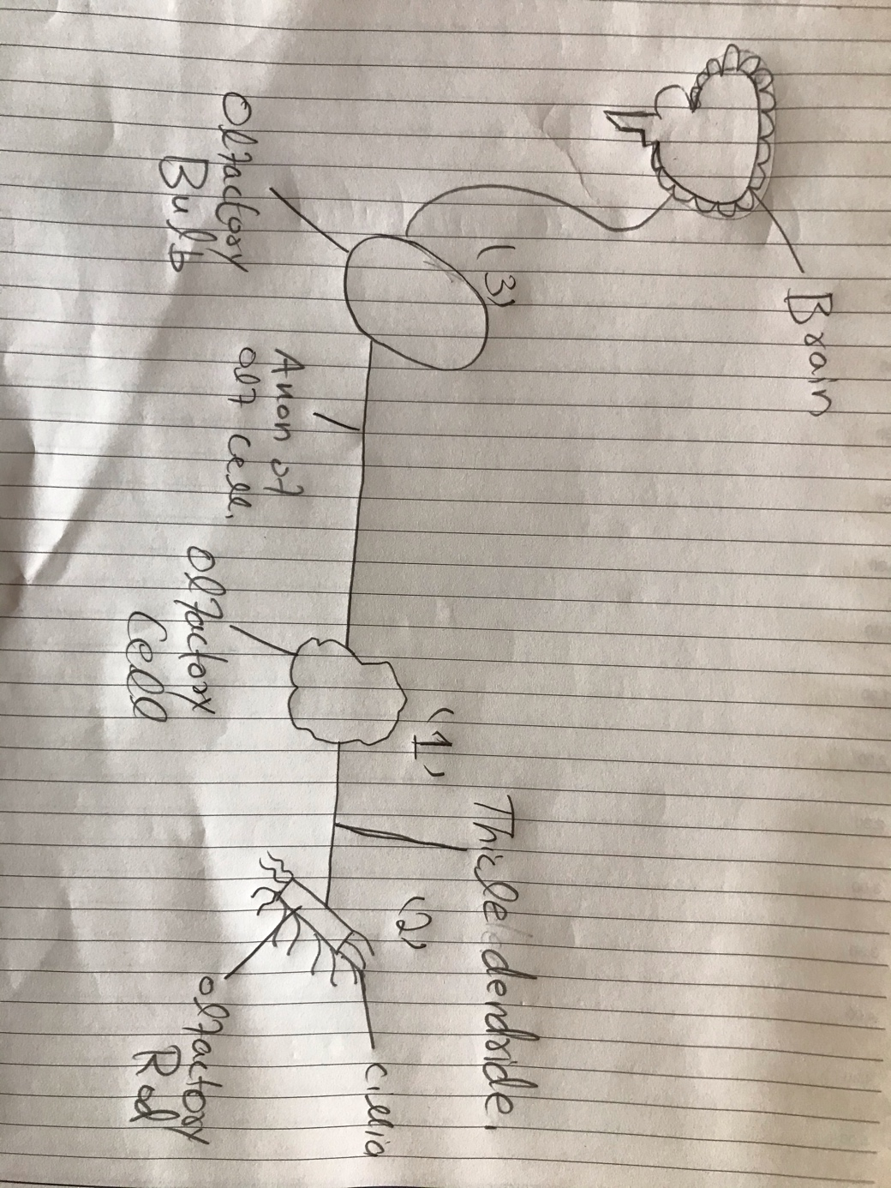
- Daigram:

Q:2 difference between Haemostasis haematopoiesis and homeostasis?

- Hameostasis:
  - Is the wound healing.This involves blood clothing. Haemostasis has three major steps 1)vasoconcentration 2) temporary blockage of a break by a platelet plug 3) blood coagulation and formation of a fibrin clot.these procceses seal the hole until tissue are repaired.
- Homoeostasis:
  - It is the process by which varriable are regulated so that internal condition remain stable and relatively constant.Example of homeostasis include the regulation of temprature and the balnced between acidity and alkalinity P.H. It is the process that maintain the stability of the human body internal envioment in respones to changes in external comdition.
- Haematopoiesis:
  - Is the process by which immature precursor cells devolop into mature blood cells the curruntly accepted theory on how this process work is called the monophyletic theory which simply means that a single type of stem cell gives rise to all the mature blood cells in the body

Q: 2 PART B). Erythroblastosis Fetails?
- Erythroblastosis fetail is a hemolytic anemia in the fetua or neonate caused by trans placental transmission of maternal antibodies to fetal RBCs The disorders ussualy results from incompatibility between maternal and fetal blood groups. Often RH antigens.

Q: 3 what is immunty
- Immunity is deffined as the capicity of the body to resist pathogenic agents. It is the abilit of body to reset the entry of different types of foreign bodies like bacteria. Virus. Toxic. Substances. Etc

- Different types of immunity:

- Two types of immunity

  - Innate immunity
  - Acquired immunity
- Inmate immunity
  - Innate immunity is the inborn capacity of the body to resist pathogens. By chance, if the organisms enter the body, innate immunity eliminates them before the development of any disease. It is other wise called the natural or non-specific immunity.
  - This type immunity represents the first line of depense against any type of pathogens. Therefoe, It is also called non-specific immunity.

- Acquired immunity:
  - Acquired immunity is the resetance devolped in the body against any specific foreign body like bacteria,viruses, toxins, Vaccines or transplanted tissues. So, this type immunity is also known as specific immunity.
  - It is the most powerfull immune mechanisms that protects the body from the invading organisms or toxic substances. Lympocytes are responsible for acquired immunity.
Q: 3 PART B) difference between antigen and antibody:
- Antigen:
  - Antigen is any foreign particle that elicits an immune response or that specially binds to to an antibody or a T-Cell receptor often used as a synonym for immunogen
- Antibodies:
  - Antibodies or immunoglobulins orglycoprotiens consisting of identical heavy chains that recogonaize a specific epitope on an antogen and facilitates elimination of that antigen.

Q: 4 different functions of antibodies
- IgA plays a role in localized defense mechanism in external secretions like tears
- IgD is involved in recognition of the antigen by B lymphocytes.
- IgE is involved in allergic reaction
- IgG is responsible for complement fixation
- IgM is also responsible for complement fixation

Q: 4 PART B) difference between primary and secondary response to an antigen?
- • The primary immune response occurs when an antigen comes in contact to the immune system for the first time. During this time the immune system has to learn to recognize antigen and how to make antibody against it and eventually produce memory lymphocytes.
- • The secondary immune response occurs when the second time (3rd, 4th, etc.) the person is exposed to the same antigen. At this point immunological memory has been established and the immune system can start making antibodies immediately.

Q: 5 cell mediate immunity

- The cell mediate immune system consist of T-Cells which originate in the bone marrow, but moves to the tymus where there devolopment is completed T-Cells are highly specilized cells in the blood and lymph. They fight bacteria, viruses, fungi, protozoans, cencer, etc,, with in bost cells and against fight foreign matter such as organ transplant.
- There are three kinds of T-cells cytotoxic T-cells directly kill invader healper T-cells and B-cells and other T-cells to do their jobs. supressorT-cells suppress the of B and other T-cells so they don’t overreaction the cellular immune response.

- Antibody mediate immunity

    - The humoral immune system consists of B-cells which originate in the bone marrow and stay there to devolop B-cells can produce antibodies but need exposur to foreign antigen to do so. These antigens are cell surface oligosacharides and protiens which the cells uses as’
    - Antibodies are chemically protiens present in blood plasma and lymph. They help in fighter bacteria and viruses in body fluids. All daughter cells of a B-cells will be able to produce the same antibodies as thr mother cell.Antibodies bond a certain parts of antigen to mark it for destruction ( by the T-cells)

