DENTAL SEC A ANATMOY, 2ND SEMESTER,FINAL TERM
MAM KOUSAR SHAH JEHAN
STUDENT NAME_Muhammad Amir__________ , ID____15682_________
Attempt all questions. Every question carry 10 marks.
Q1. Write a note on pituitary gland, its harmones and abnormalities?

Ans * pituitary gland:

It is a small structure in the head. It is called the master gland because it produces hormones that control other glands and many body functions including growth. ... These influences are exerted through the effects of pituitary hormones on other endocrine glands except for growth hormone which acts directly on cells.

* It's Hormones:

adrenocorticotropic hormone, which stimulates the adrenal glands to secrete steroid hormones, principally cortisol.

growth hormone, which regulates growth, metabolism and body composition.

luteinising hormone and follicle stimulating hormone, also known as gonadotrophins.

It's abnormalities:

The symptoms of hypopituitarism depend on which hormones your pituitary gland is not producing enough of. ... If it doesn't produce enough follicle-stimulating hormone or luteinizing hormone, it might cause problems with sexual function, menstruation, and fertility.

* Sign and symptoms

Headaches.

Vision problems.

Unexplained weight gain.

Loss of libido.

Feeling dizzy and nauseous.

Pale complexion.

Muscle wasting.

Coarsening of facial features.
;;;;;;;;;;;;;;;;;;;;;;;;;;;;;;;;;;;;;;;;;;;;;;;;;;;;;;;;;;;;;;;;;;;;;;;;;;;;;;;;;;;;;;;;;;;;;;;;;;;;;;;;;;;;;;;
Q2.write a note on shoulder joint and wrist joint?

Ans *note on shoulder joint:

The shoulder joint (glenohumeral joint) is a ball and socket joint between the scapula and the humerus. It is the major joint connecting the upper limb to the trunk. It is one of the most mobile joints in the human body, at the cost of joint stability.

The shoulder joint is formed where the humerus (upper arm bone) fits into the scapula (shoulder blade), like a ball and socket. Other important bones in the shoulder include: The acromion is a bony projection off the scapula. The clavicle (collarbone) meets the acromion in the acromioclavicular joint.

* wrist joint:

The wrist joint (also known as the radiocarpal joint) is a synovial joint in the upper limb, marking the area of transition between the forearm and the hand.

The wrist joint also referred to as the radiocarpal joint is a condyloid synovial joint of the distal upper limb that connects and serves as a transition point between the forearm and hand. A condyloid joint is a modified ball and socket joint that allows for flexion, extension, abduction, and adduction movements
;;;;;;;;;;;;;;;;;;;;;;;;;;;;;;;;;;;;;;;;;;;;;;;;;;;;;;;;;;;;;;;;;;;;;;;;;;;;;;;;;;;;;;;;;;;;;;;;;;;;;;;;;;;;;;;;;;;;;;;;;;;;;;;;;;;;;;
Q3.what is axilla and cubital fossa and its important contents?

QAns ) Tahe cubital fossa is an area of transition between the anatomical arm and the forearm. It is located as a depression on the anterior surface of the elbow joint.

Contents-:

The contents of the cubital fossa include vessels, nerves and the biceps tendon (lateral to medial):

Radial nerve – this is not always strictly considered part of the cubital fossa, but is in the vicinity, passing underneath the brachioradialis muscle. As it does so, the radial nerve divides into its deep and superficial branches.

Biceps tendon – runs through the cubital fossa, attaching to the radial tuberosity, just distal to the neck of the radius.

Brachial artery – supplies oxygenated blood to the forearm. It bifurcates into the radial and ulnar arteries at the apex of the cubital fossa.

Median nerve – leaves the cubital between the two heads of the pronator teres. It supplies the majority of the flexor m uscles in the forearm.

Axilla :- The axilla (also, armpit, underarm or oxter) is the area on the human body directly under the joint where the arm connects to the shoulder. It also contains many sweat glands. ... The underarm regions seem more important than the genital region for body odor, which may be related to human bipedalism.

Contents:-

The axilla contains both the axillary artery and axillary vein. The vein runs medial to the artery along its length. The cords of the brachial plexus surround the axillary artery and are named after their position relative to the artery.

;;;;;;;;;;;;;;;;;;;;;;;;;;;;;;;;;;;;;;;;;;;;;;;;;;;;;;;;;;;;;;;;;;;;;;;;;;;;;;;;;;;;;;;;;;;;;;;;;;;;;;;;;;;;;;;;;;;;;;;;;;;;;;;;;;;;;;

Q4.write a note on lower limb and its main important structures briefly?

Ans Note the lower limb ;

The lower limb is divided into three regions.these are the thigh located between the hip and knee joints.the leg. Located between the knee and ankle joint; and the distal to the to the ankle the foot.there are 30 in each lower limb.

Its main impotent structure ;

The lower limbs consist of four major part ; a girdle formed by the hip bones .the thigh . the leg . and the foot it is specialized for support of weight.adaptation to gravity and locomotion.

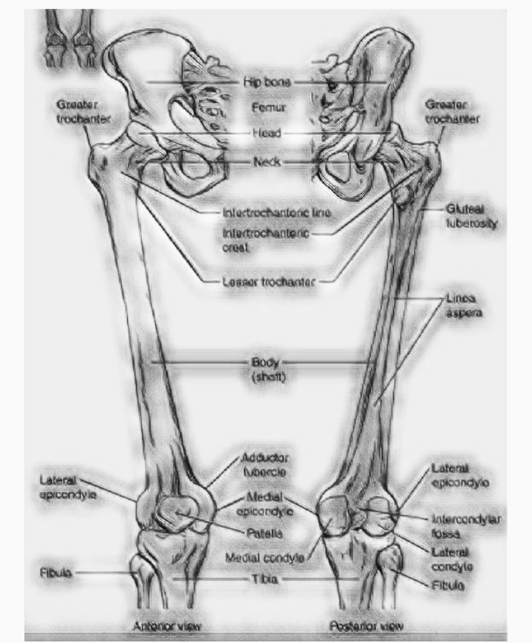
;;;;;;;;;;;;;;;;;;;;;;;;;;;;;;;;;;;;;;;;;;;;;;;;;;;;;;;;;;;;;;;;;;;;;;;;;;;;;;;;;;;;;;;;;;;;;;;;;;;;;;;;;;;;;;;;;;;;;;;;;;;;;;;;;;;;;;;;;;;
Q 5 .[i]A person fell down from a tree and become unconscious, with bleeding from head, what will you do as a first aid?

Ans (i)….Keep the person still. Until medical help arrives, keep the injured person lying down and quiet, with the head and shoulders slightly elevated. ...

Stop any bleeding. Apply firm pressure to the wound with sterile gauze or a clean cloth. ...

Watch for changes in breathing and alertness.

For severe bleeding, take these first-aid steps and reassure the injured person.

Remove any clothing or debris on the wound. ...

Stop the bleeding. ...

Help the injured person lie down. ...

Don't remove the gauze or bandage. ...

Tourniquets: A tourniquet is effective in controlling life-threatening bleeding

The primary causes for concern are the airway and the circulation. Thereafter, the major concern is to avoid secondary injuries, such as would arise from careless movements of the neck in an unconscious person.

If they are breathing – roll them into the recovery position (on their side so that their tongue falls forward in their mouth and any vomit can drain away), trying not to twist their neck or spine at all. Any head injury could have caused spinal damage as the head recoils from the blow.

If they are not breathing start CPR.

Call for an ambulance.

(ii) you have to meet with your friend and you came to know he is covid positive, what precautionary measures will you take?m

(ii)

Maintain at least 1 metre (3 feet) distance between yourself and others. Why? When someone coughs, sneezes, or speaks they spray small liquid droplets from their nose or mouth which may contain virus. If you are too close, you can breathe in the droplets, including the COVID-19 virus if the person has the disease.

• Avoid visitors while you have symptoms.

• Household members should stay in a different room or if that is not possible, maintain a distance of at least 1 meter.

• Hand must be cleaned before and after preparing food, before eating, after using the toilet, and whenever hands look dirty.

THE END

