Faiza noor
16029

Question no 1

STEPS INVOLVE IN THE URIC ACID FORMATION :

The following steps involve in the uric acid formation are given below in the following.

STEP. 1: FORMATION OF CARBAMOYL_PHOSPHATE.
* condensation of co2, ammonia, and ATP to form carbamoyl phosphate is catalyzed by mitochondrial carbamoyl phosphate synthase I.
* formation of carbamoyl phosphate requires 2 Mol of ATP, one of which serves as a phosphate donor.
* the reaction proceeds stepwise.
* Reaction of bicarbonate with ATP forms carbonyl phosphate and ADP.
* ammonia then displaces ADP, forming carbamate and orthophosphate.
* phosphorylation of carbamate by the second ATP then forms carbamoyl phosphate.
* A cytosolic form of this enzyme, carbamoyl phosphate synthase II, uses glutamine rather than ammonia as the nitrogen donor and functions in pyrimidine biosynthesis.

REACTION
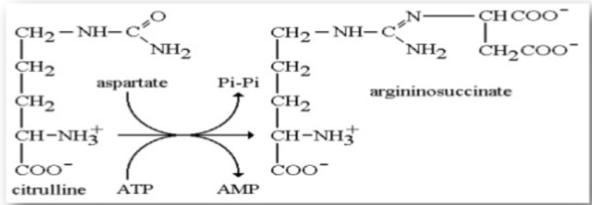

*CPS1 is strongly activated by N-acstyl glutamate, which controls the overall rate of urea production.

STEP. 2: FORMATION OF CITRULLINE :
* The carbamoyl group of carbamoyl phosphate is transferred to ornithine, forming citrulline and ortho phosphate.
* the reaction catalyzed by ornithine trans carbamoylase.
* subsequent metabolism of citrulline take place in the cytosol.

Reaction
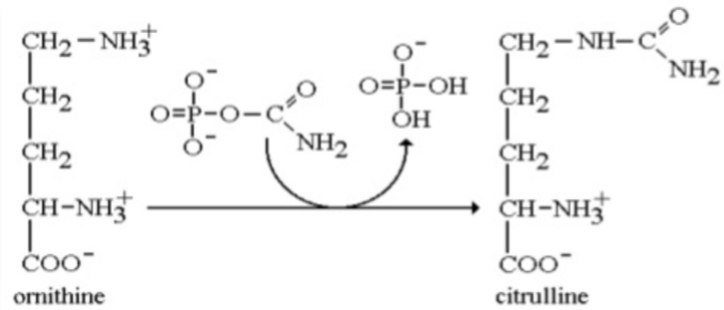

This enzyme has no regulatory significance. The reminder of the urea cycle steps take place in the cytosol. This requires the continuous export of citrulline and the uptake of ornithine across the inner mitochondrial member.

STEP. 3:FORMATION OF ARGINO SUCCINATE :

* Argininosuccinate synthase (ASS) links l_aspartate and citrulline via the amino group of aspartate and provides the second nitrogen of urea.
* the reaction requires ATP and involves intermediate formation of CITRULLYL-AMP.
subsequent displacement of AMP by aspartate then forms Argininosuccinate.

REACTION
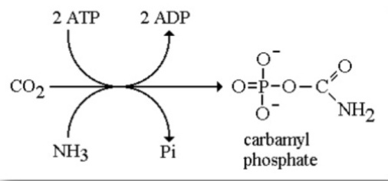

* production of arginino_succinate is an energetically expensive process, since the ATP is split to AMP and pyrophoshpate.
* the pyrophoshpate is then cleaved to in organic phosphate using pyrophoshpate, so the overall reaction costs two equivalents of high energy phosphate per mole.

STEP. 4 : CLEAVAGE OF ARGINO SUCCINATE :

* cleavage of arginino_succinate catalyzed by Argininosuccinate lyase (ASL) proceeds with retention of nitrogen in arginine and release of the aspartate skeleton as fumarate.
* addition of water to fumarate forms L_ malate, and subsequent NAD+_dependent oxidation of malate forms oxaloacetate.
* transmination of oxaloacetate by glutamate aminotransferase then re_forms aspartate. Carbon skeleton of aspartate_fumarate thus acts as a carrier of the nitrogen of glutamate into a precursor of urea.

REACTION
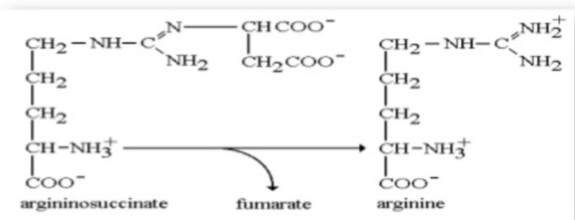

This reaction sequence is very similar to the conversion of IMP and AMP in the purine biosynthetic pathway. In each case fumarate is formed as a by _product. Fumarate is not transported by mitochondria, so this requires the presence of cytosolic fumarate to form malate.

STEP. 5:CLEAVAGE OF ARGININE :

* hydrolytic cleavage of the guanidino group of arginine, catalyzed by the liver arginase (ARG1) releases urea, the other product, ornithine, reenters liver mitochondria for additional rounds of urea synthesis.
* ornithine and lysine are potent inhibitors of arginase, competitive with arginine.

REACTION
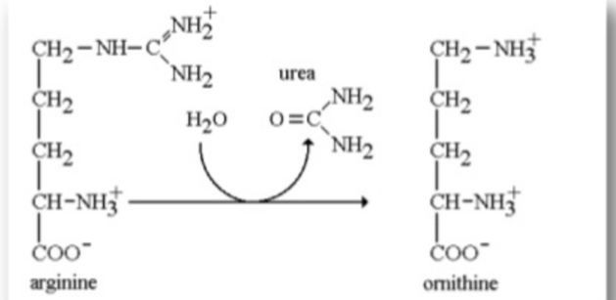

*arginine also serves as the precursor of the potent muscle relaxent nitric oxide (NO) in a Ca2+- dependent reaction catalyzed by NO synthase.

Answer no 3
In electron transport chain their is more energy is produced as compaired to glycolysis and kerb's cycle

ELECTRON TRANSPORT CHAIN

electron transport chain are occur in mitochondrial inner membrane different clusters of protein are present .

PROTEIN INVOLVE IN ELECTRON TRANSPORT CHAIN

foure protein are involve in ETC.
*FMN ( flemo protein)
*FeS (iron sulphur protein)
*ubiquinone
* cytochrome( c,b,a,a3)
These are divided into four complex
In complex one FMN,in complex two FeS,in complex three cytochrome C,in complex four cytochrome a and a3 .
The electron transport means to produce electrons.
In first step FMN 1 the NADH are convert in NAD+ and hydrogen release and leave the electron the two electron release and these two electron are added in complex 1 FMN1 . Then the electron move in Q .
Second complex FeS the FADH are converted into FAD and two electron are released and then two electron are move in FeS.
Total electron are in ebiqunione are five these electron are goes to complex 3 cytochrome Cthen cytochrome B and then cytochrome a and a3 are all in complex four then all electron are moves and the oxygen is present and they gain the electron so the negative sign appear O-1 and the 2H+ and then the 2H+ and then make H2O.

Answer no 4
BETA OXIDATION
The following steps of beta oxidation are given below in the following

1)dehydrogination
2) hydration
3) oxidation
4)thyolisis
" Each step is catalyzed by a distant enzyme "

1) dehydrogenation
It is a chemical reaction that involves the removal of hydrogen from an organic molecule . It is reverse of dehydrogenation it is an important element because it conveets alkanes.

2) hydration
In second step the double bond between C2 and C3 of transenoyl CoA is hydrated forming the end product . L beta hydroxyacyl group(OH) in C2 in place of double bond . This reaction is catalyzied by another enzyme enoyl CoA hydrates . This step requires water.

3) Oxidation
In bio chemistry beta oxidation is the catabolic process by which fattu acid molecules are broken down in the cytosol in prokrytes and in the mitchondria in eukaryotic to generate acetyl CoA which enters the ctric acid cycle and NADH and FADH 2 which are co enzymes used in ETC.

4) thyolisis
In bio chemistry the thyolisis is reaction with the thiol {R-SH} that cleaves one compound in to two . This reaction is silmilar to hydrolysis ,which involves water instead of a thiol.

Question. 2
Following are the clinical significance of the enzymes,
A) ALKALINE PHOSPHATASE:
Alkaline phosphatase in serum consists of 4 structural genotypes :the liver bone kidney type, the intestinal type, the placental type, and the variant from the germ cells. It occurs in osteoblasts, hepatocytes, leukocytes, the kidney, spleen, placenta, prostate, and the small intestine. The liver bone kidney type is particularly important.
A rise in the alkaline phosphatase occurs with all forms of cholestasis, particularly with obstructive jaundice. It is also elevated in diseases of the skeleton system, such as Paget disease, hyperparathyroidism, rickets and osteomalacia, as well as with fractures and malignant tumors. A considerable rise in the alkaline phosphatase activity is sometimes seen in children and juveniles. It is caused by increased osteoblast activity following accelerated bone growth.

B) CREATINE KINASE:
Creatine kinase (CK) is an enzyme that catalyzes the reversible phosphorylation of creatine (CR) by adenosine triphosphate (ATP). when muscle contracts, ATP is converted to adenosine diphosphate(ADP), and CK catalyzed the rephosphorylation of ADP To ATP using creatine phosphate as the phosphorylation reservoir. The CK enzymes is a dimer composed of subunits derived from either muscle (M) or brain (B). Three isoenzymes have been identified. Striated muscle (MM), heart tissue (MB), and brain (BB). normal serum CK is predominantly the ck_MM isoenzyme.
CK activity is greatest in striated muscle, heart tissue, and brain.

C) GAMMA_GLUTAMYL TRANSFERASE:
gamma glutamyl transferase (GGT) is primarily present in kidney,liver, and pancreatic cells. Small amounts are present in other tissues even though renal tissue has the highest level of GGT, the enzyme present in the serum appears to originated primarily from the hepatobilliary system, and GGT activity is elevated in any and all forms of liver disease. It is highest in cases of intra _or posthepatic biliary obstruction, reaching level some 5 to 30 times normal. GGT is more sensitive than alkaline phosphatase (ALP), leucine aminopeptidase, aspartate transaminase, and alanine aminotransferase in detecting obstructive jaundice, cholangitis, and cholecystitis; it's rise occurs earlier than the with these other enzymes and persists longer. Only modest elevation (2-5 times normal) occurs in infectious hepatitis, and in this condition, GGT determination are less useful diagnostically than are measurements of the transaminase.
Normal values are observed in various muscle diseases and in renal failure. Normal values are also seen in cases of skeleton disease, children older than 1 year, and in healthy pregnant women conditions in which ALP is elevated.

Question.no 5 answer

URINE FORMATION
The filter un wanted substance from the blood and produce urine to excrete them .

"Three main steps of urine formation"
STEPS:
» glomerolous filtration
» reabsorbtion
»secretion

STARTING POINT
The formation of urine begins with in the functional unit of the kidney ,the nephron . Urine flows through the nephrons through a system of converging tubules called collecting duct.

NORMAL RANG OF URINE

On average ,this liter results in production of about 125mL/min filtrate produced in (range of 90 to 140mL/min) and 105mL/min filtrate produced in women ( range of 80 to 125mL/min) . This amount aquotes to a volume of about 180L/day in men and 150L/day in women .

NORMAL URINE CHARACTERISTICS

Characteristic / normal values

* volume »»750-2000mL/24hr.

*pH »»»4.5 - 8.0

* specific gravity »»» 1.003 - 1.032

