Name: Tauqeer ahmed
ID: 13912
Department: BS(RAD)
Submitted to: Mam Maheen.

Q1: What are the major differences between CT scan and MRI scan?
Ans:

Before discussing the difrences between MRI and CT scan we should first know something about MRI and CT scan.

CT scan:

A computerized tomography scan (CT or CAT scan) uses computers and rotating X-ray machines to create cross-sectional images of the body. These images provide more detailed information than normal X-ray images. They can show the soft tissues, blood vessels, and bones in various parts of the body. A CT scan may be used to visualize the:
- head
- shoulders
- spine
- heart
- abdomen
- knee
- chest
During a CT scan, you lie in a tunnel-like machine while the inside of the machine rotates and takes a series of X-rays from different angles. These pictures are then sent to a computer, where they’re combined to create images of slices, or cross-sections, of the body. They may also be combined to produce a 3-D image of a particular area of the body.

Why Is a CT Scan Performed?

A CT scan has many uses, but it’s particularly well-suited for diagnosing diseases and evaluating injuries. The imaging technique can help your doctor:
- diagnose infections, muscle disorders, and bone fractures
- pinpoint the location of masses and tumors (including cancer)
- study the blood vessels and other internal structures
- assess the extent of internal injuries and internal bleeding
- guide procedures, such as surgeries and biopsies
- monitor the effectiveness of treatments for certain medical conditions, including cancer and heart disease
The test is minimally invasive and can be conducted quickly.

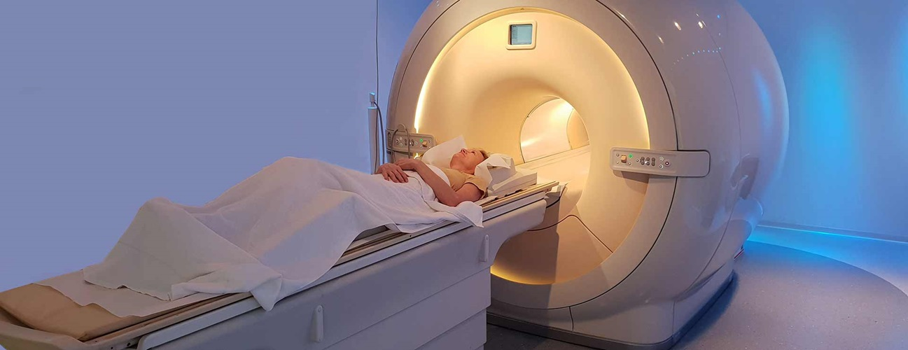

MRI scan:
A magnetic resonance imaging (MRI) scan is a common procedure around the world.MRI uses a strong magnetic field and radio waves to create detailed images of the organs and tissues within the body.Since its invention, doctors and researchers continue to refine MRI techniques to assist in medical procedures and research. The development of MRI revolutionized medicine.

Fast facts on MRI scanning:

- MRI scanning is a non-invasive and painless procedure.
- Raymond Damadian created the first MRI full-body scanner, which he nicknamed the Indomitable.
- The cost of a basic MRI scanner starts at $150,000 but can exceed several million dollars.
- Japan has the most MRI scanners per capita, with 48 machines for every 100,000 citizens.

An MRI scan uses a large magnet, radio waves, and a computer to create a detailed, cross-sectional image of internal organs and structures.
The scanner itself typically resembles a large tube with a table in the middle, allowing the patient to slide in.
An MRI scan differs from CT scans and X-rays, as it does not use potentially harmful ionizing radiation.

Uses:

The development of the MRI scan represents a huge milestone for the medical world.
Doctors, scientists, and researchers are now able to examine the inside of the human body in high detail using a non-invasive tool.
The following are examples in which an MRI scanner would be used:
- anomalies of the brain and spinal cord
- tumors, cysts, and other anomalies in various parts of the body
- breast cancer screening for women who face a high risk of breast cancer
- injuries or abnormalities of the joints, such as the back and knee
- certain types of heart problems
- diseases of the liver and other abdominal organs
- the evaluation of pelvic pain in women, with causes including fibroids and endometriosis
- suspected uterine anomalies in women undergoing evaluation for infertility
This list is by no means exhaustive. The use of MRI technology is always expanding in scope and use.

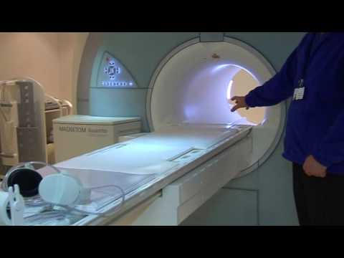

Difference between MRI and CT scan:

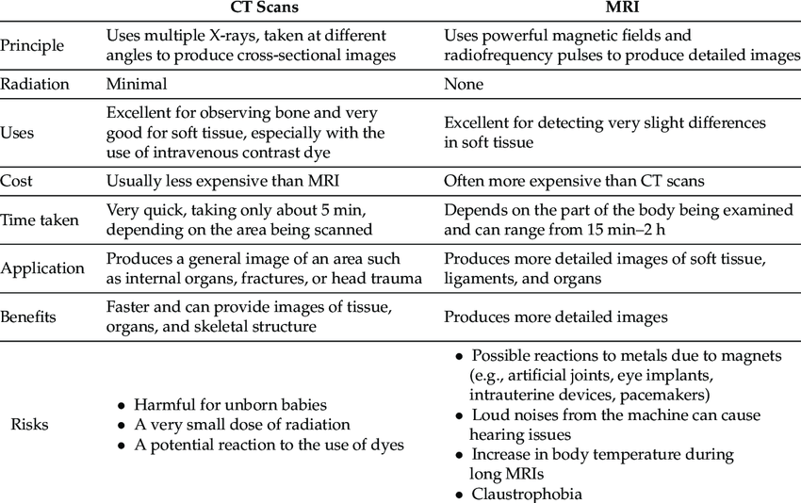

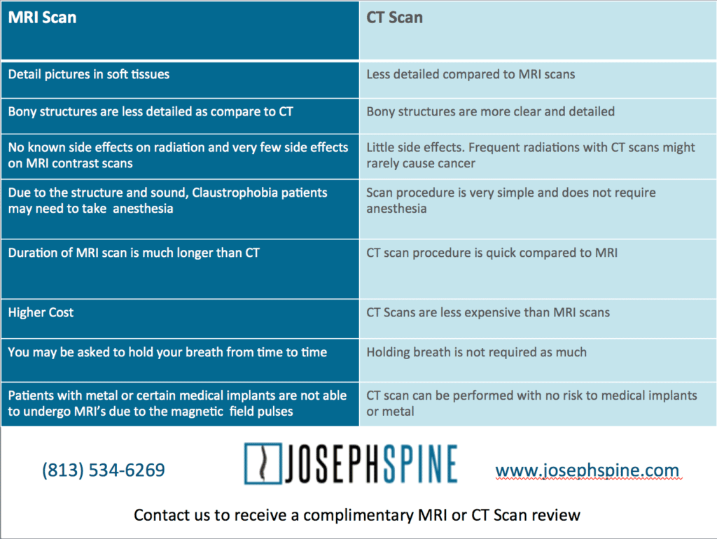

Q2: Which 3D reformation techniques are commonly used in musculoskeletal CT imaging? Explain them.
Ans:

Although Magnetic Resonance Imaging (MRI) is the modality of choice for imaging the musculoskeletal system; Spiral CT remains a viable alternative. Spiral CT is faster, less expensive, easily available and has the potential to evaluate a wide range of musculoskeletal diseases, thus making it an important diagnostic tool . The availability of new algorithms and better computer generated software for multiplanar and 3-D image reconstruction has further enhanced the importance of Spiral CT in musculoskeletal imaging. The use of 3-D reconstructions of spiral CT in the musculoskeletal system is of tremendous advantage to patients in whom CT is desired to delineate the presence and extent of congenital anomalies, traumatic injury, tumour, infection and inflammation. It also has specific role in postoperative evaluation, especially when the results of plain radiography fail to answer the doubts of the orthopaedic surgeon regarding satisfactory alignment of complex fractures . 3-D CT imaging is able to compensate for streak artifacts due to the presence of metallic implants such as plates, pins and prostheses and because of this it is an established modality for postoperative cross-sectional imaging in orthopaedic patients also.
A total of 60 3-D spiral CT imaging studies of the musculoskeletal system were carried out at the CT scan center of a large service hospital, during a six month period from June 2002 to November 2002 on patients ranging from a few months to 68 years of age. The investigations were carried out on a Philips Tomoscan AV spiral CT scanner with a gantry rotation period of one second. The various anatomic regions studied using 3-D spiral CT are depicted in Table 1. To achieve best results with accurate illustration of the musculoskeletal anatomy and pathology, examination techniques need to be optimized, and to achieve this, imaging protocols that were followed . Using the protocols described above axial CT data obtained was reconstructed at 0.5 to 1 mm intervals with segmented interpolation and a restricted field of view of 16 to 18 cm. This yielded 180 to 320 images which were then sent to a work station for 3-D reconstruction which was done using shaded surface display (SSD) and volume rendering (VR) algorithms.

Creation of a 3-D CT image begins with the acquisition and then reconstruction of these axial image data subsets into either SSD or volume rendered reconstructed image. Both these algorithms have been extensively applied to CT data for 3-D visualization of skeletal pathology however each has its potential limitations. Certain disadvantages of SSD makes volume rendering a preferred algorithm for 3-D musculoskeletal imaging applications. Surface rendering shows gross 3-D relationships most effectively, but suffers from additional stair-step artifacts and fails to efficiently display lesions hidden behind overlying bone or located beneath the cortex. Volumerendering algorithms show subcortical lesions and minimally displaced fractures better and with fewer artifacts. In the present study both the 3-D rendering algorithms for musculoskeletal imaging have been used. Comprehensive understanding of sutural anatomy and skull deformity is important for the diagnosis and surgical correction of craniostenosis. To achieve this 3-D imaging is most often resorted to as 2-D CT studies alone fail to detail the relationships of the axially oriented structures. Studies have suggested that 3-D reconstruction is a more accurate method in diagnosing craniostenosis than thin section axial CT images alone, because 3-D CT can depict suture patency, extent of synostosis (i.e., complete versus incomplete bone bridging) and associated calvarial deformities. In the present study three patients with suspected craniostenosis underwent 3-D CT studies and in all of them craniostenosis was confirmed, two patients had stenosis of the sagittal suture with dolichocephalic skull and one had stenosis of the coronal suture with brachycephalic skull. One child with Apert’s syndrome underwent 3-D CT studies to delineate the extent of stenosis of the sutures and associated craniofacial anomalies. The study revealed craniostenosis involving the coronal sutures with resultant turri-brachycephalic skull; the midline of the calvaria had a gaping defect, extending from the glabella to the posterior fontanelle via the metopic suture, anterior fontanelle and sagittal suture. The child also had associated bilateral choanal atresia. 3-D CT imaging provided precise delineation of the various craniofacial defects which led to an effective preoperative planning and the child was taken up for successful surgery. Two patients with polyostotic craniofacial fibrous dysplasia underwent 3-D CT studies which demonstrated thickening and enlargement of thebase of anterior cranial fossa along with narrowing of the superior orbital fissures and the optic canals. These patients also underwent surgery to relieve the narrowing of the superior orbital fissures and optic foramina. 3-D CT imaging in congenital and developmental craniofacial anomalies is important in the pre-operative evaluation and therapy planning than in diagnosis and the results are much better than plain radiographs and 2-D CT scans . The major utilization of 3-D CT imaging in this study was in the evaluation of craniofacial trauma. A linear fracture if oriented in the plane of the CT section may be missed on routine axial 2-D CT and it is here that the role of 3-D CT imaging is invaluable. This modality of imaging is of great help in evaluating complex maxillary, mandibular and orbital fractures as it accurately depicts comminuted fractures, describes in detail the relationship of the bone fragments to each other, to the bone of origin and adjacent structures . Rotated fractured bone fragments are better evaluated using 3-D CT imaging as they can be viewed from innumerable angles and be compared to the normal contralateral side. Sometimes subtle rotational abnormalities can only be appreciated on 3-D images. In the present study 15 patients underwent 3-D CT imaging for craniofacial injuries out of which 9 had complicated comminuted fractures involving the mandible and maxilla (Fig 3). The exact amount of gap between the fractured ends of the bone, precise localization of the bone segments and the relationship of these fragments to the bone of origin and to each other was accurately assessed. Another patient who developed a palatal fistula as a result of gun shot wound in the maxilla was evaluated using 3-D CT imaging. The precise anatomy of the bony defect in the maxilla and the hard palate was delineated and the patient was successfully operated . Thus 3-D CT imaging is an important means to diagnose and exemplify complicated craniofacial fractures and provide a foundation for effective pre surgical management in these patients. Although plain radiography and MRI remain the mainstay in evaluation of tumours of the bone, studies conducted by the Radiology Diagnostic Oncology Group have shown that CT is not only as efficacious but is superior to MRI in the detection of cortical destruction and calcification. In the present study 3-D CT imaging was performed in a total of 10 patients with tumours in various regions of the body. Five patients had primary bone tumours which included osteosarcoma of the lower end of femur in three and osteochondroma of the femur and tibia in two. Two patients had large calcified meningiomas; one arising from the sphenoid ridge on the left side and the other was a large right sided parasagittal meningioma. The aim of performing 3-D CT in patient with meningiomas was to get a true assessment of the extent of the lesion, acquire a global view of the tumour and to evaluate the bone of origin. Three patients who had ameloblastoma of the mandible also underwent 3-D CT imaging which provided a precise anatomic representation of the mass lesion with accurate depiction of the extent of spread. This allowed accurate pre-operative diagnosis and provided the surgeons with good pre and intraoperative conceptualization of the lesion which improved respectability and reduced the duration of surgery thereby providing better surgical outcome. 3-D CT has a specific role in radiation therapy planning; it reassembles the 2-D CT images into a more intuitively obvious shape which simulates the anatomic form thereby helping the radiotherapist to visualize the relationships between tumour target, normal tissue and delivered dose. Another advantage of 3-D imaging is that it can calculate tumour volume pre-operatively which can be compared with the volume of tumour resected on surgery, this will establish whether the tumour has been removed completely or not. Pelvic injury is a major cause of morbidity and mortality following trauma, the average mortality associated with it being 18-24%. Radiological evaluation of the injured pelvis has been simplified with the advent of CT which apart from providing crosssectional display of structures; has the ability to distinguish bone, soft tissue, muscle, pelvic organs and fat with great accuracy. However planar axial CT too has limitations, it may underestimate or even overlook the presence of fractured fragments lying entirely in the transaxial plane. These potential limitations can be overcome by the use of 3-D imaging; it is now possible to reformat the transaxial CT data into 3-D images which allow an integrated CT imaging approach in which conventional CT images are first evaluated followed by 3-D reconstruction. The anatomy of interest can be rotated through innumerable positions in any 360° sequence until the best view is obtained so that the viewer can study the various surfaces of the pelvis. In the present study 12 patients with complicated fractures of the pelvis underwent 3-D CT imaging to assess the nature and degree of fractures. In all the patients the fractures were comminuted with multiple bone fragments lying separately from the bone of origin . On axial planar CT all the fractures could not be identified and the bone of origin of the separated fragments could not be ascertained, thus making 3-D imaging mandatory. Intra-articular bone fragments causing subluxation of the hip joint could be easily identified. Moreover it provided the surgeon with an overview of the entire pelvis as it would appear on surgery thereby helping him in planning accurate management. Thus 3-D CT imaging is valuable in defining the full extent of pelvic trauma and is particularly useful in showing the spatial relationship of fragments before surgical management. Although MRI is considered to be the gold standard in the evaluation of avascular necrosis of the femoral head, with a sensitivity of 97% and specificity of 85% , spiral CT too has a specific role in its diagnosis and staging. With the introduction of 3-D imaging it is possible not only to accurately diagnose the lesion but also stage it, which has a direct bearing on the surgical procedure to be employed. Early detection of avascular rotational osteotomy or core decompression with or without vascularized grafting initiated in the initial period lead to preservation of joint function . In the present study 5 cases of avascular necrosis of the femoral head underwent 3-D CT imaging which clearly delineated areas of sclerosis, compression and contour alteration of head of femur along with acetabular involvement (Fig 7). It has been confirmed by various studies that CT examination upgraded staging in 30% of the hips studied moreover asymptomatic and radiographically normal contralateral hips were found at CT to have stage II or even stage III avascular necrosis. Subtle alterations in femoral-head and acetabular contours joint spaces are very well defined on CT which are not seen on plain radiographs. CT studies with 3-D imaging has made significant contributions to the diagnosis and staging of avascular necrosis of femoral head and has consequently altered the choice of surgical management to the benefit of the patient. The role of 3-D imaging in post operative status evaluation is unsurpassed as compared with other imaging modalities. Plain radiographs do not provide the required information, moreover there is so much of overlap of adjacent structures that correct interpretation is not always possible. MRI may be contraindicated due to the presence of metallic implants or may produce artifacts which interfere with accurate interpretation of images. 3-D CT imaging not only provides accurate delineation of the bony contours and relationship of the bones forming the joints, it also assesses the spatial relationship of the orthopaedic hardware to the parent bone. In the present study 12 patients underwent 3-D CT imaging for evaluation of their post operative status; out of these 5 patients had undergone craniofacial surgery with metallic implants, 3 had undergone hemimandibulectomy with fibular grafts and 4 patients had internal fixation implants in the pelvis. Crosssectional imaging in post operative patients has traditionally been a source of frustration for both the radiologist and the orthopaedic surgeon because CT images are limited by streak and MR images by susceptibility artifacts. Spiral CT with advanced 3-D imaging eliminates most streak artifact and produces high-quality images depicting perfectly the relationships between hardware, bones and joints. Thus spiral CT is a powerful modality for evaluation of the musculoskeletal system, particularly when coupled with advanced 3-D imaging features. This modality of imaging has become an important part in the evaluation of musculoskeletal disease and its inclusion in routine musculoskeletal imaging protocols has changed the diagnosis and management in a significant number of cases.

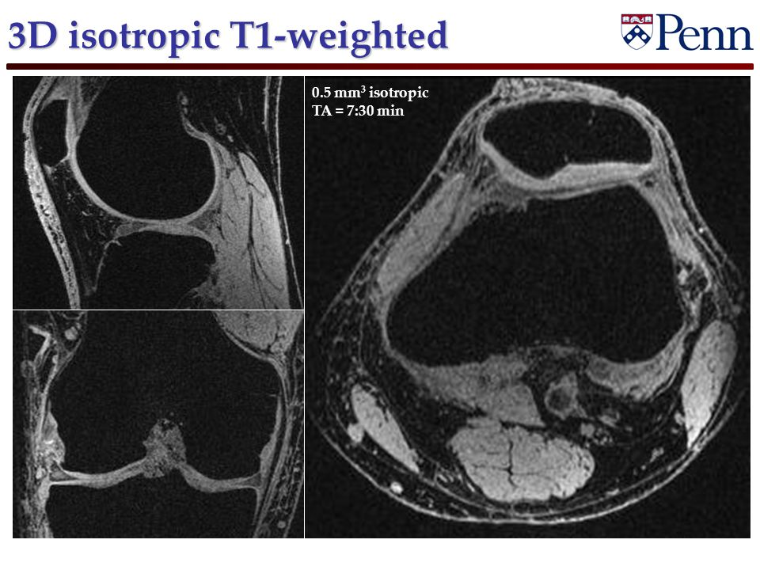

3D CT Skull aperts syndrome:

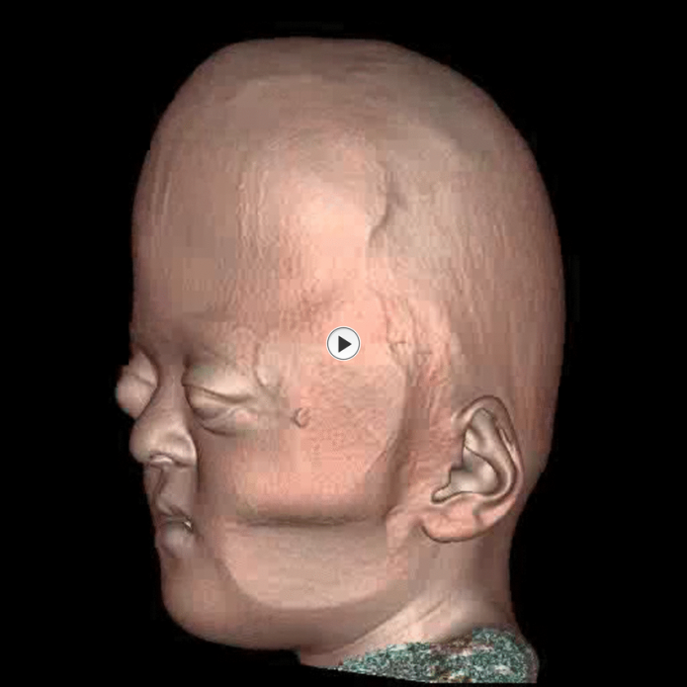
Q3: What is the function of surestart in CT imaging?
Ans:

The use of state-of-the-art helical CT scanners allows for ultra fast examination of larger regions of the body. Due to the short examination time, optimum utilization of the intravenous contrast medium bolus is of extreme importance. The Sure Start function grants this in a very simple way.

Function of surestart:

A low-dose planning scan (scanogram with 50 mA) is obtained on the Aquilion 64, Toshiba’s 64-row CT, to define the start and end of the spiral scan, identify the widest dimension of the heart, and place the SureStart . The start position is placed just above the origins of the coronary arteries, using the left atrial appendage for orientation. The scan ends just below the heart, and can be stopped manually. The SureStart is placed at the start of the spiral scan, by positioning the active line exactly over the upper boundary of the scan as illustrated. The SureStart should not contain the coronary arteries or be placed too high . Careful planning of the scan is essential for achieving an optimal result while minimizing radiation exposure.

Planning the individual scan delay on the Aquilion 64 using the SureStart bolus tracking tool is illustrated . The selected scan plane, just above the origin of the coronary arteries, is chosen to start the scan at the optimal time by monitoring the arrival of the contrast bolus in a region of interest (ROI) placed in the descending aorta. Important landmarks in this plane are the sternum anteriorly and the descending aorta posteriorly. Also seen in this plane are a segment of the pulmonary trunk and a portion of the anterolateral chest wall. The ROI in the descending aorta is used to monitor the increase in Hounsfield units (HU) after initiation of contrast injection.

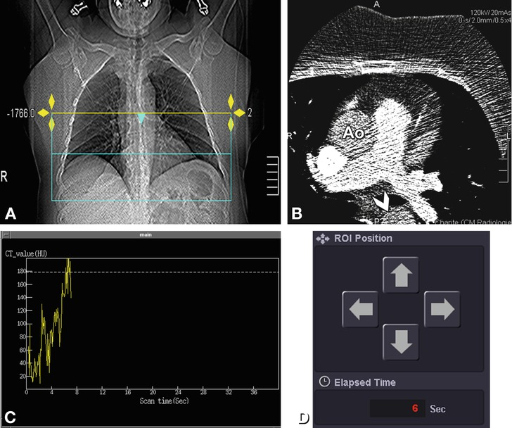

Start of the helical coronary examination. The position of the SureStart has been defined on the basis of the planning scan (Panel A). Next, a continuous low-dose scan (30–50 mA) is acquired at the level of the start of the spiral scan for triggering the spiral scan after IV contrast administration (Panel B). Contrast arrival can be tracked in real time. The continuous scan is started not earlier than 15 s after initiation of contrast administration for reasons of radiation protection and to ensure optimal opacification of the target vessels. Contrast arrival is measured in an ROI in the descending aorta (arrowhead and small circle in Panel B). The continuous increase in HU in the ROI over time is represented in Panel C in the form of a graph. The breathing command starts once the defined threshold of 180 HU has been reached. The scan then starts with a 3-s delay to allow the heart rate to normalize after inspiration. The arrows in Panel D represent cursor movements and can be clicked to correct the position of the ROI in the descending aorta if necessary and also displayed the elapsed time. Ao ascending aorta

The scan delay after contrast injection can be determined in one of the two ways: (1) by injection of a test bolus to determine the patient’s individual circulation time and optimize the spiral scan parameters accordingly, or (2) by bolus tracking, with automatic triggering of the scan once a predefined Hounsfield threshold has been reached . Use of the test bolus method increases the total amount of contrast injected and may be inaccurate because the circulation time may vary. Contrast agent injection is usually followed by an automatic 40-ml intravenous saline flush administered at a flow rate of 4 ml s⁻¹, which serves to wash out the right ventricle and improve coronary artery visualization.
Precontrast baseline attenuation is also measured in the descending aorta. In our experience, good results are achieved using a threshold of 180 HU when baseline attenuation is in the range of approximately 30–60 HU. On the basis of our experience, we recommend the use of the SureStart bolus tracking option because it consistently yields good-quality images.

Q4: What are the major differences between single slice CT and multislice CT?
Ans:

In order to understand the different types of CT imaging scans, you must first understand the meaning of the word “tomography.” This Greek word comes from two distinct words “tomos” and “graphe.” “Tomos” means “section or slice” while “graphe” means “drawing.”
When a patient passes through the CT, the circular opening rotates and takes a series of x-rays. Each rotation takes approximately 1 second. During the rotation, beams of radiation are used to make an image of the particular section of the patient’s body inside the circular opening.
Multiple slice CT scanners, first introduced in 1998, could take 4 separate images in each rotation. Since then, technology has improved and now, the CT scanners can take between 6 and 16 separate images in a single rotation.

This has improved the diagnostic capabilities of CT scanners. Recently new scanners capable of producing 32, 40 and even 64 images have been announced. These scanners will increase the diagnostic capabilities of CT scanners even further, resulting in clearer images and lower doses of radiation.
Multi-slice scanners mean that it takes less time to complete a CT scan. Additionally, the amount of radiation is reduced. The amount of radiation experienced depends on two factors. First, the design of the scanner impacts the amount of radiation required. Secondly, how the scanner is used determines the amount of radiation used.
One of the key differences between single slice scanners and multi-slice scanners is the geometric efficiency of the scan. This is directly proportional to the beam used during the imaging process. If the efficiency decreases from 100 percent down to 50 percent and all other factors remain equal, the dose of radiation must be doubled. Additionally, the amount of radiation used depends on the scan’s parameters- kV, rotation time, mA, scan field of view, focal spot size, pitch and slice width.

Singleslice CT pic.

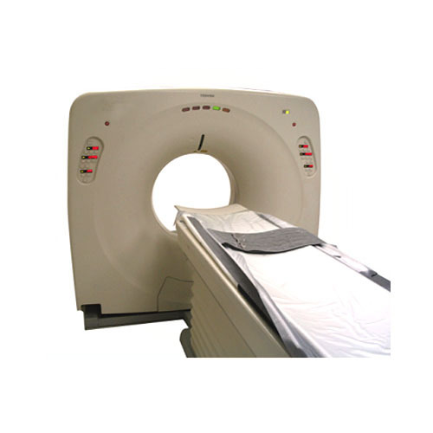

Multislice ct pic:

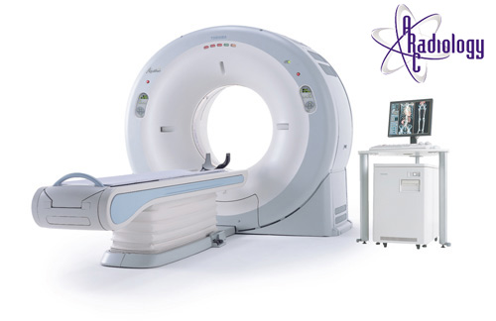

- During its 25-year history, CT has made great improvements in speed, patient comfort, and resolution. As CT scan times have gotten faster, more anatomy can be scanned in less time. Faster scanning helps to eliminate artifacts from patient motion such as breathing or peristalsis

- How Single Slice work:

- 1. The single slice Ct scan had an x-ray source and a single detector. 2. Data acquisition involved moving both the tube and detector across the scanning plane to acquire a serious of transmission measurements. 3. All data collected through a 180 degree rotation.

- Parts of single slice CT scan 1. Gantry X-ray tube High voltage Generator Detector Pre patient collimator Post patient collimator 2. Table 3. Ups 4. Control panel

- DISADVANTAGES 1. High patient dose 2. Slow performance 3. MPR low accuracy 4. Low image quality 5. Artifacts

- Multi Slice CT Scan:

- The 1980s saw incremental development of CT scanner technology: shorter scan times and increased matrix sizes, until by the late 1980s scan times were down to only 3 seconds and matrix sizes were up to 1024 x 1024. Development continued through the 1990s, with the introduction of spiral (continuous) scanning in the early 1990s and the development of multi-slice scanners, with 4-slice scanners and 0.5 second scan times being 'state-of- the-art' by the end of the century.

- Current Use of CT Scan Development of CT scanner technology continued through the early years of the 21st century, particularly with multi- slice scanners. At the time of writing, high-end scanners were offering up to 320 slices, dual-source and dual- energy x-ray sources

- How multislice scanners works? The Multi Slice Ct is special because multiple detectors are placed next to each other so the Ct can collect multiple slice data at the same time (single scan) .

- The Multi slice can work sequential and spiral mode also. In the simplest Multi slice Ct there are rows of detectors. In these, the radiographer/ assistant can set the slice thickness with the help of the collimator just as the conventional Ct. An important thing is that, usually the number of measurable slices is differ from the number of detectors.

- Part of the Multi Slice CT:

- SCAN Gantry 1) X-ray tube 2) High voltage generator 3) Lesser light 4) Cooling system 5) Rows of detectors 6) Variable collimator Control penal

- Advantage 1. Perform special contrast study(biphasic , CT Angiograms) 2. Limiting Radiation doses 3. Improved spatial resolution 4. Reduce Motion artifact 5. Less contrast medium required 6. Change the field area 7. 3D image

- Disadvantages Expensive Delivers High Dose of Radiation Ring artifact

- Generation of CT Scan 1st Generation: Single detector Single X-Tube Pencil Beam Tube rotate at 180 degree
- 2nd Generation: Single x-ray tube Detectors 1-30 Beam fan shape Tube rotate 180 degree

- . 3rd Generation: Single x ray tube Detector 400-1000 Beam fan shape Rotate and rotate Use slip ring technology

- 4th Generation: Rotate and stationary X-ray tube Rotate at 360 degree Detector stationary Detectors in ring form Imaging time in sub seconds

- Slip Ring Technology Slip rings are electromechanical device consist of circular electrical conducting rings and brushes that transmit electrical energy across a moving interface. Slip rings originally design to carry AC and DC power from a rotating platform .

- The five pair of larger brushes provide the voltage required by the x ray tube and the 3 pair of smaller one transfer signals from gantry controller. Brushes are used to transmit electrical power to the CT scanner components. There are two types of brushes that can be used wire and composite.

Q5: What are general protocols for performing CT contrast studies?
Ans:

One important PET/CT protocol decision is whether IV contrast will be used and how and when it will be administered. There are different CT scan protocols for combined PET/CT that are performed in clinical practice today noncontrast with low current (40 mAs used for AC and localization only) noncontrast with normal current (140 mAs), (3) normal current with IV and/or oral contrast or both low-dose (for AC) and full-current (for diagnostic interpretation)

Low-Dose Noncontrast CT:

Performing CT at a low-dose (40-60 mAs) reduces the sensitivity and specificity of the modality for detecting malignant lesions but usually is adequate for general anatomical localization and is sufficient for performing PET AC. In this method, the CT replaces the typical transmission scan performed on dedicated PET scanners, significantly reducing scan times (as much as 40%) relative to dedicated PET. It also provides better anatomical localization compared with traditional point source– based transmission scans, particularly in the lung . Outpatient imaging centers without medical personnel that are available immediately or centers in which the interpreting physician is trained in PET/nuclear medicine generally use this type of scanning algorithm. In addition to the decreased diagnostic sensitivity, additional disadvantages of this type of approach include the presence of CT images that need to be interpreted but generally cannot be billed for separately because of the poor quality of the images. If clinically indicated, a separate diagnosticquality CT may be performed as part of the PET/CT scanning session or as a separate CT performed on another CT scanner. However, in addition to decreasing the accuracy of the coregistration, using another device to acquire a diagnostic CT diminishes the advantage of imaging consolidation provided by PET/CT.

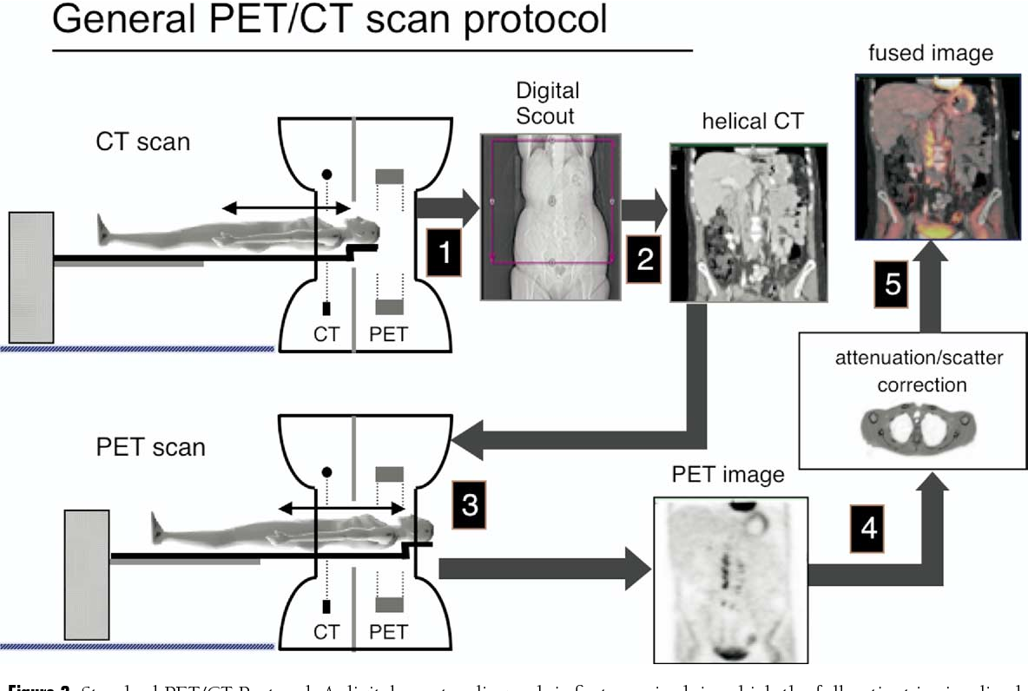

Noncontrast CT:

This method uses a full-dose CT before performing the PET portion of the examination. This method might be performed in patients with a significant contrast allergy or, perhaps in patients being evaluated for a single pulmonary nodule. The CT portion of the examination generally is interpreted and reported, particularly in cases in which this is the desired CT imaging protocol.

Contrast-Enhanced CT:
The protocol that takes maximal advantage of the original design concepts of a state-of-the-art CT and PET in the same device is one that uses contrast-enhanced CT protocols for PET/CT imaging. This method attempts to maximize the diagnostic potential of the CT scan by using both oral and IV contrast before performing the PET portion of the examination. Depending on the quality of the CT component, the PET/CT scanner, these images may be comparable to the quality of a CT scan performed on a dedicated CT scanner.6-9 However, factors including breathing artifacts and large scanning field of view can result in significant differences in the quality of the images.10 One important consideration for the use of IV contrast is whether there is appropriate medical coverage available to respond to possible untoward contrast reactions. Also debate still exists as to whether IV and/or oral contrast offer overlapping, purely complementary, or synergistic information, given the added information offered by FDG on the PET part of the examination. Several studies have been published confirming improved diagnostic accuracy of contrast-enhanced CT compared with that of noncontrast CT for differentiating between benign and malignant processes.11-35 Although many of these studies demonstrate a diagnostic improvement of contrast over noncontrast CT, many also suggest that, for various tumor types, using a multiphasic enhancement technique may further improve the diagnostic capability of CT. Malignancies with characteristic enhancement patterns, such as hepatocellular carcinoma, which generally enhance (and may only be detectable) during the arterial phase, may be less apparent on portal venous or delayed-phase images.11,16,31 Conversely, cholangiocarcinomas may show delayed enhancement, and optimization of the CT protocol for this indication includes performing a delayed-phase scan at approximately 10 minutes. These types of protocols are possible with PET/CT, although they require more planning and, in some cases, more time. Because most oral and IV contrast agents have the potential of generating artifacts on the AC PET images on most scanners, there are also protocol considerations when using contrast agents for the CT portion of a PET/CT examination. These artifacts, which are discussed in more depth in the subsequent sections, generally are easy to recognize and not usually clinically relevant. In addition, contrast agents render vessels and bowel distinct from other structures, helping to improve reader confidence and specificity in differentiating benign from malignant FDG uptake. Centers must, therefore, weigh the potential benefits of having a contrast-enhanced CT with the disadvantages of AC artifacts on PET from using contrast. At the University of Pittsburgh Medical Center, the overwhelming majority of CT scans performed as part of a PET/CT are performed with oral and IV contrast.

Low-Dose CT Followed by Contrast-Enhanced CT:

One way to avoid CT AC artifacts caused by IV contrast is to perform a low-dose noncontrast CT that can be used for AC first. Then, after the PET portion of the examination, a contrast-enhanced CT can be performed for diagnostic purposes. However, the disadvantage of this protocol is an increase in the radiation exposure to the patient because they are undergoing 2 CT scan.

Artifacts on PET/CT Related to CT Protocols IV Contrast AC:

Artifacts As mentioned previously, one of the stated reservations about the use of contrast media is that they may cause artifacts on the AC PET images when using CT for AC.9,37-40 When dense contrast material is present in central venous structures during the CT acquisition, but not during the PET portion of the examination, there tends to be an overcorrection of the PET data. This mismatch causes an area of linear artifact (mimicking intense FDG accumulation) on the AC PET images (Fig. 6).41 Atypically, this artifact can appear focal and mimic a malignant lymph node in the axilla or supraclavicular area.40 Conversely, a focus of FDG-avid tumor also could be obscured by the artifact.41 In addition, artifacts can have atypical appearances that can confound image interpretation as well. A relatively simple solution to diagnostic uncertainty regarding the presence of a CT-based AC artifact is to inspect the non-AC PET images, which should show no evidence of FDG activity. Unfortunately, it can be cumbersome to switch between the AC PET data and non-AC PET data using many PET/CT viewing systems, and some fusion viewing systems will not allow side-by-side comparison of AC and non-AC PET images. Alternatively, venous AC artifacts can be reduced by using dual-head CT contrast injectors that uses a saline flush after the contrast bolus to decrease the amount of contrast material in the central veins.

Future Direction of CT Protocols:

Very few studies have been performed actually comparing noncontrast with contrast-enhanced PET/CT. Even fewer studies have addressed the issue of whether multiphasic enhancement of the CT portion of a PET/CT offers any potential benefit. However, a single phase of contrast enhancement for CT may not be optimal or adequate in some settings. For example, some hepatic tumors are variably FDG–avid and are well known to be reliably detected only on a particular phase of a contrast-enhanced CT scan. Hepatocellular carcinoma typically is detected optimally on only an “arterial-phase” contrast-enhanced CT scan, whereas cholangiocarcinoma usually is best seen on delayed enhanced CT. Neither arterial nor delayed-phase images acquired routinely on PET/CT examinations; rather, the CT images are acquired during a single phase of parenchymal enhancement, often referred to as the “portal venous” phase. Although it is possible to do a noncontrast, portal venous phase and delayed CT, it is difficult or impossible to obtain arterial and portal venous phases of imaging with the same bolus injection of contrast during a PET/CT examination. Because the software is designed to progress to the PET portion of the examination after a CT, most commercially available PET/CT scanners cannot quickly scan the patient during different phases of parenchymal enhancement. If arterial and portal venous phases are desired for a particular patient, the only current alternative is to perform two bolus injections, one for arterial acquisition and the second for the portal venous phase of imaging. More studies are needed to determine which patients may benefit from multiphase CT imaging in PET/CT.

