Subject: Human Anatomy II
Instructor: Dr. Arooba
Section: B
June 22nd 2020.
Total marks: 50
Student . Name .. Mudassar rauf
ID . . 15947
- Attempt the following questions. Add diagrams where needed. Each carries 10 marks.
1. What are the major features of intracranial fossae of the skull?
Ans:- IntraCranial fossae:-
* 2 paired bones frontal and temporal
* 3 unpaired ethomoid, sphenoid,and occipital
Cranial fossa:-
A cranial fossa is formed by the floor of the cranial cavity.

Cranial fossa
Cranial fossae boundaries.svg
Intracranial fossae:-( Superior veiw)
Cranial cavity is divided into three parts:
*Anterior cranial fossae
* Middle cranial fossae
* Posterior cranial fossae

Three cranial fossae and its boundaries.
Purple: Anterior cranial fossa
Blue: Middle cranial fossa
Green: Posterior cranial fossa
Boundaries
1: Sphenoidal limbus (anterior margin of the chiasmatic groove)
2: Posterior borders of the lesser wings of the sphenoid
3: Dorsum sellae of the sphenoid bone
4: Superior borders of the petrous part of the temporal bone

5: Groove for transverse sinus of the occipital bone

There are three distinct cranial fossae:

Anterior cranial fossa (fossa cranii anterior), housing the projecting frontal lobes of the brain
Middle cranial fossa (fossa cranii media), separated from the posterior fossa by the clivus and the petrous crest
Posterior cranial fossa (fossa cranii posterior), between the foramen magnum and tentorium cerebelli, containing the brainstem and cerebellum.
2. Write note on the cranial nerves?
Ans:-Cranial nerves are the nerves that emerge directly from the brain (including the brainstem), of which there are conventionally considered twelve pairs. Cranial nerves relay information between the brain and parts of the body, primarily to and from regions of the head and neck, including the special senses of vision, taste, smell, and hearing.[1]
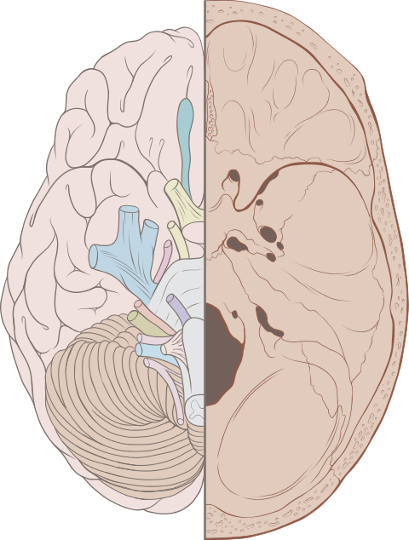

Left View of the human brain from below, showing origins of cranial nerves.
Right Juxtaposed skull base with foramina in which many nerves exit the skull.
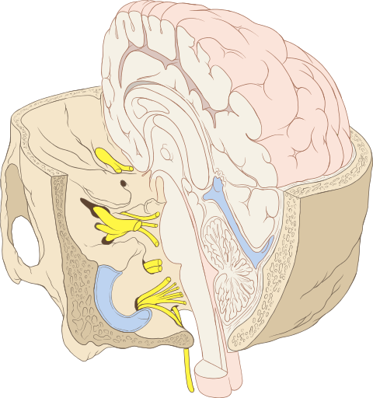
Cranial nerves as they pass through the skull base to the brain.
The cranial nerves emerge from the central nervous system above the level of the first vertebrae of the vertebral column.[2] Each cranial nerve is paired and is present on both sides. There are conventionally twelve pairs of cranial nerves, which are described with Roman numerals I–XII. Some considered there to be thirteen pairs of cranial nerves, including cranial nerve zero. The numbering of the cranial nerves is based on the order in which they emerge from the brain and brainstem, from front to back.[2]
The terminal nerves (0), olfactory nerves (I) and optic nerves (II) emerge from the cerebrum, and the remaining ten pairs arise from the brainstem, which is the lower part of the brain.[3]

The cranial nerves are considered components of the peripheral nervous system (PNS),[3] although on a structural level the olfactory (I), optic (II), and trigeminal (V) nerves are more accurately considered part of the central nervous system (CNS).[4]

The cranial nerves are in contrast to spinal nerves, which emerge from segments of the spinal cord.[3]
3. Write note on the salient features of norma frontalis and norma occipitalis of skull?
Ans:-Saint features of any online color measurement system are. Continues real time measurement of any products on a Process line which allows us to respond to product colors changees when they happen improment process while providing assurance that our product Is whitn specepic .
Making decisions about allocating monitoring the process variables affect color helping control processes variables.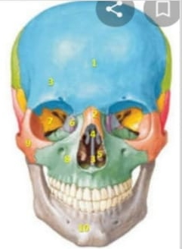
- Norma frontals.
- From the forehead orbit nasa .
- I region maxila & mandible are the prominen
- Visible
- The frontals bone.
- Nasal bone .
- Vomer Spenoid bone .
- The maxila the zygomatic bone The mandible.
- Occipital bone.
- The occipital bone is the trapezoid shaped bone it the lower back area of the cranium. The occipital is cupped like saucer in order to house the back part of the brain. It's one of seven bones that fuse together to from the skull and is directly next to five of the craniun bones. Of the skull and occipital grow fuse together later between the ages of 26 and 40.
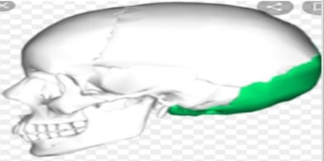
4. What do you know about the muscles of hip and knee?
Ans:-musle of hib:-The hip acetabulam is a cup like depression located on the inferolotatral aspect of the pelvis it is cavity is depened by the precens ofa collier. The acetabular labrum the head of femur is and fits completely into the concaity of the acetabulam. Both acetabulam and head of femur are covered in articular cartilage which is thinker at the place of weatght bearing.
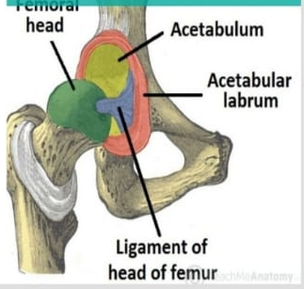
Musle of knee:-The muscle of knees including the quadri. Hamstring and the muscles of the calf. This muscle work in Groups to flex extand and stabilz the knee joint This motion of the of the knee allow the body to for form such important moments as walking running kicking and jump ping Extend along the inperior scarface of the thigh are the four musical of the quadriceps. Large muscle origanate in the ilium and femur and insert on the Tibia.
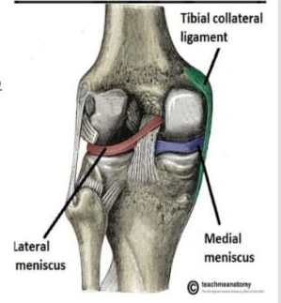

5. Write a comprehensive note on the femoral triangle?
- The femoral triangle in the interiors superior third of the thigh asub facial space that appears as a tranulaglar depression inferior to the inguunal ligament the depression is visible when the thigh is abducted flexed and Latrally rotated.
- The border of the femoral triangle ligament superiorly the aductor longus muscle medially and the sartorius the apex of the trigular is located distally and is formed by the inter section o-f the Latral border of the femoral triangle is composed sevra masale.
- The femoral triangle in the interiors superior third of the thigh asub facial space that appears as a tranulaglar depression inferior to the inguunal ligament the depression is visible when the thigh is abducted flexed and Latrally rotated. The border of the femoral triangle ligament superiorly the aductor longus muscle medially and the sartorius the apex of the trigular is located distally and is formed by the inter section o-f the Latral border of the femoral triangle is composed sevra masale.

