IQRA NATIONAL UNIVERSITY MID TERM ASSIGNMENT PAPER.
ID: 16099 SECTION: A. TEACHER: ENGR.USAMA ALI
SEMESTER SPRING FALL 2020. SUBJECT: CONCRETE TECHNOLOGY.
MODULE: 2nd SEMESTER. TOTAL MARKS: 30.
NOTE: Attempt all questions. Write short and to the point answers. Unnecessary gibberish will cause deduction in marks.

Q1: Which step is taken to prevent flash setting of cement. Also, write steps to prevent false setting of concrete.
ANS: STEP TO PREVENT FLASH SETTING OF CEMENT:
The step which is taken to prevent flash setting of cement is the addition of gypsum in cement.
STEPS TO PREVENT FALSE SETTING OF CEMENT:
The steps taken to prevent false setting of cement is to keep the temperature below the dehydration point of gypsum and the clinker should be cooled before grinding.

Q2: Draw a graph showing the strength development of pure compounds of cement.

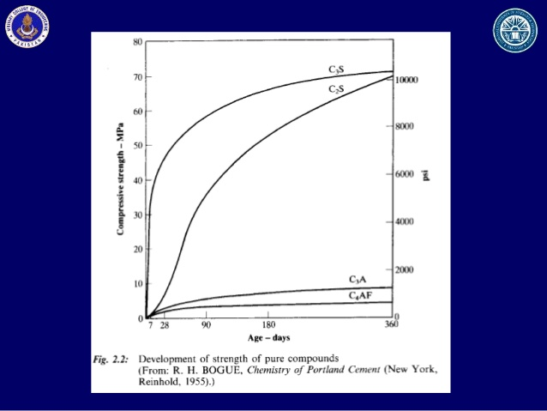

Q3: Why type 3 cement is rapid hardening and type 4 low heat producing? Draw a graph showing the development of heat of hydration of different cement types.
ANS: REASON:
Type 3 cement is rapid hardening because its rapid hardening ability is due to the presence of increased amount of C₃S compound and due to finer grinding of the cement clinker. Type 4 is low heat producing because it contains less amount C₃S and C₃A percentage.

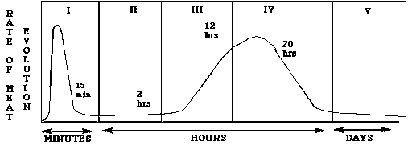

Q4: What is the effect of compaction on entrapped air of concrete? What will be the effect on strength if concrete is not compacted sufficiently? Explain with graph.
ANS: The compaction of concrete effects or results in the elimination of entrapped air present in the concrete to make it durable. If the concrete is not compacted sufficiently, there will be alot of defects and the concrete slab will suffer from loss of strength.

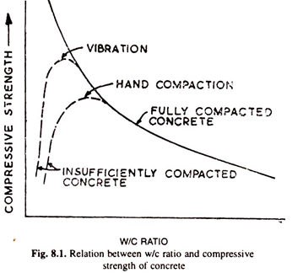

Q5: Why is the percentage of gypsum added to cement is limited only to 5%?
ANS: The percentage of gypsum added to a cement is limited only to 5% because if the amount of gypsum exceeds from 5%, it will lower the strength of cement and it also accelerates the setting time of cement which also results in weaker strength.

Q6: What is the effect of following on the bond strength of concrete?
ANS:
1: SHAPE OF AGGREGATE:
If the shape of aggregate is angular and elongated, it will have high surface to volume ratio and better bond characteristics.
2: SIZE OF AGGREGATE:
With increase in maximum aggregate size used in concrete, the compressive strength and splitting tensile strength decrease. When high maximum aggregate size of coarse aggregates values are used, there is no variation in bond strength but it reduces when maximum aggregate size of less than 10mm is used.
3: TEXTURE OF AGGREGATE:
It can be either smooth [rounded] or rough. A smooth surface can improve workability, yet a rougher [elongated] surface generates a stronger bond between the paste and the aggregates creating a higher strength.
4: BLEEDING:
Bleeding in concrete decreases strength, lowers the resistance and bond strength and cause poor bonds between successive lifts.
Q7: What is the effect of following on the workability of concrete?
ANS:
1: POROSITY AND ABSORPTION:
The porosity of an aggregate may also affect the workability of concrete. If the aggregate can absorb a great deal of water, less will be available to provide workability.
2: AIR ENTRAINING AGENT: The general effects of air entrainment are freeze thaw resistance along with increase workability, decrease strength, reduce bleeding and segregation.
3: COARSE AGGREGATE TO FINE RATIO:
In order to attain a workable, high strength and durable concrete a mix with 12% cement and 1.2coarse to fine ratio is used.
4: GRADING OF AGGREGATE:
Grading of aggregates have the maximum effect on workability of concrete. It reduces the voids in aggregate, which requires less compacting effort and thus low water cement ratio is sufficient for properly graded aggregates.

Q8: What is the effect of fineness of cement on the following.
ANS:
1: STRENGTH OF CONCRETE:
The 28th day compressive strength of concrete, with or without entrained air increases with an increase in cement fineness.
2: RATE OF HEAT EVOLUTION DURING HYDRATION:
Fineness of cement effects the rate of heat evolution in such a way that by increasing fineness, the rate of heat generation also increases.
3: TOTAL HEAT OF HYDRATION:The rate of heat generation increases as cement fineness increase and experiments show that increase of fineness of cement has no effect on total heat of hydration at 7 days
4: WORKABILITY OF CONCRETE:
The workability of non air-entrained concrete is increased by increasing the cement fineness. The concrete containing no entrained air is not significantly affected by variations in the fineness of cement.

Q9: WHAT STEPS CAN BE TAKEN DURING TRANSPORTATION AND PLACEMENT OF CONRETE TO PREVENT SEGREGATION OF CONCRETE?
ANS:
DURING TRANPORTATION:
It should be remixed properly, jolts and jerks should be avoided during transportation of concrete by mixers and if unmonitored, excess water is added by unskilled labours for Increasing workability leading to higher water cement in concrete, which should be avoided to prevent segregation.
DURING PLACEMENT:
If placing concrete straight from a truck, pour vertically and never let the concrete fall more than one and a half meters. It is advised to provide soft blows using iron hammer at the edges and corners soon after finishing.
Other than this supervision is really important and experience teaches everything.
THE END.

