**Basic Mathematics Midterm Paper**

**Jalal Mehmood**

**BBA**

**ID 13871**

**Submitted to Sir Raza Ahmed Khan**

**Question 1**

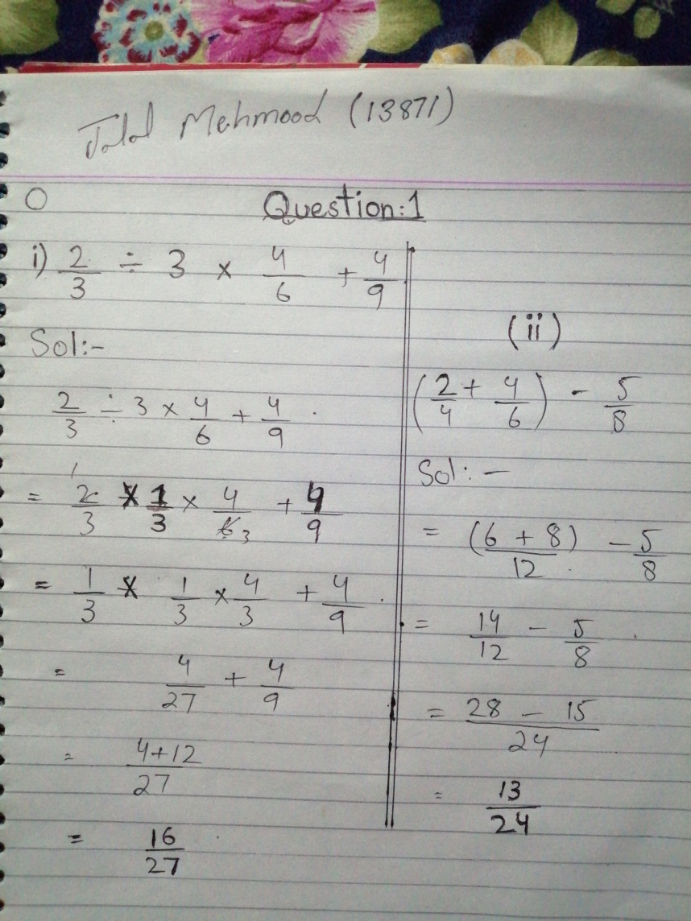

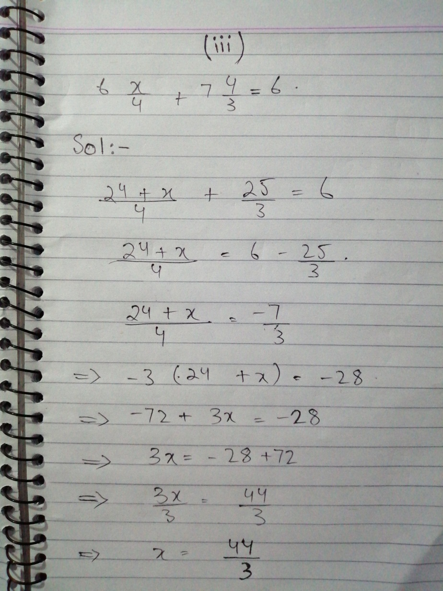

**Question 2**

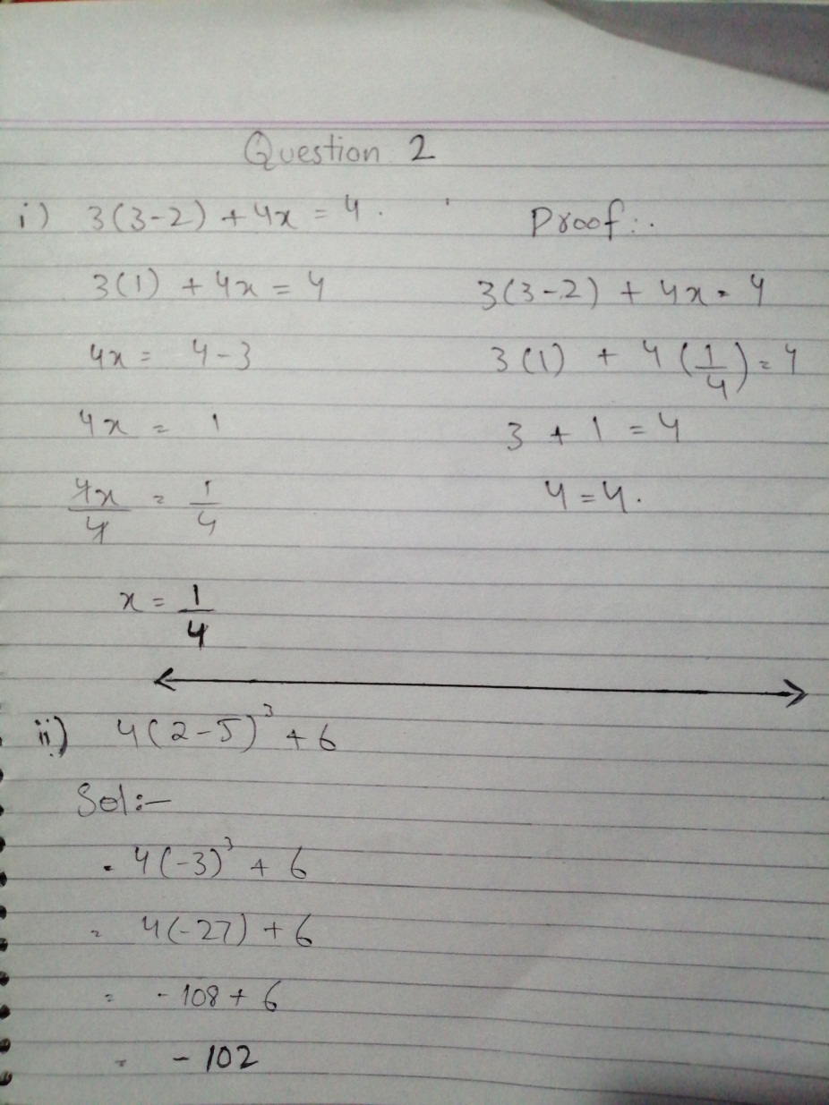

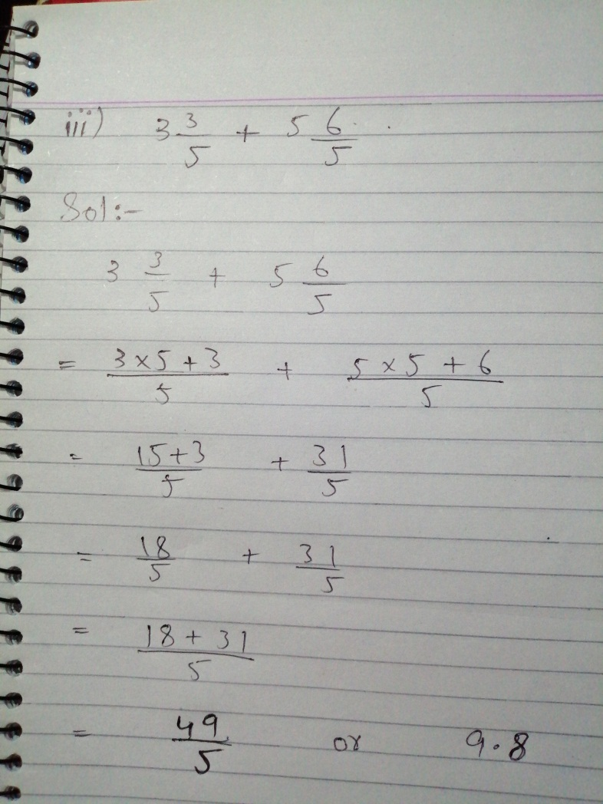

**Question 3**

