Final-Term Assignment

Course Title: Human Physiology II
Rad 2nd semester section A
Instructor: Dr. M .Shahzeb khan (PT)
Marks: 50

Note:
- Attempt all questions, all questions carry equal marks.
- Answer Briefly and to the point, avoid un-necessary details

Q1: (A) How stimulus of smell moves from nostril to brain? Make a Diagram as well

Q 2: (A) What is difference between Haemostasis, Haematopoiesis and Homeostasis?
(B) What is Erythroblastosis fetalis?

Q3: (A) What is Immunity? Explain different types of immunity
(B) What is difference between Antigen and Antibody?

Q4: (A) Write down different functions of Antibody
(B) Write difference between Primary and secondary response to an antigen

Q5: Write difference between cell mediated and Antibody Mediated
Immunity

Namr. Farhadullah Khan
Father name. Haji munawar khan
ID 16628
Subject Physiology
Section A

Question 3.
Answer A.
========
the ability of an organism to resist a particular infection or toxin by the action of specific antibodies or sensitized white blood cells.
"immunity to typhoid seems to have increased spontaneously"
Similar.
2.
protection or exemption from something, especially an obligation or penalty.
"the rebels were given immunity from prosecution"
Two types of immunity exist — active and passive: Active immunity occurs when our own immune system is responsible for protecting us from a pathogen. Passive immunity occurs when we are protected from a pathogen by immunity gained from someone else.
Answer B.
========
Antigens are molecules capable of stimulating an immune response. Each antigen has distinct surface features, or epitopes, resulting in specific responses. Antibodies (immunoglobins) are Y-shaped proteins produced by B cells of the immune system in response to exposure to antigens
==================================
Question 5.
Answer.
=======
Cell-mediated immunity is an immune response that does not involve antibody Rather, cell-mediated immunity is the activation of phagocytes, antigen-specific cytotoxic T-lymphocytes, and the release of various cytokines in response to antigen. Historically, the immune system was separated into two branches: humoral immunity for which the protective function of immunization could be found in the humor (cell-free bodily fluid or serum and cellular immunity, for which the protective function of
was associated with cells. CD4 cells or helper T cells provide protection against different pathogens. Naïve t cell, which are immature T cells that have yet to encounter an antigen , are converted into activated effector T cells after encountering antigen-presenting cells (APCs). These APCs, such as 5, dendritic cell, and B cell in some circumstances, load antigenic peptides onto the MHC of the cell, in turn presenting the peptide to receptors on T cells. The most important of these APCs are highly specialized dendritic cells; conceivably operating solely to ingest and present antigens.
Anti body mediated Immunity
•There are two main mechanisms of immunity within the adaptive immune system – humoral and cellular.
• immunity is also called antibody-mediated immunity. With assistance from helper T cells, B cells will differentiate into plasma B cells that can produce antibodies against a specific antigen.
==========================
Question 4.
Answer A.

========

•IgA are also first defense for mucosal surfaces such as the intestines, nose, and lungs.
.IgM is involved in the ABO blood group antigens on the surface of RBCs.
•IgM enhance ingestions of cells by phagocytosis.
•I.e. bind to mast cells and basophils which participate in the immune response.
• Some scientists think that IgE’s purpose is to stop parasites.
• IgD is present on the surface of B cells and plays a role in the induction of antibody production.

Question 4.
Answer B.
=======
• The primary immune response occurs when an antigen comes in contact to the immune system for the first time. During this time the immune system has to learn to recognize antigen and how to make antibody against it and eventually produce memory lymphocytes.
• The secondary immune response occurs when the second time (3rd, 4th, etc.) the person is exposed to the same antigen. At this point immunological memory has been established and the immune system can start making antibodies immediately.
=================================
Question 2.
Answer A.
========
what is the difference between homoeostasis and haemostasis. Haemostasis: is the of wound healing. This involves blood clotting. ... Examples of homeostasis include the regulation of temperature and the balance between acidity and alkalinity.
Answer B.
========
Erythroblastosis fetalis is hemolytic anemia in the fetus (or neonate, as erythroblastosis neonatorum) caused by transplacental transmission of maternal antibodies to fetal red blood cells. The disorder usually results from incompatibility between maternal and fetal blood groups, often Rho(D) antigens.

Question 1.
Answer.

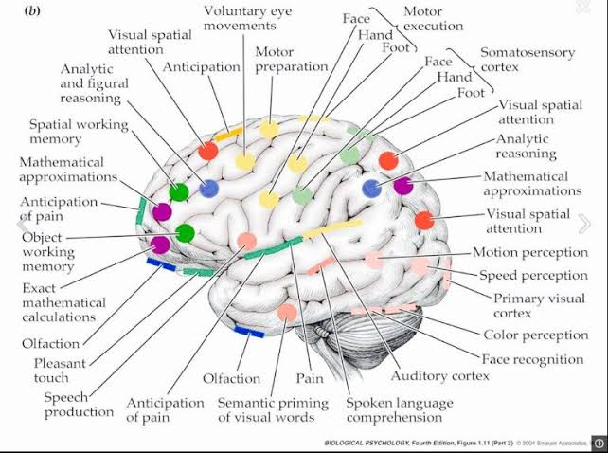
Brain Diagram.

I'm sorry sir
Darak he Diagram bandya ha
😔😔😔😔😔😔😔

