Name:- Altaf Noor Student ID:- 16186
Section A
Paper:- Physiology

Q No 1:-
Answer:- Hematopoiesis
Hematopoiesis is the process by which immature precursor cells develop into mature blood cells. The currently accepted theory on how this process works is called the monophyletic theory which simply mean that a single type of stem cells gives rise to all the mature blood cells in the body. This stem is called the pluripotential stem cells.
The process of hematopiesis
The monophyletic theory of hematopoiesis states that pluripoten stem cells multiply to produce more pluripotent stem cells, thus ensuring the steady and lasting supply of stem cells. Some of the pluripotent stem cells differentiate into precursor cells that are at least partially committed to become one type of mature blood cell.
Pluripotent stem cells multiply slowly into one of five possible unipotential stem cells which then multiply rapidly into the precursor of the specific mature blood cells for which they are destined.
Although the pluripotient stem cells and the unipotential stem cells cannot be distinguished form one another histollogically, the precursor cells can be distinguished with a trained and practiced eye.
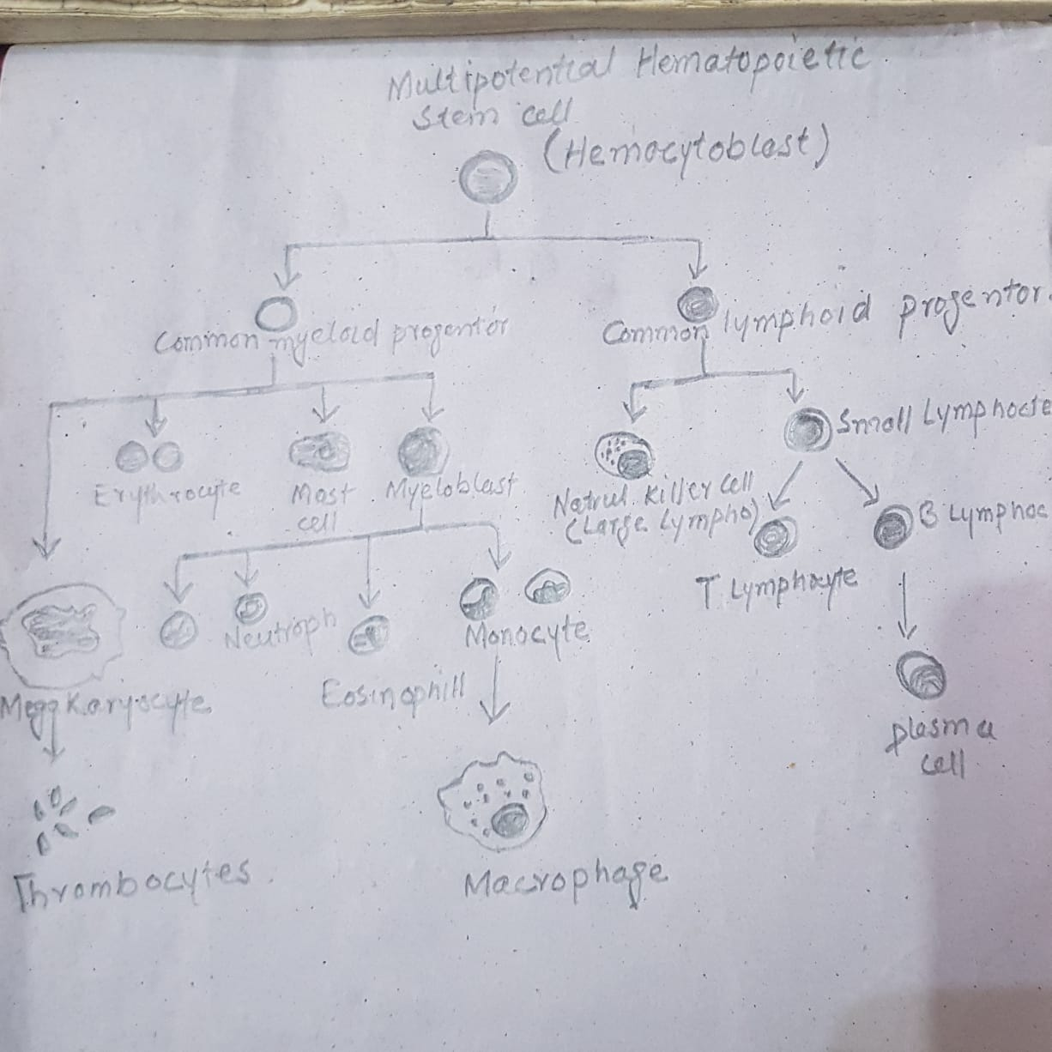

Q No 2:-
Answer:- Factors that influence the respiratory rate
The brain is the primary controller of respiratory rate. It receives input from sensors that detect oxygen and carbon dioxide levels in the blood. Blood pH a reflection of its relative acidity or alkalinity also influence respiratory rate. Activity level and the presence of drugs or alcohol are other important factors that affect respiratory rate.

Brainstem Rhythmicity center
Breathing usually takes place outside of your conscious awareness. The rhythicity center in the brainstem controls this function. Within this center are so called I nerve cells that control inspiration and E never cells that control exhalation. The I and E never cells alternative to coordinate the rhythmic pattern of inhalation and exhalation. Condition damage the rhythmicity center, such as brainstem stroke, are often catastrophic, causing respiratory arrest the cessation of breathing.

Cerebral Cortical Input
As anyone who has ever blown out a candle or practiced yoga knowns, you can voluntarily control your breathing. The conscious control of breathing is under the direction of an area of the brain known as the cerebral cortex, which controls all voluntary muscle movement. Strokes in certain areas of the cerebral cortex and condition that depress a person’s level of consciousness can interfere with the voluntary control respiration.

Blood carbon dioxide
The amount of carbon dioxide in the blood exerts a strong influence on respiratory rate. As your activity level increase, your cells especially muscls cells produce increased amounts of carbon dioxide. The rhythmicity center in the brainstem detects increased carbon dioxide and increases the respiratory rate to eliminate the excess. The lugs release carbon dioxide into air during exhalation. The blood carbon dioxide level is a critical factor in the control of breathing during sleep.

Blood Oxygen
Blood oxygen content exerts a secondary on respiratory rate. Normally, the blood oxygen level is 80 to 100 mmHg. Respiratory rate is stimulated if it drop below 50. A blood oxygen level below 50 is extremely low, which is why this respiratory control is secondary importance compared to other mechanism of respiratory rate regulation.

Q No 3:-
Answer:-
- Epidermis
- Dermis
- Hypodermis
Epidermis
The epidermis is the tin, outer layer of the skin that is visible to the eye and works to provide protection to the body. It does not contain blood vessels and is, therefore, dependent on the dermis, the layer of the skin underneath it, to provide access to nutrient and dispose of waste.
Keratinocytes are the most common types of cells in the epidermis and are responsible for the protein keratin. These cells exist in progressive stage of the differentiation from the deepest to the superficial layer of cells. These cells are responsible for the production of melanin, which contributes to the color of the skin of the individual. It also helps to protect the body form ultraviolet radiation present in sunlight that can damage the DNA of the skin cells. Langerhans cells provides in the bone marrow are as present in the epidermis and work to detect foreign substance and inflection, as a part of the immune system skin. These cells are also thought to be involved in the development of skin allergies
.
Stratum Granulosum
The stratum granulosum has a grainy appearance due to further changes to the keratinocytes as they are pushed from the stratum apinosum. The cells ( three to five layers deep ) become flatters, their cell membranes thicken, and they generate large amounts of the proteins keratin, which is fibrous, and keratohylin, which accumulates as lamellar granules within the cells. These two proteins make up the bulk of the keratinocyte mass in the stratum granulosum and give the layer it’s grainy appearance.

Stratum Lucidum
The stratum lucidum is a smooth, seemingle translucent layer of the epidermis located just above the stratum granulosum and below the stratum corneum. This thin layer of cells is found only I the thick skin of the palms, soles, and digits. The keratinocytes that compose the stratum lucidum are dead and flattened. These cells are densely packed with eleiden, a clear protein rich in lipids, derived from keratohyalin, which gives these cells their transparent i.e lucid, appearance and provides a barrier water.

Stratum Corneum
The stratum corneum is the most superficial layer of the epidermis and is the layer expose to out side environment. The increase keratinization ( also called cornification ) of the cells in this layer gives it is name.
There are usually 15 to 30 layer of cells in the stratum corneum. This dry, dead layer helps prevent the penetration of mircrobes and the dehydration of underlying tissus and provide a mechanical protection against abrasion for the more delicate, underlying layer. Cells in this layer are shed periodically and are replace by cells pushed up from the stratum granulosum.

Q NO 4:-
Answer:- Lymphatic system

The tissue and organs that produce store and carry white blood cells that fight infections and other diseases. This system includes the bone marrow, spleen, thymus, lymph nodes, and lymphatic cessels.

Components of the lymphatic system

The lymphatic system consists of a fluid vessels that transport the lymph and organs that contain lymphoid tissue.
Lymph

Lymph is a fluid similar in composition to blood plasma. It is derived from blood plasma as fluids pass through capillary walls at the arterial end. As the interstitial fluid begins to accumulate, it is picked up enters the lymph capillaries, it is called lymph. Returning the fluid to the blood prevents edema and helps to maintain normal blood volume and pressure.
Lymphatic Vessels

Lymphatic vessels, unlike blood vessels, only carry fluid away from the tissue. The smallest lymphatic vessels are the lymph capillaries, which begin in the tissue space as blind-ended sacs. Lymph capillaries are found in all regions of the body except bone marrow, central nervous system and tissue, such as the epidermis, that lack blood vessels.
The microscopic lymph capillaries merge to form lymphatic vessels. Small lymphatic vessels join to form large tributaries called lymphatic trunks, which drain large regions. Lymphatic trunks merge until the lymph enters the two lymphatic ducts. The right lymphatic duct drains lymph form the upper right quadrant of the body. The thoracic drain all the rest.

Lymphatic Organs

Lymphatic organ are characterized by clusters of lymphatic and other cells, such as macrophages enmeshed in a framework of short, branching connective tissue fibers. The lymphocytes originate in the red bone marrow with other types of blood cells and are carried in the blood form the bone marrow to the lymphatic organs. When the body is expose to microorganisms and other foreign substances, the lymphocytes proliferate within the lymphatic organs and are sent in the blood to the site of the invasion. This is part of the immune response that attempts to destroy the invading agent.
The lymphatic organs include:
- Lymph nodes
- Tonsils
- Spleen
- Thymus

Q No 5:-
Answer:- Blood Pressure
Blood pressure is the force of blood against the walls of the arteries. Blood pressure is recorded as two numbers, the systolic pressure( the pressure when the heart beats) over the diastolic pressure ( the pressure when the heart relaxes between beats).
We record this with the systolic pressure first( on the top ) and the diastolic pressure second ( below). For example, if the systolic pressure is 120 mmHg and the diastolic pressure is 80 mmHg, we would describe the blood pressure as ‘120 over 80’, written 120/80.

You will need
- Sphygmo – manometer
- Blood pressure cuffs: small, medium, large
- Stethoscope
- Chair
- Patient’s care notes or observation chart
- Alcohol wipe

Preparation
- Ask whether the patient needs the toilet.
- Ask the patient to sit down. The patient should have rested for 3-5 minutes before starting the procedure.
- Wash and dry your hands.
- Explain to the patient what you are going to do. This will help reduce their anxiety.
- Explain the sensation of the cuff tightening on their arm and reassure them that this is safe.

Method
- Ask the patient to loosen any tight clothing or remove long sleeved garments so that it is possible to access the upper arm. Do not use an arm that may have a medical problem.
- Place the cuff around the upper arm and secure.
- Connect the cuff tubing to the sphygmo-manometer tubing and secure.
- Rest the patient’s arm on a surface that is level with their arm.
- Place the stethoscope over the brachial artery ( in the bend of the elbow) and listen to the pulse.
- Pump up the cuff slowly and listen for when the pulse disappears. This is an indication to stop inflating the cuff.
- Start to deflect the cuff very slowly whilst watching the mercury level in the sphygmomanometer.
- Note the sphygmomanometer reading when the pulse reapers: record this as the systolic pressure.
- Deflate the cuff further until the pulse disappears: record this reading as the diastolic pressure.
- Tell the patient the blood pressure reading.
- Disinfect the stethoscope drum and ear pieces with the alcohol wipe
- Wash and dry your hands.
- Report an extremely low or high reading to the clinically qualified person in charge of the patient’s care.

