IQRA NATIONAL UNIVERSITY
DEPARTMENT OF ALLIED HEALTH SCIENCES
Mid-Term Examination (Summer 2020) (BS DT 1st, BS MLT 1st, BS RAD 1st)
Course Title: Human Anatomy-l Instructor: Ms. Maria Feroze
Time: 4 hours

Note:
- Attempt all questions from this section, all questions carry equal marks.

Q1. Define the following terms:
- Motor unit:
A motor unit is a single motor nerve and the associated muscle fibers that are innervated upon stimulation from the nerve.
- Ipsilateral:
On the same side, as opposed to contralateral.
For example:
a tumor involving the right side of the brain may affect vision ipsilaterally'that is, in the right eye.
- Supination:
Rotation of the forearm and hand so that the palm faces forward or upward also a corresponding movement of the foot and leg in which the foot rolls outward with an elevated arch.
- Axial skeleton:
The axial skeleton is the part of the skeleton that consists of the bones of the head and trunk of a vertebrate. In the human skeleton, it consists of 74 bones and is composed of six parts; the skull (22 bones), the ossicles of the middle ear, the hyoid bone, the rib cage, sternum and the vertebral column.
- Arteriosclerosis:
Atherosclerosis refers to the buildup of fats, cholesterol and other substances in and on your artery walls (plaque), which can restrict blood flow.
Shunt:
In medicine, a shunt is a hole or a small passage which moves, or allows movement of, fluid from one part of the body to another. The term may describe either congenital or acquired shunts; and acquired shunts (sometimes referred to as iatrogenic shunts) may be either biological or mechanical
Q2. Differentiate between type 1 and type 2 muscle fibers.
Type 1 (slow fibers)
- Present in the postural muscles.
- These are red in color because of large amounts of myoglobin
- Fatigue resistant.
Type 2 (Fast Fibers)
- Present in the muscles required for body movements
- These are paler in color because of small amounts of myoglobin
- Fatigue easily.
Intermediate fibers
- Type of fast fibers which are resistant to fatigue.

Q3. Classify the bones according to their shape.
Bone Classifications (Table 6.1)
Bone classification | Features | Function(s) | Examples
Long | Cylinder-like shape, longer than it is wide | Movement, support | Femur, tibia, fibula, metatarsals, humerus, ulna, radius, metacarpals, phalanges
Short | Cube-like shape, approximately equal in length, width, and thickness | Provide stability, support, while allowing for some motion | Carpals, tarsals
Flat | Thin and curved | Points of attachment for muscles; protectors of internal organs | Sternum, ribs, scapulae, cranial bones
Irregular | Complex shape | Protect internal organs, movement, support | Vertebrae, facial bones
Sesamoid | Small and round; embedded in tendons | Protect tendons from excessive forces, allow effective muscle action | Patellae
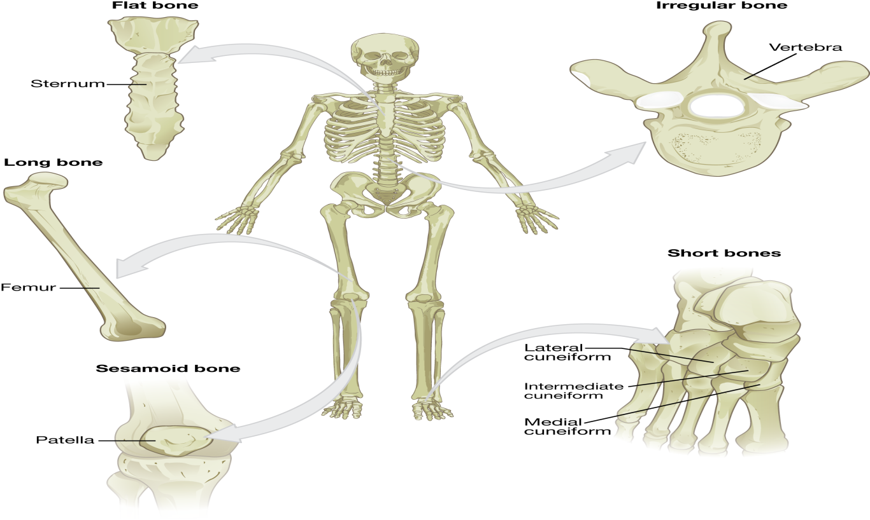

Q4. What is the difference between artery, vein and capillary?
Arteries:
- Arteries carry blood away from the heart; the main artery is the aorta.
Veins:
- Veins are blood vessels that bring blood back to the heart and drain blood from organs and limbs.
Capillary:
- Capillaries carry blood away from the body and exchange nutrients, waste, and oxygen with tissues at the cellular level.
Q5. What do you know about the mechanism of skeletal muscle contraction?
In vertebrates, skeletal muscle contraction are neurogenic as they require synaptic input from moter neurons to produce muscle contractions … once innervated, the protein filaments within each other skeletal muscle fiber slide past each other to produce a contraction, which in explained by the sliding filament theory.
Sliding Filament Mechanism
- Cross-bridge interaction between actin and myosin brings about muscle contraction by means of sliding filament mechanism.
- Increase in Ca²⁺ starts filament sliding
- Decrease in Ca²⁺ turns off sliding process
- Thin filaments on each side of sarcomere slide inward over stationary thick filaments toward center of A band during contraction
- As thin filaments slide inward, they pull Z lines closer together
- Sarcomere shortens
- All sarcomere throughout muscle fiber’s length shorten simultaneously
- Contraction in accomplished by thin filaments from opposite sides of each sarcomere sliding closer together between thick filaments.

Q6. What is the anatomical position of scapula and clavicle in human body?
Scapula:
- The scapula (shoulder blades) lies on the posterior aspect of the shoulder. It is supported by the clavicle, which also articulates with the humerus (arm bone) to from the shoulder oint. The scapula in flat, triangular-shaped bone with a prominent ridge running across its posterior surface.
Clavicle:
- The collarbone is a large doubly curved long bone that connects the arm to the trunk of the body. Located directly above the first rib, it acts as a strut to keep the scapula in place so that the arm can hang freely. Medially, it articulates with the manubrium of the sternum (breastbone) at the sternoclavicular joint.

