NAME: NOOR RAZZAQ
STUDENT ID: 15187
DPT 4TH SEMESTER
EXERCISE PHYSIOLOGY
Q1: write a paragraph on short term and long terms effect of exercise on cardiovascular system?
Answer: The effects of exercise on cardiovascular system or heart are various:
- SHORT TERM EFFECTS:
Regular exercise has enhancing effects on the body it can be related to the different part of the body. But especially every physical activity relates to the heart and the vascular system of the body. Short term effects can be vital for the temporary or ongoing activities of the body. The short term effects of exercise on cardiovascular system are:
- Exercise increases the stroke volume of cardiovascular system.
- It increases in normal heart rate
- Physical exercise increase in cardiac output (Q)
- It increases the normal blood pressure of a person
- Vascular shunting takes place

- LONG TERM EFFECTS :
Exercise has many positive effects on heart health. One of the key effect of physical activity is that it helps to modify and lessen the heart defects and cardiovascular diseases. The long term effects of exercise is slow and gradual and thus helps the body in more beneficial ways and can be noticed over a range of period. Exercise brings continuity to the long health conditions. Some of the long term effects of exercise on heart or cardiovascular system are:
- Exercise lower the risk of high blood pressure
- Exercise also lessen the risk of diabetes
- It maintains the body weight to normal
- It reduces inflammation through the body
- It helps in increase of red blood cells
- It increase in maximum heart out put
- It increase strength of heart muscle
- Drop in resting heart rate
- A quicker recovery rate after exercise to return to resting heart rate
- Increase maximum cardiac output
- Reduction in cholesterol levels
- Reduce the risk of likelihood of coronary heart fail
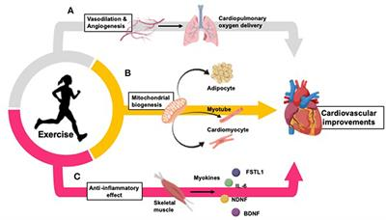

Q2: During exercise which hormones are involved and how they response to exercise?
ANSWER: Hormones are necessary for the normal functioning of the body. Exercise has a powerful effect on balancing, suppressing these hormones. When you exercise your body releases some hormones or chemicals called endorphins.these endorphins interact with the receptors in your brain that reduce your perception of pain. Endorphins also triggers a positive in the body.
Hormones correct the fluid imbalances in various regions i.e
- Posterior pituitary gland
- Adrenal cortex
- Kidneys

IN Pituitary gland:
In posterior pituitary it secretes antidiureatic hormone (ADH)
- Produced in hypothalamus , travels to posterior pituitary
- Secreted upon neutral signal from hypothalamus.
ADH is involved in the water reabosrption of kidneys and thus less water is secreted in urine.
In Adrenal Cortex:
In adrenal cortex it releases the hormones mineralocorticoids .
The major mineralocorticoids are aldosterone. It has effects in NA+ retention by kidneys. This means that water retention through osmosis and K+ excretion.
IN KIDNEYS:
The above hormones of ADH and aldosterone target the tissues on kidneys. The ADH and aldosterone act on erthropoiten (EPO), rennin.
This EPO is released by the low oxygen level in kidneys. Thus it stimulates the production of red blood cells. This the adaptation process for people living on high altitudes.
This also stimulates the rennin enzyme which is necessary for blood volume and blood pressure. Thus sympathetic nervous system impulses. 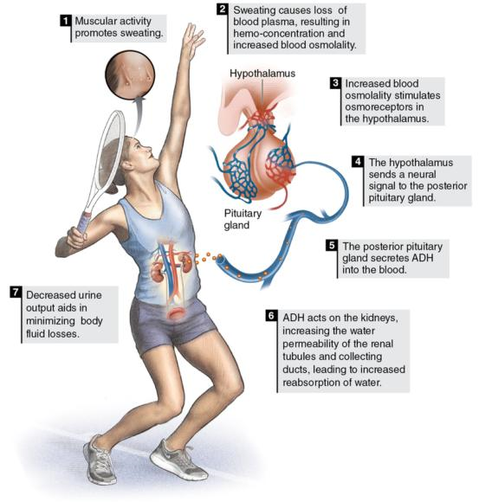

THANK YOU!!!

