Name Safi Ur Rahman ID/ 14659
Assignment > Computer Application Student of >Allied health science MlT 4th semester

Computer Applications (Major Assignment)
Q. Different types of transmission media?
Your answer should include:
- Brief description of each media.
- Characteristics
- Benefits and limitations (if any)
Use appropriated diagram for each media type.

Computer Application Assignment in,
 | Brief description of each media.
ii | Characteristics
iii | Benefits and limitations  & Diagrams

Transmission Media
> It is the way in which data can be transmitting from one place to another,
While it providing a pathway in which a sender can send message and receiver is able to receive the data or message and ready to reply.
The message which sent to another in form of data then converting to binary digits.
So, binary digits will encode into signals and then be transmitted as over appropriate medium.

There are two pathways of transmission medium
1. Guided media & 2.Unguided media

1. Guided media,
Also termed as wired media
This media are the cable that are tangible or have physical existence.
It’s the way in which data can move clearly./no errors

<>Guided media involved,
*Twisted pair cable
*Coaxial cable
*fibre optic cable
While,
2. Unguided media,
Also termed as wireless media,
Means data not clearly moves due to errors

>Unguided media involved,
*Radio Waves
*Micro waves
*Infrared waves

Guided Medias Cables

*Twisted pair cable,
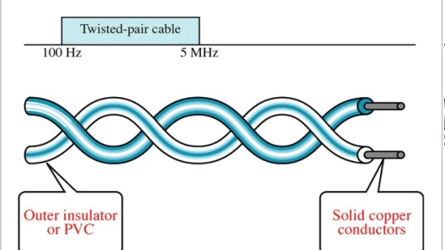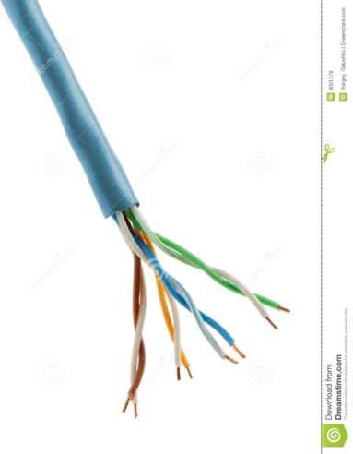
This cable is paired with copper wires.
Copper wires are good performance, and available at low costs. While it is common for transmitting signals.
>twisted pair cable is consists of tow conductors, each and every conductor have its plastic insulator, and twisted each other to form a signal media.
>and in these tow wires, one is used for carrying actual signals and 2nd is for ground references.
>these cables are coloured coated, for identifications.
>those wires are twisted to help reducing the noise and cross talk.
>this cable is mostly uses in telephone lines that providing data channels and voice.

Types of Twisted pair cable,
*Unshielded TP
&
*Shielded TP

*Shielded TP,
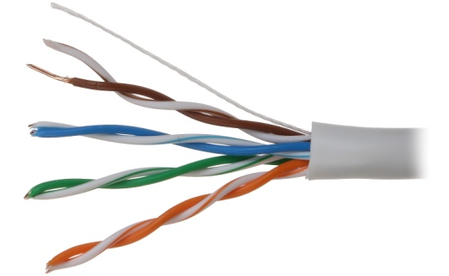
This cable is more common,
And available as with low costs as compare to shielded UTP.
And easily available due to more uses.
UTP cable is consists of 2-4 pairs of twisted cables.
Cable with tow pair uses Rj-11 connector and 4 pairs with Rj-45.
>Rj-11 connector presents in telephone, while
>Rj-45 connector presents in Ethernets.
>Rj-11 involved 6 pins, while Rj-45 involved 8 pins.

*Shielded TP,
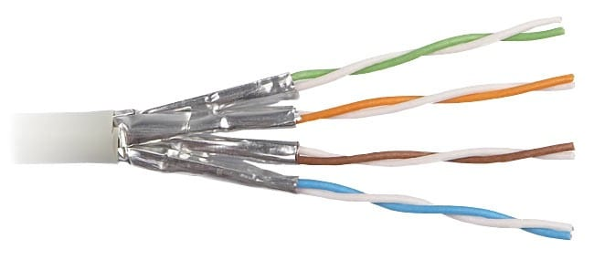
This type of cable have a metal foil covering, that encases every pair of insulator conductor.
Electromagnetic noise as penetrates as prevented by metal casing.
This cable is similar up to but the difference is to involve it mesh shielding which protects from the (EMI) electromagnetic inteferance. And the higher transmission rate be allowed.
This cable is available with high costs as compare to twisted pair and coaxial.

*Coaxial Cable,
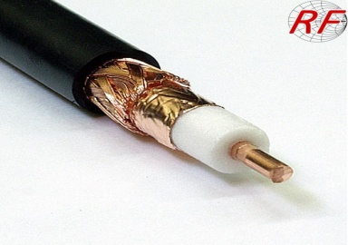without connector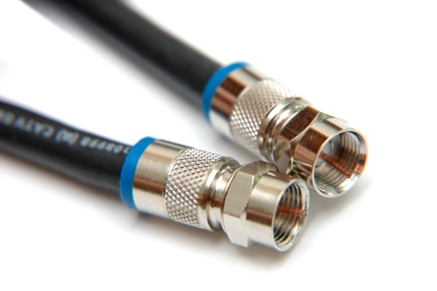With connector
>It copper cable with better shielded as compare with twisted pair cable.
At this cable signals may travel with longer distance. Through high speed.
The shield minimizes electrical and radio frequency interference.
Coaxial cable mostly used in television industries and widely uses in computer networks like Ethernet.
This cable has tow wires of copper.
The inner copper wire in centre and made of solid conductor, which is enclosed with insulator sheeth.while,
2nd copper wire is wrapped around and uses for the protections of noise.
All layers covered with plastic cover and protect the inner layers from the fire or water.

Coaxial Cable Standards

- These cables are categorized by radio government (RG) ratings.
Each cable available with different Rj numbers, like
50-ohm >Rj-7 r Rj-11 > it used with thick internet
50-0hm >Rj-58 > used with thin Ethernet
75-ohm >Rj-59 > used with cable television

>ohm-means-two types of connectors, 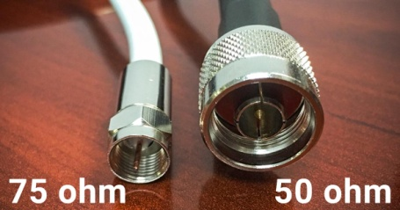
50 ohm and 75 ohm

* Fibre Optic Cable
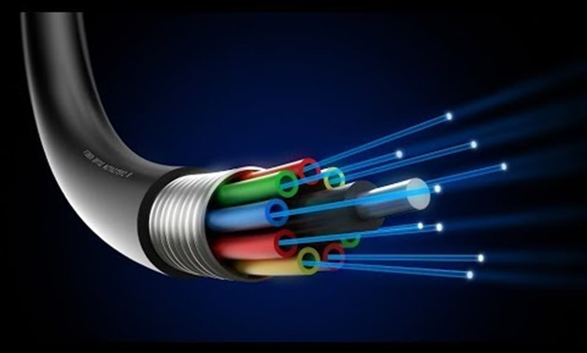
This cable is higher and advance quality cable for data transmitting.
And it is made from thin glass or plastic. It can transmit data as in form of light up to distance of thousands of miles.
It will not affect with electromagnetic interference. So, noise is less.
Fibre optic cable can caries communication signals using pulses of light generated as small laser or light emitting diodes. 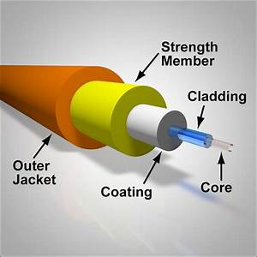
This cable is consisting of one or more strands glass, the centre of each strand known as core, that providing pathways for lights to be travelling. The core surrounded by a layer glass called core cladding, while cladding can reflects lights under and allow light to pass through bends in the cable. No light escapes glass core due to reflective cladding.

Advantages of Optical Fibre
>fibre optic cable bandwidth is high than the metal cables. Means to caries more data.
>fibre optic cable is smaller and lighter weight.
>low attenuation
Attenuation means low signals, it can decreases attenuations.
>electromagnetic interference not be affected here in fibre optic cable.
>The data can travelling as long distance and no weakness.

Disadvantages of optical fibre,
>This cable is expensive
>it’s difficult to installing
>Maintenance is difficult and high costs.
2. Unguided/wireless Media
Here in these types of media the data can transmit without virus/means data will moves unguided.
Here the data can moves through electromagnetic waves.
- Electromagnetic waves help to move data from one place to another area.
- Electromagnetic waves have contact among electric and magnetic field.

Waves
Is a disturbance or vibrations or energy which can travels with any mediums from one location to another location.
You like cans seines waves as in seas.
- A wave is the transferring of energy, through a form of matter called medium.
- Radio waves and micro waves are electromagnetic waves.

Radio Waves

> It is electromagnetic waves (EM) and its wavelength is 1millimetere and 100 kilometres. 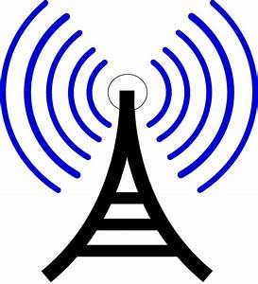
The radio frequency is simple to generate because its wavelength is longer distance.
Radio stations can transmit by the radio transmitters and the receiver can catches the signals.
Both transmitters and receivers use antennas to radiate or capture radio signals.

These given are the radio waves,
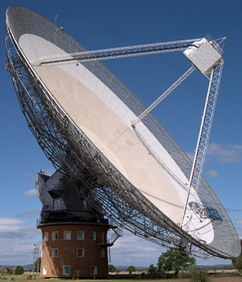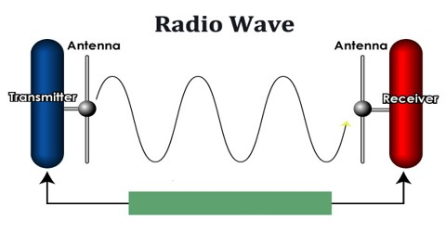
Those radio waves are widely uses for the communication both as outdoors and indoors.
Radio waves is omnidirectional means,
Radio waves can ravels with both four directions.
It is used in mobile, radio and televisions and son on.

Microwaves Transmission
- It is the type of radio waves with higher frequency. And classified with subclass of the radio waves. Micro waves frequency is 300 MHz to 300 GHz.
Microwaves are uses as point to point communication because their small wavelength which means that the signal is focused onto a narrow. And each antenna must within line of sight of next antenna.
Point –point M.wave

Infrared Waves
This wave frequency is between 300 GHz to 400 THz. And it is uses for short range communications.
It is used for very short communications like TV remote, wireless speakers, automatic doors hand held devices etc.
This wave has high frequency which prevents interference between one system to another.
Its wavelength is small and frequency is high, bcs the communication range is small.

(The black image shows infrared waves)

Disadvantages of Infrared Waves
- The infrared signals does not uses for long distance communications.
- We cannot uses infrared waves outside the building because sun’s rays contained infrared waves that can interfere with communications.

The E
n___________________________________________________d

