IQRA NATIONAL UNIVERSITY
NAME : Hidayatullah khan
ID: 14311
Final Term Examination
Subject Name: Applied Physics
Class: BS SE-1, CS-1
Instructor: M Khalid Hamid
Total Marks: 50
Note: Attempt all Questions

Q1:
a: How to calculate the magnetic force on current carrying wire?
ANSWER:
We can derive an expression for the magnetic force on a current by taking a sum of the magnetic forces on individual charges. (The forces add because they are in the same direction.) The force on an individual charge moving at the drift velocity vd is given by
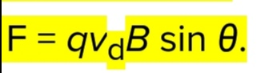. Taking B to be uniform over a length of wire l and zero elsewhere, the total magnetic force on the wire is then
(N), where N is the number of charge carriers in the section of wire of length l. Now, N = nV, where n is the number of charge carriers per unit volume and V is the volume of wire in the field. Noting that V = Al, where A is the cross-sectional area of the wire, then the force on the wire is F = (qvdB sin θ) (nAl). Gathering terms,
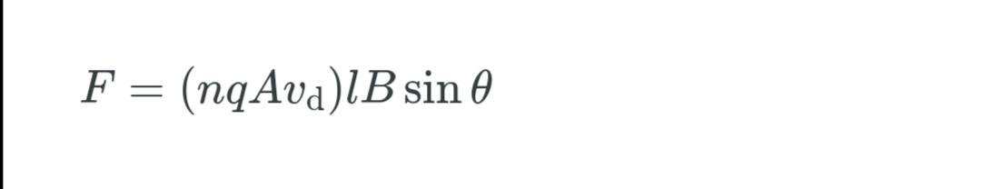

Because 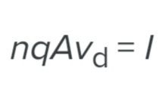

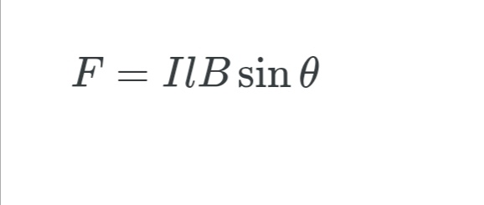
is the equation for magnetic force on a length l of wire carrying a current I in a uniform magnetic field.
Q 1:
B: What is the difference between Resistance and Resistivity?
ANSWER :
- Resistance: is defined as the property of the conductor which opposes the flow of electric current. It is also defined as the ratio of the voltage applied to the electric current flowing through it. The resistance of a conductor depends on the length, area of cross-section, and the nature of the material that is used in the manufacturing of the conductor. For a conductor, the resistance is directly proportional to the length of the conductor and inversely proportional to the area of cross-section.

- Resistivity: is defined as the resistance offered by the material per unit length for unit cross-section. The SI unit of resistivity is Ohm.meter. Resistivity increases linearly with temperature. The resistivity of conductors is low when compared to the resistivity of the insulators. Therefore, it can be represented as:
- Resistivity of conductors < Resistivity of alloys < Resistivity of insulators.
Q2:
a: What is the difference between reflection and refraction?
ANSWER:
Difference between Reflection and Refraction
Reflection:
- This phenomenon usually occurs in mirrors.
- Reflection can simply be defined as the reflection of light when it strikes the medium on a plane.
- The light entering the medium returns to the same direction.
- Considering the light waves, they bounce from the plane and change direction.
- The angle of incidence of the light is equal to the angle of reflection.

Refraction:
- This phenomenon usually occurs in Lenses.
- Refraction can be defined as the process of the shift of light when it passes through a medium leading to the bending of light.
- The light entering the medium travels from one medium to another.
- The light waves pass through the surface while simultaneously change from medium to medium.
- The angle of incidence is not equal to the angle of reflection.

Q no 2 b:
Explain the difference among angle of incident, angle of reflection and angle of refraction with the help of formulae and a single diagram?

ANSWER :

- The angle formed between the normal and the incident ray at the point of incidence is called the angle of incidence.
- Similarly, the angle formed between the normal and the reflected ray at the point of incidence is called the angle of reflection.
- The angle formed between the refracted ray and the normal is called the angle of refraction.

Diagrams:

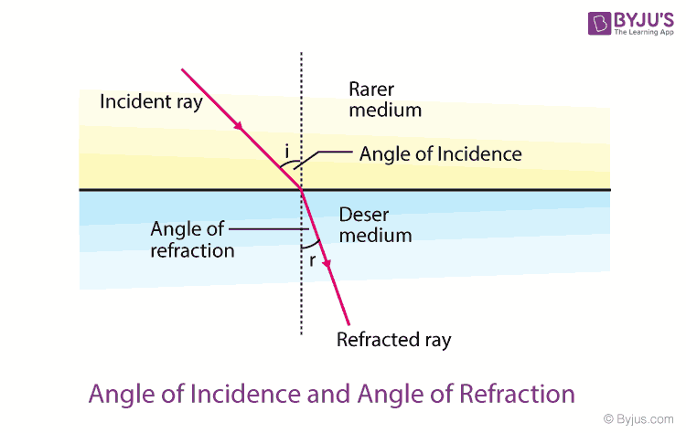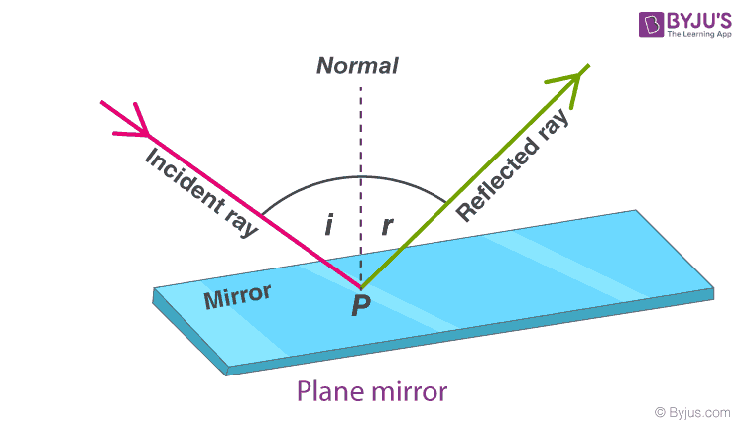

Q no 3 :
A:Find the difference between electric potential energy and electric potential?

ANSWER :
The basic difference between electric potential and electric potential energy is that Electric potential at a point in an electric field is the amount of work done to bring the unit positive charge from infinity to that point, while electric potential energy is the energy that is needed to move a charge against the electric field.
The gravitational potential at a point in the gravitational field is the gravitational potential energy of a unit mass placed at that point. In this way, the electric potential at any point in the electric field is the electric potential energy of a unit positive charge at that point.
If W is the work done in moving a unit positive charge q from infinity to a certain point in the field, the electric potential V at this point is given by:
V = W/q
It implies that electric potential is measured relative to some reference point and like potential energy we can measure only the change in potential between two points.
Electric potential is the scalar quantity. Its unit is volt which is equal to joule per coulomb (J/C).

Q no 3:
B: How to find the potential difference between any two points in the electric field lines?
ANSWER:
- the equation to calculate the electric potential difference is super easy: V = Ed. In this equation, V is the potential difference in volts (or Joules per coulomb), E is the electric field strength in the area (in newtons per coulomb), and d is the distance between the two plates (in meters).

Q no 4:
A:Compare the depletion regions in forward bias and reverse bias?
- The width of the depletion layer in a p-n junction diode decreases in forward bias due to repulsion of carriers from battery terminals, holes from p-type and electrons from n-type. Now, due to small number of ions in depletion region its potential decreases.
- Under reverse bias (applying a negative voltage to the P-side with respect to the N-side), the potential drop (i.e., voltage) across the depletion region increases. Essentially, majority carriers are pushed away from the junction, leaving behind more charged ions.
- usually at the juncture of P-type and N-type materials, in which there is neither an excess of electrons nor of holes. Large depletion regions inhibit current flow.
- Depletion region or depletion layer is a region in a P-N junction diode where no mobile charge carriers are present. Depletion layer acts like a barrier that opposes the flow of electrons from n-side and holes from p-side.

Q no 4 :
B:How reverse breakdown occur in a diode?

ANSWER:
- When a diode is reverse biased the positive terminal is connected to the n side of the junction and the negative terminal is connected the p junction. This results in the drawing of electrons towards the n junction and holes towards the p junction. Now there are some minority carriers which are present in the diode which conduct electricity in the range of micro amperes. Now if we increase the voltage the bonds near the junction starts breaking off which produces large number number of electron hole pairs which suddenly increases the current output. Hence the diode behaves like an ordinary conductor. This is called as breakdown. Now there are two ways to breakdown which are zener breakdown and avalanche breakout. Both of have the same mechanism of breakdown but they occur in two different types of diodes. Zener breakdown occurs in heavily doped diodes with small depletion layer whereas avalanche breakdown occurs in moderately doped diodes with larger depletion layer.

Q no 5:
A:Explain the Magnetic field of solenoids?

ANSWER :
- A solenoid is a long coil of wire wrapped in many turns. When a current passes through it, it creates a nearly uniform magnetic field inside.
- The magnetic field within a solenoid depends upon the current and density of turns.
- The energy density of the magnetic field depends on the strength of the field, squared, and also upon the magnetic permeability of the material it fills. Iron has a much, much larger permeability than a vacuum.
- Even small solenoids can exert forces of a few newtons.

Q no 5:
B:Explain the Magnetic field of Toroids?

ANSWER :
TOROID DEFINITION:
- If a solenoid is bent in a circular shape and the ends are joined, we get a toroid. Alternatively, one can start with a nonconducting ring and wind a conducting wire closely on it. The magnetic field in such a toroid can be obtained using Ampere's Law.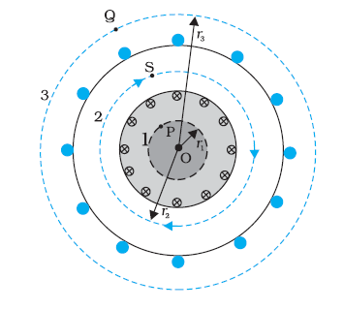

- The magnetic field in the open space inside (point P) and exterior to the toroid (point Q) is zero. The field B inside the toroid is constant in magnitude for the ideal toroid of closely wound turns.The direction of the magnetic field inside is clockwise as per the right-hand thumb rule for circular loops.

