

NAME : ***Muhammad Saad***

ID : ***16097***

Department : ***BSc Civil Engineering***

Section : ***A***

Instructor : ***Ar. Aleena Babar***

Subject : ***Architecture and Town Planning***

***Final Paper***

***Question No 1:*  
 Point out slums in Peshawar. What steps would you recommend to improve the livelihood of people living in these slums? While suggesting slum improvements. Keep the current economic and political situation of the Government in mind as well as pay careful attention to the context.**

**Ans:**There are round about 18 slums in Peshawar in which some are Shaheed Abad, Taj Abad, Gujjar Camp, Changrabad, and Gharib Abad.

Here we will consider Taj Abad slum and discuss its problems also steps for the improvement **Taj Abad problems:**

The estimated number of people and houses in Taj Abad is increasing day by day there are estimated 2000 houses in this slums and averagely each house holds 11 members. Water supply is through government or by private means such as dug well to the 65% people the remaining houses fulfill their need of water from the source outside the house. Most of the houses are 5-8 Marla’s. People living in these slums have poor health conditions due to high population, poor hygiene and sewage. Not good access to the utilities such as electricity and natural gas. Most of the streets connecting to the main road are unpaved and the streets which are paved have very poor maintenance. There is no open space in this slum. The people living in this slum are very low in education and also in skill most of the men are labor.

**Steps for improvement:**

Ist of all the Government should send back all the afghan refugees back to their own country with dignity because these refugees are the main cause of over population in these slums and over population generated most the problems in this slum. Then the people here need to be educated and government should start skilled enhancement and awareness programs in these slums. With the awareness programs the people will understand that over population is generating most of the problems here so they will also control their population with having two or three kids per one family. All people should be given access on the government level to the Utilities such as electricity, natural gas and water supply. The street having unpaved road which are connecting them to the main road should be paved and the paved streets should be maintained properly.

***Question NO: 2*  
Explain the structure and pattern of Islamabad Master Plan. Also mention what could have been done during the planning stage to make this master plan better or mention what was done wrong while planning Islamabad by criticizing it?**

**Ans:**

**Structure and pattern of Islamabad master plan:**

The urban structure and patterns in Islamabad can be divided into (1) village sprawl and leapfrog, (2) planning expansion, (3) fringe sprawl and infilling, and (4) merge.

The structure and pattern of mater plan of Islamabad can be divided into 4 parts which is Village sprawl and leapfrog, planning expansion, fringe sprawl and infilling, and merge. The 1st type of structure and pattern refers to a village upgradation into a town it’s also shows a leapfrog pattern of urban growth this pattern can be seen around the sectors in zone-1. The master plan determines the use of urban land suitably. The 2nd structure and pattern of urban growth refers to the urban expansion. In this structure and pattern the master plan consists of cropland, shrub and grassland, desert, or woodland. To increase this pattern, a road and highway network is built first. Then, the buildings and other complexes are constructed sequentially within the functional zoning areas, mainly happening in in Zone-I and -II.The third structure and pattern of urban growth involves sprawl from the urban fringe associated with infilling inside of a city. Fringe sprawl involves conversion of various land-use types at the urban fringe to buildings and roads. Fringe sprawl and infilling normally occur at the same time. It is usually accompanied by the emergence and spread of slums because of the lack of basic facilities, such as purified water supply, sanitation condition, and primary health center. This structure and pattern presented in Zone-I, -II, and -IV around the downtown of Islamabad and north fringe of Rawalpindi City. The fourth structure and pattern is a combination of adjacent cities or towns, i.e. when they are close to each other and finally become one unit. The occurrence of this structure and pattern usually involves merging two neighboring cities or towns of similar size into one, or expanding cities to the neighboring towns and villages in the periphery. The typical examples appeared in Zone-V.

**What was done wrong while planning in Islamabad:**

The original Master Plan of Islamabad, covering the urban area of Rawalpindi was never put into practice. The plan has focused on building physical infrastructure as compared to develop institutional framework necessary for implementing the plan. CDA has not plan or built any affordable housing schemes, thousands of low-income families have been unable to even dream of purchasing a house in the formal market. As a direct consequence, some families have found residence in the servant quarters of higher-income home. Analyzing the planning of Islamabad today we can clearly see the lack of planning and implementation for the upcoming years since from its inception. And the problems are growing day by day as the city construction is progressing. The true aspiration of a new capital for Pakistan to be fit for the century or more has not been achieved. The capital city of Islamabad was meant to be home to different social groups, classes and ethnicities in Pakistan; it has utterly failed to achieve this vision.

***Question No: 3*   
Which Land use model best represents Peshawar . After identifying Model type , mark all the zones on the map as discussed in the model. Additionally explain the form of Peshawar City.**

**Ans:**The infrastructure of Peshawar shows that Peshawar is **Multiple Nuclei Model.** As we see Peshawar has multiple CBD area in each zone and region also each region has its own residential area and some contain industrial area too as we can see in Hayatabad. The black under circle area on the map represent industrial areas, Red under circle area represents CBD areas, Green represent low class residential area, Grey( High class Residential),Dark black (Medium class residential), whereas Blue under circle area represent residential areas.  
**Zones:  
Black: Industrial Area  
RED: CBD  
Green: Low class Residential Area  
Grey: High class Residential Area  
Dark Black: medium class Residential Area  
Blue: Residential Area**



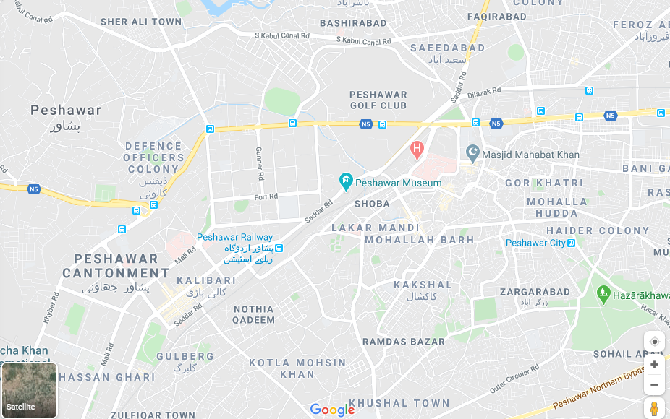



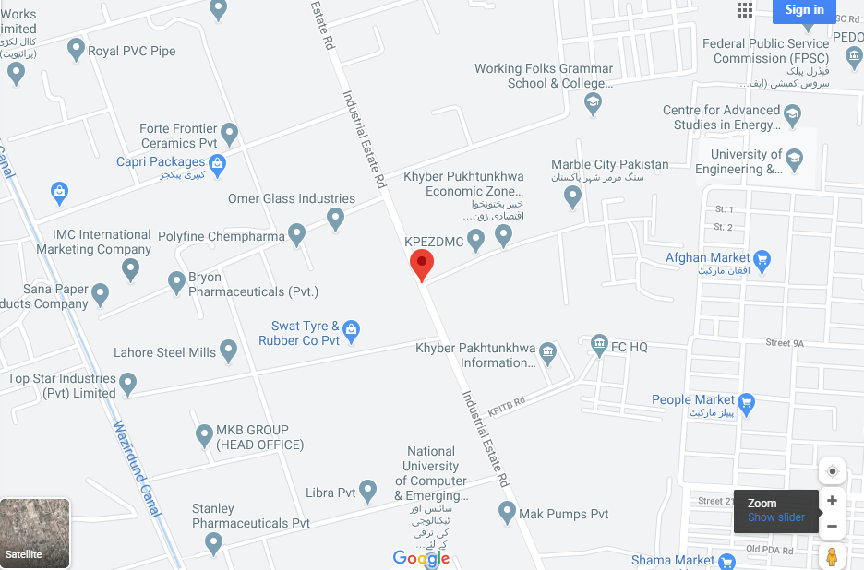 ***Form of Peshawar City:***The form of Peshawar city is Linear. As we know that a city which runs parallel to river and be built so that the wind blow from the residential area to the industrial area. The city also consists of a series of functionally specialized parallel sectors. The linear city is an urban plan for elongated urban formation. Some of the sectors which make a city linear are as follows.



* Consist of segregated zone for railway lines
* A zone for residential which consist of social institutions, residential buildings, children’s band.
* A park zone and an agriculture zone which have gardens and state-run farms
* And in case of city expansion additional sectors could be added to the each end of band, and the city could become easily longer than growing wider.

So as we can see from above discussed point Peshawar is a linear city .