DPT SEC B PHYSIOLOGY, 2ND SEMESTER
MAM KOUSAR SHAH JEHAN
STUDENT NAME : _Muhammmad Faiq_____ , ID_16451____________
Attempt all questions. Every question carry 10 marks.
Q1. Write a note on pituitary gland, its harmones and abnormalities?
ANS:
Pituitary gland;
The pituitary gland is also called the hypophysis is a small gland about 1 centimeter in diameter
Location;
The pituitary gland lies at the base of the brain and is connected by the hypothalamus of the brain by the pituitary stalk.
Division of the gland;
It is divide into anterior pituitary and posterior pituitary gland.
- Anterier pituitary gland;
The hormones release by the pituitary gland are as fallow;
- Growth hormones:
Stimulates protein synthesis
- Thyroid stimulating hormones:
It stimulates synthesis and secretion of thyroid hormones
- Adrenocorticotropic hormones:
Stimulates the synthesis and secretion of adrenocorticol hormones.
- Prolactin:
Promotes the secretion of female breasts and secretion of milk.
- Follicle-stimulating hormones:
Its cause growth of follicles and the sperm maturation of testes.
- Luteinizing hormones;
It stimulates testosterone synthesis and it also stimulate ovulation in the ovaries.
- Posterior pituitary;
- Antidiuretic hormones
They are also called vasopression. The main function of it is increase reabsorption of water by kidneys and it increase blood pressure.
B. oxytocin;
It stimulates milk ejection and uterine contraction.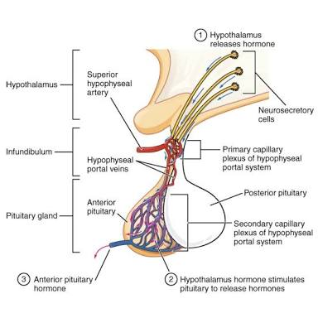
Abnormalities of pituitary gland;
Abnormalities accour due to increase or decrease of hormones release.
- Dwarfism
It is also called panohypopituitary and is mostly acour in children due to decrease amont of hormones release by the anterior pituitary
- In this disease the feathers of the body develop in appropriate proportion to eache other but the rate of growth is decreased
- It can cause the the inflammation of anterior pituitary gland and also truma.
- It can be treated by using the growth hormones. 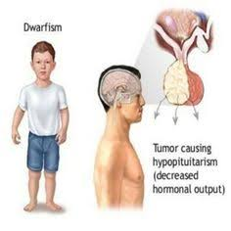

- Gigantism:
Increased activity of pituitary gland is called hyperpituitarism and it affect the hormones of gigantism
- In children the overactivity of the glad cause increased secreation of gigantism hormones as a result body grows rapidly including bones there is also enlargement of liver kidneys and heart.
- It can treated by removal or irradtion of tumer of anterior pituitary gland
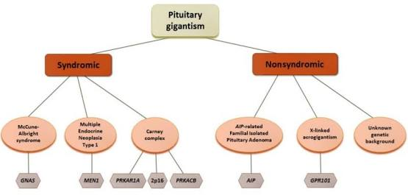
- Acromegaly;
- Hyperpiuitarism after puberty as the person can not grow taller so the only soft tissue grows.
- In this disease the body is in regular shpe according to normal body
- It can be treated by gamma radiation.
Q2. What is erythrocyte, erythropoiesis, erythrocytosis and erythropenia?
Ans:
Lets first define and explain erythrocytes
- Erythrocyte.

Erythrocyte is also called red blood cell .it is biconcave is shape and are the most abundant cells of the lood and are necessary for the delivery of oxygen to tissue
The main function of the erythrocyte are as;
- Helps in the transport of oxygen
- Helps in the maintain of acid base balancing
- Maintain blood viscosity and also ionic balance
Erthropoiesis;
It is the process by which new blood cells are produced RBCS .
This process are produced when the erythrocytes are produced it is triggered by erthropoitein are released and it take place in the bone marrow where hemopiotic stem cells differtiate and eventually shed their nuclei to become reticulocyte.
And erthropoisies are occour in the fetal life at the age of 7and age of 20.
Erythrocytosis: or polycythemia
Erhtrocytosis is defined as an increase in red blood cells mass usually absolute and is also associated with an increase hematrocrit and hemoglobin concentration . it is also called erthrocytosis.
Types;
There are two types of erythrocytosis or
Secondary polycythemia
Whenever the tissue become hypoxic because of too little oxygen.and it is due to rise in rbc count is due to to deficient oxygen at such height.
Primary polycythemia;
This is caused by a problem with cells in the bone marrow.

Erythropenia;
- A decrease in the number of the red blood cells and it is associated with anemia
- It is caused by the mutation in the genes that control how many RBCS our bone marrow makes

Q3. What is platelets and write about clotting mechanism and its all steps?
Platelets:
- they are also called thrombocytes and are 4 micrometer in diameter.
- They are formed in the bone marrow of mega karyocytes
- The normal cocentration of platelets are 150,000 and 300,000 per microliter
Function of platelets;
- Actin myosin contraction
- Residuals of both endoplasmic and golgi apparatus
- ATP and ADP are also formed in mitochondria by platelets.
- Blood congulation is also performed platelets.
Life span;
It has the half life span 8 to 12 days
Clotting mechanism:
Coagulation and clotting mechanism is the process or mechanism by liquid blood is change into gel blood.
THE MECHANISM OF invoves the following steps
- Adhesion of platelets;
Immeditly after an injury the endothelium lining the vessel damaged and the underlaying collagen exposed to platelets and the platelets combine with it by the process of adhesion.
- Activation of platelets;
After that platelets truns on messenger to activate more platelets and newly platelets come right at the injury site.
- Aggregation;
    - Now when there combine a lot of platelets it form a plug at injry and become swollen
Fibrin deposition ;
At this time hemostsis occur and the dipostion of fibrin is placed and platelets are stop.
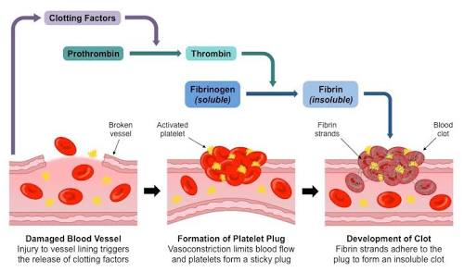
Q4. Write a detail note on A BO system?
The abo blood group system is the most important blood group in the human body transfusion
- It is found on platelets epithelium and cells of other than rbc
History
It was discovered by Landsteiner in 1909 he abnd his five co-workers began mixing each other red blood cells and serum together and accidently performed the first forword and reverse ABO grouping which are
- A 41%
- B 9%
- AB 3%
- O 47%
- This classification is done on the basis of presence and absence of inherited antigenic substance on the surface of RBC.
Explanation;
The person having blood group A and having a antigen A and a person having antigen B or AB or C having antigen B, AB and O.
Transfusion;
Similarly a person with blood group A have antibodies B and vice versaif during transfusion a person having blood group A is provided with the donor blood group B the antigen will once recognize the antigeb B and will agglutinate or clamp RBC on the having antigen on them.
Importance of ABO;
- Almost all normal healthy individuals above 3-6 months of age have naturally occurring ABS to the abo that they lack and are without antigenic stimulation.
- There are two groups one is the ABO and other is RH factor
- The transfusion reaction is caused by the agglutinogens and agglutinins.
Rh factor:
Rh factor or Rhesus factor is anther type of antigen present on RBC those having it are called Rh+ factor and those lacking it are Rh negative
A person with Rh – blood if provided with Rh+ blood will at once start producing antibodies anti_ RH which will clump the RBC with Rh + positive .
The D antgen is very immunogenic .indivdual exposed to it will very likely make an antibody to it.
Q5.(i) A person fell from a tree and become unconscious, with bleeding from head, what will you do as a first aid?
Ans;
If a person fell from a tree and become unconscious with bleeding from the head steps fallowed by us are:
- Check whether the person is breathing
- Lossen any restrictive clothing or belts. If they don’t regain consciousness with in one minute call 1122 emergency service.
- Check their air way to make sure there is no obstraction if he is coughing or moving these are the signs of positive.
- Tight his head by by a bandage so that the bleeding may stop now.
- Laying the person so that tbhe position face laying up and his arm at the side
- Keep the person worm until the emergency medical come,
- Just stay with him until the emergency come.

(ii) you have to meet with your friend and you came to know he is covid positive, what precautionary measures will you take?
Ans if you want to meet a friend that has a covid 19 to protect yourself you will have to fallow the fallowing instruction;
- Regularly and thoroughly clean your hands with detol when you are going on the way.
- Maintain at least 1 meter or 3 feet distance between yourself and your friend
- Avoide going to crowd in the hospital
- Don’t touch any thing in the hospital just go to meet your friend.
- To stay safe always wear a mask. And also wear gloves.
- Avoide toucbhing of your eyezs nose and mouth because they may contain virus that you don’t know.
- Don’t make any handshake with your friend just take salam with him ask about his health.
The best way is to stay home stay safe……
End……………..

