Name shagufta akbar
Roll No 6926
Subject neuroanatomy
Assignment submitted to Mam Maria feroze
Date 22/8/2020
Department allied health sciences
Mid term examination
Question 1 :Give the overview of the meninges and their relationship to the skull and brain?
Answer.OVERVIEW OF THe Meninges
THE Meninges refer to the membranous coverings of the brain and spinal cord. There are three layers of meninges, known as the dura mater, arachnoid mater and pia mater.
These coverings have two major functions:
• Provide a supportive framework for the cerebral and cranial vasculature.
• Acting with cerebrospinal fluid to protect the CNS from mechanical damage.

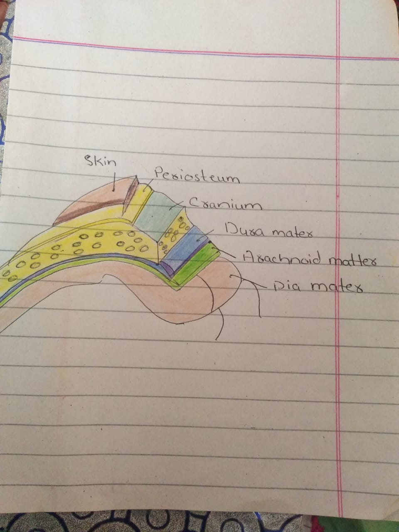
‘’Overview of the meninges and their relationship to the skull”

The meninges are often involved cerebral pathology, as a common site of infection (meningitis),
and intracranial bleeds.

Dura Mater
The dura mater is the outermost layer of the meninges, lying directly underneath the bones of the skull
and vertebral column. It is thick, tough and inextensible.
Within the cranial cavity, the dura contains two connective tissue sheets:
• Periosteal layer – lines the inner surface of the bones of the cranium.
• Meningeal layer – deep to the periosteal layer inside the cranial cavity. It is the only layer
present in the vertebral column.
Between these two layers, the dural venous sinuses are located. They are responsible for the venous
vasculature of the cranium, draining into the internal jugular veins.
In some areas within the skull, the meningeal layer of the dura mater folds inwards as dural
reflections. They partition the brain, and divide the cranial cavity into several compartments. For
example, the tentorium cerebelli divides the cranial cavity into supratentorial and infratentorial
compartments.
The dura mater receives its own vasculature; primarily from the middle meningeal artery and vein. It is
innervated by the trigeminal nerve (V1, V2 and V3).
Clinical Relevance: Extradural and Subdural Haematomas
A haematoma is a collection of blood. As the cranial cavity is effectively a closed box, a haematoma can
cause a rapid increase in intra-cranial pressure. Death will result if untreated.
There are two types of haematomas involving the dura mater:
• Extradural – arterial blood collects between the skull and periosteal layer of the dura. The
causative vessel is usually the middle meningeal artery, tearing as a consequence of brain
trauma.
• Subdural – venous blood collects between the dura and the arachnoid mater. It results from
damage to cerebral veins as they empty into the dural venous sinuses.
Pia Mater
The pia mater is located underneath the sub-arachnoid space. It is very thin, and tightly adhered to the
surface of the brain and spinal cord. It is the only covering to follow the contours of the brain (the gyri
and fissures).
Like the dura mater, it is highly vascularised, with blood vessels perforating through the membrane to
supply the underlying neural tissue.
Question 2.write down the name of the largest part of the brain also explain its internal and external structure ?

Answer. Anatomy of the Brain

Overview
The brain is an amazing three-pound organ that controls all functions of the body, interprets information from the outside world, and embodies the essence of the mind and soul. Intelligence, creativity, emotion, and memory are a few of the many things governed by the brain. Protected within the skull, the brain is composed of the cerebrum, cerebellum, and brainstem.
The brain receives information through our five senses: sight, smell, touch, taste, and hearing - often many at one time. It assembles the messages in a way that has meaning for us, and can store that information in our memory. The brain controls our thoughts, memory and speech, movement of the arms and legs, and the function of many organs within our body.
The central nervous system (CNS) is composed of the brain and spinal cord. The peripheral nervous system (PNS) is composed of spinal nerves that branch from the spinal cord and cranial nerves that branch from the brain.

Brain

There are four major parts of the brain: cerebrum, cerebellum, limbic system and brain stem. Each serves a specific purpose to keep us functioning. Everything we think, see, hear and touch is processed by the brain.
FUNCTIONAL DIVISION
The cerebellum can also be divided by function. There are three functional areas of the cerebellum – the
cerebrocerebellum, the spinocerebellum and the vestibulocerebellum.
CEREBROCEREBELLUM
the largest division, formed by the lateral hemispheres. It is involved in
planning movements and motor learning. It receives inputs from the cerebral cortex and
pontine nuclei, and sends outputs to the thalamus and red nucleus. This area also regulates
coordination of muscle activation and is important in visually guided movements.

Right brain – left brain

The cerebrum is the largest part of the human brain. It is divided into two cerebral hemispheres.
The cerebral cortex is an outer layer of grey matter, covering the core of white matter. The cortex is split into the neocortex and the much smaller allocortex. The neocortex is made up of six neuronal layers, while the allocortex has three or four. Each hemisphere is conventionally divided into four lobes – the frontal, temporal, parietal, and occipital lobes. The frontal lobe is associated with executive functions including self-control, planning, reasoning, and abstract thought, while the occipital lobe is dedicated to vision. Within each lobe, cortical areas are associated with specific functions, such as the sensory, motor and association regions. Although the left and right hemispheres are broadly similar in shape and function, some functions are associated with one side, such as language in the left and visual-spatial ability in the right. The hemispheres are connected by commissural nerve tracts, the largest being the corpus callosum.
Three major structures are visible in most views of the human brain: the cerebral hemispheres, the cerebellum, and the caudal or medullary portion of the brainstem In addition to the large size of the cerebral hemispheres (about 85 percent of the brain by weight), their surface is highly convoluted. The ridges of these convolutions are known as gyri (singular, gyrus), and the valleys between them are called sulci (singular, sulcus) or, if they are especially deep, fissures. The convoluted surface of the cerebral hemispheres comprises a continuous layered or laminated sheet of neurons and supporting cells about 2 mm thick called the cerebral cortex.

.Deep structures
Pathways called white matter tracts connect areas of the cortex to each other. Messages can travel from one gyrus to another, from one lobe to another, from one side of the brain to the other, and to structures deep in the brain .
Hypothalamus: is located in the floor of the third ventricle and is the master control of the autonomic system. It plays a role in controlling behaviors such as hunger, thirst, sleep, and sexual response. It also regulates body temperature, blood pressure, emotions, and secretion of hormones.
Pituitary gland: lies in a small pocket of bone at the skull base called the sella turcica. The pituitary gland is connected to the hypothalamus of the brain by the pituitary stalk. Known as the “master gland,” it controls other endocrine glands in the body. It secretes hormones that control sexual development, promote bone and muscle growth, and respond to stress.
Pineal gland: is located behind the third ventricle. It helps regulate the body’s internal clock and circadian rhythms by secreting melatonin. It has some role in sexual development.
Thalamus: serves as a relay station for almost all information that comes and goes to the cortex. It plays a role in pain sensation, attention, alertness and memory.
Basal ganglia: includes the caudate, putamen and globus pallidus. These nuclei work with the cerebellum to coordinate fine motions, such as fingertip movements.
Limbic system: is the center of our emotions, learning, and memory. Included in this system are the cingulate gyri, hypothalamus, amygdala (emotional reactions) and hippocampus (memory).

The brain is protected by the skull, suspended in cerebrospinal fluid, and isolated from the bloodstream by the blood–brain barrier. However, the brain is still susceptible to damage, disease, and infection. Damage can be caused by trauma, or a loss of blood supply known as a stroke. The brain is susceptible to degenerative disorders, such as Parkinson's disease, dementias including Alzheimer's disease, and multiple sclerosis.

Question 3. define and explaian the following
- Subdural Hematoma
- Cerebrovascular Accident
- Cerebellar Dysfunction
Answer. Subdural hematoma
A subdural hematoma (SDH) is a type of bleeding in which a collection of blood—usually associated with a traumatic brain injury—gathers between the inner layer of the dura mater and the arachnoid mater of the meninges surrounding the brain. It usually results from tears in bridging veins that cross the subdural space.
Subdural hematomas may cause an increase in the pressure inside the skull, which in turn can cause compression of and damage to delicate brain tissue. Acute subdural hematomas are often life-threatening. Chronic subdural hematomas have a better prognosis if properly managed.
In contrast, epidural hematomas are usually caused by tears in arteries, resulting in a build-up of blood between the dura mater and the skull. The third type of brain hemorrhage, known as a subarachnoid hemorrhage, causes bleeding into the subarachnoid space between the arachnoid mater and the pia mater

- Cerebrovascular accident (CVA)
- Cva is the medical term for a stroke. A stroke is when blood flow to a part of your brain is stopped either by a blockage or the rupture of a blood vessel.
Risk Factors: Atrial fibrillation; Diabetes…

Types of cerebrovascular accident
There are two main types of cerebrovascular accident, or stroke: an ischemic stroke is caused by a blockage; a hemorrhagic stroke is caused by the rupture of a blood vessel. Both types of stroke deprive part of the brain of blood and oxygen, causing brain cells to die.
Symptoms of a cerebrovascular accident
- difficulty walking
- dizziness
- loss of balance and coordination
- difficulty speaking or understanding others who are speaking
- numbness or paralysis in the face, leg, or arm, most likely on just one side of the body
- blurred or darkened vision

Types of CVA

Ischemic stroke
An ischemic stroke is the most common and occurs when a blood clot blocks a blood vessel and prevents blood and oxygen from getting to a part of the brain. There are two ways that this can happen. One way is an embolic stroke, which occurs when a clot forms somewhere else in your body and gets lodged in a blood vessel in the brain. The other way is a thrombotic stroke, which occurs when the clot forms in a blood vessel within the brain

Hemorrhagic stroke
A hemorrhagic stroke occurs when a blood vessel ruptures, or hemorrhages, and then prevents blood from getting to part of the brain. The hemorrhage may occur in any blood vessel in the brain, or it may occur in the membrane surrounding the brain.
- CEREBELLAR DYSFUNCTION
Cerebellar disorders have numerous causes, including congenital malformations, hereditary ataxias, and acquired conditions. Symptoms vary with the cause but typically include ataxia (impaired muscle coordination). Diagnosis is clinical and often by imaging and sometimes genetic testing.
SIGN AND SYMPTOMS
- INCORRDINATED MOMENTS
- ATAXIC DYSARTHRIA
- TITUBATION
- INTENTION TREMORS
- DYSMETRIA PRESENT
- NYSTAGMUS
CAUSES OF CEREBLLAR DYSFUNCTION
- Heriditary
- Spinocerebellar ataxia
- Friedreich,s ataxia
- Congenital malformation
- Acquired
- Developmental
- demylination

