ANS 1:
Definition of desalination:
Desalination is a process take in this process it take away minerals components from saline water, more generally desalination of water refers to that in this process salt and minerals are removing which are targeted in the substance or we can say that it is a process in which minerals and salt is removing from saline water to make the water suitable for drinking, industrial use and for irrigation system. Why it is important to do this because world’s less than 3 % water is fresh, out of this three 2% is frozen so the world human will rely on less than 1 % water, in coming time it’s importance will become more because of world’s population is becoming more and more and it is really important to be mention that out of this one percent, 60% water is located at only 10 countries.
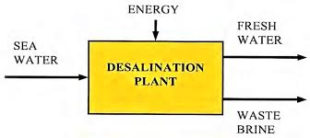
Methods for Desalination:
There are four methods for Desalination.
- Distillation (Evaporation):
- In this method first the saline water is heated in a container until the water is evaporated for the reason to leave the salt and other minerals behind.
- After this happened the evaporated water will condense because of low temperature to make water drops and will be dropped in a separate container.
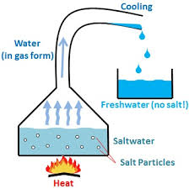
- No a days this method is not beneficial compare to others because of fuel cost.

- Electrodialysis: Simply this method is used to transport salt ions from one solution through ion exchange membrane to another solution under the influence of an applied electric potential difference. In which cell this happens is called electro dialysis cell. Salt ion is coughing from negative plate or simply we can say that in this method electrically charged membrane are used to separate ions.
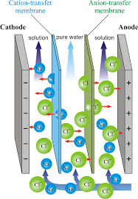
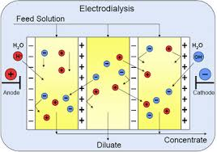

- : In freezing method the water is freezing to remove fresh water from salty water or we can say that when the water is becoming crystallized to ice, salt partials are easy to be removed. Overall there steps to be used in this method
- First water will become ice
- Ice will be washed
- Ice melting for the reason to remove salt from water
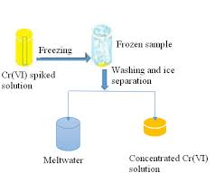
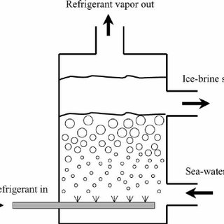
- Reverse Osmosis (RO): Reverse osmosis is a water purification process that uses a partially permeable membrane to remove ions, unwanted molecules and large particles from drinking water, in reverse osmosis, an applied pressure is used to overcome osmotic pressure. This process is used for both industrial and potable water. It significantly decrease the salt and other potential impurities in the water.
Steps involved in reverse osmosis
- Step:
- Removal of sediments from the water like clay, silt, stone and other impurities.
- For doing such a 5 micron filtered is used
- The filter make the particles suspended
- Step: In this step carbon filter is using for removal of particles.
- Step: In third step there in need to pass the water from a dense and compacted carbon filter and most of the contamination is removing here.
- Step: Now all the heavy metals are removed now are drained out from the reverse osmosis system.
- Step: In this lost stage the water is now perfect for consumption.
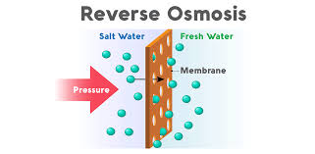

Note: Reverse method is preferable compare to others.

Ans 2: There are four types of water distribution system
- Dead End System: It is suitable for old towns and cities having no definite pattern of roads.
- Advantages:
- It is good for old towns because it does not need definite pattern.
- It is cheap
- Determination of discharge is easy
- Determination of pressure is easy
- Less valves can be used
- Pipes in this network can be laid easily
- Design of main pipes, sub and branches are based on required demand of population.
- Disadvantages:
- Due to many dead ends, stagnation of water occurs in pipes.
- Pressure is not constant
- Pressure is very less at remote parts
- Because of this less pressure sedimentation can occur
- To solve this problem there is need for more scour valves and it will make it expensive.

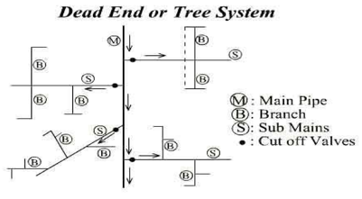

- Radial System: In this system the area is dividing at different zones.
- Advantages:
- It gives quick service
- Stagnation does not occurs
- Calculation of pipe sizes are easy.
- Disadvantages:
- Need more pipes
- Need more valves

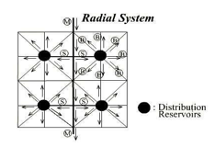

- Grid Iron system: It is suitable for cities having rectenguler layout, where the water mains and branches are laid in rectangles.
- Advantages:
- Water is kept in good circulation due to the absence of dead ends
- In the cases of a breakdown in some section, water is available from some other direction
- Disadvantages:
- Proper designing is relatively difficult.
- Pipe die calculation is hard due to lot use of valves
- More usage of valves
- These valves will reduce pressure.
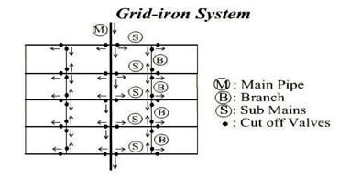

- Ring system: The supply main is laid all along the peripheral road and sub mains branch out from the mains.
- Advantages:
- Determination of size of pipes are easy.
- Water can be supplied to any point from at least two direction.
- While maintaining a part the other one cannot be effected.
- The area is divided into different zones
- In the case of a breakdown in some sections, water is available from some other direction.
- Disadvantages:
- Exact calculation of sizes of pipes is not possible due to provision of valves on all branches.
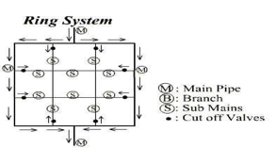
Note: From the above four I will select for the newly township in hilly area the Radial system will be preferable. Because for every different elevated area there will be separate tank.

Ans 3:
Different type of reservoir
Distribution reservoirs, also called service reservoirs, are the storage reservoirs, which store water for distributing during emergencies (such as during fires, repairs, peak demand etc.) and also to help in absorbing the hourly fluctuations in the normal water demand.
It should be located as near as possible to the center of demand. Water level will have sufficient elevation to have enough pressure.

Function of distributed reservoirs:
- To absorb the hourly variation in the demand
- To maintain constant pressure in the distribution main
- Water storage can be supplied during emergency.
There are two different types of reservoir:
- Surface reservoir:
- These reservoirs are mostly rectangular and circular in shape.
- We can name to this reservoir a ground reservoir.
- When we have much water to be stored this reservoir is suitable.
- This reservoir can be made from stones, bricks, plain or form reinforced concrete
- When gravity system is needed, location of the reservoir will be at high elevation to obtain much pressure.
- When reservoir Is becoming empty and there is no water so the wall will have enough strength against pressure which comes from out side
- Ground water table will be in kept while designing the reservoir.
- Floor of this reservoir can be made from R.C.C, stone blocks which will have sufficient water proofing.
- Construction joints will be water proved
- For inspection and aeration, manhole, ventilation pipes and stairs are provided.
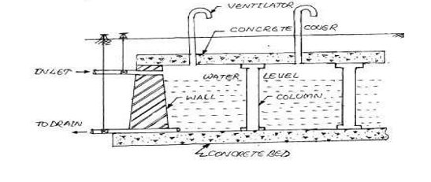

- Elevated Storage Reservoirs: Storage Reservoirs (ESRs) also referred to as Overhead Tanks are required at distribution areas which are not governed and controlled by the gravity system of distribution.
- Shape is rectangular
- If the topography of the town is not suitable for gravity system, the elevated tank or reservoir are used to provide sufficient pressure head
- They are constructed where combine gravity and pumping system of water distribution is adopted
- The Total capacity can be found from the following
Its Capacity can be found from the following three.
- Balancing storage: The quantity of water required to be stored in the reservoir for equalizing or balancing fluctuating demand against constant supply is known as the balancing storage (or equalizing or operating storage).
- Breakdown Storage: The breakdown storage or often called emergency storage is the storage preserved in order to tide over the emergencies posed by the failure of pumps, electricity, or any other mechanism driving the pumps. A value of about 25% of the total storage capacity of reservoirs, or 1.5 to 2 times of the average hourly supply, may be considered as enough provision for accounting this storage.
- Fire Storage: The third components is a fire one and it is used for fire extinguishing and this amount can be calculated from several formulas like.

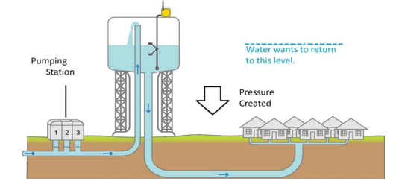
Q is a fire demand liter per second and p is population in thousands.

Note: When we are designing a reservoir the above three will be added for the capacity of tank.
Ans 4:
Why pumps are using at water supply system.
- Simply we can say that it is using for transferring of liquid from source to a destination
- More simply we can say that when they’re in need for carrying water at an elevation pumps are used.
- For pressure can be used as well
- For circulation of water can be used in a system.
- A pump can be designed for Head , Discharge and for pressure
- A pump has two heads 1) static 2) Friction head

How to calculate a pump curve:
- Head curve: From head curve we know that how much head we have for a given flow for and this head is inversely proportional to population, this graph will be seen at figure at green color.
- Efficiency: Secondly we have to know about efficiency of a pump for a given flow rate.
- Best Efficient point: A line will be draw from the maximum point of efficiency to the head curve the intersection point will show that how much head is there for how much people.
- Break Horsepower: This curve will show power to be required for a pump
And we will see that from figure there is need for 200 horsepower.

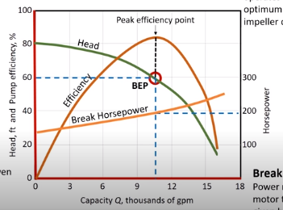

Note: Dear Sir Help me I am Sharif and I need good GPA for teaching in Afghanistan.

