Name: Syed Muhammad Hussain Shah
ID:15844
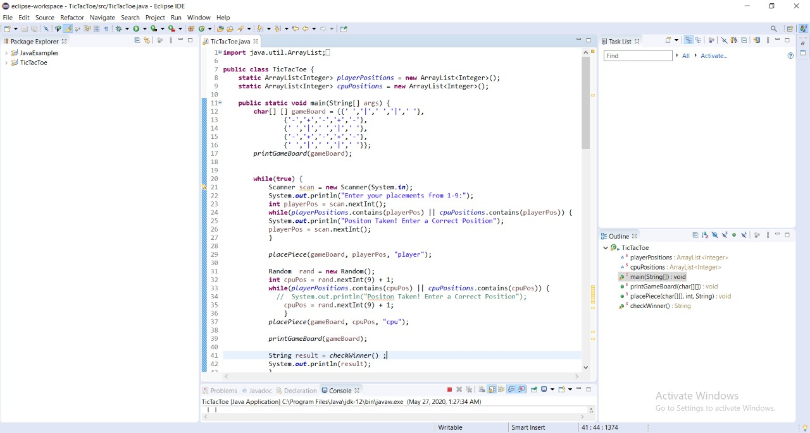
Explanation: 2D array has been use first and it is array of char(character) because we are making the game board first and we are making the game board using character/symbols so that’s why char data type has been used

Next thing is that we are using loops in which we take input from the user and if that position on the board is already take so it will give a message that this position is already taken and and force the user to perform another turn
Rand has been used for the cpu by which cpu decides the position of the tic or tac
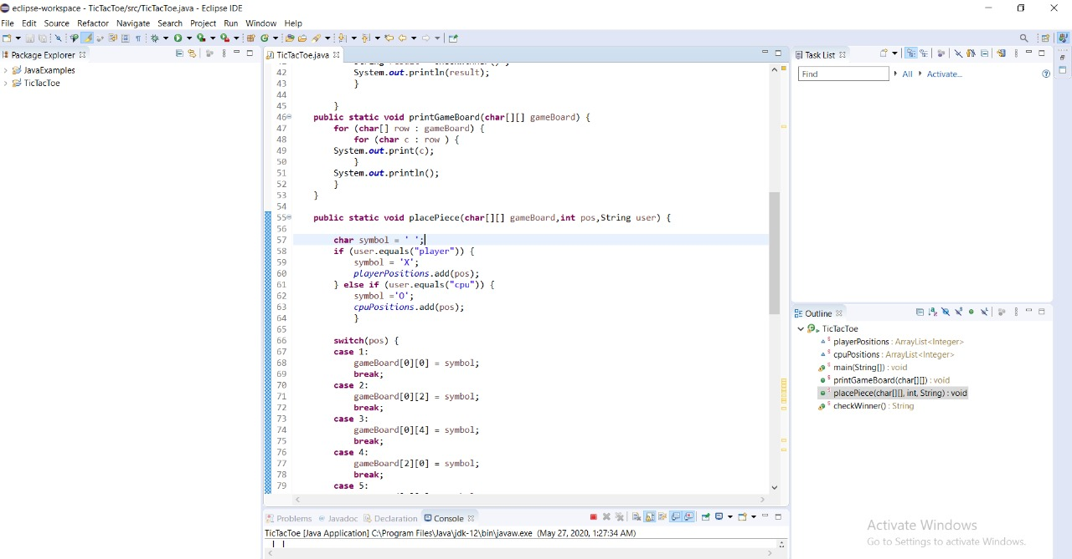
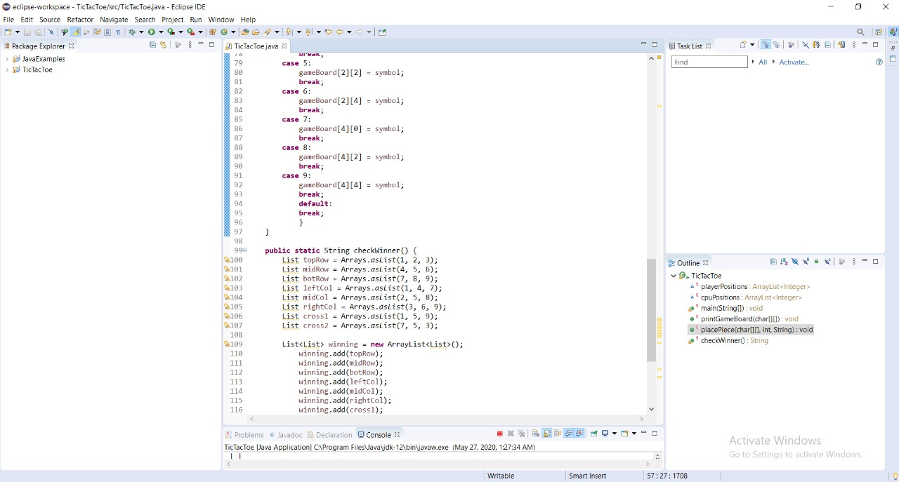

Explanation of above 2 pics: here loop(for) is used so that to keep the game going on when one player perform his turn so that it moves to cpu turn and cpu perform his turn then again player and vice versa until game is finished

Switches are used reason is that when one player perform his turn so on the game board that position is marked is tic or tac.
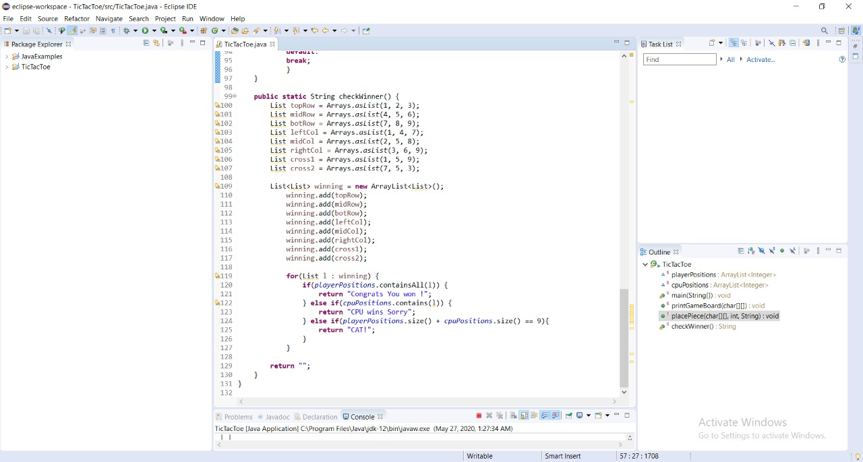
In this picture list are made in which there are possible ways of winning if that statement comes true so it will declare the game as win and lose to the other player
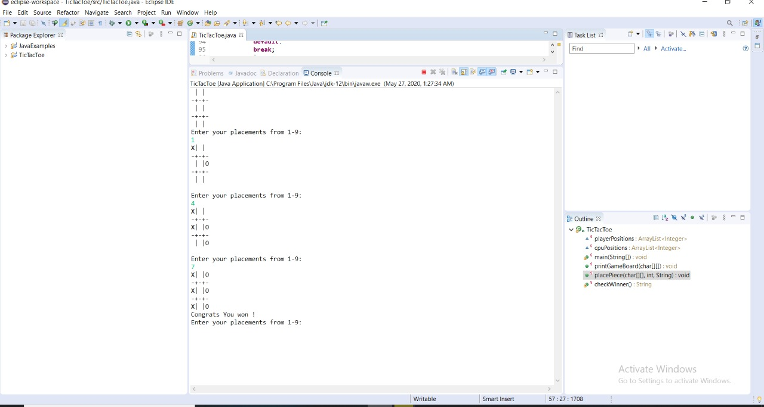
Result after compilation

