Mid Exam

Name: Salman Tahir
ID: 15173
Program: BBA
Course: Basic Statistics
Instructor: Raza Ahmed Khan

Fill the following statements with appropriate words and options: (1- Each)
1. Statistics is the word of ……Latin…………….
2. Numbers deals with ……quantitive …………………. data
3. Ordinal study deals with …………order…………
4. ……clustering…………… is the process which categorize data in different groups.
5. Histogram which construct on behalf of ……discrete……….data is called.
6. The grading score of ILETS belongs with ………percentile…… measurement scale.
7. Peshawar temperature recorded at 32⁰ F is the example of ……interval……… scale.
8. Statistics has unlimited number of usage in advance research studies. (T/F) T
9. Number of dots in a line is the relevant example of countable data. (T/F) F
10. Non scale data do not belongs with the field of Statistics. (T/F) T

Question No: 02
- Differentiate between Descriptive & Inferential statistics with suitable examples.
Answer:
Descriptive statistics:
These are the procedures used to summarize, organize, and make the sense of set of scores and observations
Descriptive statistics give information that describes the data in some manner. Descriptive statistics describe a sample. That’s pretty straightforward. You simply take a group that you’re interested in, record data about the group members, and then use summary statistics and graphs to present the group properties. With descriptive statistics, there is no uncertainty because you are describing only the people or items that you actually measure. You’re not trying to infer properties about a larger population.
In this branch of statistics, the goal is to describe. Numerical measures are used to tell about features of a set of data. There are a number of items that belong in this portion of statistics, such as:
The average, or measure of the center of a data set, consisting of the mean, median, mode, or midrange
The spread of a data set, which can be measured with the range or standard deviation
Overall descriptions of data such as the five number summary
Measurements such as skewness and kurtosis
The exploration of relationships and correlation between paired data
The presentation of statistical results in graphical form
For example
Suppose a pet shop sells cats, dogs, birds and fish. If 100 pets are sold, and 40 out of the 100 were dogs, then one description of the data on the pets sold would be that 40% were dogs.
This same pet shop may conduct a study on the number of fish sold each day for one month and determine that an average of 10 fish were sold each day. The average is an example of descriptive statistics.

Inferential Statistics:

These are the procedures used that allow researchers to infer or generalize observations made with samples to the large population from which they were selected.
Inferential statistics takes data from a sample and makes inferences about the larger population from which the sample was drawn. Because the goal of inferential statistics is to draw conclusions from a sample and generalize them to a population, we need to have confidence that our sample accurately reflects the population. This requirement affects our process. At a broad level, we must do the following:
- Define the population we are studying.
- Draw a representative sample from that population.
- Use analyses that incorporate the sampling error.
Example
You might stand in a mall and ask a sample of 100 people if they like shopping at Sears. You could make a bar chart of yes or no answers (that would be descriptive statistics) or you could use your research (and inferential statistics) to reason that around 75-80% of the population (all shoppers in all malls) like shopping at Sears

Descriptive vs. Inferential Statistics
Although descriptive statistics is helpful in learning things such as the spread and center of the data, nothing in descriptive statistics can be used to make any generalizations. In descriptive statistics, measurements such as the mean and standard deviation are stated as exact numbers.
Even though inferential statistics uses some similar calculations — such as the mean and standard deviation — the focus is different for inferential statistics. Inferential statistics start with a sample and then generalizes to a population. This information about a population is not stated as a number. Instead, scientists express these parameters as a range of potential numbers, along with a degree of confidence.

- Differentiate between Countable & Uncountable data with suitable examples.
Answer:
Discrete Data
Discrete Data can only take certain values.
Discrete data is counted

Continuous Data
Continuous Data can take any value (within a range)
Continuous data is measured
Discrete data can only take particular values. There may potentially be an infinite number of those values, but each is distinct and there's no grey area in between. Discrete data can be numeric -- like numbers of apples -- but it can also be categorical -- like red or blue, or male or female, or good or bad.

Some examples of discrete data:
- The number of customers who bought different items
- The number of computers in each department
- The number of items you buy at the grocery store each week

Continuous data are not restricted to defined separate values, but can occupy any value over a continuous range. Between any two continuous data values, there may be an infinite number of others. Continuous data are always essentially numeric.
Some examples of continuous data include:
- The weight of newborn babies
- The daily wind speed
- The temperature of a freezer

Question

Elaborate the word Frequency Distribution precisely.

Frequency distribution
The frequency against a value refers to the number of times that specific value occurs in a particular data set. Frequency distribution of a data set records frequencies of all possible values in the data set. That helps in taking an informal review or overview of the entire data.
A frequency distribution shows us a summarized grouping of data divided into mutually exclusive classes and the number of occurrences in a class. It is a way of showing unorganized data notably to show results of an election, income of people for a certain region, sales of a product within a certain period, student loan amounts of graduates, etc. Some of the graphs that can be used with frequency distributions are histograms, line charts, bar charts and pie charts. Frequency distributions are used for both qualitative and quantitative data.
The three types of frequency distributions as per the type and range of values in the data:
1. Categorical
A categorical frequency distribution is the tabulation of the number of times each category occurs in the data. It is described in a table with names of the categories under the left column and individual frequency in the right column.
Use
This is used when the data is qualitative, with or without order. A bar graph represents such a distribution.

2. Grouped
The grouped frequency distribution is the tabulation of the frequencies for grouped ranged of numerical data. It records the value for each value in the data set in the particular range where it would lie.
Use
This is used when the data is quantitative and large such that it is not possible to record each value individually. Hence they are grouped in class intervals or bins, and then each value is tallied into which interval they lie.
Histograms represent such distribution.

3. Ungrouped
Ungrouped distribution is the same as the categorical frequency distribution, except it records the numerical values discretely and records the number of times each of the value occurs in the entire data.
Use
That is used when the data is small in size and quantitative in nature.

Question
B. Construct an appropriate frequency distribution for the following data related to an experimental yield.
93, 89,75, 97,75,47, 73, 40, 100, 42, 39, 75, 13, 39, 89, 78, 32, 72, 51, 21, 92, 45, 29, 58, 16, 31, 6, 82, 76, 10, 10, 32, 2, 25, 98, 94, 93, 91, 68, 20, 19, 61, 37, 98, 72, 61, 72, 19, 81, 78.

Construct the followings about the Question 3 (b).
• Ogive curve & Histogram
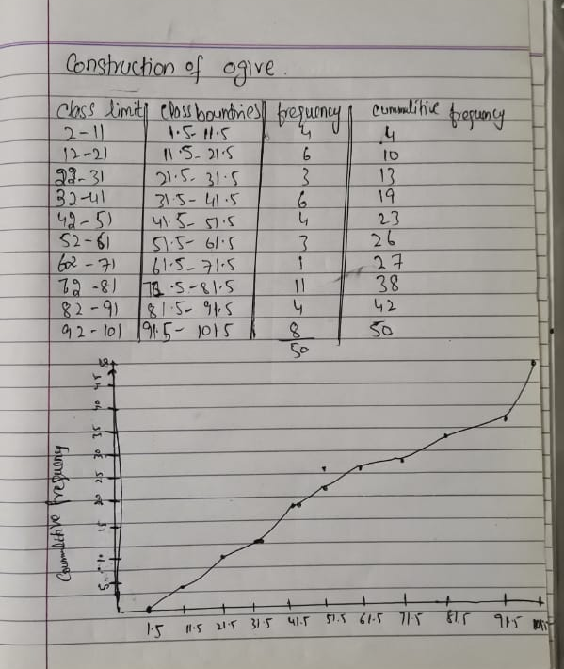

Histogram

